01 {0,A}
02 A
03 A <= 0? 6 : 4 → return A
04 {0,A}
05 → 22 (Halt) → return 0
06 A
07 {0,A,A}
08 A
09 A-1
10 {0,A,A,A-1}
11 A-1
12 A-1 <= 0? 14 : 13
13 → 21 return A(2)
14 A
15 A(2)*A(1)
16 {0,A,A(2)*A(1),A-1}
17 A-1
18 A-2
19 {0,A,A(2)*A(1),A-2}
20 → 11
21 A(2)*A(1) →
22 Halt
→
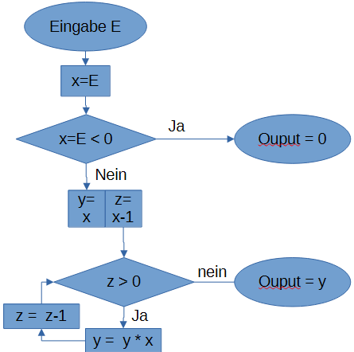

Output σ(0)

a) Es rechent .
b)

c)
- READ 1
- LOAD *1
- STORE 2
- LOAD *1
- JGTZ 15
- ADD 1
- STORE 1
- LOAD *1
- JGTZ 20
- WRITE 0
- GOTO 21
- LOAD *1
- MULT *2
- STORE 1
- LOAD *2
- SUB 1
- STORE 2
- LOAD *2
- JGTZ 12
- WRITE 1
- HALT

