**MongoDB – Kafka Source-Sink Connectors**

* **Create MongoDB Replica Cluster**
* **Configure Kafka-MongoDB Connector**
* **Run Kafka Connect API**
* **Test MongoDB-Source-Sink through Kafka**

**Create MongoDB kafka Cluster**

Install MongoDB

Copy MongoDB configuration file i.e mongod.cfg C:\Program Files\MongoDB\Server\4.2\bin\ mongod.cfg

Create its copy and rename the new mongoDB config files.

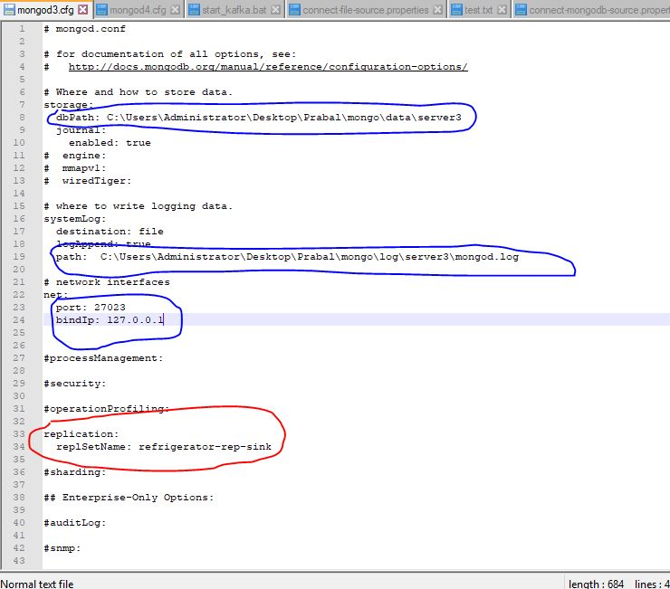

Update the Blue Marked Field as unique for each file.

Add Red Marked Field as Same for the Replica Cluster

Start servers: mongod –config <path of MongoDB.cfg file>

Repeat for all Servers.

On the main server (PRIMARY) set up the replica.

Rs.initiate()

Rs.add(“<hostname:port>”) – Repeat

Rs.slaveOk() on the Secondary server console.

Rs.status()

**Configure Kafka-MongoDB Connector**



Add these files to Kafka Conf Folder.

In Connect-standalone.properties file.

Add Property plugin.path=<mongoDB connector jar path>

Mongodb- Kafka Connector Jar



Refer Links :

<https://github.com/mongodb/mongo-kafka>

<https://github.com/hpgrahsl/mongo-kafka>

<https://docs.mongodb.com/kafka-connector/current/>

Start Kafka (Zookeeper + Server)

Create Topics

**Sink Connector Properties**

name=mongo-sink

connector.class=com.mongodb.kafka.connect.MongoSinkConnector

tasks.max=1

# Connection and sink configuration

connection.uri=mongodb://localhost:27024,localhost:27023

database=mongo-t

collection=fridge

topics=mongo-test

poll.max.batch.size=1000

poll.await.time.ms=5000

# Change stream options

pipeline=[]

batch.size=0

change.stream.full.document=updateLookup

collation=

**Source Connector Properties**

name=mongo-source

connector.class=com.mongodb.kafka.connect.MongoSourceConnector

tasks.max=1

# Connection and source configuration

connection.uri=mongodb://localhost:27020,localhost:27021,localhost:27022

database=refrigerator

collection=fridge

topic.prefix=mongo_conn

poll.max.batch.size=1000

poll.await.time.ms=5000

# Change stream options

pipeline=[]

batch.size=0

change.stream.full.document=updateLookup

collation=

-----------------------------------------------END-------------------------------------------------------

Note : Topic Name should be (${topic.prefix}.${database}.${collection}).