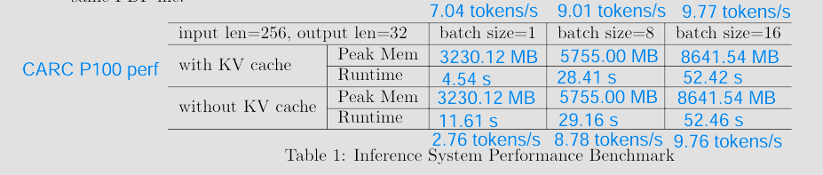Inference System Performance Benchmark (P100)

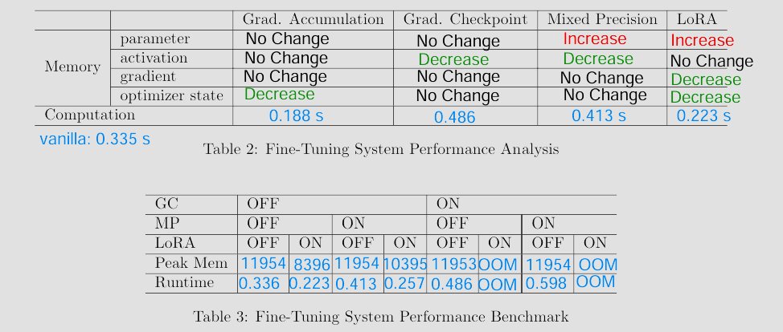Finetuning System Performance (P100)