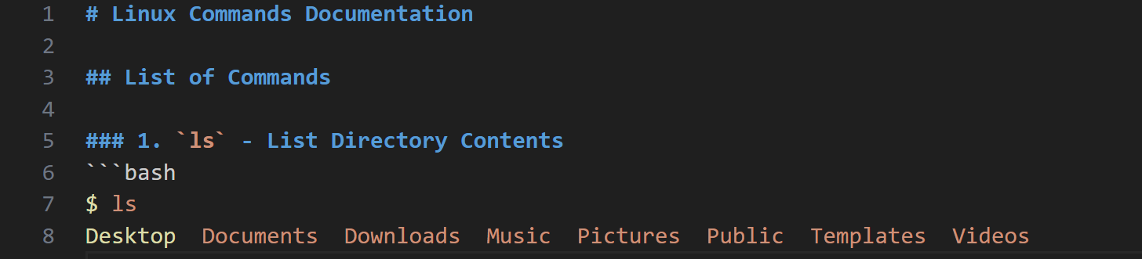

The ‘ls’ command lists the contents of the current directory.

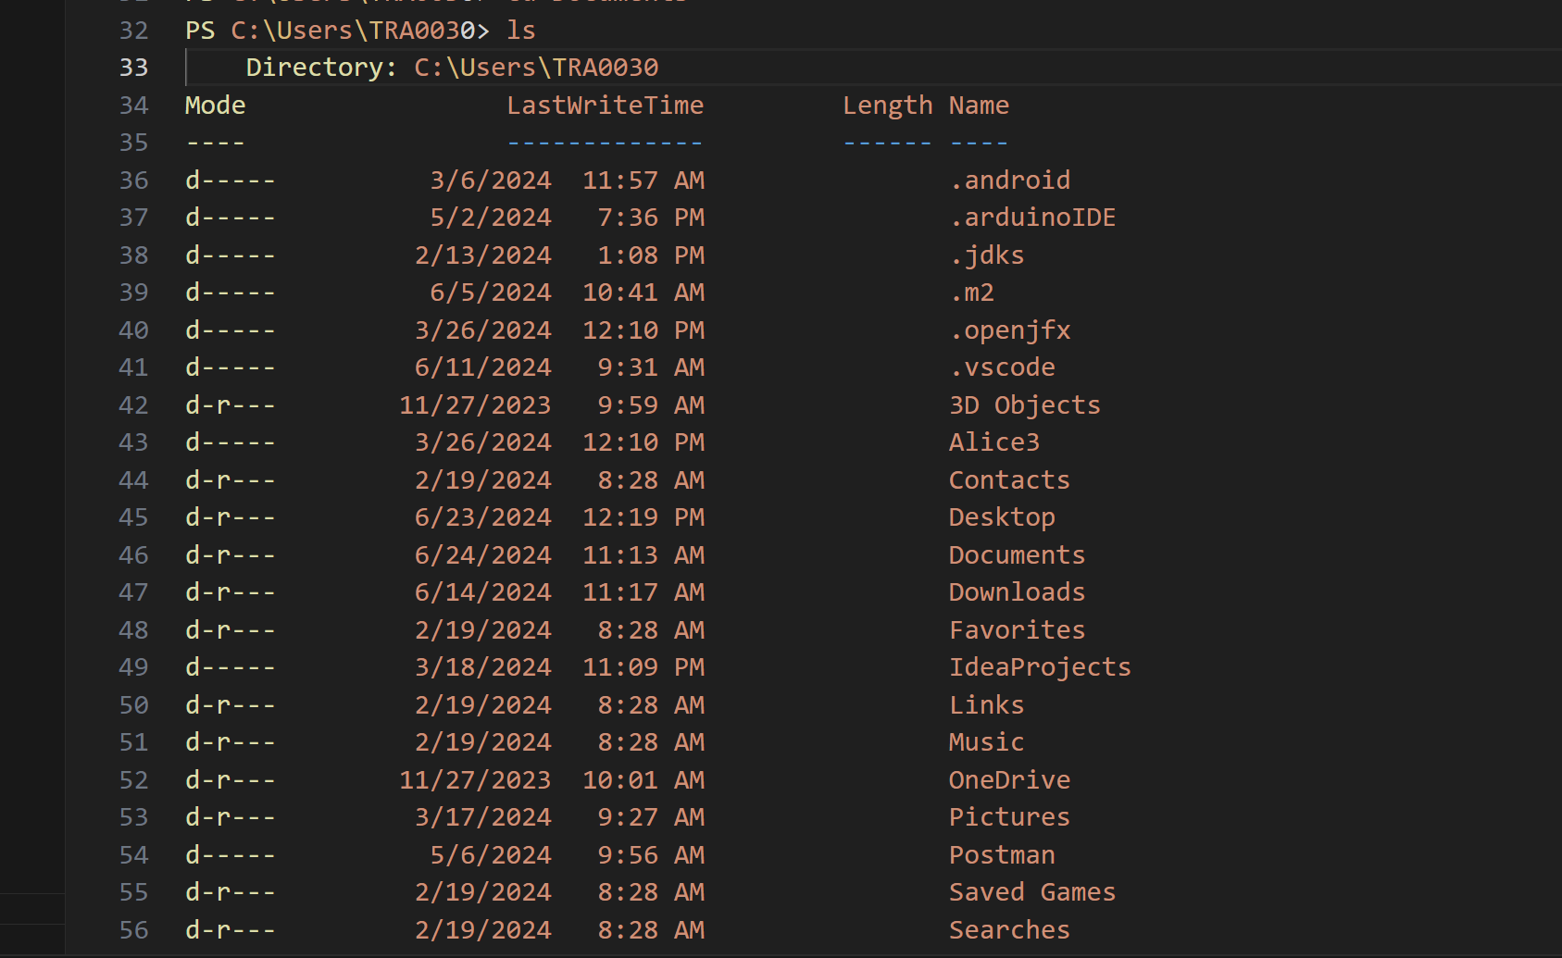

pwd - Print Working Directory

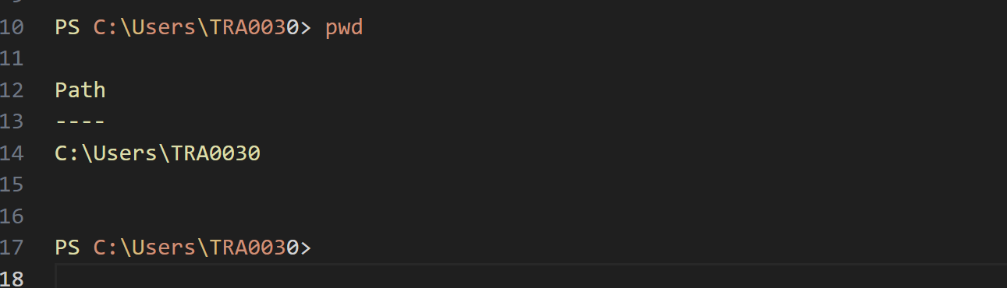

The pwd command prints the path of the current working directory.

mkdir - Make Directory

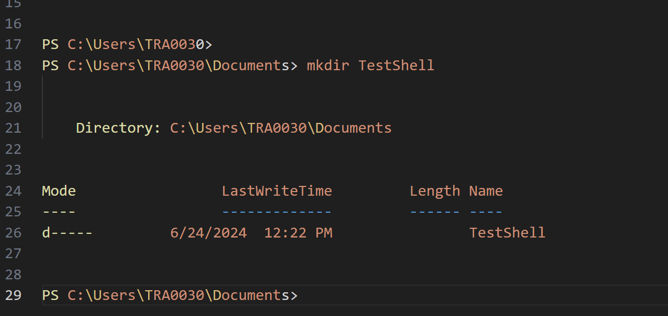

The mkdir command creates a new directory named TestShell.

cd - Change Directory

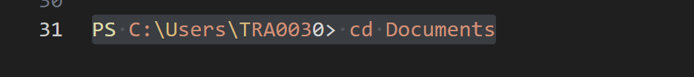

The cd command changes the current directory to Documents. Use cd .. to go back to the parent directory.

cp - Copy Files or Directories

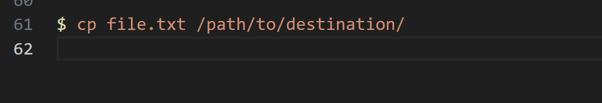

The cp command copies files or directories from one location to another.

**mv - Move Files or Directories**



The mv command moves files or directories from one location to another.

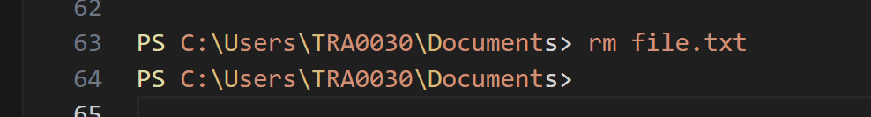

The rm command removes (deletes) files. Use rm -r directory to remove directories recursively.



The touch command creates a new empty file named newfile.txt.



cat - Concatenate and Display File Content

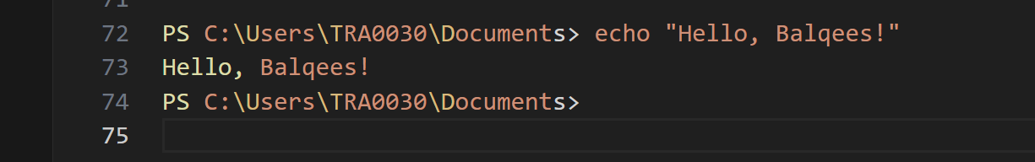

The echo command prints text to the terminal or standard output.

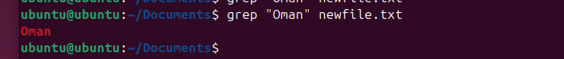

The grep command searches for lines containing a specified pattern in a file.

The chmod command changes the permissions (read, write, execute) of files and directories.



Numeric Mode

7 for the owner: Read, Write, and Execute

7 for the group: Read, Write, and Execute

7 for others: Read, Write, and Execute

Symbolic Mode

Read, write, and execute for everyone:

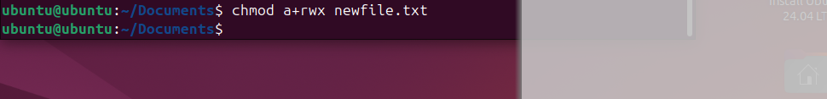

Read (r)

Write (w)

Execute (x)

u for owner

g for group

o for others

a for all (owner, group, and others)

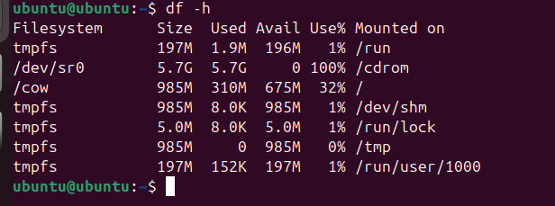

The df command displays disk space usage of file systems.

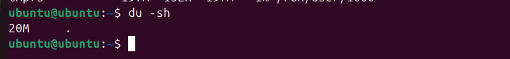

The du command estimates file and directory space usage.



The tar command creates or extracts files from an archive file (e.g., .tar, .tar.gz).

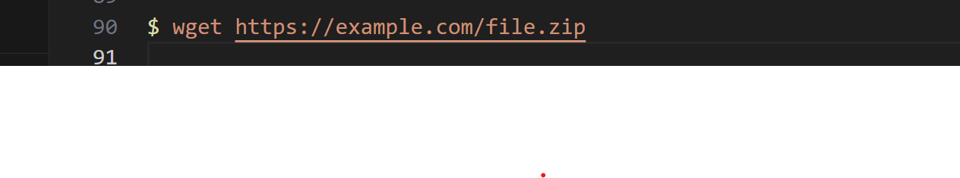

The wget command downloads files from the internet using HTTP, HTTPS, or FTP protocols.

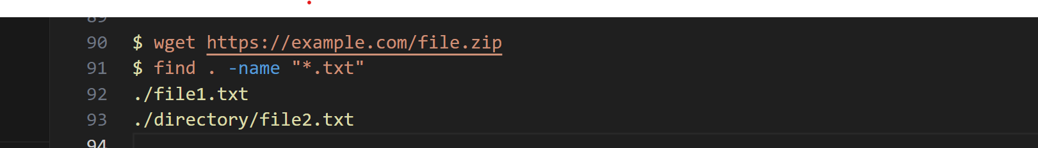

The find command searches for files in a directory hierarchy based on various criteria.



The top command displays real-time information about Linux processes and system resource usage.



The ps command reports a snapshot of current processes. Use ps aux for detailed information.



The ssh command connects to a remote host securely using the SSH protocol.

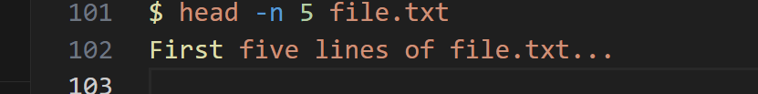

The head command prints the first few lines of a file. Use -n to specify the number of lines.

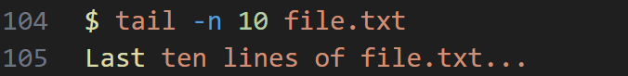

The tail command prints the last few lines of a file. Use -n to specify the number of lines.

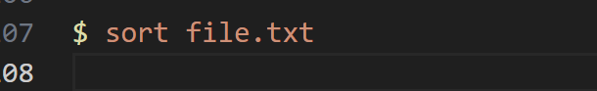

The sort command sorts the lines of a text file alphabetically or numerically.



The uniq command filters out repeated lines from a sorted file.

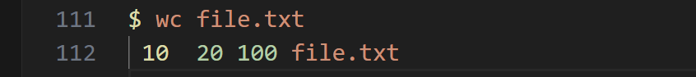

The wc command counts lines, words, and bytes in a file.

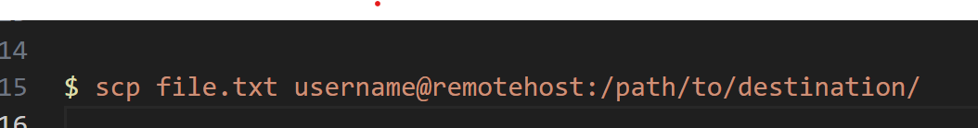

The scp command securely copies files between hosts using SSH.