Lane-Emden Numerical Methods Results

Figure 1: FDM - Final Nodal Values
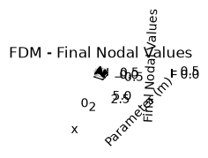
Caption: FDM - Final Nodal Values generated under configured numerical tolerance and grid resolution.

Figure 2: FDM - Relative True Error
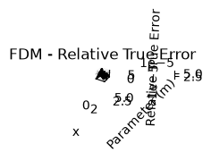
Caption: FDM - Relative True Error generated under configured numerical tolerance and grid resolution.

