Research Assignment 2 (RA2)
Research Question, Methodology, Environment Setup, and Baseline Capture
Cloud Security in a Three-Tier Application: From Vulnerabilities to Best Practices

Field | Details
Course | CSIS 4490 - Special Topics in Cybersecurity / Cloud Security
Institution | Douglas College
Group | Cloud Security Group 3
Project Name | Secure Wallet - Three-Tier Cloud Security Baseline
Team Members | Balraj Singh (300394347), Daniel Anaya Murcia (300403740), Israel Ogunseye (300368938)
Instructor | Gabriel Vitus
Submission | Research Assignment 2 - Week 5
Date | June 2, 2026
Repository | https://github.com/Balraj7860/SpecialTopicInCyberSecurity_Project.git

Submission statement: This RA2 document is written as a group submission. We describe the environment we built, the baseline we tested, and the security controls we will apply in the next project phase. All data shown is demo data only.

1. Executive Summary
For RA2, we formalized our research direction and established a working baseline environment for our three-tier cloud security project. Our application, Secure Wallet, includes a React/Vite frontend, a Node.js/Express REST API backend, and a planned Google Cloud SQL database tier. The current baseline is intentionally simple so that we can clearly demonstrate security weaknesses before applying cloud security controls.
Our project focuses on the first two course themes: Identity, Access, and Secrets; and Network Exposure and Perimeter Controls. The current application supports login, registration, Admin/User role separation, user dashboard functions, saved cards, transaction records, profile updates, password updates, and admin user management. These features give us enough application behavior to test unauthorized access, role separation, credential handling, and database/network exposure in later phases.
RA2 Deliverable | How We Addressed It
Research Question | Defined a focused, testable question connected to IAM, secrets, RBAC, Cloud SQL, and firewall restrictions.
Objectives | Defined measurable goals for baseline setup, security control implementation, and before/after testing.
Scope | Included GCP three-tier application security; excluded monitoring/resilience and multi-cloud complexity.
Methodology | Used a mixed experimental and analytical method with reproducible tests.
Environment Type | Selected a GCP cloud environment supported by a local baseline development environment.
Setup Documentation | Documented repository structure, tools, commands, ports, and known setup decisions.
Baseline Capture | Captured current frontend/backend behavior, API tests, screenshots, and baseline weaknesses.
Alignment | Mapped the setup directly to the research question, objectives, and methodology.

2. Research Question
To what extent do least-privilege IAM configurations, centralized secrets management through Google Cloud Secret Manager, role-based end-user authentication, and restricted VPC firewall rules reduce exposure and unauthorized access risk in a three-tier web application deployed on Google Cloud Platform?
This research question is testable because we can compare the insecure baseline against a secured version using the same repeatable tests: login attempts, admin/user access checks, API responses, Cloud SQL access behavior, secret-handling evidence, and network exposure checks.

3. Research Objectives
- Build a working baseline three-tier application with a frontend, backend API, and planned Cloud SQL database tier.
- Document the environment setup clearly enough that another student could reproduce the baseline.
- Identify baseline weaknesses related to credentials, role enforcement, database design, and network exposure.
- Apply or prepare security controls including backend role checks, least-privilege IAM, Secret Manager, Cloud SQL access restrictions, and VPC firewall rules.
- Compare before-and-after results using API outputs, screenshots, and configuration evidence.

4. Scope Definition

4.1 Included Scope
- A three-tier web application with presentation, application/API, and database tiers.
- Google Cloud Platform as the target cloud environment.
- React/Vite frontend for user interaction and demo evidence.
- Node.js/Express backend for REST API behavior and access control testing.
- Google Cloud SQL as the planned managed database tier.
- Admin/User role separation for application-level access control.
- Theme 1: Identity, Access, and Secrets.
- Theme 2: Network Exposure and Perimeter Controls.
- Before-and-after evidence using screenshots, command outputs, API responses, and configuration checks.

4.2 Excluded Scope
- Theme 3, Hardening, Monitoring, and Resilience, is excluded from this phase so we can go deeper on the first two themes.
- Multi-cloud and hybrid-cloud deployment are excluded; all cloud work is based on GCP.
- Production-grade banking/payment processing is excluded. Secure Wallet is a demo security application only.
- Real payment cards, real personal information, and real financial transactions are not used.
- Advanced production infrastructure such as CDN, autoscaling, and full observability pipelines are outside RA2 scope.

5. Methodology Design
We are using a mixed methodology. The experimental part involves building a baseline environment, testing access behavior, applying controls, and repeating the same tests. The analytical part involves comparing baseline weaknesses against improved security controls using structured evidence.
Phase | What We Do | Evidence Collected
1. Baseline Setup | Run frontend and backend locally; prepare GCP/Cloud SQL direction. | Repository structure, commands, screenshots, tool versions.
2. Baseline Testing | Test login, registration, admin routes, user routes, profile, cards, and transactions. | API status codes, browser screenshots, test tables.
3. Security Controls | Implement or prepare IAM, Secret Manager, Cloud SQL restrictions, and firewall rules. | GCP screenshots, policy outputs, configuration notes.
4. Comparison | Repeat tests after controls are applied. | Before/after table showing reduced exposure and unauthorized access prevention.

5.1 Validity and Reproducibility
- We use the same baseline accounts for repeated tests: user/user123 and admin/admin123.
- We record exact ports and commands: frontend on port 3000 and backend on port 5001.
- We document tool versions and repository structure.
- We avoid using real personal or financial data.
- We test both expected access and blocked access, including a regular user being denied admin routes.

6. Environment Type and Justification
Our selected environment is a GCP cloud security environment supported by a local development baseline. We use the local environment first because it lets us confirm the application behavior before moving cloud controls into the project. We use GCP because the research question specifically depends on cloud controls such as IAM, Secret Manager, VPC firewall rules, and Cloud SQL access restrictions.
Layer | RA2 Baseline | GCP Direction
Frontend | React/Vite running locally on http://localhost:3000. | Deploy as the presentation tier using the approved GCP hosting approach.
Backend API | Node.js/Express running locally on http://localhost:5001. | Deploy as the application/API tier using the group-approved GCP compute option.
Database | In-memory demo data for baseline testing. | Move persistent data to Google Cloud SQL.
Secrets | Demo credentials exist in baseline code for controlled testing. | Move sensitive configuration to Google Cloud Secret Manager.
Network | Localhost baseline ports. | Restrict Cloud SQL/backend exposure using VPC firewall rules and private/restricted access.

7. Environment Setup Documentation

7.1 Repository Structure
Repository path used for our RA2 baseline: /Users/balrajhundal/Documents/STIC/SpecialTopicInCyberSecurity_Project
Folder/File | Purpose
frontend/ | React/Vite frontend containing login, registration, dashboard, profile, cards, transactions, and admin UI.
backend/ | Node.js/Express API containing authentication, authorization, user management, cards, transactions, profile, and password routes.
database/ | Database planning area for Cloud SQL documentation.
docs/ | Assignment documentation and research artifacts.
evidence/ | Folder reserved for screenshots and testing evidence.
infrastructure/ | Folder reserved for GCP/infrastructure planning and setup documentation.
package.json | Root helper scripts for project setup.

7.2 Tools and Versions
Tool | Version/Status | Purpose
Node.js | v22.22.3 | Runs frontend and backend JavaScript code.
npm | 10.9.8 | Installs dependencies and runs project scripts.
React | 19.2.6 | Frontend UI framework.
Vite | 5.4.21 | Frontend dev server and production build tool.
Express | 4.19.2 | Backend REST API framework.
Git/GitHub | Repository connected | Version control and collaboration.
Google Cloud Platform | Project target environment | IAM, Secret Manager, Cloud SQL, and VPC firewall controls.

7.3 Frontend Setup
- Open a terminal at the project root.
- Run: cd frontend
- Run: npm install
- Run: npm start
- Open: http://localhost:3000
- Confirm that the application login page loads at http://localhost:3000.

7.4 Backend Setup
- Open a second terminal at the project root.
- Run: cd backend
- Run: npm install
- Run: npm run dev
- Confirm the terminal shows: Secure Wallet backend running on http://localhost:5001
- Confirm the backend health route responds at: http://localhost:5001/
Port decision: The backend uses port 5001 because macOS uses port 5000 on this machine. The frontend API calls were aligned to port 5001.

8. Baseline Capture
The baseline capture records the current state before final GCP security hardening. This gives us evidence to compare against the secured version later.

8.1 Baseline System Evidence
This table records the local baseline evidence requested in the RA2 guide before any final cloud security controls are applied.
Evidence Area | Captured Baseline State
OS and platform | macOS 26.5, build 25F71, Apple Silicon arm64
Network configuration | Local testing uses loopback 127.0.0.1 for browser-to-service access; Wi-Fi interface en0 is active with private IP 192.168.1.108/24.
Frontend running service | Node process listening on TCP port 3000 for the React/Vite frontend.
Backend running service | Node process listening on TCP port 5001 for the Express backend API.
Application baseline mode | Local development baseline with demo data; Google Cloud SQL, Secret Manager, IAM, and VPC firewall controls are planned for the secured comparison phase.
Baseline Item | Captured State
Frontend service | React/Vite application running on localhost:3000.
Backend service | Node.js/Express API running on localhost:5001.
Authentication | Login supports demo user and admin accounts.
Authorization | Admin routes require admin role; user routes require login.
Database | In-memory data only for RA2 baseline; Cloud SQL is planned for the next stage.
Secrets | Demo credentials are visible in baseline code and must be replaced by secure secret handling later.
Network exposure | Local baseline only; GCP VPC firewall restrictions will be added later.

8.2 Baseline API Test Results
Test Case | Endpoint | Expected Result | Observed Result
Backend health check | GET / | Backend returns running message. | Passed: HTTP 200.
Unauthenticated profile access | GET /me | Request blocked before login. | Passed: HTTP 401.
Invalid login | POST /login | Wrong password rejected. | Passed: HTTP 401.
User login | POST /login | Regular user logs in successfully. | Passed: HTTP 200.
User blocked from admin | GET /admin/users | Regular user cannot access admin users. | Passed: HTTP 403.
Admin login | POST /login | Admin logs in successfully. | Passed: HTTP 200.
Admin user management | GET/POST/PUT/DELETE /admin/users | Admin can list, add, edit, and delete users. | Passed in local API checks.
Cards feature | GET/POST/DELETE /cards | Logged-in user can manage saved demo cards. | Passed in local API checks.
Transactions feature | GET/POST /transactions | Logged-in user can manage demo transactions. | Passed in local API checks.
Profile/password feature | GET/PUT /profile and PUT /password | Logged-in user can update profile/password. | Passed in local API checks.

8.3 Baseline Weaknesses Identified
Area | Current Baseline Weakness | Planned Improvement
Credential storage | Demo passwords are stored directly in server.js. | Use hashed passwords and Secret Manager for sensitive values.
Session handling | Backend uses one global currentUser variable. | Use proper sessions or JWT-based authentication.
Database persistence | Data is stored in memory and disappears on restart. | Move users/cards/transactions/profile data to Cloud SQL.
Database security | Cloud SQL connection is not implemented yet. | Restrict Cloud SQL access and avoid public exposure.
IAM | Least-privilege cloud service accounts are not finalized yet. | Create dedicated service accounts with only required permissions.
Network perimeter | Only local ports are used in baseline. | Apply VPC firewall restrictions and controlled backend/database access.

9. Evidence Screenshots
The following screenshots were captured from the working RA2 baseline environment. They demonstrate that the frontend and backend are integrated and that both user and admin flows exist for later access-control testing.
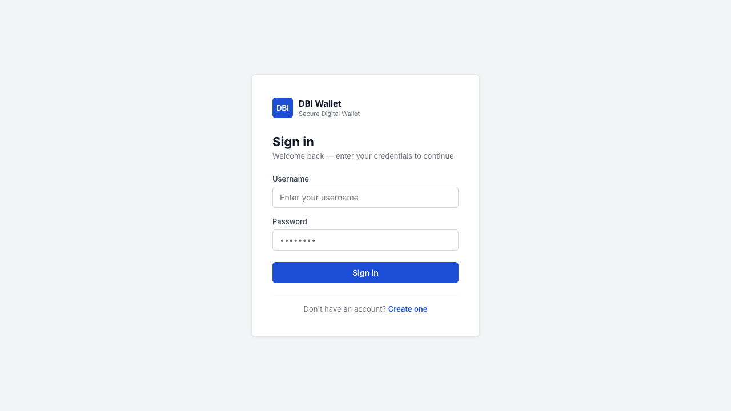
Figure 1. Application login page running locally at http://localhost:3000.
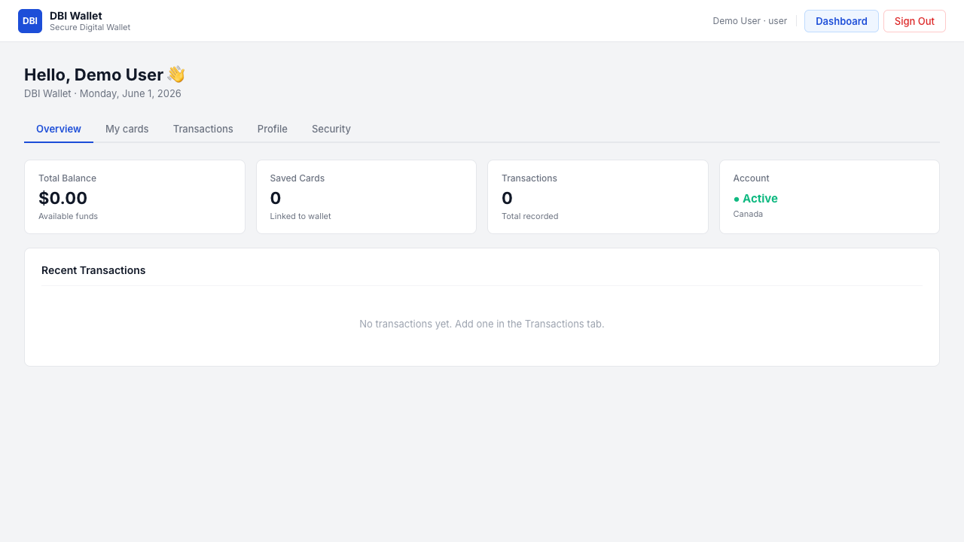
Figure 2. Regular user dashboard after successful login.
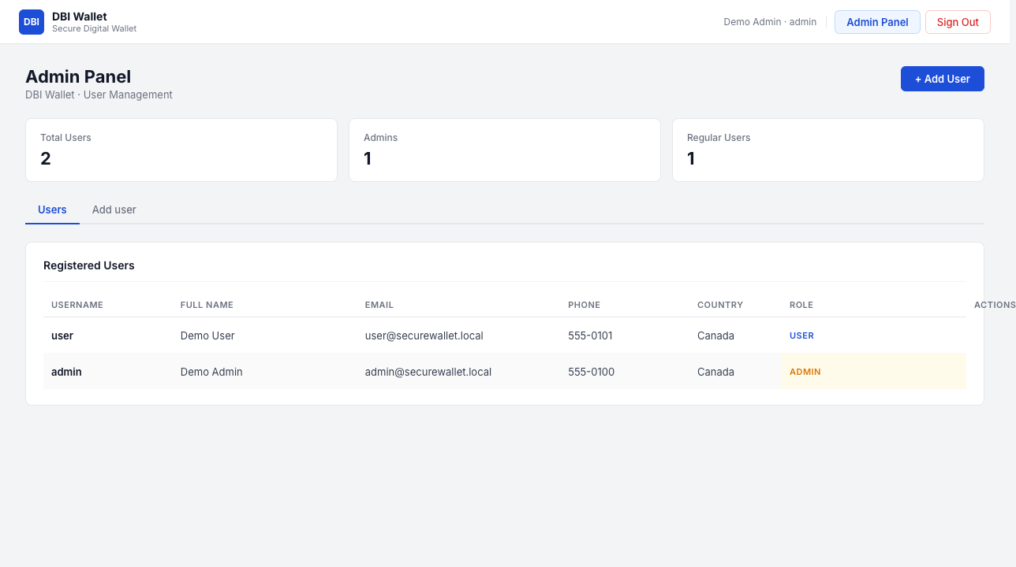
Figure 3. Admin panel showing user-management functionality after admin login.

10. Alignment with Research Plan
Research Plan Element | How the RA2 Environment Supports It
Three-tier application | The project separates frontend, backend API, and planned database layers.
Identity and access testing | The app has user and admin roles, login, protected routes, and admin-only endpoints.
Secrets management theme | The baseline exposes why hardcoded/demo credentials are insecure, preparing us for Secret Manager.
Network exposure theme | The baseline identifies ports and prepares us to test Cloud SQL and firewall restrictions.
Before/after comparison | We documented baseline behavior so the same tests can be repeated after security controls.
Reproducibility | Commands, ports, versions, routes, and expected responses are recorded.

11. Team Responsibilities
Team Member | Primary Responsibility for Project Work
Daniel Anaya Murcia | Frontend presentation tier, user interface, and frontend support for demo flows.
Israel Ogunseye | Cloud implementation, GCP security infrastructure, network topology, and traffic-flow/security engineering.
Balraj Singh | Backend REST API support, application security engineering, Admin/User role access, database connectivity planning, credential-handling controls, and access restriction testing.

Although responsibilities are divided, we review the system as a team because the frontend, backend, database, IAM, secrets, and network controls must work together for the final project demonstration.

12. Next Implementation Steps
- Connect the backend to Google Cloud SQL instead of using in-memory data.
- Move database credentials and other sensitive values to Google Cloud Secret Manager.
- Hash passwords instead of storing plaintext demo passwords.
- Replace the global currentUser baseline with a real session or token-based authentication mechanism.
- Create least-privilege service accounts for backend/database access.
- Restrict Cloud SQL access using approved GCP networking controls.
- Repeat the same baseline API tests after controls are applied and compare the results.

13. References
- B. Alouffi et al., “A Systematic Literature Review on Cloud Computing Security: Threats and Mitigation Strategies,” IEEE Access, vol. 9, pp. 57792-57807, 2021.
- A. Mondal and S. Paul, “Cloud Computing Security Issues & Challenges: A Review,” Proc. 2020 International Conference on Computer Communication and Informatics, 2020.
- A. Moubayed, A. Refaey, and A. Shami, “Software-Defined Perimeter (SDP): State of the Art Secure Solution for Modern Networks,” IEEE Network, vol. 33, no. 5, pp. 226-233, 2019.
- S. K. Basak, L. Neil, B. Reaves, and L. Williams, “What are the Practices for Secret Management in Software Artifacts?” Proc. IEEE Secure Development Conference, 2022.
- N. F. Syed et al., “Zero Trust Architecture (ZTA): A Comprehensive Survey,” IEEE Access, vol. 10, pp. 57143-57179, 2022.

