Research Assignment 2 (RA2)
Required Deliverables: Theory 25% + Hands-On Environment Setup 75%
Secure Wallet: GCP Environment Setup and Baseline Checks
Field | Details
Course | CSIS 4490 - Special Topics in Cybersecurity / Cloud Security
Institution | Douglas College
Group | Cloud Security Group 3
Project Name | Secure Wallet - Three-Tier Cloud Security Baseline
Team Members | Balraj Singh (300394347), Daniel Anaya Murcia (300403740), Israel Ogunseye (300368938)
Instructor | Gabriel Vitus
Submission | Research Assignment 2 - Week 5
Date | June 2, 2026
Repository | https://github.com/Balraj7860/SpecialTopicInCyberSecurity_Project.git

RA2 Component | Weight | Required Deliverables Included
Theory Component | 25% | Research question, objectives, scope, and test plan
Hands-On Component | 75% | Environment setup, screenshots, baseline checks, and link back to the research plan

This is our RA2 setup report. We kept it focused on the items asked in the RA2 guide: the theory plan, the environment setup, and the baseline evidence we have so far.

Theory Component - 25%

1. Research Question
How much can least-privilege IAM roles, Secret Manager, role-based login, and restricted VPC/firewall rules reduce unauthorized access and exposure in our three-tier Secure Wallet application on Google Cloud Platform?
We chose this question because it can be tested with the same application before and after security controls are added. We can compare login behavior, admin/user access, API responses, secret handling, Cloud SQL access, and network exposure.

2. Research Objectives
- Build and document a baseline three-tier application with a React/Vite frontend, Node.js/Express backend API, and planned Google Cloud SQL database tier.
- Identify baseline weaknesses related to authentication, role enforcement, credential handling, database access, and network exposure.
- Prepare measurable before-and-after tests that can show whether IAM, Secret Manager, Cloud SQL restrictions, and VPC firewall controls reduce unauthorized access risk.

3. Scope Definition
Included in Scope | Excluded from Scope
GCP security controls, three-tier app structure, identity/access testing, secrets handling, network exposure, perimeter controls, admin/user role testing, and before/after comparison. | Theme 3 hardening/monitoring/resilience, multi-cloud design, production payment processing, real personal or financial data, autoscaling, CDN, and full enterprise monitoring.

4. Methodology Design
Our method is to first get a simple working version running, record how it behaves, and then use the same checks again after the security controls are added. This lets us compare the baseline version with the secured version instead of only describing the controls in theory.
- Baseline setup: get the project running first, then record the folder structure, commands, screenshots, and running services.
- Baseline testing: check the current login, admin access, API access, cards, transactions, profile, and password features. We record screenshots and API results as proof.
- Security control comparison: repeat the same tests later after IAM, Secret Manager, Cloud SQL, and firewall restrictions are added.
- Reproducibility: keep the ports, versions, demo accounts, expected results, and observed results written down so another person can follow our setup.

Hands-On Component - 75%

5. Environment Type and Justification
Our environment is a GCP-based cloud security project, but for RA2 we are still using a local baseline first. This helps us understand the app before adding cloud controls. We need GCP because our project depends on IAM, Secret Manager, Cloud SQL, VPC networking, and firewall restrictions. Since paid cloud resources are not part of this RA2 stage, we only documented Cloud Console readiness and planning screens.
Layer | RA2 Baseline | GCP Direction
Frontend | React/Vite running locally on http://localhost:3000. | Later, this can become the presentation layer in GCP.
Backend API | Node.js/Express running locally on http://localhost:5001. | Later, this can become the application/API layer in GCP.
Database | In-memory demo data for RA2 baseline testing. | Move persistent data into Cloud SQL.
Secrets | Demo credentials exist in baseline code for controlled testing. | Move sensitive configuration into Secret Manager.
Network | Localhost baseline ports. | Restrict backend and database access with VPC/firewall rules.

6. Setup Documentation

6.1 Platform and Tools
Tool or Platform | Version or Status | Purpose
Operating system | macOS 26.5, build 25F71, Apple Silicon arm64 | Local baseline development and testing machine.
Node.js | v22.22.3 | Runs frontend and backend JavaScript code.
npm | 10.9.8 | Installs dependencies and runs project scripts.
React | 19.2.6 | Frontend UI framework.
Vite | 5.4.21 | Frontend development server and build tool.
Express | 4.19.2 | Backend REST API framework.
Git/GitHub | Repository connected | Version control and group collaboration.

6.2 Basic GCP Readiness Setup for DBI-SecureWallet
For RA2, we opened the real Google Cloud Console project named DBI-SecureWallet and checked the GCP areas we will need later. We looked at the project settings, APIs, Secret Manager, Cloud SQL, Cloud Run, IAM roles, VPC, firewall rules, and load balancing. We did not create Cloud SQL instances, Cloud Run services, API keys, secrets, firewall rules, or other paid resources for RA2.
Naming note: the project name shown for our course work is DBI-SecureWallet. Google Cloud still keeps the original technical project ID in the console, so that ID may appear in screenshots even though it is not the project name we are presenting.
Readiness Area | Observed Setup | Why It Matters
Project context | Project display name is DBI-SecureWallet. | Makes the Cloud Console match our Secure Wallet project name.
Console access | We can open the selected project in Google Cloud Console. | Shows that we can use the real GCP UI for setup evidence and later work.
APIs & Services | We reviewed the APIs & Services dashboard. | This is where we will enable required APIs later, such as Cloud Run, Secret Manager, and Cloud SQL Admin.
Secret Manager | We found the Secret Manager API page; no secrets were created for RA2. | This supports our later plan to replace demo credentials with managed secrets.
Cloud SQL | We reviewed the Cloud SQL console for database planning; no new database was created for RA2. | This connects to later checks for database access, password policy, and connection security.
Cloud Run | We reviewed Cloud Run; no service was deployed for RA2. | This is one possible place to host the backend API later.
IAM roles | We reviewed IAM roles without showing personal user emails. | This connects to our least-privilege IAM theme.
VPC network | We opened the VPC creation/planning screen; no VPC was created. | This helps us plan private network separation later.
Firewall/perimeter | We opened the firewall rule planning screen; no firewall rule was submitted. | This supports our plan for ingress/egress restrictions.
Load balancing | We reviewed the load balancer type/architecture screen; no load balancer was created. | This helps us explain how HTTP/HTTPS traffic could flow in the future cloud design.

GCP Evidence Screenshots
These are real screenshots from our Cloud Console project. They show where we will configure the cloud services later. We only opened the planning/configuration pages for RA2 and did not submit or create any resources from these screens.
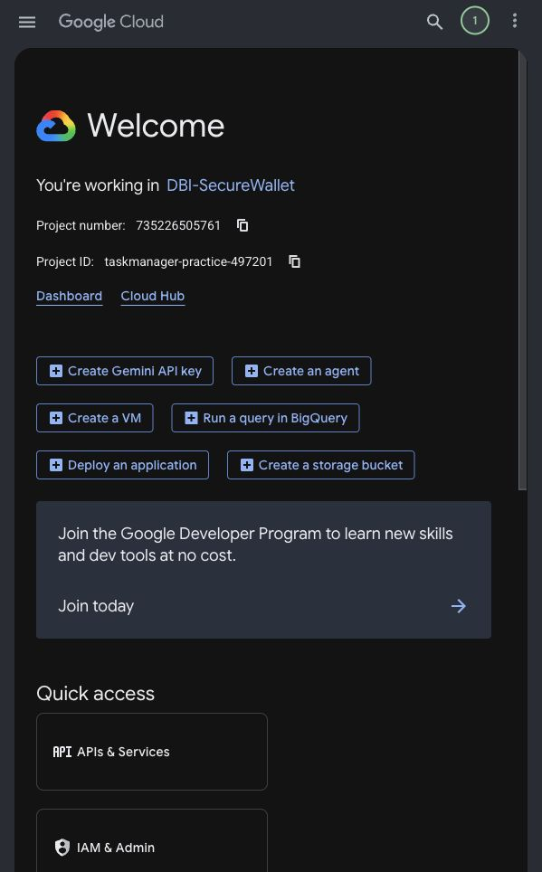  Evidence A - Full Cloud Console home page confirming the DBI-SecureWallet project context. | 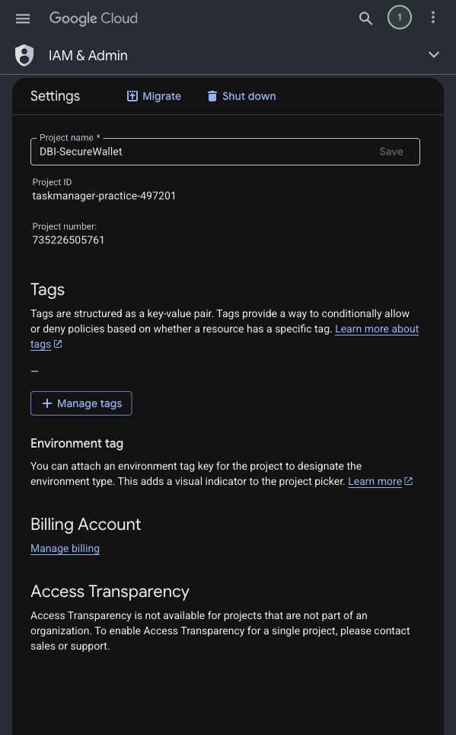  Evidence B - Full project settings page showing the course-facing project name.
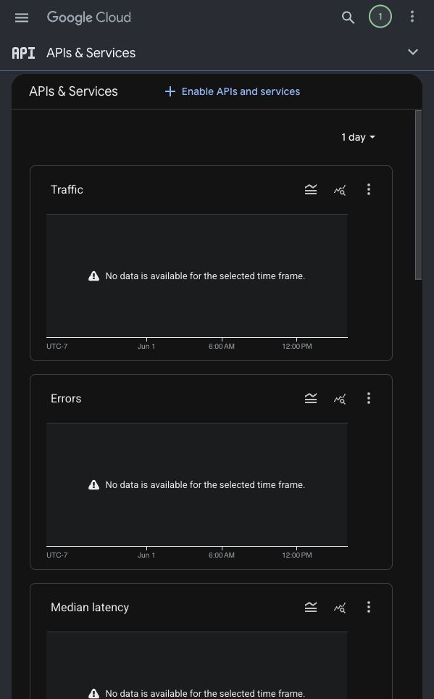  Evidence C - APIs & Services dashboard for future API enablement. | 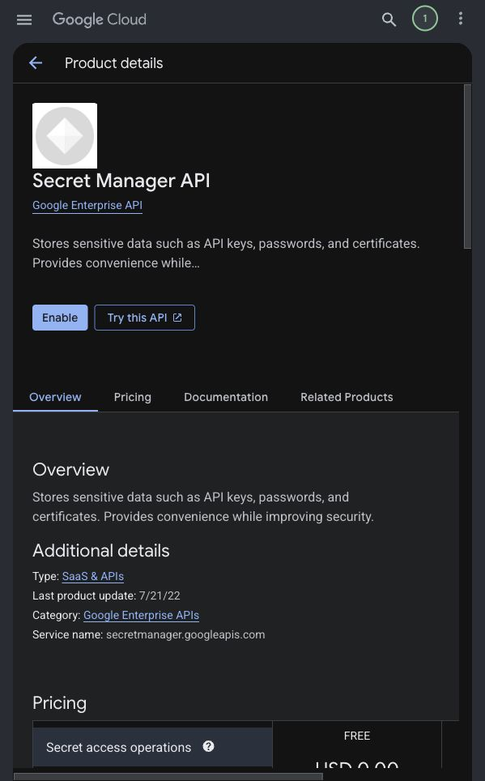  Evidence D - Secret Manager API page for future secrets management.
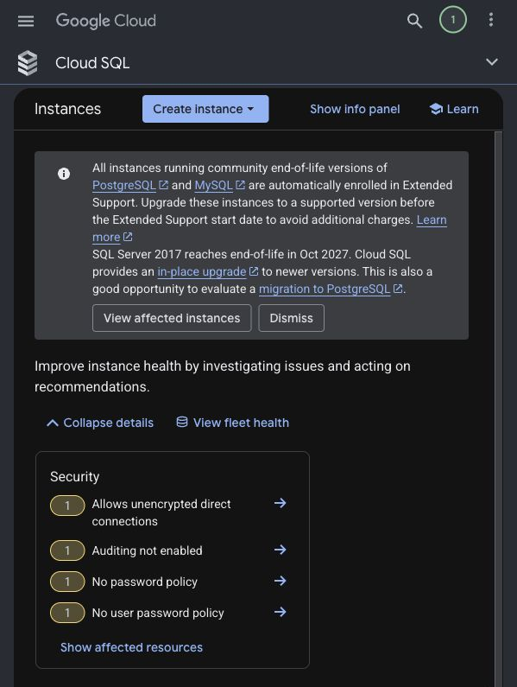  Evidence E - Cloud SQL console used for database-layer hardening planning. | 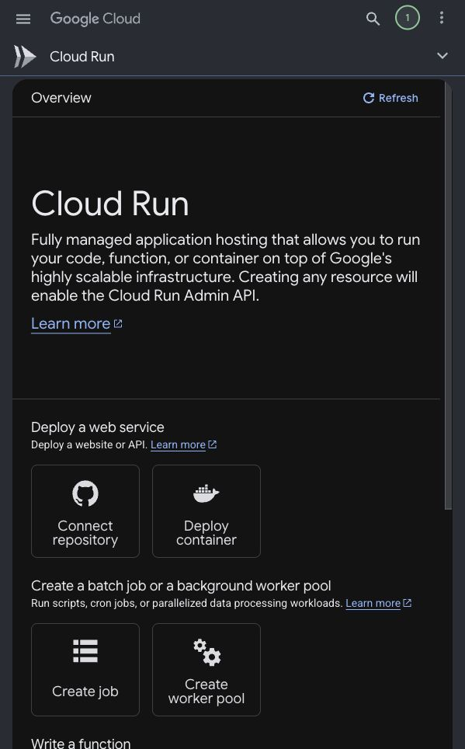  Evidence F - Cloud Run console used for future backend deployment planning.
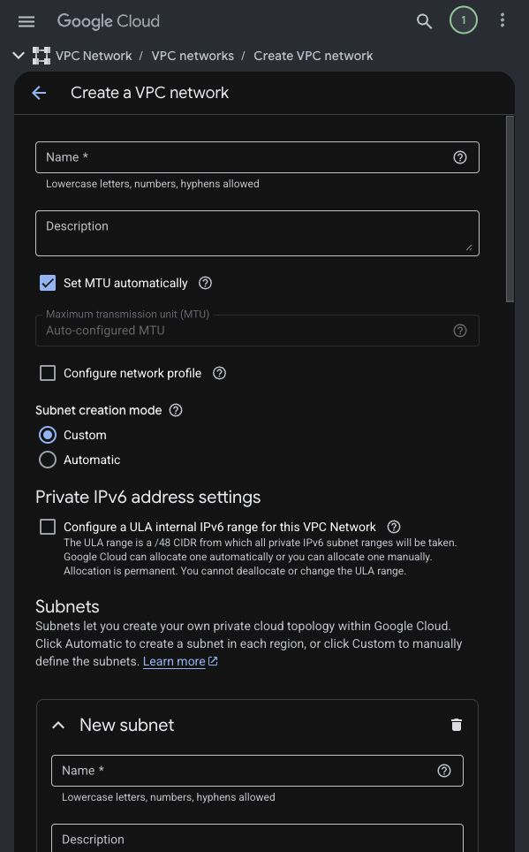  Evidence G - VPC Network planning screen for private network design. | 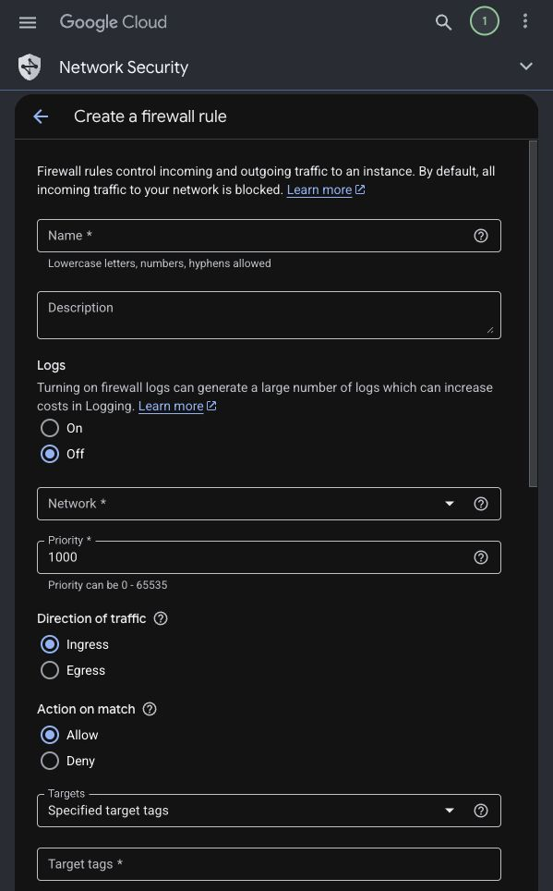  Evidence H - Firewall rule planning screen for perimeter control.
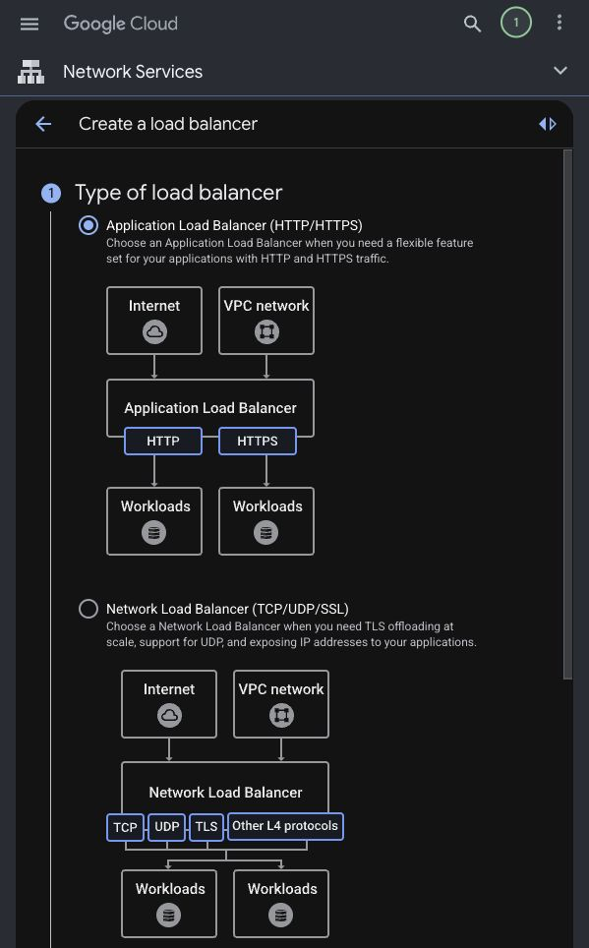  Evidence I - Load balancer selection showing HTTP/HTTPS architecture options. | 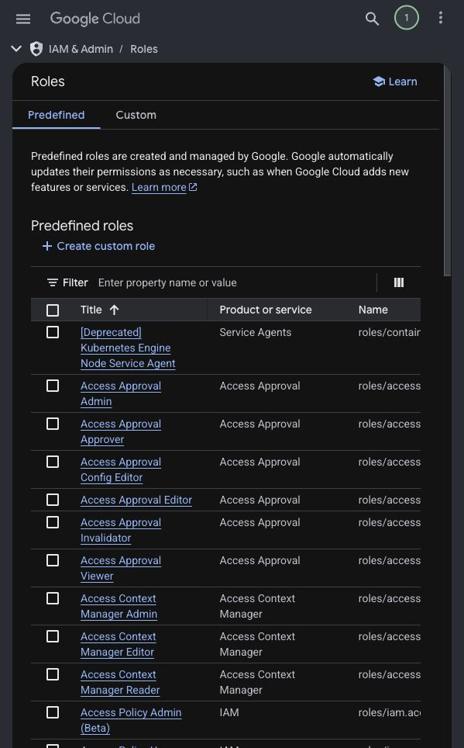  Evidence J - IAM Roles page for least-privilege role planning.

6.3 Repository Structure
Folder/File | Purpose
frontend/ | React/Vite frontend with login, registration, dashboard, profile, cards, transactions, and admin pages.
backend/ | Node.js/Express backend API with authentication, authorization, user management, cards, transactions, profile, and password routes.
database/ | Area for Cloud SQL planning notes.
docs/ | Assignment documents and research files.
evidence/ | Place for screenshots and test evidence.
infrastructure/ | Place for GCP/infrastructure planning files.
package.json | Root scripts for running project setup commands.

6.4 Setup Steps
Part | Steps
Frontend | 1. Open terminal at project root.  2. Run: cd frontend  3. Run: npm install  4. Run: npm start  5. Open: http://localhost:3000  6. Confirm that the login page loads.
Backend | 1. Open a second terminal at project root.  2. Run: cd backend  3. Run: npm install  4. Run: npm run dev  5. Confirm backend starts on http://localhost:5001  6. Confirm the health route responds at http://localhost:5001/
Resolved setup issue | We used backend port 5001 because port 5000 was already taken on this Mac. The frontend API calls were changed to use port 5001.

6.5 Setup Evidence Screenshots
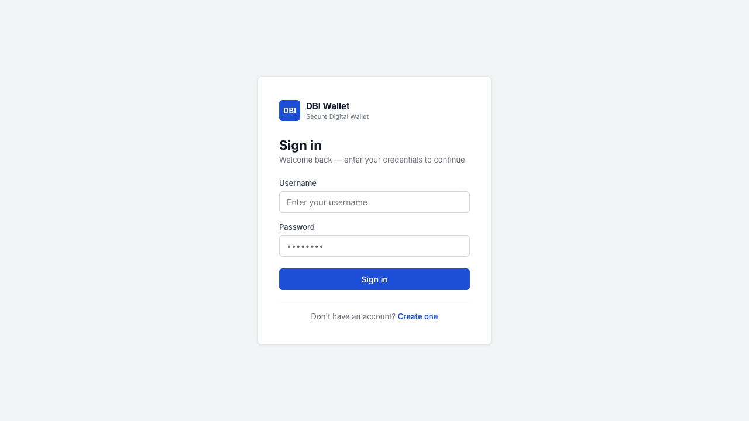
Figure 1. Application login page running locally at http://localhost:3000.
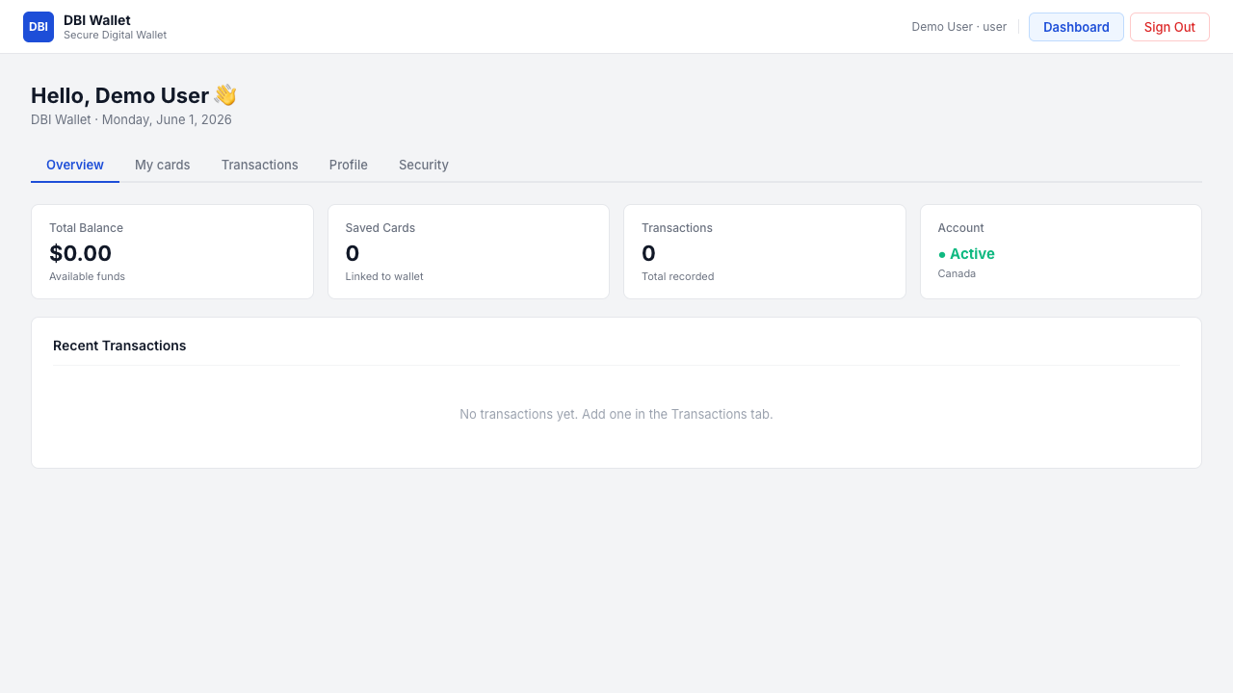
Figure 2. Regular user dashboard after successful login.
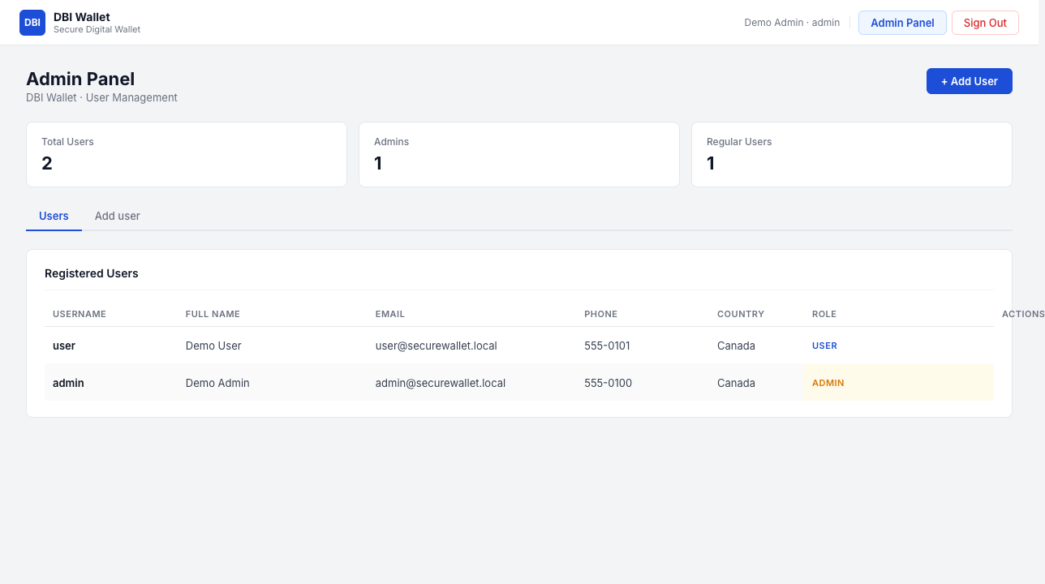
Figure 3. Admin panel showing user-management functionality after admin login.

7. Baseline Capture
This section records what is working right now before we add the final GCP security controls. We will use this as the comparison point later.
Baseline Area | Captured State
OS and platform | macOS 26.5, build 25F71, Apple Silicon arm64.
Network configuration | Local testing uses loopback 127.0.0.1 for browser-to-service access. Wi-Fi interface en0 is active with private IP 192.168.1.108/24.
Running frontend service | Node process listening on TCP port 3000 for the React/Vite frontend.
Running backend service | Node process listening on TCP port 5001 for the Express backend API.
Authentication | Demo user and admin accounts can log in.
Authorization | Admin routes require admin role; user routes require login.
Database | In-memory data only for RA2 baseline; Cloud SQL is planned for the next secured stage.
Secrets | Demo credentials are visible in baseline code and must be replaced by secure secret handling later.
Network exposure | Local baseline only; GCP VPC firewall restrictions will be added later.
GCP readiness | We verified Cloud Console access for DBI-SecureWallet and found the areas we will need later: APIs, Secret Manager, Cloud SQL, Cloud Run, IAM roles, VPC networking, firewall controls, and load balancing. We did not create paid resources for RA2.

7.1 Baseline API Test Results
Test Case | Endpoint | Expected Result | Observed Result
Backend health check | GET / | Backend returns running message. | Passed: HTTP 200.
Unauthenticated profile access | GET /me | Request blocked before login. | Passed: HTTP 401.
Invalid login | POST /login | Wrong password rejected. | Passed: HTTP 401.
User login | POST /login | Regular user logs in successfully. | Passed: HTTP 200.
User blocked from admin | GET /admin/users | Regular user cannot access admin users. | Passed: HTTP 403.
Admin login | POST /login | Admin logs in successfully. | Passed: HTTP 200.
Admin user management | GET/POST/PUT/DELETE /admin/users | Admin can list, add, edit, and delete users. | Passed in local API checks.

8. Alignment with Research Plan
Research Plan Element | How the Environment Supports It
Three-tier application | The project has separate frontend, backend API, and planned database layers.
Identity and access testing | The app already has user/admin roles, login, protected routes, and admin-only endpoints.
Secrets management theme | The baseline shows where demo credentials need to be replaced by Secret Manager later.
Network exposure theme | The baseline identifies the current ports and prepares us for Cloud SQL and firewall testing.
Before/after comparison | We can run the same API and access-control tests again after adding security controls.
Reproducibility | Commands, ports, versions, routes, expected results, and observed results are written down.

