A Deterministic-First, AI-Assisted Architecture for Multi-Vendor Network Security Compliance Auditing
Balraju Konne and Team NextGen
Department of Information Technology
Chaitanya Bharathi Institute of Technology (Osmania University)
Hyderabad, India
balrajukonne@gmail.com

Abstract—Security benchmarks are written once, but network devices are configured in many vendor dialects, so the same control has to be checked against different syntax by hand. This paper presents an offline, on-premise compliance auditor built for NTRO problem statement 26155. Uploaded configurations are routed by a fail-closed vendor detector to a vendor adapter that emits a vendor-neutral Common Security Model (CSM). A deterministic rule engine evaluates the CSM and returns only PASS, FAIL or UNKNOWN; frameworks are reported through a shared rule model, with CIS and DISA STIG evaluated natively and NIST SP 800-53 and ISO/IEC 27001 through a crosswalk that reports unmapped controls as not assessed. A local language model is confined to an advisory side channel: it may propose a mapping for an unrecognised line, but nothing takes effect until an authorised reviewer approves it, and remediation is displayed, never executed. Each finalised audit is appended to a SHA-256 hash-chained ledger and exported from one canonical, editable report that also carries device identity. Cisco IOS-XE and Juniper Junos are implemented; Arista EOS and Palo Alto PAN-OS are in the current build scope. On one reference machine the deterministic path audited a 2,220-line configuration in about 5 ms, while local model inference took seconds per line, so the two paths are reported separately.
Index Terms—network compliance auditing, configuration analysis, Common Security Model, deterministic rule engine, local large language model, human-in-the-loop, tamper-evident logging, CIS, NIST SP 800-53, DISA STIG.
I. INTRODUCTION
Critical infrastructure runs on network devices from several vendors, each with its own command language and configuration structure. Security standards do not vary in this way. Reading a large configuration by hand against a benchmark takes days per device, depends on scarce expertise, and gives different answers for different reviewers. Configuration errors are also a leading contributor to breaches; the 2023 Verizon Data Breach Investigations Report attributes a large share of incidents to the human element, including error and misconfiguration [1].
Two obvious approaches both fall short. A purely rule-based parser is dependable but brittle, since the first unfamiliar command becomes a blind spot. A purely model-based checker copes with unfamiliar text but cannot be replayed, cannot show why it decided, and cannot be defended to an auditor. Sending device configurations to a cloud model is also unacceptable in many government settings.
We therefore divide responsibility strictly: the AI interprets, humans approve, deterministic rules decide, and nothing is executed on a live device. The contributions are as follows.
- A vendor adapter boundary and a vendor-neutral CSM, so the compliance engine does not change when a vendor is added.
- A three-state evaluator in which UNKNOWN is a first-class result, extended by a crosswalk evaluator that reports unmapped framework controls as not assessed instead of passed.
- An advisory local-AI path with mandatory human approval, recorded provenance, and a precise statement of what “learning” means here: stored deterministic mappings, not retrained model weights.
- A central remediation registry, device identity extraction, a tamper-evident ledger and a single canonical report.
- Separate, hardware-stated measurements of the deterministic and AI paths, and an explicit account of what is built and what is not.
II. BACKGROUND AND RELATED WORK
Four bodies of guidance define the controls we evaluate: NIST SP 800-53 Rev. 5 [2], the CIS Benchmarks [3], the DISA Security Technical Implementation Guides [4], and ISO/IEC 27001:2022 [5]. NIST’s Security Content Automation Protocol [6] established the idea of machine-checkable benchmark content, which our rule engine follows in spirit while remaining a self-contained, offline tool.
Vendor-neutral modelling is well established. OpenConfig defines common data models for network devices [7], and we use it as a reference for the shape of the CSM rather than as a dependency. Batfish analyses configurations offline to reason about reachability and access control [8]; full reachability simulation is outside our scope, and we do not claim it. For unfamiliar text we use DistilBERT, a distilled transformer that keeps most of BERT’s language-understanding ability at a fraction of the size [9], to score unmapped lines against rule categories. Tamper evidence for the audit record follows the hash-chained logging idea of Schneier and Kelsey [10].
The distinguishing choice is the trust boundary. Rather than asking whether a model can produce or judge configuration text, we ask how a model can help a human extend a deterministic mapping while staying out of the decision path.
III. DESIGN PRINCIPLES AND THREAT MODEL
A. Principles
- Deterministic authority. PASS, FAIL and UNKNOWN come only from rules, and identical input yields identical output.
- Fail closed. Unsupported or ambiguous vendors are rejected, and an incompatible vendor and framework pair returns an explicit error (HTTP 422).
- Honest gaps. UNKNOWN never becomes PASS, and a framework control that no rule maps to is marked not assessed and excluded from every score.
- Human approval. An AI suggestion is untrusted until an authorised reviewer approves it.
- Offline by construction. The product excludes live device access. Configurations arrive as files, and an automated static test forbids sockets, subprocess calls and SSH libraries anywhere in the source tree, since auditing a device must never risk changing it.
B. Threat model
TABLE I
THREATS AND MITIGATIONS
Threat | Mitigation | Residual risk
AI output used as a verdict | No code path lets it set a result state | None by design
Wrong AI mapping | Reviewer approval; conflicts never overwrite a trusted mapping | Reviewer error
Malicious upload | Allow-listed types, size caps, data-only handling, ZIP guards | Parser bugs
History tampering | Hash chain with verification | Needs backups
Cross-user access | JWT identity, roles, ownership isolation | Single-node demo
Unsafe fix | Display-only; static conflict check | Narrow scope

IV. SYSTEM ARCHITECTURE
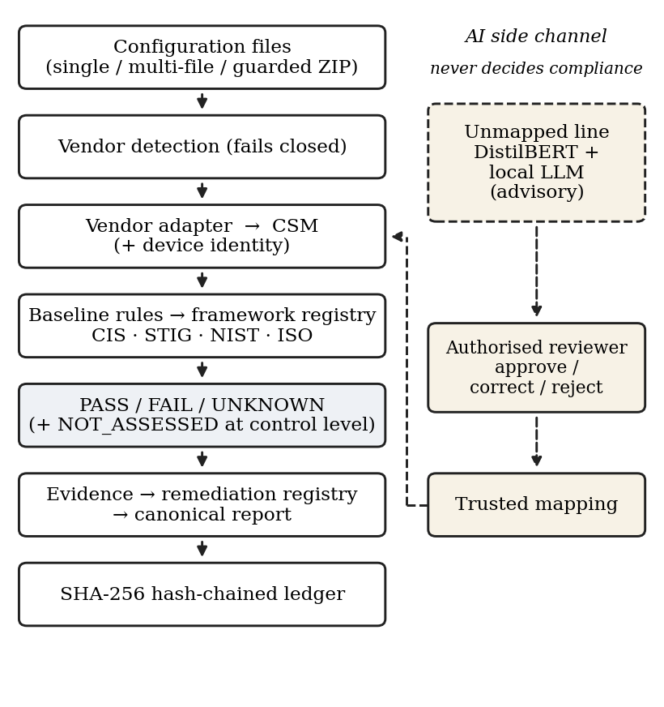
Fig. 1. Processing pipeline and the advisory AI side channel. Only the deterministic path produces compliance results.
A. Ingestion and vendor adapters
A file is validated, its vendor is detected, and it is routed to an adapter that emits CSM fields; the engine never reads vendor syntax. Adding a vendor requires an adapter, a baseline rule set, remediation entries, crosswalk entries and tests, with no change to the central engine. Detection fails closed and never guesses. Cisco IOS-XE [11] is the reference implementation. The Junos adapter [12] canonicalises both the brace-structured and the flat set-style syntax into one statement form before extraction, which exercises the adapter boundary. Arista EOS will reuse the Cisco parser by subclassing, overriding only platform identity and EOS management syntax, with a test that a Cisco file is never captured as Arista. A PAN-OS parser for set-style configuration is planned. Multi-file upload, with per-file error isolation, and a guarded ZIP path are planned; ZIP support is included only if every guard exists (a cap on the summed uncompressed size, an entry-count cap, rejection of absolute and parent-directory paths, symlink skipping, and an extension filter).
B. Common Security Model and device identity
The CSM is a structured record defined by a JSON Schema, covering management access, logging, time sources, SNMP, routing protection and interfaces. Its device block holds hostname, vendor, platform, hardware model, serial number, OS version and management IP. These are read by plain regular expressions from header comments or from appended show output in the same upload, because a bare running configuration usually lacks a serial number. The management address follows a fixed per-vendor preference and is otherwise empty, with no “first interface with an address” fallback. Missing values are stored as null and rendered as “Not In Config” only at display time, so no stored report or hash input changes.
C. Deterministic evaluation and frameworks
Each vendor has a baseline rule set. CIS and DISA STIG are evaluated natively for Cisco, with 7 and 10 controls respectively, and each of the Cisco and Junos baselines has 10 rules. NIST SP 800-53 Rev. 5 and ISO/IEC 27001:2022 are evaluated by one generic crosswalk evaluator parameterised by framework identifier, which works for any vendor whose adapter emits CSM. A test fails if an active baseline rule has no crosswalk entry. For each framework control the result rolls up as follows.
- If any mapped rule fails, the control fails.
- Otherwise, if any mapped rule is unknown, the control is unknown.
- Otherwise, if all mapped rules pass, the control passes.
- If no rule maps to the control, it is not assessed. This marker is excluded from pass, fail and unknown counts and from any score.
Coverage is stated as executable control counts and never as complete catalogues.
D. Advisory AI subsystem
DistilBERT [9] scores an unmapped line against rule categories and proposes a CSM field with a confidence value. Local models served through Ollama write the rationale and plain-language explanations only: llama3.2:1b as the fast model and qwen2.5:7b-instruct (4-bit) as the quality model. Four modes are selectable: automatic, fast, quality and deterministic only; a manual model choice is a parameter rather than a fifth mode. Inference is loopback-only and restricted to an allow-list of models. If the runtime is unavailable, times out, refuses or returns malformed output, the system falls back to templates, so an AI failure never changes a verdict.
Approved mappings are stored as deterministic rules and applied to later audits without redeployment. This is the entire sense in which the system learns: model weights are never fine-tuned or retrained. Each suggestion is meant to record eleven provenance fields, namely the raw line, suggested field, confidence, rationale, model, model version, model checksum, vendor, reviewer, timestamp and status. The model version and checksum are not yet stored, and adding them is planned work.
E. Trusted Rule Library
Approved mappings are held in a library with a suggestion queue, vendor filter, search, provenance, approver identity, timestamps and revocation for authorised users. A new mapping that conflicts with an existing one is flagged and never silently overwrites it. The reject path is structurally unable to write to the trusted store. A planned review-screen shortcut lets a reviewer choose a category such as SSH version, syslog server or AAA to pre-fill the standard target fields before one-click approval.
F. Remediation and conflict analysis
A central registry keyed by baseline rule identifier holds ordered, device-specific command lines for every active Cisco and Junos rule, with placeholders filled from the CSM or left visible. CIS and STIG controls resolve to remediation through their mapped baseline rules, so no separate entries exist for them. A test fails if any rule or control lacks remediation. Remediation is never executed.
The conflict taxonomy has four categories: direct contradiction, shadowing, overlap and redundancy. The implemented checker, however, covers one rule (Cisco NTP) with two checks. For any other failed rule the interface states that conflict analysis is not available, rather than reporting no conflicts, and “no conflict detected” is never read as “safe”. Generic analysers are a stretch goal.
G. Ledger and canonical report
Every finalised audit appends an entry whose SHA-256 hash commits to the previous entry, and chain verification, backup and recovery are supported. There is one canonical report per audit, and PDF and DOCX files are exports of it, not separate sources. Reviewers may edit only human-content fields; authoritative fields cannot be changed through the API (Table II). Each edit records editor, timestamp, field, old and new value and version. The editor is taken from the JWT, a stale version returns HTTP 409, and edited content is marked as edited manually. Reports created before device identity was added must still export and verify unchanged, which a regression test enforces.
TABLE II
REPORT FIELD POLICY
Editable | Immutable
Executive summary; observations; recommendations; additional findings; final notes; control notes; remediation commentary | Result states; control IDs; vendor; framework; evidence; audit identity; system snapshot; ledger and cryptographic data

H. Access control and interface
Three roles exist. The viewer sees a read-only compliance dashboard. The uploader submits configurations and tracks its own history. The reviewer runs the full workflow: dashboard, review queue, review setup for AI mode and frameworks, and an audit workspace with overview, results, evidence, AI review, remediation, conflict analysis and report. The interface follows role, goal and workflow instead of exposing backend modules as navigation, and separation is enforced in both API and routes. Accounts are pre-seeded with no self-registration; test accounts are kept out of the production database and, where ledger records reference them, deactivated rather than deleted.
V. IMPLEMENTATION STATUS
Table III separates what is built from what is not, and Table IV relates the system to the problem statement.
TABLE III
IMPLEMENTATION STATUS
Capability | State
Cisco IOS-XE parser and audit | Implemented
Junos parser and audit | Implemented
Fail-closed vendor routing | Implemented
Human-approved AI mapping; trusted library | Implemented
Adaptive model selection (4 modes) | Implemented
Canonical report, API, PDF and DOCX | Implemented
JWT and role-based access | Implemented
Hash-chained ledger | Implemented
Remediation registry (20 entries) | Code complete, in verification
Device identity extraction | Code complete, in verification
NIST and ISO crosswalk | Code complete, in verification
Arista EOS; PAN-OS | Planned, current scope
Multi-file and guarded ZIP upload | Planned, current scope
Fortinet; live retrieval; job queue | Future work

TABLE IV
RELATION TO THE PROBLEM STATEMENT
Requirement | State | Note
Many vendors | Partial | Two built, two planned
Vendor-neutral schema | Met | JSON-Schema CSM
CIS, NIST, STIG, ISO | Partial | Native and crosswalk; mapped controls only
Training interface for new syntax | Met | Form-based, not a block builder
Learning without redeployment | Met, scoped | Stored rules, no retraining
AI interpretation | Met | Advisory only
Single or bulk ingestion | Partial | Multi-file planned
One PDF per device | Met | Canonical export
Serial and hardware ID | In verification | From appended show output
Severity and remediation | Met / in verification | Registry covers baselines
Netmiko or NAPALM | Excluded | Deliberate, see III-A

VI. EVALUATION
A. Method
The deterministic path (upload, parse, CSM, compliance) is measured separately from the AI path (unmapped line to suggestion), because mixing them would hide that one is fast and reproducible and the other is neither. All timings come from a single laptop with an Intel Core i5-1235U and 16 GB of RAM, and are measurements, not guarantees. Bulk-path timing will be measured per file and per batch once that feature is built.
B. Results
TABLE V
MEASURED LATENCY ON THE REFERENCE MACHINE
Measurement | Result
Deterministic audit, 2,220 lines | about 5 ms
DistilBERT mapping, per line | about 15 ms
llama3.2:1b rationale, per line | 3.5 to 6.3 s
qwen2.5:7b rationale, per line | 22 to 23 s

The deterministic path is far below the five-second target for roughly two thousand lines. The generative path is three to four orders of magnitude slower and depends on the model, so we report ranges with hardware instead of a single figure. The smaller model’s refusal rate never settled at zero on security-flavoured prompts. We record this as a known limitation and rely on the template fallback instead of tuning prompts until it seems to disappear.
C. Verification policy
Agent or tool narration is not treated as evidence. A work package is closed only when raw output shows the following.
- The full test suite passes twice in a row, and tests use a temporary database and export directory, so the real audit-session count does not grow.
- Ledger chain verification passes, and the registered framework identifiers match what the API lists.
- Each sample configuration, run through every applicable framework twice, gives identical output.
- The generated PDF text shows the device fields and at least one remediation command, and the old-report integrity test passes.
The remediation, identity and crosswalk package is code complete and currently being taken through this gate. Its known open items are not-assessed handling for unmapped controls, removal of the management-address fallback, and the certified-report integrity check.
VII. LIMITATIONS
- Only Cisco and Junos are implemented. Arista, PAN-OS and Fortinet are not, and no claim is made for them.
- Executable controls number in the tens per framework, and NIST and ISO assess mapped controls only. No catalogue is covered in full, and NCIIPC controls are not implemented.
- Conflict analysis covers one rule. Unused-interface detection depends on the word “unused” in a description; routing checks cover BGP only; SNMP checks flag any community string.
- The suggestion record lacks model version and checksum, and the small model’s refusal rate is not zero.
- Serial numbers require appended show output. Test configurations are prepared or public examples, and results on production configurations are not yet measured.
- The demo uses SQLite on one node. Multi-reviewer approval, background queues, live retrieval and network simulation are not built, and the system does not simulate traffic or reachability.
VIII. FUTURE WORK
Near-term work is the Arista and PAN-OS adapters, multi-file and guarded ZIP ingestion, the missing provenance fields, review-screen category shortcuts and a legacy-code cleanup before submission. Beyond the current scope are Fortinet, generic conflict analysers for all four categories, a background queue with progress streaming, reachability simulation, opt-in live retrieval as a separate module, multi-reviewer approval, expanded framework catalogues, NCIIPC integration when authoritative material exists, and multi-tenant deployment.
IX. CONCLUSION
A compliance auditor can use a local language model for what such models do well, reading unfamiliar text, without granting it authority it should not have. Verdicts come from deterministic rules, mappings become trusted only after human approval, remediation is shown and never run, and each finalised audit is chained and exportable. The remaining work is breadth: more vendors, more controls, a more general conflict analyser, and evaluation on real configurations. We prefer a narrower system whose claims all hold to a wider one where they do not.
REFERENCES
[1] Verizon, “2023 Data Breach Investigations Report,” Verizon Business, 2023.
[2] Joint Task Force, “Security and Privacy Controls for Information Systems and Organizations,” NIST, Gaithersburg, MD, USA, Special Publication 800-53, Rev. 5, Sep. 2020.
[3] Center for Internet Security, “CIS Benchmarks for Cisco devices,” CIS, East Greenbush, NY, USA. [Online]. Available: https://www.cisecurity.org/cis-benchmarks
[4] Defense Information Systems Agency, “Security Technical Implementation Guides (STIGs),” DoD Cyber Exchange. [Online]. Available: https://public.cyber.mil/stigs/
[5] Information security, cybersecurity and privacy protection — Information security management systems — Requirements, ISO/IEC 27001:2022, 2022.
[6] D. Waltermire, S. Quinn, H. Booth, K. Scarfone, and D. Prisaca, “The Technical Specification for the Security Content Automation Protocol (SCAP): SCAP Version 1.3,” NIST, Special Publication 800-126, Rev. 3, Feb. 2018.
[7] OpenConfig, “Vendor-neutral, model-driven network management designed by users.” [Online]. Available: https://www.openconfig.net
[8] A. Fogel et al., “A general approach to network configuration analysis,” in Proc. 12th USENIX Symp. Networked Syst. Design Implement. (NSDI), Oakland, CA, USA, May 2015, pp. 469–483.
[9] V. Sanh, L. Debut, J. Chaumond, and T. Wolf, “DistilBERT, a distilled version of BERT: smaller, faster, cheaper and lighter,” arXiv:1910.01108, 2019.
[10] B. Schneier and J. Kelsey, “Secure audit logs to support computer forensics,” ACM Trans. Inf. Syst. Secur., vol. 2, no. 2, pp. 159–176, May 1999.
[11] Cisco Systems, “Cisco IOS XE configuration guides.” [Online]. Available: https://www.cisco.com
[12] Juniper Networks, “Junos OS documentation.” [Online]. Available: https://www.juniper.net/documentation/

