**Name : Balram mandal**

**Roll No: 30**

**Assignment No.04**

Q. Develop a RESTful API for a Library Management System using Django REST Framework (DRF). The system should manage books and authors with basic CRUD functionality

# Project Setup

Install Django

Start a new Django project : LibraryManagementSystem

Create an app 1 : library

Add to INSTALLED_APPS in settings.py

# Model Creation : library/models.py

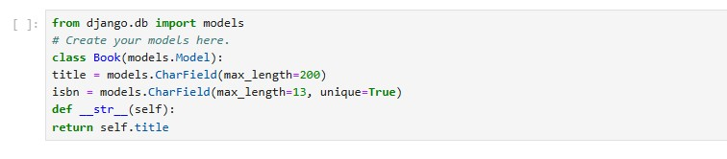

# Serializer : library/serializers.py

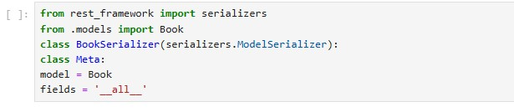

# Views : library/views.py

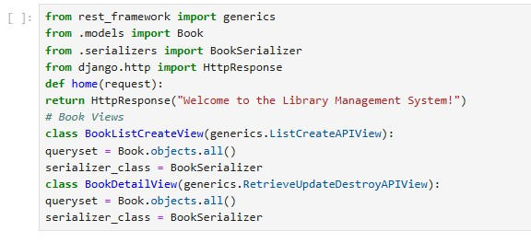

# URL Configuration : library/urls.py

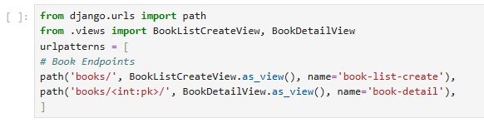

# URL Configuration : LibraryManagementSystem/urls.py

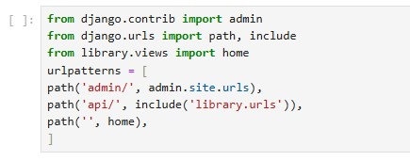

**Output**

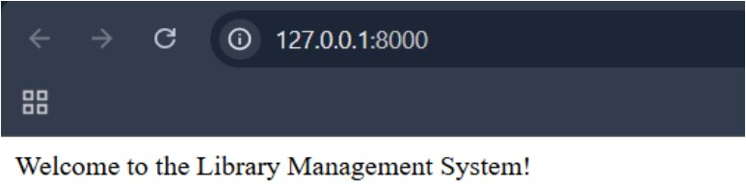

**CRUD Functionality:**

* List all books (GET) or create a book (POST).

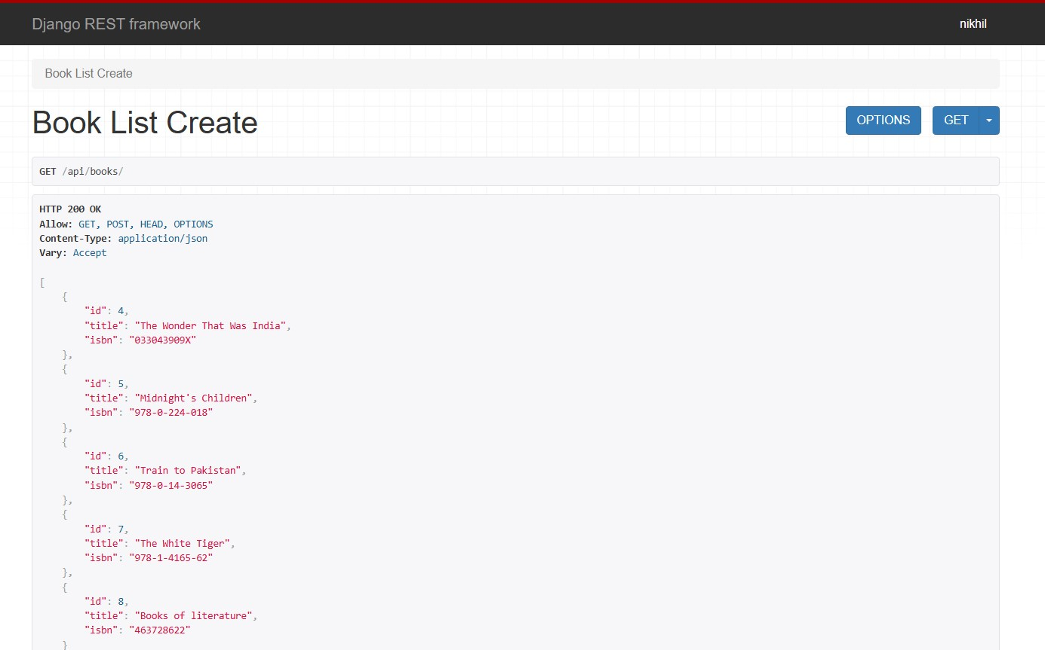

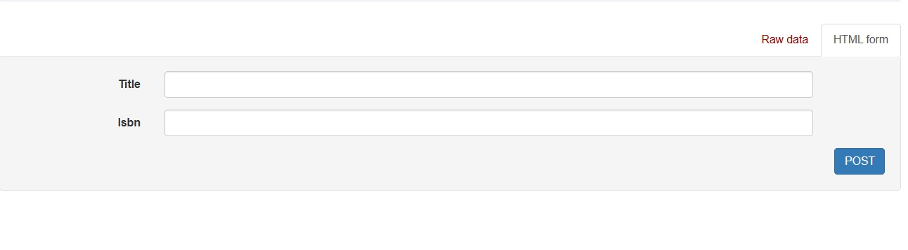

* Retrieve, update, or delete book with ID 5 (GET, PUT, DELETE).

