Balram Mandal

Roll No-30

# EXP.NO-10

|  |
| --- |
| import numpy as np  import matplotlib.pyplot as plt import cv2  image = cv2.imread('bappa.webp')  image_rgb = cv2.cvtColor(image, cv2.COLOR_BGR2RGB)  plt.imshow(image_rgb) plt.title("Original Image") plt.axis("off") plt.show() |

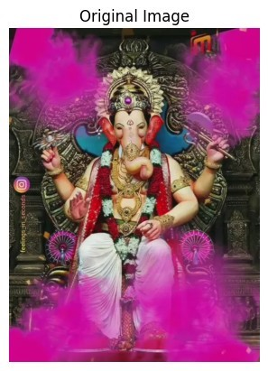

image_gray = cv2.cvtColor(image, cv2.COLOR_BGR2GRAY) plt.imshow(image_gray, cmap='gray') plt.title("Grayscale Image") plt.axis("off") plt.show()

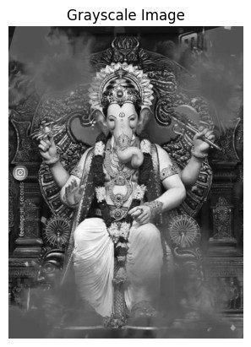

cropped_image = image_rgb[50:200, 50:200] plt.imshow(cropped_image) plt.title("Cropped Image") plt.axis("off") plt.show()

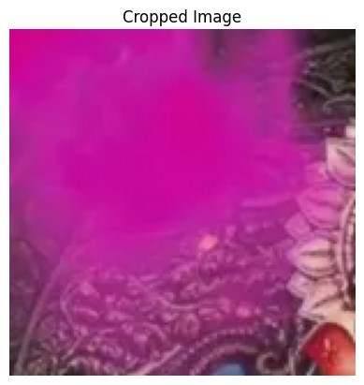

bright_image = np.clip(image_rgb + 50, 0, 255) plt.imshow(bright_image.astype(np.uint8)) plt.title("Brightened Image") plt.axis("off") plt.show()

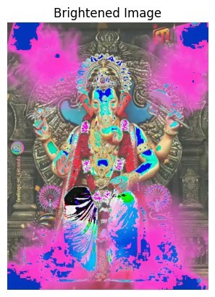

sobel_x = cv2.Sobel(image_gray, cv2.CV_64F, 1, 0, ksize=5) sobel_y = cv2.Sobel(image_gray, cv2.CV_64F, 0, 1, ksize=5) edge_image = np.sqrt(sobel_x**2 + sobel_y**2) plt.imshow(edge_image, cmap='gray') plt.title("Edge Detection") plt.axis("off") plt.show()

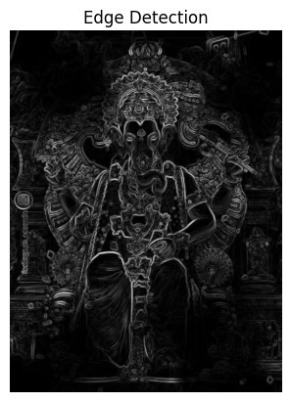

cv2.imwrite('modified_image.jpg', cv2.cvtColor(bright_image, cv2.COLOR_RGB2BGR))

True