Balram Mandal

Roll No. 30

Exp.NO.11

Program to Demonstrate Data Series using Pandas

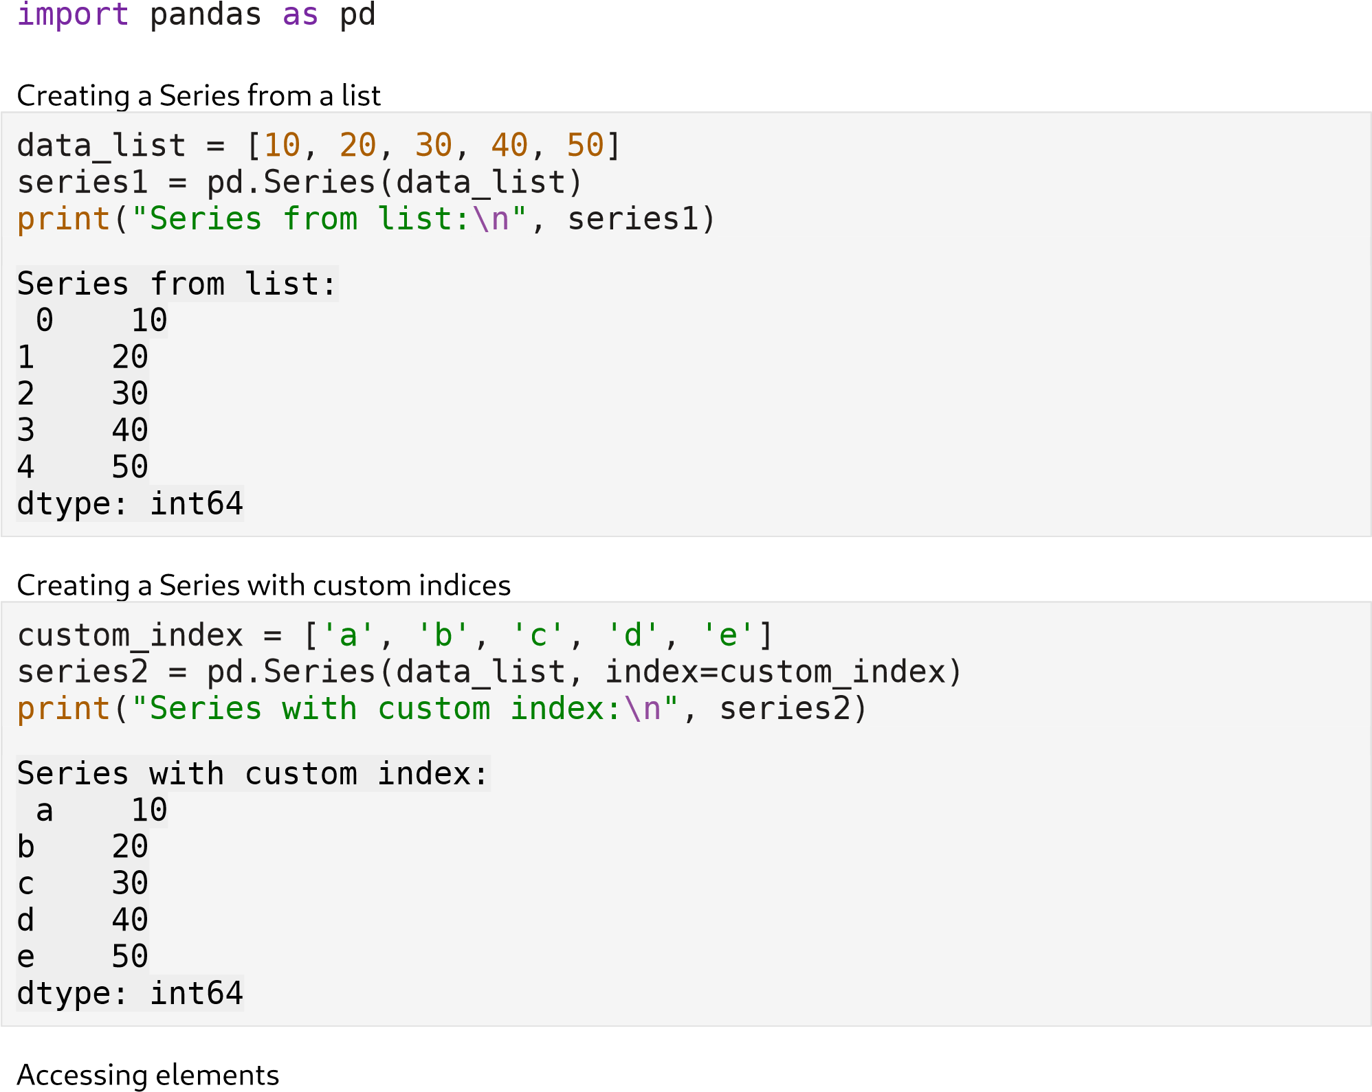

print("Accessing element at index 'c':", series2['c'])

Accessing element at index 'c': 30

Performing operations on Series

print

(

"Adding 5 to each element:

\n

"

, series2

+

5

)

Adding 5 to each element:

a 1

5

b 2

5

c 3

5

|  |  |  |  |  |
| --- | --- | --- | --- | --- |
| |  |  | | --- | --- | | d 45 e 55 |  | | dtype: int64 | | |

Creating Series from a dictionary

|  |
| --- |
| data_dict = {'Math': 80, 'Physics': 90, 'Chemistry': 85} series3 = pd.Series(data_dict) print("Series from dictionary:\n", series3)  Series from dictionary:  Math 80  Physics 90 Chemistry 85 dtype: int64 |

Checking basic statistics

|  |
| --- |
| print("Maximum marks:", series3.max())  print("Subjects scored above 85: \n", series3[series3 > 85])  Maximum marks: 90 Subjects scored above 85:  Physics 90 dtype: int64 |