FleXperience: An Online Fitness Place Finder in Davao City

A Capstone Project Proposal

Presented to the Faculty of the

Information and Communications Technology Program

STI College Davao

In Partial Fulfilment

of the Requirements for the Degree

Bachelor of Science in Information Technology

Jonhyl E. Balsamo

Charles Angelo B. Cuizon

Chellsey Anndria C. Argente

John Harvey P. Sarno

Christopher John A. Abanes

May 25, 2024

ENDORSEMENT FORM FOR PROPOSAL DEFENSE

TITLE OF RESEARCH: FleXperience: An Online Fitness Place Finder in Davao City

NAME OF PROPONENTS: Jonhyl E. Balsamo

Charles Angelo B. Cuizon

Chellsey Anndria C. Argente

John Harvey P. Sarno

Christopher John A. Abanes

In Partial Fulfilment of the Requirements

for the degree Bachelor of Science in Information Technology

has been examined and is recommended for Oral Defense.

ENDORSED BY:

Clyde Anthony L. Migue

Capstone Project Adviser

APPROVED FOR PROPOSAL DEFENSE:

Engr. Elvi Lito Ubas, CPE, MEEd

Capstone Project Coordinator

NOTED BY:

Vincent Bryan F. Calija

Program Head

# May 25, 2024

# APPROVAL SHEET

This capstone project proposal titled: FleXperience: An Online Fitness Place Finder in Davao Ciprepared and submitted by Johnyl E. Balsamo, Charles Angelo B. Cuizon, Chellsey Anndria C. Argente, John Harvey P. Sarno and Christopher John A. Abanes, in partial fulfillment of the requirements for the degree of Bachelor of Science in Information Technology, has been examined and is recommended for acceptance and approval.

Clyde Anthony L. Migue

Capstone Project Adviser

Accepted and approved by the Capstone Project Review Panel

in partial fulfillment of the requirements for the degree of

Bachelor of Science in Information Technology

|  |  |
| --- | --- |
|  |  |
| Panel Member | Panel Member |

Lead Panelist

Noted:

|  |  |
| --- | --- |
| Engr. Elvi Lito Ubas, CPE, MEEd | Vincent Bryan F. Calija |
| Capstone Project Coordinator | Program Head |

May 25, 2024

# Table of Contents

|  |  |  |
| --- | --- | --- |
|  | | Page |
| Title Page | | i |
| Endorsement form for Proposal Defense | | ii |
| Approval Sheet | | iii |
| Table of Contents | | iv |
|  | |  |
| Introduction | | 1 |
|  | Project Context | 1 |
|  | Purpose and Description | 4 |
|  | Objectives | 5 |
|  | Scope and Limitations | 7 |
|  |  |  |
| Review of Related Literature/Systems | | 10 |
|  | Related Studies and/or Systems  Synthesis | 10  12 |
|  |  |  |
| Technical Background | | 14 |
|  | Overview of Current Technologies to be Used in the System | 14 |
|  | Calendar of Activities | 15 |
|  | Gantt Chart | 16 |
|  | Resources | 18 |
|  |  |  |
| Methodology, Results, and Discussion | | 20 |
|  | Requirements Gathering and Analysis | 22 |
|  | Design | 23 |
|  | Iteration 1: Employee Personal Information | 23 |
|  | Iteration 2: Time and Attendance Tracking | 28 |
|  | Iteration 3: Generate Payroll Calculation and Report | 32 |
|  | Iteration 4: Track and Manage Employee Requests | 37 |
|  | Iteration 5: Employee Taxes, Deductions and Contributions | 42 |
|  | Iteration 6: Override Feature for Payroll Clerk | 47 |
|  | Deployment | 51 |
|  | Maintenance | 52 |
|  |  |  |
| References | | 54 |
|  | |  |
| Appendices | | 55 |
|  | Resource Persons | 60 |
|  | Personal Technical Vitae |  |
|  | |  |

# Introduction

## Project Context

The increasing interest in health and fitness, people are constantly searching for fitness centers that meet their needs. However, traditional methods of finding fitness places, such as word-of-mouth or basic online searches, have some drawbacks. A significant issue we observed is the lack of a centralized platform that can efficiently and effectively help users find fitness places based on various criteria. Traditional methods tend to struggle with providing real-time, personalized, and location-based recommendations (Natus, S. T., Curth, M., Kerber, L. E., & Gonçalves, M. A. 2021).

We have also acknowledged traditional forms of word-of-mouth and physical visits as some possible criticism when it comes to how people selected their gyms in the past, which is both time-consuming and limited. Those who want to get their sweat on can often find traditional methods or gym discovery search a bit time consuming, especially if they are in pursuit of an establishment that specifically meets certain wayfarer criteria (like facilities located near the office with top-of-the-line equipment and membership options). This could result in only partial information and possibly unhappiness at the chosen gym because not enough options were taken into account. (Gonçalves, C., Biscaia, R., Correia, A., & Diniz, A. (2014)).

Even though technology has becoming an integral part of virtually every industry across the globe, some people are still resorting to Window shopping i.e., asking friends for recommendations and flipping through local directories with So many digital resources available. But these are imperfect methods, because the information becomes quickly outdated or only renders some of it (so you can't even have a clear idea if that's your gym) and eventually no visitor will be able to find his/her real needs in one list. And because of reliance on manual work, which sometimes means not finding special gyms.

The introduced Online Fitness Finder system is proposed to deal with such issues. The web based platform by this system will provide users with a significant amount of information and easier means to find fitness centers from the comfort of their homes. The system will offer real-time data, user reviews and elaborative details of facilities and services that would help the users to take an informed decision without resorting back to traditional method.

The proposed solution is designed to address the limitations of traditional gym-finding methods, including difficulties in accessing up-to-date information, challenges in discovering specialized fitness centers, and the inefficiencies of manual searches. By focusing on these key areas, the innovative approach of the Online Fitness Finder aims not only to overcome existing challenges but also to enhance the overall user experience, making it easier and more efficient for individuals to find fitness centers that align with their needs and preferences.

The proposed web-based Online Fitness Place Finder system features three key attributes. Accessibility, scalability, and automation.

First, comprehensive accessibility: The system is designed to be accessible from any device with an internet connection, whether a smartphone, tablet, or computer. This ensures that users can conveniently search for and explore fitness centers from anywhere, at any time, promoting a seamless experience in their fitness journey.

Second, dynamic search capabilities: Scalability is crucial for this system as it supports an expansive and flexible search engine. The system can easily accommodate a growing database of fitness centers and dynamically filter results based on user-specific criteria such as location, facilities, and services offered. This adaptability ensures that the system remains relevant and useful as new fitness centers emerge or user preferences evolve.

Third, personalized recommendations: The proposed system leverages advanced algorithms to offer personalized recommendations based on user preferences, past searches, and feedback. This feature helps users discover fitness centers that best match their individual goals, whether they are looking for a specialized studio or a full-service gym, thus enhancing the decision-making process and user satisfaction.

Purpose and Description

The proposed system aims to empower individuals on their fitness journey by providing a map of suitable fitness gyms and locations. This platform allows users to explore nearby parks, running tracks, and outdoor fitness spots ideal for various exercises such as jogging, yoga, or calisthenics. Enabling them to find the right facility to meet their fitness goals. It also features user ratings and membership details.

The platform uses mapping technology and user-generated reviews to help users discover new workout spots, whether they prefer outdoor or gym sessions. This feature enhances fitness routines and wellness journeys. Users can explore various exercise locations, including parks, running tracks, and outdoor fitness areas, and access detailed information about each spot, including user ratings and reviews. This feature is particularly beneficial for newcomers to the city who are passionate about fitness, helping them locate nearby workout spots or gyms easily, supporting their fitness goals.

The platform integrates fitness gyms in Davao City, offering registered users easy access to gyms and the option to book personal trainers. This feature aims to provide professional guidance and convenient access to fitness facilities, assisting users in achieving their fitness goals.

Objectives

This project is a web-based fitness tool specifically designed for fitness enthusiasts in Davao city can utilize a web-based tool to track and locate ideal exercise spots and gyms. This tool, utilizing modern mapping technology and user-friendly features, simplifies the process of finding and accessing fitness facilities in the city.

This project aims to:

* Develop a weight tracking feature

This module is designed to focus on tracking weight progress is a crucial role in a fitness journey, providing valuable insights into the user's progress over time, enhancing their overall fitness experience.

* Develop a mapping feature

The proponents are developing a mapping system in Davao City, utilizing open-source libraries to create a mapping feature that will assist users in locating fitness spots and facilities in the city.

* Implement a meal macro analytics feature using pie chart

This feature provides users can track their food intake by using a visual representation of macronutrients in their meals. This helps them meet their dietary goals by accurately tracking their intake, such as protein or calories, and supporting their fitness journey.

* Develop a personalized workout plans Module

The trainer provides personalized workout plans tailored to each gym member’s fitness goals, ensuring they meet their specific body type and fitness level. These plans can track the total calories burned, ensuring the exercises are suitable for their current fitness level and desired outcomes.

* Develop a personalized Nutrition Plans Module

Trainers provide personalized nutrition plans to students, tailored to their specific dietary needs and health goals. These plans take into account individual preferences and objectives, ensuring the recommended meals effectively support nutritional requirements and desired outcomes.

* Develop a fitness gym registration module

Fitness gyms in Davao City must register on our system to be featured on the website, allowing users to check facilities, locations, and rates.

* Develop a user registration module

The proponents are going to develop a user registration module is that in order for users to access features that are only available to registered users like hiring a personal trainer at a particular gym, enrolling in fitness centers, and receiving customized diet and workout plans they must first register in our system.

## Scope and Limitations

Scope

The capstone project is to design, develop, and implement the Subscription-based Payroll System for businesses handling the employees. The FleXperience An Online Fitness Place Finder in Davao City supports:

Mapping:

The feature utilizes open-source mapping libraries to create an interactive map that identifies various fitness facilities, including their locations, services, and accessibility.

Personalized Workout Plans Module:

Trainers can create customized workout routines for users, tracking calories burned and ensuring the exercises match the user's fitness level and desired outcomes.

Limitations

This capstone project is limited to the development of a web-based fitness tool specifically designed for users in Davao City. The system is tailored to general fitness needs, which may not cater to the highly specialized requirements of all users, such as those with specific medical conditions or advanced athletic training needs. Furthermore, the project focuses on standard fitness features, including weight tracking, mapping of local fitness spots, and meal macro analytics. There are inherent limitations in the tool’s ability to address unique fitness and nutritional goals that require personalized professional consultation beyond the scope of what the system offers.

Geographical Limitation:

The mapping feature and gym registration module are limited to fitness spots and gyms within Davao City. The tool will not cover locations outside this area.

Internet Connectivity:

As a web-based tool, the system requires a stable internet connection. Users with limited or no internet access may experience difficulties in using the platform.

****Limited Nutritional and Fitness Expertise****:

The system relies on the expertise of trainers for personalized plans. The effectiveness of these plans may vary based on the trainer’s qualifications and the user’s adherence to the advice.

# review of related literature/systems

## Related Studies and/or Systems

This chapter contains the review of related studies or systems used in this study.

Web-based Gym Management System (K G S T Gamage, 2017)

According to K G S T Gamage, (2017) their proposed system is designed to automate the registration process for an individual by capturing all required information and validating their Identification Number to prevent duplicate entries, ensuring a seamless and efficient registration process.

The system is designed to create suitable exercise schedules by utilizing data from individual health records and exercises. It proposes the best set of exercises for each individual, ensuring a suitable schedule for each individual's needs. This system ensures efficient and effective gym workouts.

## Synthesis

Jakkamsetti, S. P., et al. (2020), Online Payroll Software Management primarily focuses on handling cash advances, allowances, and the generation of pay slips. Their system has two home pages for the admin—the owner of the system—and user, mainly the HR, separately. The user home page consists of payroll entry page and fine employee page.

Babirye, S., et., (2023), the Integrated Payroll Personnel System focuses on accuracy in payroll calculation in preventing payroll fraud. The system aims to improve and reduce fraud, including the elimination of ghost workers.

Teja, P. R., & Patra, R., (2023), A study on PayRoll-Management System focuses on aiming to modernize their payroll system by moving away the manual processes and implementing a more automated, secure, and efficient solution in calculating employees' salaries and benefits.

The WageGauge: Payroll Solutions Through Subscription-Based Models proposes a web-based payroll system with subscription- based that addresses the limitations of a traditional payroll systems, particularly for businesses in the Philippines.

The difference between online payroll management system and our system is that online payroll software management system likely requires upfront license purchases, potentially leading to higher initial costs while our system, WageGauge: Payroll Solutions Through Subscription-Based Models allows for potentially lower upfront costs and spreads the cost over time. Our system emphasizes scalability to accommodate growth in the number of employees, making it a better fit for businesses with expansion plans. WageGauge prioritizes accessibility with remote access from any device with an internet connection while the online payroll software management system prioritizes on-premises installations that limit accessibility for remote employees.

Additionally, for businesses prioritizing affordability and scalability our subscription model and scalability features might be more attractive. For proper attendance tracking, our system has QR code scanner integration for the DTR, which is a valuable feature for businesses.

The difference between integrated payroll personnel system (IPPS) and our system is that IPPS is solely focuses for local government use, addressing issues such as ghost workers and fraudulent activities through features like time and attendance management, employee data management, and performance management. However, IPPS has been noted to have flaws, including liability to ghost workers, and lack of integrity checks on payroll data, necessitating improvements to enhance its effectiveness in fraud prevention and overall payroll management. While our system, WageGauge is adaptable for use across businesses of all sizes making it more versatile solution. QR code scanner integration strengthens WageGauge’s fraud prevention mechanisms compared to IPPS. Additionally, as a web-based system, WageGauge is accessible from any device with an internet connection, unlike IPPS, which have limitations in accessibility.

WageGauge’s subscription-based model offers potentially more cost-effective and scalable options for businesses compared to the traditional one-time purchase installation model that often used by systems like IPPS. WageGauge emphasizes data security and access controls to prevent authorized modifications to employee data or payroll calculations, ensuring the integrity of payroll process. In summary, WageGauge aims to modernize the entire payroll process for businesses of various sizes and industries. The system seems to have a clear advantage in terms of affordability, scalability, and accessibility. Our system will help streamline payroll processes for businesses of various sizes.

TECHNICAL BACKGROUND

## Overview of Current Technologies to be Used in the System

Technologies that help business owners expand their enterprises are among humanity’s greatest innovations. A website is among these breakthroughs. Websites are accessible to all users due to their adaptability, visual appeal, and ease of use. They are now essential for companies as they improve precision and promote automation.

WageGauge is an online payroll system designed to streamline payroll calculations for businesses. Unlike traditional systems, WageGauge offers a web-based platform accessible from any desktop device with a web browser and internet, making it scalable, dynamic, and user-friendly. WageGauge automates many manual payrolls task, freeing up valuable time for HR professionals and business owners. By utilizing this system, the risk of errors in processing payroll is greatly reduced, offering peace of mind to both employers and employees.

The proponents are going to use Figma, a design tool, to create mockups for the website’s user interface. To build the website itself, they will use HTML for the webpage structure and CSS to control the appearance and layout. JavaScript adds interactivity and functionality, making the website more engaging for both users and website administrators.

The proponents have decided to use Node.js for this project. They believe it's the best choice because it offers a lot of useful features. One of these is its rich ecosystem. Express.js has a vast ecosystem of open-source libraries and modules available through npm (Node Package Manager), which developers can leverage to accelerate development and add functionality to their applications.

## Calendar of Activities

The Gantt chart presents the summary of the proponents’ duration of activities. Below are the legends of activity indication where BLUE indicates as starting or not finished and YELLOW as on progress or finished.

## Resources

* Hardware

In this section outlines the system’s hardware needs. The table below lists the hardware components utilized for building the system.

Table 1. Device Specifications

|  |  |  |  |  |  |
| --- | --- | --- | --- | --- | --- |
|  | Operating System | Processor (CPU) | Memory (RAM) | Storage | Monitor/Display |
| Device 1 | Windows 64-bit | Ryzen 3 3200G | 16 GB | 512 GB | AOC 1621 wb/ 1366 x 768 |
| Device 2 | Windows 64-bit | Intel Core i5-4790 | 16 GB | 250 GB | AO6 1366 x 768 60hz |
| Device 3 | Windows 64-bit | Ryzen 3 3200G | 16 GB | 512 GB | AOC 1621 wb/ 1366 x 768 |
| Device 4 | Windows 64-bit | AMD PRO A10-8770 | 8 GB | 256 GB | 1440 x 900 Resolution |
| Device 5 | Windows 10 Home Single Language | Intel® Pentium® Silver N5000 CPU @ 1.10GHz, 1101 Mhz | 4 GB | 118 GB | 1366 x 768 Resolution |

* Software

The proponents plan on using the Windows operation system on both desktops and laptops. Before diving into development, the proponents will use Figma to create a prototype or mockup design for the system. For backend development, the proponents will use ExpressJS and MySQL, and open-source relational database. To enhance both appearance and functionality of the system, they will use HTML, Tailwind CSS, and JavaScript.

# Methodology

In this development of WageGauge, a web-based payroll system, an iterative model was utilized instead of the traditional waterfall model. Unlike the linear progression of the waterfall model, the iterative model allows for a cyclical approach, enabling the team to continuously refine and enhance the system’s features. This iterative approach fosters ongoing feedback and adjustment, empowering the team to promptly address any emerging issues or modifications.

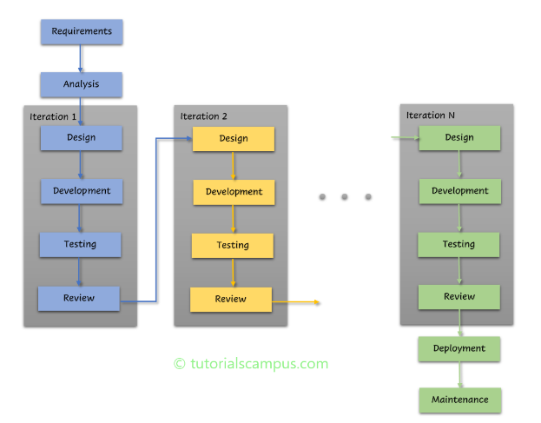

Each iteration represents a cycle of planning, designing, implementing, and testing, allowing the proponents to focus on refining specific aspects of the system with each iteration. This approach not only fosters a sense of continuous improvement but also provides opportunities for feedback and course correction along the way.

By dividing the development process into manageable iterations, the team can concentrate on delivering tangible outcomes at each phase, resulting in accelerated feedback loops and expedited resolution of identifies setbacks. Moreover, the iterative model encourages collaboration and adaptability, ensuring a more responsive framework for WageGauge’s evolution. Ultimately, the iterative model facilitates continuous improvement and ensures that WageGauge remains aligned with evolving requirements.

## Requirements Gathering and Analysis

The project begins by gathering data and seeking advice from experts in payroll systems or other professionals experienced in this field. This helps the proponents get a a complete understanding of payroll systems, making sure they make informed decisions and plan the project effectively. At first, the group studied on their own to get a basic idea of how the system works or how the business process works in this kind of system. Then after acquiring initial information about the proposed system the proponents proceed in finding individuals acquainted with any of these professionals to facilitate the proponent’s consultation inquiries.

The proponents have realized the significance of not depending solely on the information gathered. They have decided to extend their efforts by engaging in group or self-study sessions. This collaborative learning approach allowed them to explore the system more comprehensively, leading to a deeper or clearer understanding and better-informed decision-making in developing this system. In their exploration of the payroll system, the team had an interview with a payroll clerk. From this interview, the proponents gathered key functional requirements that the system needed to fulfill.

First, it had to capture and manage the employee’s personal information. Another functional requirement identified was the need to keep track of when employees showed up for work and when they left. It also had to calculate each employee’s pay and generate reports. Furthermore, it needed to handle various employee-related requests such as leaves, cash advances, overtime pay, and official business trips. The proponents also learned that it was important for the system to handle taxes and other deductions correctly to avoid potential issues. Lastly, the system needed to generate an excel sheet containing attendance history of the employee and it also needed a feature that allows the payroll clerk to make changes if necessary. In short, the system had to effectively manage employee information, time, finances, requests while maintaining a user-friendly user interface (UI) for users.

## Design

The proponent’s Data Flow Diagram (DFD) has already captured the objectives of this project, in which the proponents will be using for every iteration. To cite once again, the proponents used the iterative model in order for them to continuously improve each function and/or objective until the entire system is completed. The first and succeeding iterations are shown below as each DFD are cropped to emphasize each objective and the amount of iterations are not yet finalized as the system is still in development.

**First Iteration: Employee’s personal information.**

1. **Design**

During this phase, technical specifications are derived from the business requirements. The developers create the software’s architecture using various diagrams and design patterns that will aim to satisfy each requirement and/or objectives, one of which is the Data Flow Diagram, which is shown below.

The objective for this iteration is to have a module that the HR could use to input the personal details of the employee.

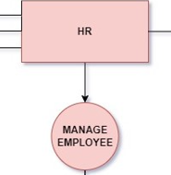

1. **Development**

In this phase, the developers will undertake the coding and implementation of the features planned for the current iteration. To achieve the objectives of creating a module that the HR department can use to input the personal details of the employee, the developers will:

Implement the Singleton Pattern, to ensure that only one instance of the HR module exists at any time, facilitating efficient management and consistent state of the employee personal details input system.

Use Tailwind CSS for styling, developers will employ Tailwind CSS to style the user interface, creating a modern, responsive, and user-friendly design for the HR module. This will ensure that the interface is intuitive and accessible for HR personnel.

Develop the backend with Express.js, for the server-side development, the developers will use Express.js to build a robust and scalable API. This API will handle requests from the HR module, processing and storing employee personal details efficiently and securely.

Database Management with MySQL, the developers will use MySQL as our database management system to securely store and manage the employees’ personal information. MySQL will ensure data integrity and support complex queries required for HR operations.

1. **Testing**

In this phase, we will conduct thorough white-box testing to ensure that the HR module functions as intended. The developers will test the internal structures and workings of the code. This testing efforts will focus on validating the logic, flow, and data handling within the module. The following testing attempts will be made:

For input validation, the developers will test with both valid and invalid inputs to ensure the system correctly validates employee details such as name, date of birth, and email. For instance, valid inputs like “Juan Dela Crus” for name, “1990-05-12” for date of birth, and juandelacrus@example.com for email should be accepted, while invalid inputs such as an empty name, an invalid date format, or an incorrect email format should trigger appropriate error messages.

In terms of data handling, the developers will test the creation, updating, and deletion of employee records in the database. The developers will input new employee details like “Kamado Tanjiro” with a date of birth of “1985-08-25” and email “kamadotanjiro@example.com” to verify creation. The developers will update an existing employee record by changing the name to “Kamado Nezuko” and delete records using the employee ID, ensuring these operations correctly modify the database without affecting other data.

For integration testing, the developers will examine the interaction between the HR module and the backend API to ensure seamless data flow. For example, when the HR module sends a request to the API to save new employee details, the API should correctly handle the request and store the data in MySQL, providing appropriate success or error responses.

Functional testing will involve testing each feature of the HR module to ensure they perform as expected. This includes accessing the form to input new employee details, submitting the form with details like “Gojo Satoru” born on “!992-11-17” with the email “getocomeback@gmail.com” , and verifying that the data is correctly saved and a confirmation message is provided upon successful submission.

The developers will also perform boundary testing by inputting edge cases to ensure the module handles boundary conditions gracefully. This includes testing with minimum and maximum input lengths for names, boundary values for dates, and minimal email formats. For instance, testing with the name "A" or a very long name, a date of birth like "1900-01-01", and a minimal email like "x@y.z" should be handled without errors.

Lastly, for error handling, the developers will test the module’s response to unexpected inputs and conditions by forcing errors such as database disconnection or invalid API endpoints. The system should gracefully handle these errors, providing meaningful error messages to the user and logging details for debugging. By conducting these testing attempts, the developers aim to ensure that the HR module is robust, handles various input scenarios effectively, and maintains data integrity throughout the process.

1. **Review**

The HR employee management system is evaluated for functionality and performance throughout the review process. The adviser of the proponents takes on the responsibility of giving input through black-box testing on behalf of the clients because actual clients are not present at this point.

The adviser does a feedback evaluation once the HR employee management system’s black-box testing is finished. The HR employee management system is then improved iteratively by the developers, who fix any errors, glitches or mistakes found during testing.

The developers move on to the following iteration, which deals with employee time and attendance monitoring, after resolving these problems.

**Second Iteration: Time and attendance tracking of employees.**

1. **Design**

Displayed below is the Data Flow Diagram, enabling employees to track their attendance history. The Employee DTR table retrieves data sourced from time-in and time-out time information data.

The objective for this iteration is to have a module with time and attendance tracking in their menu or dashboard I which the employee will see his/her rendered time-in and time-out.

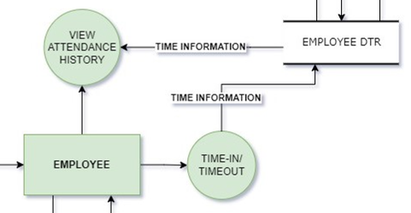

1. **Development**

In this iteration, the developer’s primary objective is to develop a module for time and attendance tracking within the employee section for menu or dashboard. To achieve this goal, developers will implement the following strategies:

Implementing the Singleton Pattern, we will ensure that only one instance of the time and attendance tracking module exists at any given time, guaranteeing efficient management and consistent data representation for each employee.

Utilizing Tailwind CSS for styling, tailwind CSS will be employed to design and style the user interface of the time and attendance module. This will result in a modern, responsive, and user-friendly interface that seamlessly integrates into the menu or dashboard.

Developing the back-end with Express.js, express.js will serve as the backbone for building a robust and scalable API to support the functionality of the time and attendance module. This API will handle requests from the front-end, processing and retrieving employee time-in and time-out data efficiently.

Database Management with MySQL, MySQL will be utilized as the database management system to securely store and manage employee time and attendance records. It will ensure data integrity and support complex queries required for tracking employee attendance effectively.

1. **Testing**

In this phase, the developers will verify the integration testing on how the biometric system integrates with the database for storing and retrieving time-in and time-out records. Developers will also test the integration between the Employee DTR table and the attendance tracking dashboard to ensure seamless data flow and synchronization.

Functional testing will involve testing the QR code scanner functionality to accurately capture and record employee time entries. The developers will also assess the functionality of the attendance tracking dashboard to ensure it displays the fetched data from the Employee DTR table correctly, providing employees with accurate and real-time attendance information.

Using code coverage tools, the developers will analyze the QR system’s code-base to ensure comprehensive coverage. This will help identify any untested or unreachable code, ensuring thorough testing of the system.

Error handling testing, the developers will test the QR scanner’s error handling mechanisms to ensure it responds appropriately to errors, exceptions, and boundary conditions encountered during time-in and time-out entries, as well as data fetching from the employee DTR table.

Performance testing will assess the QR scanner’s performance under various conditions, including stress and load testing to evaluate scalability and response time during peak usage. Developers will also evaluate the performance of data fetching from employee DTR table to ensure timely and efficient retrieval of attendance records.

The implementation of security testing is under consideration by the developers to identify and mitigate potential vulnerabilities within the QR code scanner. This approach would ensure the system’s resilience against unauthorized access and data breaches, safeguarding the user information.

1. **Review**

In the review phase, the proponents will conduct black-box testing to evaluate the functionality and usability of the developed system. Given the absence of an actual client at this stage, the proponent’s adviser will assume the role of the client, providing feedback on behalf of potential end-users.

During the black-box testing, the focus will be on assessing the system’s functionality from an end-user perspective, without direct knowledge of its internal workings. This approach ensures that the system meets the specified requirements and its intuitive and user-friendly for future users.

The feedback gathered during black box testing will be used to inform further iterations of development, enabling the system to be refined and improved based on user expectations and preferences.

By conducting thorough black box testing and gathering feedback from the proponent's adviser acting as the client, the developers aim to ensure that the developed system meets the needs and expectations of its intended users, even in the absence of a real client at this stage of development.

The developers move on to the following iteration, which deals with the payroll clerk, in which the goal is to generate a payroll calculation and report.

**Third Iteration: Generate payroll calculation and report.**

1. **Design**

Displayed below is the Data Flow Diagram, which shows how the payroll calculation and reports are generated by retrieving data from the database table that contains the necessary information for payroll calculation.

The aim of this third iteration is to develop a module for payroll calculation for the payroll clerk. After the payroll clerk collects the salaries, taxes, overtime, bonuses, deductions, and other variable pay components, a payroll summary for each employee will be generated. There will be a button to calculate the necessary data for payroll calculation. Following the payroll calculation, a payroll report will be produced.

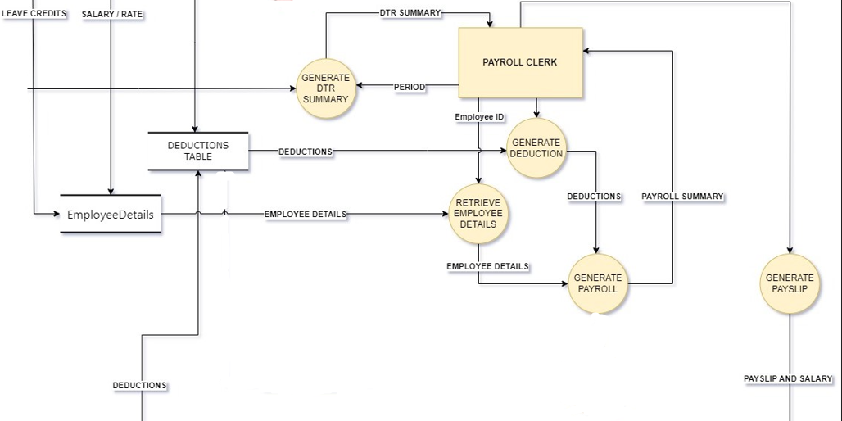

1. **Development**

In this phase, the developers embark on a structured process to ensure accurate and efficient processing of employee compensation. With the aim of leveraging technologies like the Singleton pattern for data consistency, Tailwind CSS for sleek interface design, Express.js for robust backend development, and MySQL for secure database management, the developers proceeds with the following approach:

The initial step in the payroll calculation journey involves the payroll clerk retrieving a Daily Time Record (DTR) summary from the approved employee DTR table. This summary serves as a cornerstone, providing essential insights into employee attendance and work hours. Armed with this data, the payroll clerk moves on to the next crucial task.

Following the acquisition of the DTR summary, the payroll clerk delves into retrieving detailed employee information. This includes gathering data on individual salaries and examining remaining leave credits. Notably, any outstanding leave credits are converted to cash and integrated into the payroll calculation process to ensure accurate compensation for employees’ efforts and leave utilization.

With employee details at hand, the payroll clerk proceeds to retrieve deductions from the deductions table. These deductions encompass various financial withholdings such as taxes, insurance premiums, and retirement contributions. They are instrumental in determining the final net pay for each employee.

Once all necessary data for payroll calculation is gathered, including DTR summaries, employee details, and deductions, the payroll clerk enters the pivotal phase of generating the payroll. Employing predefined formulas and calculations, they meticulously compute each employee's gross pay, deductions, and ultimately, net pay.

Subsequently, the payroll clerk transitions to the task of generating individual pay slips for each employee. These pay slips serve as comprehensive documents detailing crucial compensation information such as the employee's name, pay period, gross pay, deductions, net pay, and any supplementary details pertinent to their compensation package.

1. **Testing**

During this phase, the payroll calculation module undergoes thorough evaluation to ensure its accuracy, reliability, and user-friendliness. Among the various scenarios tested, particular attention is given to situations where incorrect data is deliberately inputted to assess the module’s response to errors and exceptions.

Developers deliberately input incorrect periods when generating Daily Time Records (DTRs). This could involve entering invalid date ranges or selecting improper time periods. The objective is to observe how the module handles such erroneous inputs and whether it effectively communicated errors to the users.

Developers simulate scenarios where incorrect periods are entered due to human error or oversight. They carefully document the module’s response, paying close attention to the clarity of error messages and the module’s ability to reject invalid inputs without disrupting overall system functionality.

Developers will also intentionally input incorrect employee ID’s when retrieving employee details, such as salary and leave credits. Developers mimic situations where incorrect identifiers are entered, either due to typographical errors or unauthorized access attempts.

The primary goal is to assess how the module identifies and handles invalid employee ID’s. Testers closely monitor the module’s response, evaluating its ability to detect incorrect ID’s, provide clear feedback to the user, and prevent unauthorized access to sensitive employee data.

1. **Review**

In this phase, the proponent’s adviser will meticulously assess the progress and functionality of the payroll calculation module, which the developers are aiming to refine and enhance its performance based on valuable feedback.

As the proponent’s project is currently devoid of actual clients, proponents will rely on their thesis adviser, who graciously steps into the role of the client for testing purposes. The adviser’s insights and evaluations serve as invaluable benchmarks for the system’s efficacy and usability.

After the reviewing of the current module that is made in this iteration, the developers move on to the following iteration, which deals with the supervisor’s module, in which the goal is to monitor and manage employee vacation leave, sick leave, cash advances, overtime, and official business requests.

**Fourth Iteration: Track and manage employee requests.**

1. **Design**

In this phase, the proponents show the Data Flow Diagram of the supervisor, which indicates how it tracks and manages the requests of employees.

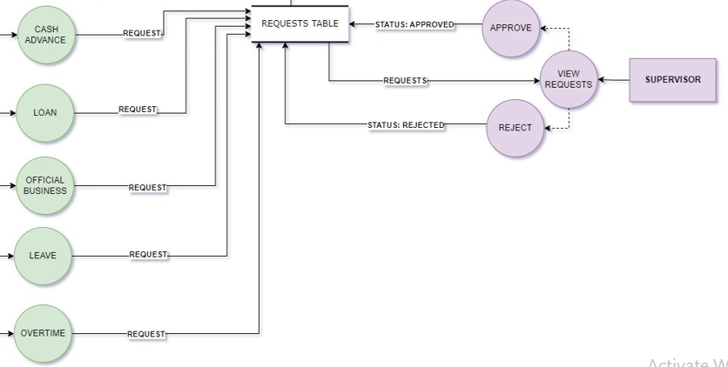The aim of this fourth iteration is to develop a module that will keep track and manage requests particularly for supervisor or to whom it will be assigned in the business. There will be a notification menu, wherein all the requests of employees will be shown by category: vacation leave, sick leave, cash advances, official business. If one of the requests is clicked there will be a prompt that will show the full details of the request and there will be a button for approval: approve or reject.

1. **Development**

In this phase, the developer’s attention shifts towards crafting a robust request management module. Developers will utilize cutting-edge technologies to ensure the effectiveness of the request management module. The Singleton Pattern ensures consistent access to request data, while Tailwind CSS enhances the user interface for supervisors. Express.js facilitates robust API creation for seamless request processing, and MySQL securely manages all request-related data.

Viewing employee requests, developers commence with the implementation of a crucial functionality: enabling supervisors to seamlessly view incoming requests from employees. Through a meticulously designed interface using Tailwind CSS within the supervisor’s dashboard, access to pertinent request data from the request table is facilitated. This feature not only provides supervisors with a comprehensive overview of pending requests but also ensures that information retrieval is consistent and efficient throughout the system. By incorporating the Singleton pattern, the developers guarantee that data access remains synchronized and uniform across all instances, enhancing the overall reliability of the system.

Supervisors has the ability to review and take decisive action on employee requests. Through an intuitive interface, supervisors can effortlessly navigate through pending requests and promptly approve or reject them based on their merits. With each action, the system dynamically updates the status of the corresponding request in the request table, ensuring transparency and clear communication between supervisors and employees. This functionality not only expedites the decision-making process but also fosters a seamless flow of information within the organization.

Certain approved requests, such as cash advances and loans, necessitate further processing to facilitate deductions in subsequent payroll cycles. To address this, the developers integrate functionality to seamlessly transition approved requests to the deductions system. By updating the deductions table with relevant information, the developers will ensure that payroll processing accurately reflects the approved requests, thereby minimizing discrepancies and streamlining administrative tasks for the payroll department.

1. **Testing**

In this phase, the developers will be testing the implemented and/or developed supervisor’s module. To ensure thorough testing, the proponents employ white-box testing, as developers will be the first to test the module. This approach allows the developers to delve deep into the codebase and identify any potential issues or bugs early in the development process. This testing includes: user interface testing, functional testing, and integration testing.

User Interface (UI) testing is vital to ensure that supervisors can effortlessly navigate and interact with the graphical interface of the supervisor module. This involves meticulously examining various aspects of the user interface. First, navigation testing, supervisors should be able to seamlessly move through different sections and functionalities of the module using intuitive navigation menus, buttons, and links. Second, layout testing, the layout of the user interface needs to be consistent and visually appealing across various devices and screen sizes, including desktops, tablets, and mobile phones. Third, form and input testing, it’s crucial to validate that all forms and input fields within the module are functioning correctly, including proper validation of user inputs and appropriate error handling.

Functional testing focuses on verifying that the supervisor module performs its intended functions accurately and efficiently. This involves thorough testing of various functionalities. First, request handling testing, developers rigorously test the supervisor's ability to view, approve, and reject different types of employee requests, such as vacation leave, sick leave, cash advances, and official business requests. Second, status update testing, verifying that the status of requests is updated correctly in the system after a supervisor takes action ensures that the system accurately reflects the supervisor’s decisions. Third, error handling testing, the module's ability to handle errors and edge cases, such as invalid inputs or unexpected behavior, is tested extensively. Clear error messages are essential to guide users appropriately.

Integration testing ensures that different modules of the system work seamlessly together as a cohesive unit. First, API testing, verifying that communication between the supervisor module and other backend systems or services through API’s is functioning correctly. This ensures accurate data exchange and proper behavior of API endpoints. Second, database testing, ensuring that data is stored and retrieved accurately from the database, and that changes made by the supervisor module are reflected correctly throughout the system.

By conducting comprehensive testing across these dimensions, the developers ensure that the supervisor module meets quality standards and delivers a seamless experience for supervisors interacting with the system.

1. **Review**

During this phase, as the proponents lack of actual users, the proponent’s adviser will assume the role of the user. The adviser will rigorously test and review the supervisor’s module for the current iteration.

Acting as surrogate user, the adviser will provide valuable feedback to enhance the module’s functionality and usability. By meticulously examining each aspect of the module, the adviser will identify any areas for improvement and suggest necessary refinements. This feedback loop ensures that the module aligns with user expectations and requirements, despite the absence of actual end-users.

Through this collaborative process, the developers aim to iteratively enhance the supervisor's module to meet the highest standards of quality and user satisfaction. After this section, the developers move on to the following iteration, which deals with the HR’s module, in which the goal is to manage the employee’s taxes and contributions.

**Fifth Iteration: Employee’s taxes, deductions and contributions.**

1. **Design**

In this phase, the proponents show the Data Flow Diagram of the HR’s function in which it manages the deductions and contributions of the employee.

The aim of this iteration is to develop a module that the HR could use to manage the taxes and contributions. After the employee is hired the HR will have a page that could input the employee’s tax and contribution. Additionally, the HR is also capable of updating the deductions.

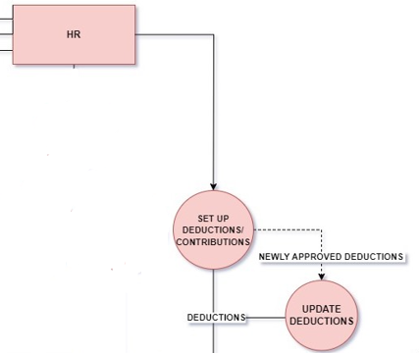

1. **Development**

In this phase, the developers will start implementing the HR’s module. The developers will be integrating several key technologies. The Singleton Pattern will be used to maintain consistent data access throughout the module. Tailwind CSS will be utilized to design a clean and intuitive user interface. Express.js will power the backend functionality, enabling robust handling of HR operations. Lastly, MySQL will serve as the database system, ensuring secure and reliable data management.

The developer’s primary objective is to create the HR module, which will empower HR personnel to manage and set up employee contributions and deductions after they are hired. This module will provide HR with the functionality to establish various deductions for employees, ensuring accurate and up-to-date financial records.

The HR module will include a feature for updating employee deductions, catering to scenarios such as damages caused by employees to the organization's products, loans credited to specific employees, and cash advances made by employees.

By implementing this module, the developers aim to simplify HR tasks, making sure that all employee financial changes are managed smoothly and clearly.

1. **Testing**

In this phase, the developers will be using white box testing as developers will be the first to test the HR module. This approach allows the developers to examine the internal workings of the module to ensure it functions correctly. Here are four specific testing methods that the developers will use to meticulously test the HR module:

Unit Testing, the developers will break down the HR module intro its smallest parts and test each individual component. This involves checking specific functions such as adding new deductions, updating existing deductions, and managing employee contributions. For example, developers will test the function that calculates deductions for an employee based on predefined criteria, ensuring it handles various scenarios like different deduction types and amounts correctly. By isolating and testing each function, the developers can identify and resolve issues at the granular level.

Integration Testing, after confirming that individual components work correctly, the developers will test how these components interact with each other. This includes ensuring that the module correctly handles data from various parts of the system, such as the employee database and the deductions table. For instance, developers will verify that when a new deduction is added or updated, it is accurately reflected in the database and that this data is correctly retrieved and displayed in the HR module. The developers will also test the interaction between the HR module and other modules, such as payroll, to ensure seamless data flow and consistency.

Input Testing, the developers will rigorously test the module’s ability to handle various inputs from users. This includes both valid and invalid inputs. For valid inputs, developers will check that the system correctly processes different types of deductions, such as loans or cash advances. For invalid inputs, developers will test scenarios such as entering incorrect data formats (e.g., letters in numeric fields), missing mandatory fields, and out-of-range values. The developers will ensure that the system provides appropriate error messages and handles these cases gracefully, maintaining data integrity and preventing crashes.

User Interface Testing, the developers will test the module's user interface to ensure it is intuitive and functional for HR personnel. This involves verifying that all interactive elements, such as buttons, forms, and drop-down menus, work correctly and that the interface displays accurate information. For example, developers will test that the form for adding a new deduction displays correctly on different devices and screen sizes and that is correctly validates input before submission. Additionally, different devices and screen sizes and that it correctly validates input before submission. Additionally, the developers will check for usability issues, ensuring that the interface is user-friendly and accessible, with clear instructions and feedback for the user.

1. **Review**

In this phase, the developers will engage their system adviser to assume the role of the client, as they do not yet have actual clients. The adviser will thoroughly test some aspects of the front side of the system, focusing on interface interactions and the accuracy of error messages. This includes navigating through the HR module, interacting with various buttons and forms, and ensuring that the system provides clear and precise feedback for any errors encountered. By doing this, the adviser will assess the usability and functionality of the interface, ensuring it meets the expected standards.

Following the adviser’s review, any feedback and suggestions for improvements will be carefully considered and implemented by the development team. This review process is crucial in identifying any remaining issues or areas for enhancement, ensuring the system is robust and user-friendly before final deployment.

Once the review is completed and the necessary adjustments are made, the developers will proceed to the next and final iteration, which focuses on developing the override feature for the payroll clerk.

**Sixth Iteration: Override feature for payroll clerk.**

1. **Design**

In this phase, the proponents present the Data Flow Diagram of the Payroll clerk’s function, which is the override feature.

The aim of this iteration is to develop a module for the payroll clerk that could override the salary of an employee, this feature could be used if the type of employee has a daily contract or unfixed rate. There will be an override button only for the payroll clerk’s UI that could tweak the specific employee’s salary.

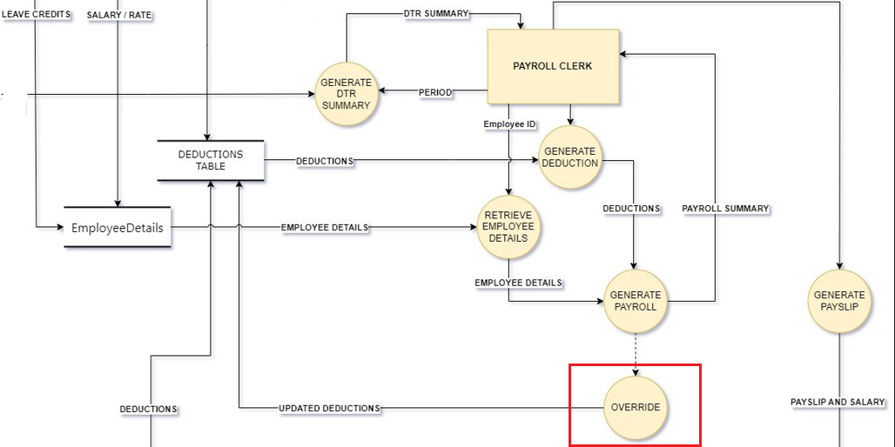

1. **Development**

In this phase, the developers will integrate the Singleton pattern, Tailwind CSS, Express.js, and MySQL to create the payroll clerk's override feature.

This phase will begin by gathering accurate data required for payroll calculations. Once collected, the payroll clerk will use this data to generate the payroll.

Subsequently, the override feature will allow the clerk to make any necessary adjustments to the generated payroll. Upon overriding, the modified data will be updated in the deductions section to reflect any changes, such as abrupt deductions.

Finally, the system will loop back to the beginning of the cycle, ensuring that the previously generated payroll is updated with the latest adjustments. This feature is essential for addressing any discrepancies or last-minute changes in the payroll process, ensuring accuracy and flexibility in payroll management.

1. **Testing**

In out testing phase, we will utilize white box testing, with developers conducting the initial testing to enhance the codebase if needed. Here are three main testing methods that will ensure developers create accurate goals for the current iteration.

Unit Testing, this testing involves testing individual components or units of code in isolation to ensure they function correctly. For example, developers may test a function responsible for calculating employee deductions by providing specific input values and verifying the accuracy of the calculated deductions.

Additionally, they may test validation functions to ensure they correctly identify and handle errors in employee input data.

Integration Testing, this testing focuses on verifying the interaction between different components or modules of the system. For instance, developers may test the interaction between the payroll calculation module and the database to ensure that payroll data is retrieved accurately and processed correctly. They may also test the integration between the payroll clerk's override feature and the deductions module to confirm that changes made to deductions are properly reflected in the system.

User Interface Testing, this testing evaluates the graphical user interface (GUI) of the application to ensure it is user-friendly, intuitive, and responsive. Developers interact with each UI component, such as buttons, input fields, and dropdown menus, to verify their functionality and responsiveness. Additionally, they test error handling in the UI by intentionally entering invalid data and verifying that appropriate error messages are displayed to guide users on how to correct their input.

1. **Review**

In this phase, the proponent’s thesis adviser will assume the role of the client as they currently do not have actual clients. The adviser will be instrumental in evaluating the system, focusing on aspects such as interface interaction and the accuracy of error messages. Specifically, the adviser will test the system to ensure it is user-friendly, intuitive, and responsive. They will also verify the effectiveness of error messages in guiding users to resolve any issues encountered during system interaction.

Once the adviser has reviewed the system and provided feedback, the development team will proceed to comprehensive testing. This testing phase will involve testing all developed modules, from the first iteration to the last, to ensure seamless integration and functionality.

The team will verify that each module operates accurately and effectively in alignment with the system's objectives. By conducting thorough testing across all modules, the developers aim to guarantee that the system functions cohesively and meets the specified requirements. Any issues or discrepancies identified during testing will be addressed promptly to ensure the system's overall integrity and performance.

**Deployment**

Once all iterations are finalized, the deployment phase of the system commences. Guided by their adviser, the development team opts to harness cloud infrastructure for this purpose. This strategic decision ensures seamless accessibility for users, a marked improvement over physical storage methods which may falter during disasters.

With the adoption of cloud storage, the system remains perpetually accessible, transcending geographical boundaries and time zones to offer uninterrupted service. Moreover, leveraging cloud platforms affords scalability, empowering the system to effortlessly accommodate surges in workload or user demand without necessitating extensive infrastructure modifications. The flexibility inherent in cloud resource allocation enables businesses to tailor their usage according to evolving needs, thereby optimizing costs. Operating on a pay-as-you-go model, cloud services often prove more cost-effective than maintaining on-premises infrastructure.

Beyond accessibility and scalability, cloud-based systems offer unparalleled reliability and uptime. Equipped with built-in redundancy and failover mechanisms, cloud providers assure continuous service availability. Prioritizing security, these providers invest substantially in robust measures to safeguard data and systems, boasting advanced security features and compliance certifications.

The deployment process unfolds with meticulous preparation of servers, ensuring their readiness for operation. Subsequently, the team focuses on configuring the database to adequately support the system's requirements. Although potential security concerns may arise with cloud deployment, they are deemed negligible in comparison to the absence of a viable physical storage alternative. Hence, the development team remains steadfast in their choice to leverage cloud infrastructure, accentuating its manifold benefits and facilitating a seamless deployment journey.

**Maintenance**

Once the developer’s payroll web-based system is deployed on the cloud, the development team recognizes the importance of ongoing maintenance to ensure its continued effectiveness. This maintenance strategy revolves around providing continuous support and optimizing the software's performance and longevity.

In the realm of cloud services, where subscription-based models prevail, the developer’s approach to maintenance begins with a keen eye on the cloud infrastructure specifications and subscription plans. Developers meticulously monitor resource utilization, keeping a close watch on metrics like CPU usage, memory allocation, storage consumption, and network bandwidth. By doing so, developers aim to strike the delicate balance between scalability and cost-effectiveness, ensuring that the developer’s subscription plan aligns seamlessly with the evolving needs of both the software and its users.

Regular updates and patches are pivotal in maintaining the security and functionality of the system. Thus, the developers prioritize the timely application of updates, patches, and security fixes provided by the developer’s cloud service provider. Before implementing any updates, the developers conduct rigorous compatibility tests in a staging environment to safeguard against potential disruptions. This proactive approach not only enhances the software's performance but also ensures compliance with regulatory standards and industry best practices.

Security remains a paramount concern in the maintenance strategy. To fortify the proponent’s system against potential threats, the proponents will employ advanced monitoring tools to continuously scan for security vulnerabilities and potential breaches. In the event of an incident, they have a well-defined incident response plan in place, enabling us to swiftly identify and mitigate security breaches.

Service disruptions or performance issues can significantly impact user experience. Thus, the proponents remain vigilant, utilizing real-time monitoring tools to detect and address any anomalies promptly. Root cause analysis is conducted meticulously to prevent recurrence, and remediation measures are implemented swiftly to minimize user impact.

The proponent’s commitment to user satisfaction extends beyond mere technical upkeep. They will maintain robust user support channels, offering timely assistance and guidance to users encountering queries or issues. Moreover, proponents will actively seek user feedback to drive continuous improvement initiatives, ensuring that the system evolves in tandem with user needs and expectations.

Comprehensive documentation serves as a cornerstone of our maintenance efforts, providing users and support staff with valuable insights into system functionalities and troubleshooting procedures. By fostering a culture of proactive maintenance within the development team, they will strive to uphold the reliability, security, and efficiency of their payroll web-based system, thereby maximizing the benefits of cloud-based deployment.

**Gantt Chart of Activities**

|  |  |  |  |  |  |  |  |  |  |  |  |  |  |  |  |  |  |  |  |  |  |  |  |  |  |  |  |  |  |  |  |  |  |
| --- | --- | --- | --- | --- | --- | --- | --- | --- | --- | --- | --- | --- | --- | --- | --- | --- | --- | --- | --- | --- | --- | --- | --- | --- | --- | --- | --- | --- | --- | --- | --- | --- | --- |
| MONTH | FEBRUARY | | | MARCH | | | | | APRIL | | | | | MAY | | | | | | JUNE | | | JULY | | | | | AUGUST | | | | | |
| ACTIVITY | 1W | 2W | 3W | | 4W | 1W | 2W | 3W | | 4W | 1W | 2W | 3W | | 4W | 1W | 2W | 3W | 4W | |  |  | |  |  |  |  | |  |  |  |  |  | |
| Capstone title brainstorming |  |  |  | |  |  |  |  | |  |  |  |  | |  |  |  |  |  | |  |  | |  |  |  |  | |  |  |  |  |  | |
| Capstone title approval |  |  |  | |  |  |  |  | |  |  |  |  | |  |  |  |  |  | |  |  | |  |  |  |  | |  |  |  |  |  | |
| Data gathering consultation system |  |  |  | |  |  |  |  | |  |  |  |  | |  |  |  |  |  | |  |  | |  |  |  |  | |  |  |  |  |  | |
| DFD making (with revision) |  |  |  | |  |  |  |  | |  |  |  |  | |  |  |  |  |  | |  |  | |  |  |  |  | |  |  |  |  |  | |
| Project context |  |  |  | |  |  |  |  | |  |  |  |  | |  |  |  |  |  | |  |  | |  |  |  |  | |  |  |  |  |  | |
| Purpose and Description |  |  |  | |  |  |  |  | |  |  |  |  | |  |  |  |  |  | |  |  | |  |  |  |  | |  |  |  |  |  | |
| Objectives of the study |  |  |  | |  |  |  |  | |  |  |  |  | |  |  |  |  |  | |  |  | |  |  |  |  | |  |  |  |  |  | |
| Scope and Limitations |  |  |  | |  |  |  |  | |  |  |  |  | |  |  |  |  |  | |  |  | |  |  |  |  | |  |  |  |  |  | |
| RRS |  |  |  | |  |  |  |  | |  |  |  |  | |  |  |  |  |  | |  |  | |  |  |  |  | |  |  |  |  |  | |
| Technical Background |  |  |  | |  |  |  |  | |  |  |  |  | |  |  |  |  |  | |  |  | |  |  |  |  | |  |  |  |  |  | |
| Requirements Gathering and Analysis (with revisions) |  |  |  | |  |  |  |  | |  |  |  |  | |  |  |  |  |  | |  |  | |  |  |  |  | |  |  |  |  |  | |

|  |  |  |  |  |  |  |  |  |  |  |  |  |  |  |  |  |  |  |  |  |  |  |  |  |  |  |  |  |  |  |
| --- | --- | --- | --- | --- | --- | --- | --- | --- | --- | --- | --- | --- | --- | --- | --- | --- | --- | --- | --- | --- | --- | --- | --- | --- | --- | --- | --- | --- | --- | --- |
| MONTH | FEBRUARY | | | | MARCH | | | | APRIL | | | | MAY | | | | JUNE | | | | JULY | | | | | | AUGUST | | | |
| ACTIVITY | 1W | 2W | 3W | 4W | 1W | 2W | 3W | 4W | 1W | 2W | 3W | 4W | 1W | 2W | 3W | 4W |  |  |  |  | |  |  |  |  |  | |  |  |  |
| Iteration 1 |  |  |  |  |  |  |  |  |  |  |  |  |  |  |  |  |  |  |  |  | |  |  |  |  |  | |  |  |  |
| Iteration 2 |  |  |  |  |  |  |  |  |  |  |  |  |  |  |  |  |  |  |  |  | |  |  |  |  |  | |  |  |  |
| Iteration 3 |  |  |  |  |  |  |  |  |  |  |  |  |  |  |  |  |  |  |  |  | |  |  |  |  |  | |  |  |  |
| Iteration 4 |  |  |  |  |  |  |  |  |  |  |  |  |  |  |  |  |  |  |  |  | |  |  |  |  |  | |  |  |  |
| Iteration 5 |  |  |  |  |  |  |  |  |  |  |  |  |  |  |  |  |  |  |  |  | |  |  |  |  |  | |  |  |  |
| Testing |  |  |  |  |  |  |  |  |  |  |  |  |  |  |  |  |  |  |  |  | |  |  |  |  |  | |  |  |  |
|  |  |  |  |  |  |  |  |  |  |  |  |  |  |  |  |  |  |  |  |  | |  |  |  |  |  | |  |  |  |
|  |  |  |  |  |  |  |  |  |  |  |  |  |  |  |  |  |  |  |  |  | |  |  |  |  |  | |  |  |  |
|  |  |  |  |  |  |  |  |  |  |  |  |  |  |  |  |  |  |  |  |  | |  |  |  |  |  | |  |  |  |
|  |  |  |  |  |  |  |  |  |  |  |  |  |  |  |  |  |  |  |  |  | |  |  |  |  |  | |  |  |  |
|  |  |  |  |  |  |  |  |  |  |  |  |  |  |  |  |  |  |  |  |  | |  |  |  |  |  | |  |  |  |
|  |  |  |  |  |  |  |  |  |  |  |  |  |  |  |  |  |  |  |  |  | |  |  |  |  |  | |  |  |  |
|  |  |  |  |  |  |  |  |  |  |  |  |  |  |  |  |  |  |  |  |  | |  |  |  |  |  | |  |  |  |

# References

Mukiri, M. N. (2013). Customized Database and Systems Tuning Methodology: A Case of Payroll Processing Optimization.

Rusly, F. H. (2018). Payroll System: “A bibliometric analysis of the literature”.

David, N. (2021). Challenges of Traditional HR and Payroll Management in Post-COVID Era.

Jakkamsetti, S. P, & Reddy, P. S. (2020). Online Payroll Software Management System.

Babirye, S., Owin, O. L. O., & Muwanga, K. E. (2023). Local Government Payroll Management System Model: A Case of Mayuge District.

Teja, P. R., & Patra, R. (2023). A Study n PayRoll- Management System.

# Appendices

1. Data Flow Diagram of WageGauge: Payroll Solutions Through Subscription-based Models

**Overview**

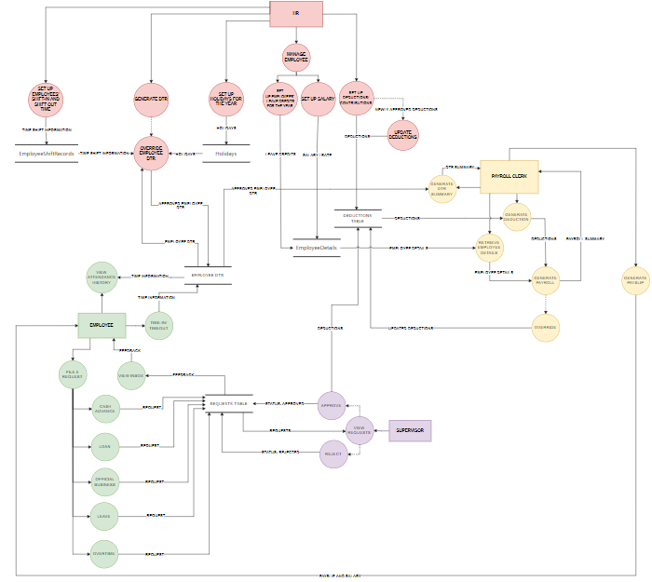

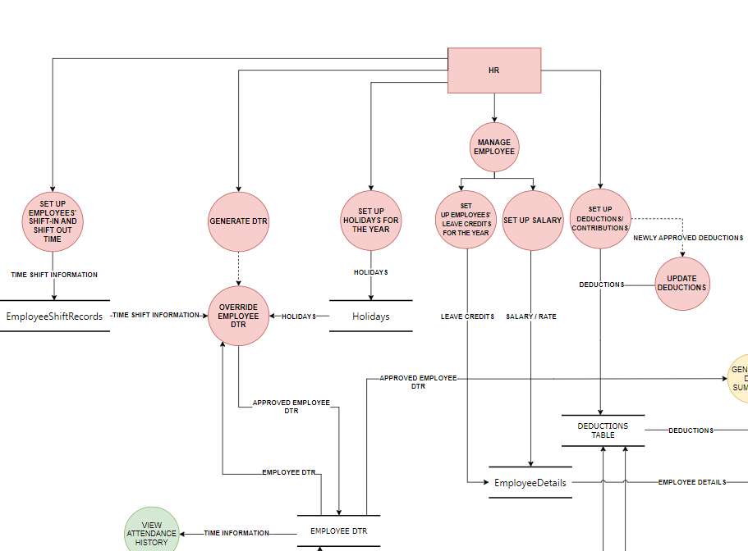**HR**

**Supervisor**

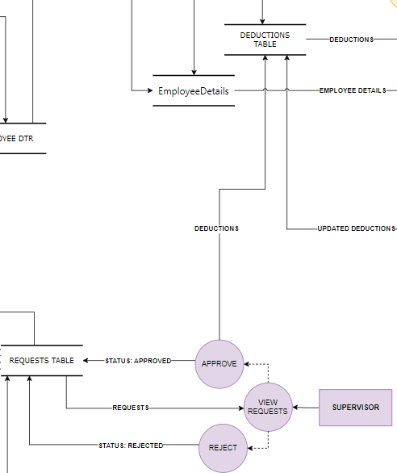

**Employee**

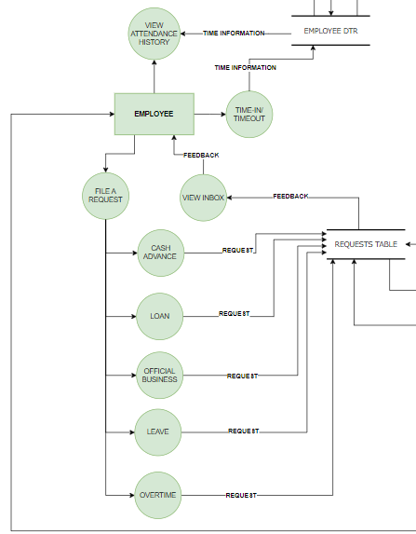

**Payroll Clerk**

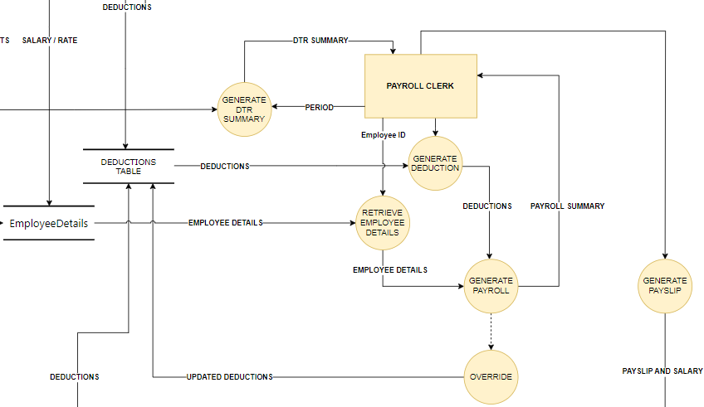

**APPENDIX A. RESOURCE PERSONS**

**Engr. Elvi Lito Ubas, CPE, MEEd**

Capstone Project Coordinator

**Mr. Clyde Anthony L. Migue**

Capstone Project Adviser

APPENDIX B. PERSONAL TECHNICAL VITAE

Curriculum Vitae of



Jonhyl E. Balsamo

Suraya Homes, Cabantian, Davao City

Balsjj04@gmail.com

0975 892 9290

EDUCATIONAL BACKGROUND

|  |  |  |
| --- | --- | --- |
| Level | Inclusive Dates | Name of school/ Institution |
| Tertiary | June 2021 - Current | STI College Davao |
| Senior High School | June 2019 – March 2021 | Cabantian National High School |
| High School | June 2015 – April 2019 | Ananda Marga Special Academic Institution |
| Elementary | June 2009 – March 2015 | Kapitan Tomas Monteverde Sr. Central Elementary School |

PROFESSIONAL OR VOLUNTEER EXPERIENCE

|  |  |  |
| --- | --- | --- |
| Inclusive Dates | Nature of Experience/  Job Title | Name and Address of Company or Organization |
| N/A | N/A | N/A |

AFFILIATIONS

|  |  |  |
| --- | --- | --- |
| Inclusive Dates | Name of Organization | Position |
| N/A | N/A | N/A |

SKILLS

|  |  |  |
| --- | --- | --- |
| SKILLS | Level of Competency | Date Acquired |
| Web Development | Beginner | February 2024 |
| Programming | Intermediate | June 2022 |

TRAININGS, SEMINARS, OR WORKSHOPS ATTENDED

|  |  |
| --- | --- |
| Inclusive Dates | Title of Training, Seminar, or Workshop |
| N/A | N/A |



Curriculum Vitae of

Charles Angelo B. Cuizon

Sta. Cruz Indangan, Buhangin, Davao City

charlescuizon2003@gmail.com

0948 754 6224

EDUCATIONAL BACKGROUND

|  |  |  |
| --- | --- | --- |
| Level | Inclusive Dates | Name of school/ Institution |
| Tertiary | June 2021 - Current | STI College Davao |
| Senior High School | June 2019 – April 2021 | STI College Davao |
| High School | June 2015 – April 2019 | Teofilo V. Fernandez National High School |
| Elementary | June 2009 – March 2015 | Teofilo V. Fernandez Elementary School |

PROFESSIONAL OR VOLUNTEER EXPERIENCE

|  |  |  |
| --- | --- | --- |
| Inclusive Dates | Nature of Experience/  Job Title | Name and Address of Company or Organization |
| N/A | N/A | N/A |

AFFILIATIONS

|  |  |  |
| --- | --- | --- |
| Inclusive Dates | Name of Organization | Position |
| N/A | N/A | N/A |

SKILLS

|  |  |  |
| --- | --- | --- |
| SKILLS | Level of Competency | Date Acquired |
| Web Development | Beginner | February 2024 |
| Programming | Intermediate | June 2022 |

TRAININGS, SEMINARS, OR WORKSHOPS ATTENDED

|  |  |
| --- | --- |
| Inclusive Dates | Title of Training, Seminar, or Workshop |
| N/A | N/A |

Curriculum Vitae of



Chellsey Anndria C. Argente

Elenita Heights Subdivision, Catalunan Grande, Davao City

Chellyssargente2002@gmail.com

0921 734 6962

EDUCATIONAL BACKGROUND

|  |  |  |
| --- | --- | --- |
| Level | Inclusive Dates | Name of school/ Institution |
| Tertiary | June 2021 - Current | STI College Davao |
| Senior High School | June 2019 – April 2021 | STI College Davao |
| High School | June 2015 – April 2019 | Pablo Lorenzo National High School |
| Elementary | June 2009 – March 2015 | Paaralang Kaunlaran Ng Nayong DDF |

PROFESSIONAL OR VOLUNTEER EXPERIENCE

|  |  |  |
| --- | --- | --- |
| Inclusive Dates | Nature of Experience/  Job Title | Name and Address of Company or Organization |
| N/A | N/A | N/A |

AFFILIATIONS

|  |  |  |
| --- | --- | --- |
| Inclusive Dates | Name of Organization | Position |
| N/A | N/A | N/A |

SKILLS

|  |  |  |
| --- | --- | --- |
| SKILLS | Level of Competency | Date Acquired |
| Web Development | Beginner | February 2024 |
| Programming | Intermediate | June 2022 |

TRAININGS, SEMINARS, OR WORKSHOPS ATTENDED

|  |  |
| --- | --- |
| Inclusive Dates | Title of Training, Seminar, or Workshop |
| N/A | N/A |

Curriculum Vitae of



John Harvey P. Sarno

Purok 3 Eliong Tibungco, Davao City

Johnsarno250@gmail.com

0930 809 4897

EDUCATIONAL BACKGROUND

|  |  |  |
| --- | --- | --- |
| Level | Inclusive Dates | Name of school/ Institution |
| Tertiary | September 2020 - Current | STI College Davao |
| Senior High School | June 2018 – March 2020 | STI College Davao |
| High School | June 2014 – March 2018 | Holy Cross of Bunawan |
| Elementary | June 2009 – March 2014 | Cavanis Elementary School |

PROFESSIONAL OR VOLUNTEER EXPERIENCE

|  |  |  |
| --- | --- | --- |
| Inclusive Dates | Nature of Experience/  Job Title | Name and Address of Company or Organization |
| N/A | N/A | N/A |

AFFILIATIONS

|  |  |  |
| --- | --- | --- |
| Inclusive Dates | Name of Organization | Position |
| N/A | N/A | N/A |

SKILLS

|  |  |  |
| --- | --- | --- |
| SKILLS | Level of Competency | Date Acquired |
| Web Development | Beginner | February 2024 |
| Programming | Beginner | June 2022 |

TRAININGS, SEMINARS, OR WORKSHOPS ATTENDED

|  |  |
| --- | --- |
| Inclusive Dates | Title of Training, Seminar, or Workshop |
| N/A | N/A |

Curriculum Vitae of



Christopher John A. Abanes

Indangan, Buhangin District, Davao City

christopherjohnabanes@gmail.com

0953 491 0425

EDUCATIONAL BACKGROUND

|  |  |  |
| --- | --- | --- |
| Level | Inclusive Dates | Name of school/ Institution |
| Tertiary | September 2021 - Current | STI College Davao |
| Senior High School | June 2019 – July 2021 | Davao City National High School |
| High School | June 2015 – April 2019 | Davao City National High School |
| Elementary | June 2009 – March 2014 | Teofilo V. Fernandez Elementary School |

PROFESSIONAL OR VOLUNTEER EXPERIENCE

|  |  |  |
| --- | --- | --- |
| Inclusive Dates | Nature of Experience/  Job Title | Name and Address of Company or Organization |
| N/A | N/A | N/A |

AFFILIATIONS

|  |  |  |
| --- | --- | --- |
| Inclusive Dates | Name of Organization | Position |
| N/A | N/A | N/A |

SKILLS

|  |  |  |
| --- | --- | --- |
| SKILLS | Level of Competency | Date Acquired |
| Web Development | Beginner | February 2024 |
| Programming | Beginner | June 2022 |

TRAININGS, SEMINARS, OR WORKSHOPS ATTENDED

|  |  |
| --- | --- |
| Inclusive Dates | Title of Training, Seminar, or Workshop |
| N/A | N/A |