Movie Ticket Booking
System

Submitted by Baltabay

Introduction

The "Online Movie Ticket Booking System" has been developed to override the problems prevailing in the practicing manual system. This software is supported to eliminate and in some cases reduce the hardships faced by this existing system. Moreover this system is designed for the particular need of the company to carry out operations in a smooth and effective manner.
Every organization, whether big or small, has challenges to overcome and managing the information of Tickets, Movie, Show Timing, Audi, Customer. Every Online Movie Ticket Booking System has different Movie needs, therefore we design exclusive employee management systems that are adapted to your managerial requirements. This is designed to assist in strategic planning, and will help you ensure that your organization is equipped with the right level of information and details for your future goals. Also, for those busy executive who are always on the go, our systems come with remote access features, which will allow you to manage your workforce anytime, at all times. These systems will ultimately allow you to better manage resources.

Motivation and Objectives

The main idea of this project is to facilitate purchases or booking tickets for movies and I wanted to try to do it on the knowledge of Java GUI. To implement the application, I needed several Java libraries and working with the JDBC driver. I used MySQL to save data of users, admins, movies, tickets. Also I used new java library – JFoenix 8.

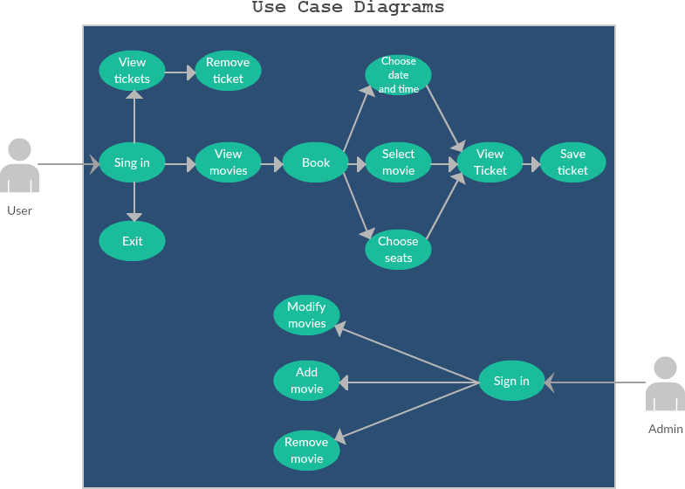
Use Case Diagrams

Implementation
1.Login page
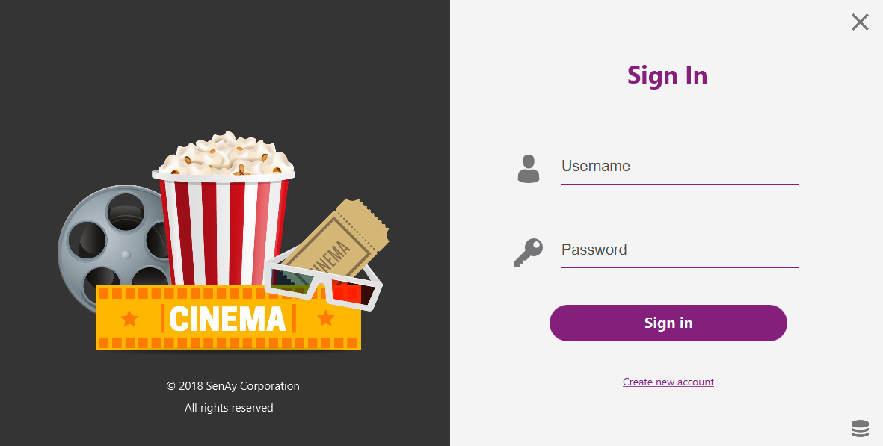
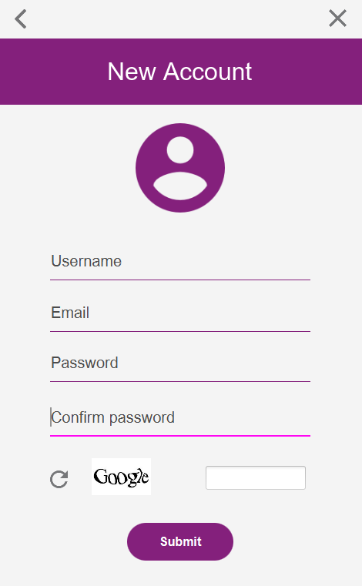

2. Create new account

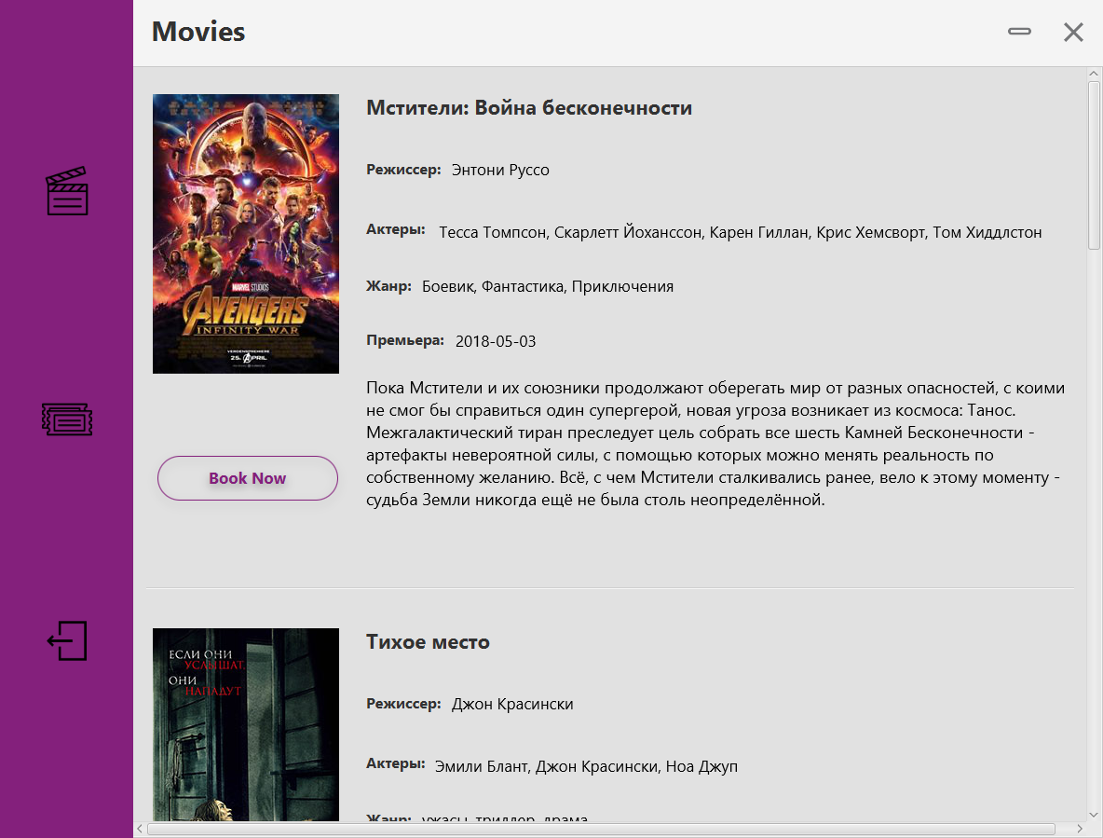
3. View movies

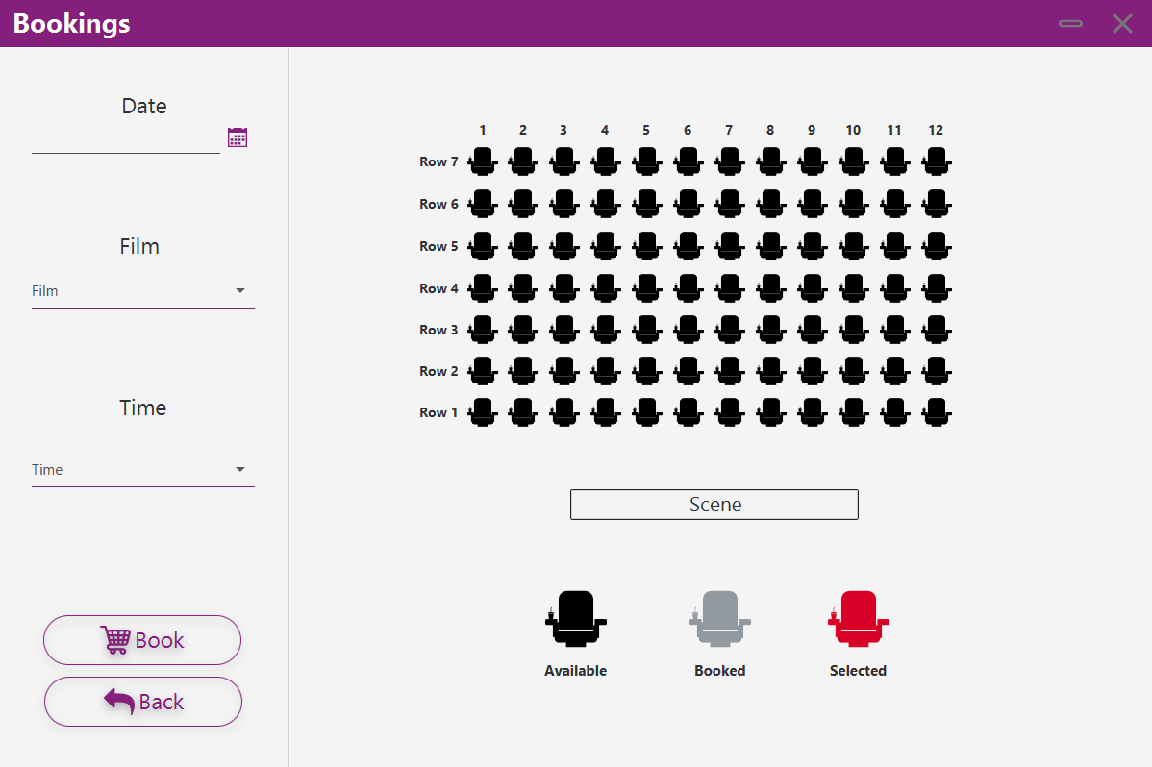
4. Booking ticket(Choose date and time, select movie)

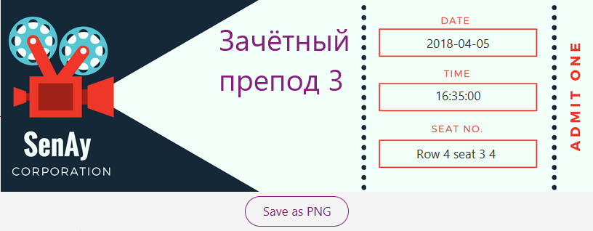
5. And finally you can view ticket and save as PNG

Conclusion

Created by Baltabay

Used libraries

Java System Library
JavaFX SDK
Jfoenix 8
MySQL connector

Link to GitHub

https://github.com/Baltabay/Ticket-Booking

Thank you all who helped me!

