[1]

Preparation of Papers for IEEE TRANSACTIONS and JOURNALS(February 2017)

First A. Author, *Fellow, IEEE*, Second B. Author, and Third C. Author, Jr., Member, IEEE

*Abstract*—These instructions give you guidelines for preparing papers for IEEE Transactions and Journals*.* Use this document as a template if you are using Microsoft *Word* 6.0 or later. Otherwise, use this document as an instruction set. The electronic file of your paper will be formatted further at IEEE. Paper titles should be written in uppercase and lowercase letters, not all uppercase. Avoid writing long formulas with subscripts in the title; short formulas that identify the elements are fine (e.g., "Nd–Fe–B"). Do not write “(Invited)” in the title. Full names of authors are preferred in the author field, but are not required. Put a space between authors’ initials. The abstract must be a concise yet comprehensive reflection of what is in your article. In particular, the abstract must be self-contained, without abbreviations, footnotes, or references. It should be a microcosm of the full article. The abstract must be between 150–250 words. Be sure that you adhere to these limits; otherwise, you will need to edit your abstract accordingly. The abstract must be written as one paragraph, and should not contain displayed mathematical equations or tabular material. The abstract should include three or four different keywords or phrases, as this will help readers to find it. It is important to avoid over-repetition of such phrases as this can result in a page being rejected by search engines. Ensure that your abstract reads well and is grammatically correct.

*Index Terms*—Enter key words or phrases in alphabetical order, separated by commas. For a list of suggested keywords, send a blank e-mail to [keywords@ieee.org](mailto:keywords@ieee.org) or visit <http://www.ieee.org/organizations/pubs/ani_prod/keywrd98.txt>

# INTRODUCTION

T

HIS document is a template for Microsoft *Word* versions 6.0 or later. If you are reading a paper or PDF version of this document, please download the electronic file,  
trans_jour.docx, from the IEEE Web site at [www.ieee.org/authortools](http://www.ieee.org/authortools) so you can use it to prepare your manuscript. If you would prefer to use LaTeX, download IEEE’s LaTeX style and sample files from the same Web page. You can also explore using the Overleaf editor at [https://www.overleaf.com/blog/278-how-to-use-overleaf-with-ieee-collabratec-your-quick-guide-to-getting-started#.Vp6tpPkrKM9](https://www.overleaf.com/blog/278-how-to-use-overleaf-with-ieee-collabratec-your-quick-guide-to-getting-started%23.Vp6tpPkrKM9)

If your paper is intended for a conference*,* please contact your conference editor concerning acceptable word processor formats for your particular conference.

# Guidelines For Manuscript Preparation

When you open trans_jour.docx, select “Page Layout” from the “View” menu in the menu bar (View | Page Layout), (these instructions assume MS 6.0. Some versions may have alternate ways to access the same functionalities noted here). Then, type over sections of trans_jour.docx or cut and paste from another document and use markup styles. The pull-down style menu is at the left of the Formatting Toolbar at the top of your *Word* window (for example, the style at this point in the document is “Text”). Highlight a section that you want to designate with a certain style, and then select the appropriate name on the style menu. The style will adjust your fonts and line spacing. Do not change the font sizes or line spacing to squeeze more text into a limited number of pages.Use italics for emphasis; do not underline.

To insert images in *Word,* position the cursor at the insertion point and either use Insert | Picture | From File or copy the image to the Windows clipboard and then Edit | Paste Special | Picture (with “float over text” unchecked).

IEEE will do the final formatting of your paper. If your paper is intended for a conference, please observe the conference page limits.

## Abbreviations and Acronyms

Define abbreviations and acronyms the first time they are used in the text, even after they have already been defined in the abstract. Abbreviations such as IEEE, SI, ac, and dc do not have to be defined. Abbreviations that incorporate periods should not have spaces: write “C.N.R.S.,” not “C. N. R. S.” Do not use abbreviations in the title unless they are unavoidable (for example, “IEEE” in the title of this article).

## Other Recommendations

Use one space after periods and colons. Hyphenate complex modifiers: “zero-field-cooled magnetization.” Avoid dangling participles, such as, “Using (1), the potential was calculated.” [It is not clear who or what used (1).] Write instead, “The potential was calculated by using (1),” or “Using (1), we calculated the potential.”

Use a zero before decimal points: “0.25,” not “.25.” Use “cm3,” not “cc.” Indicate sample dimensions as “0.1 cm × 0.2 cm,” not “0.1 × 0.2 cm2.” The abbreviation for “seconds” is “s,” not “sec.” Use “Wb/m2” or “webers per square meter,” not “webers/m2.” When expressing a range of values, write “7 to 9” or “7-9,” not “7~9.”

A parenthetical statement at the end of a sentence is punctuated outside of the closing parenthesis (like this). (A parenthetical sentence is punctuated within the parentheses.) In American English, periods and commas are within quotation marks, like “this period.” Other punctuation is “outside”! Avoid contractions; for example, write “do not” instead of “don’t.” The serial comma is preferred: “A, B, and C” instead of “A, B and C.”

If you wish, you may write in the first person singular or plural and use the active voice (“I observed that ...” or “We observed that ...” instead of “It was observed that ...”). Remember to check spelling. If your native language is not English, please get a native English-speaking colleague to carefully proofread your paper.

# MATH

If you are using *Word,* use either the Microsoft Equation Editor or the *MathType* add-on (http://www.mathtype.com) for equations in your paper (Insert | Object | Create New | Microsoft Equation *or* MathType Equation). “Float over text” should *not* be selected.

## Equations

Number equations consecutively with equation numbers in parentheses flush with the right margin, as in (1). First use the equation editor to create the equation. Then select the “Equation” markup style. Press the tab key and write the equation number in parentheses. To make your equations more compact, you may use the solidus ( / ), the exp function, or appropriate exponents. Use parentheses to avoid ambiguities in denominators. Punctuate equations when they are part of a sentence, as in

(1)

Be sure that the symbols in your equation have been defined before the equation appears or immediately following. Italicize symbols (*T* might refer to temperature, but T is the unit tesla). Refer to “(1),” not “Eq. (1)” or “equation (1),” except at the beginning of a sentence: “Equation (1) is ... .”

# Units

Use either SI (MKS) or CGS as primary units. (SI units are strongly encouraged.) English units may be used as secondary units (in parentheses). This applies to papers in data storage**.** For example, write “15 Gb/cm2 (100 Gb/in2).” An exception is when English units are used as identifiers in trade, such as “3½-in disk drive.” Avoid combining SI and CGS units, such as current in amperes and magnetic field in oersteds. This often leads to confusion because equations do not balance dimensionally. If you must use mixed units, clearly state the units for each quantity in an equation.

The SI unit for magnetic field strength *H* is A/m. However, if you wish to use units of T, either refer to magnetic flux density *B* or magnetic field strength symbolized as µ0*H*. Use the center dot to separate compound units, e.g., “A·m2.”

# Some Common Mistakes

The word “data” is plural, not singular. The subscript for the permeability of vacuum µ0 is zero, not a lowercase letter “o.” The term for residual magnetization is “remanence”; the adjective is “remanent”; do not write “remnance” or “remnant.” Use the word “micrometer” instead of “micron.” A graph within a graph is an “inset,” not an “insert.” The word “alternatively” is preferred to the word “alternately” (unless you really mean something that alternates). Use the word “whereas” instead of “while” (unless you are referring to simultaneous events). Do not use the word “essentially” to mean “approximately” or “effectively.” Do not use the word “issue” as a euphemism for “problem.” When compositions are not specified, separate chemical symbols by en-dashes; for example, “NiMn” indicates the intermetallic compound Ni0.5Mn0.5 whereas “Ni–Mn” indicates an alloy of some composition NixMn1-x.

Be aware of the different meanings of the homophones “affect” (usually a verb) and “effect” (usually a noun), “complement” and “compliment,” “discreet” and “discrete,” “principal” (e.g., “principal investigator”) and “principle” (e.g., “principle of measurement”). Do not confuse “imply” and “infer.”

Prefixes such as “non,” “sub,” “micro,” “multi,” and “ultra” are not independent words; they should be joined to the words they modify, usually without a hyphen. There is no period after the “et” in the Latin abbreviation “*et al.*” (it is also italicized). The abbreviation “i.e.,” means “that is,” and the abbreviation “e.g.,” means “for example” (these abbreviations are not italicized).

A general IEEE styleguide is available at [www.ieee.org/authortools](http://www.ieee.org/authortools).

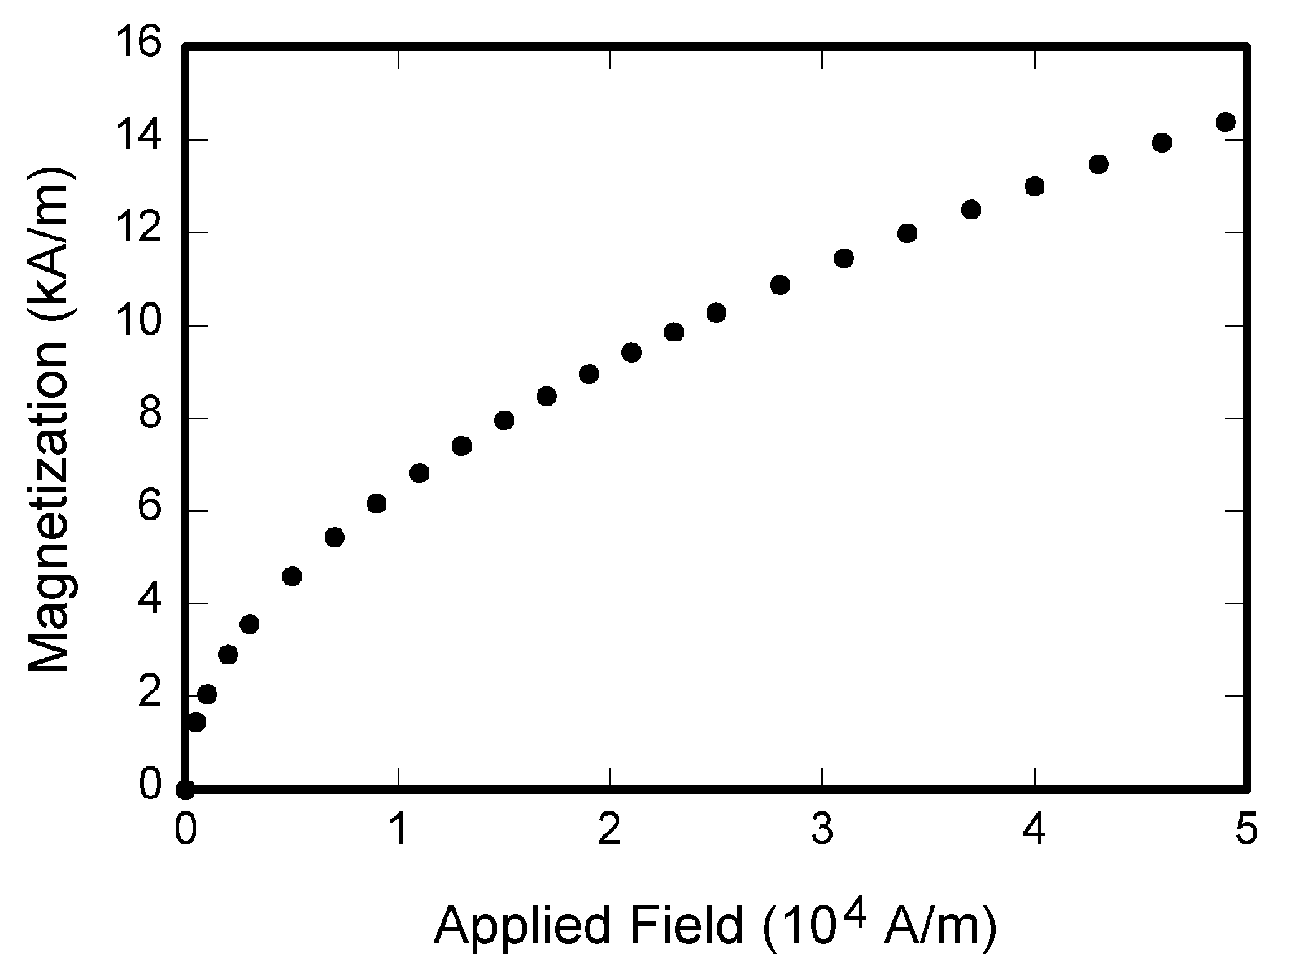

Fig. 1. Magnetization as a function of applied field. Note that “Fig.” is abbreviated. There is a period after the figure number, followed by two spaces. It is good practice to explain the significance of the figure in the caption.

TABLE I

Units for Magnetic Properties

|  |  |  |
| --- | --- | --- |
| Symbol | Quantity | Conversion from Gaussian and  CGS EMU to SI a |
| Φ | magnetic flux | 1 Mx → 10−8 Wb = 10−8 V·s |
| *B* | magnetic flux density,  magnetic induction | 1 G → 10−4 T = 10−4 Wb/m2 |
| *H* | magnetic field strength | 1 Oe → 103/(4π) A/m |
| *m* | magnetic moment | 1 erg/G = 1 emu  → 10−3 A·m2 = 10−3 J/T |
| *M* | magnetization | 1 erg/(G·cm3) = 1 emu/cm3  → 103 A/m |
| 4π*M* | magnetization | 1 G → 103/(4π) A/m |
| σ | specific magnetization | 1 erg/(G·g) = 1 emu/g → 1 A·m2/kg |
| *j* | magnetic dipole  moment | 1 erg/G = 1 emu  → 4π × 10−10 Wb·m |
| *J* | magnetic polarization | 1 erg/(G·cm3) = 1 emu/cm3  → 4π × 10−4 T |
| χ*,* κ | susceptibility | 1 → 4π |
| χρ | mass susceptibility | 1 cm3/g → 4π × 10−3 m3/kg |
| μ | permeability | 1 → 4π × 10−7 H/m  = 4π × 10−7 Wb/(A·m) |
| μr | relative permeability | μ → μr |
| *w, W* | energy density | 1 erg/cm3 → 10−1 J/m3 |
| *N, D* | demagnetizing factor | 1 → 1/(4π) |

Vertical lines are optional in tables. Statements that serve as captions for the entire table do not need footnote letters.

aGaussian units are the same as cg emu for magnetostatics; Mx = maxwell, G = gauss, Oe = oersted; Wb = weber, V = volt, s = second, T = tesla, m = meter, A = ampere, J = joule, kg = kilogram, H = henry.

# Guidelines for Graphics Preparation and Submission

## Types of Graphics

The following list outlines the different types of graphics published in IEEE journals. They are categorized based on their construction, and use of color / shades of gray:

### *Color/Grayscale figures*

### Figures that are meant to appear in color, or shades of black/gray. Such figures may include photographs, illustrations, multicolor graphs, and flowcharts.

### *Line Art figures*

### Figures that are composed of only black lines and shapes. These figures should have no shades or half-tones of gray, only black and white.

### *Author photos*

### Head and shoulders shots of authors that appear at the end of our papers.

### *Tables* Data charts which are typically black and white, but sometimes include color.

## Multipart figures

Figures compiled of more than one sub-figure presented side-by-side, or stacked. If a multipart figure is made up of multiple figure types (one part is lineart, and another is grayscale or color) the figure should meet the stricter guidelines.

## File Formats For Graphics

Format and save your graphics using a suitable graphics processing program that will allow you to create the images as PostScript (PS), Encapsulated PostScript (.EPS), Tagged Image File Format (.TIFF), Portable Document Format (.PDF), or Portable Network Graphics (.PNG) sizes them, and adjusts the resolution settings. If you created your source files in one of the following programs you will be able to submit the graphics without converting to a PS, EPS, TIFF, PDF, or PNG file: Microsoft Word, Microsoft PowerPoint, or Microsoft Excel. Though it is not required, it is strongly recommended that these files be saved in PDF format rather than DOC, XLS, or PPT. Doing so will protect your figures from common font and arrow stroke issues that occur when working on the files across multiple platforms. When submitting your final paper, your graphics should all be submitted individually in one of these formats along with the manuscript.

## Sizing of Graphics

Most charts, graphs, and tables are one column wide (3.5 inches / 88 millimeters / 21 picas) or page wide (7.16 inches / 181 millimeters / 43 picas). The maximum depth a graphic can be is 8.5 inches (216 millimeters / 54 picas). When choosing the depth of a graphic, please allow space for a caption. Figures can be sized between column and page widths if the author chooses, however it is recommended that figures are not sized less than column width unless when necessary.

There is currently one publication with column measurements that do not coincide with those listed above. Proceedings of the IEEE has a column measurement of 3.25 inches (82.5 millimeters / 19.5 picas).

The final printed size of author photographs is exactly   
1 inch wide by 1.25 inches tall (25.4 millimeters x 31.75 millimeters / 6 picas x 7.5 picas). Author photos printed in editorials measure 1.59 inches wide by 2 inches tall (40 millimeters x 50 millimeters / 9.5 picas x 12 picas).

## Resolution

The proper resolution of your figures will depend on the type of figure it is as defined in the “Types of Figures” section. Author photographs, color, and grayscale figures should be at least 300dpi. Line art, including tables should be a minimum of 600dpi.

## Vector Art

In order to preserve the figures’ integrity across multiple computer platforms, we accept files in the following formats: .EPS/.PDF/.PS. All fonts must be embedded or text converted to outlines in order to achieve the best-quality results.

## Color Space

The term color space refers to the entire sum of colors that can be represented within the said medium. For our purposes, the three main color spaces are Grayscale, RGB (red/green/blue) and CMYK (cyan/magenta/yellow/black). RGB is generally used with on-screen graphics, whereas CMYK is used for printing purposes.

All color figures should be generated in RGB or CMYK color space. Grayscale images should be submitted in Grayscale color space. Line art may be provided in grayscale OR bitmap colorspace. Note that “bitmap colorspace” and “bitmap file format” are not the same thing. When bitmap color space is selected, .TIF/.TIFF/.PNG are the recommended file formats.

## Accepted Fonts Within Figures

When preparing your graphics IEEE suggests that you use of one of the following Open Type fonts: Times New Roman, Helvetica, Arial, Cambria, and Symbol. If you are supplying EPS, PS, or PDF files all fonts must be embedded. Some fonts may only be native to your operating system; without the fonts embedded, parts of the graphic may be distorted or missing.

A safe option when finalizing your figures is to strip out the fonts before you save the files, creating “outline” type. This converts fonts to artwork what will appear uniformly on any screen.

## Using Labels Within Figures

### Figure Axis labels

Figure axis labels are often a source of confusion. Use words rather than symbols. As an example, write the quantity “Magnetization,” or “Magnetization *M*,” not just “*M*.” Put units in parentheses. Do not label axes only with units. As in Fig. 1, for example, write “Magnetization (A/m)” or “Magnetization (Am−1),” not just “A/m.” Do not label axes with a ratio of quantities and units. For example, write “Temperature (K),” not “Temperature/K.”

Multipliers can be especially confusing. Write “Magnetization (kA/m)” or “Magnetization (103 A/m).” Do not write “Magnetization (A/m) × 1000” because the reader would not know whether the top axis label in Fig. 1 meant 16000 A/m or 0.016 A/m. Figure labels should be legible, approximately 8 to 10 point type.

### Subfigure Labels in Multipart Figures and Tables

Multipart figures should be combined and labeled before final submission. Labels should appear centered below each subfigure in 8 point Times New Roman font in the format of (a) (b) (c).

## File Naming

Figures (line artwork or photographs) should be named starting with the first 5 letters of the author’s last name. The next characters in the filename should be the number that represents the sequential location of this image in your article. For example, in author “Anderson’s” paper, the first three figures would be named ander1.tif, ander2.tif, and ander3.ps.

Tables should contain only the body of the table (not the caption) and should be named similarly to figures, except that ‘.t’ is inserted in-between the author’s name and the table number. For example, author Anderson’s first three tables would be named ander.t1.tif, ander.t2.ps, ander.t3.eps.

Author photographs should be named using the first five characters of the pictured author’s last name. For example, four author photographs for a paper may be named: oppen.ps, moshc.tif, chen.eps, and duran.pdf.

If two authors or more have the same last name, their first initial(s) can be substituted for the fifth, fourth, third... letters of their surname until the degree where there is differentiation. For example, two authors Michael and Monica Oppenheimer’s photos would be named oppmi.tif, and oppmo.eps.

## Referencing a Figure or Table Within Your Paper

When referencing your figures and tables within your paper, use the abbreviation “Fig.” even at the beginning of a sentence. Do not abbreviate “Table.” Tables should be numbered with Roman Numerals.

## Checking Your Figures: The IEEE Graphics Analyzer

The IEEE Graphics Analyzer enables authors to pre-screen their graphics for compliance with IEEE Transactions and Journals standards before submission. The online tool, located at <http://graphicsqc.ieee.org/>, allows authors to upload their graphics in order to check that each file is the correct file format, resolution, size and colorspace; that no fonts are missing or corrupt; that figures are not compiled in layers or have transparency, and that they are named according to the IEEE Transactions and Journals naming convention. At the end of this automated process, authors are provided with a detailed report on each graphic within the web applet, as well as by email.

For more information on using the Graphics Analyzer   
or any other graphics related topic, contact the IEEE Graphics Help Desk by e-mail at [graphics@ieee.org](mailto:graphics@ieee.org).

## Submitting Your Graphics

Because IEEE will do the final formatting of your paper,   
you do not need to position figures and tables at the top and bottom of each column. In fact, all figures, figure captions, and tables can be placed at the end of your paper. In addition to, or even in lieu of submitting figures within your final manuscript, figures should be submitted individually, separate from the manuscript in one of the file formats listed above in section VI-J. Place figure captions below the figures; place table titles above the tables. Please do not include captions as part of the figures, or put them in “text boxes” linked to the figures. Also, do not place borders around the outside of your figures.

# Conclusion

## A conclusion section is not required. Although a conclusion may review the main points of the paper, do not replicate the abstract as the conclusion. A conclusion might elaborate on the importance of the work or suggest applications and extensions.

Appendix

Appendixes, if needed, appear before the acknowledgment.

References

*Basic format for books:*

J. K. Author, “Title of chapter in the book,” in *Title of His Published Book, x*th ed. City of Publisher, (only U.S. State), Country: Abbrev. of Publisher, year, ch. *x*, sec. *x*, pp. *xxx–xxx.*

*Examples:*

1. G. O. Young, “Synthetic structure of industrial plastics,” in *Plastics,* 2nd ed., vol. 3, J. Peters, Ed. New York, NY, USA: McGraw-Hill, 1964, pp. 15–64.
2. W.-K. Chen, *Linear Networks and Systems.* Belmont, CA, USA: Wadsworth, 1993, pp. 123–135.

*Basic format for computer programs and electronic documents (when available online):*

Legislative body. Number of Congress, Session. (year, month day). *Number of bill or resolution*, *Title*. [Type of medium]. Available: site/path/file

***NOTE:*** ISO recommends that capitalization follow the accepted practice for the language or script in which the information is given.

*Example:*

1. U.S. House. 102nd Congress, 1st Session. (1991, Jan. 11). *H. Con. Res. 1, Sense of the Congress on Approval of Military Action*. [Online]. Available: LEXIS Library: GENFED File: BILLS

*Basic format for the most common types of unpublished references:*

a) J. K. Author, private communication, Abbrev. Month, year.

b) J. K. Author, “Title of paper,” unpublished.

c) J. K. Author, “Title of paper,” to be published.

*Examples:*

1. A. Harrison, private communication, May 1995.
2. B. Smith, “An approach to graphs of linear forms,” unpublished.
3. A. Brahms, “Representation error for real numbers in binary computer arithmetic,” IEEE Computer Group Repository, Paper R-67-85.

1. This paragraph of the first footnote will contain the date on which you submitted your paper for review. It will also contain support information, including sponsor and financial support acknowledgment. For example, “This work was supported in part by the U.S. Depart­ment of Com­merce under Grant BS123456.”

   The next few paragraphs should contain the authors’ current affiliations, including current address and e-mail. For example, F. A. Author is with the National Institute of Standards and Technology, Boulder, CO 80305 USA (e-mail: author@ boulder.nist.gov).

   S. B. Author, Jr., was with Rice University, Houston, TX 77005 USA. He is now with the Department of Physics, Colorado State University, Fort Collins, CO 80523 USA (e-mail: author@lamar.colostate.edu).

   T. C. Author is with the Electrical Engineering Department, University of Colorado, Boulder, CO 80309 USA, on leave from the National Research Institute for Metals, Tsukuba, Japan (e-mail: author@nrim.go.jp).