Inteligência Artificial para Jogos

2016-2017

2º Project Report

Grupo 19:

Sofia Augusto – 78302

Tiago Baltazar – 78583

Pedro Lopes – 78910

Level 3 – Cluster Graph:

Level 4 – Comparing the pathfinding algorithms:

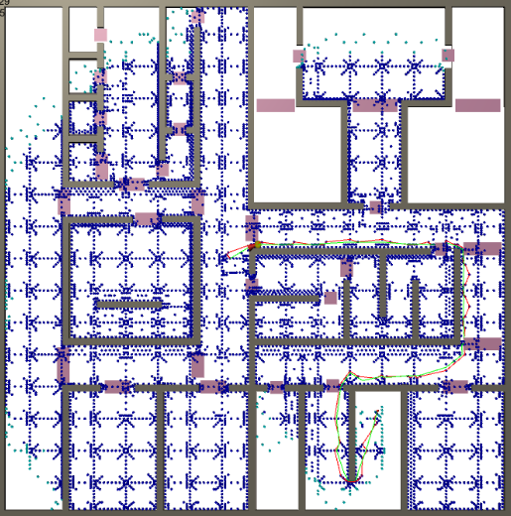AStarPathfinding:

* Priority heap as open list;
* Dictionary as closed list;
* Using Euclidean Distance;

Total Nodes explored: 8018

Max Open Nodes: 262

Total Time: 3614.0782

Time per Nodes: 0.4507

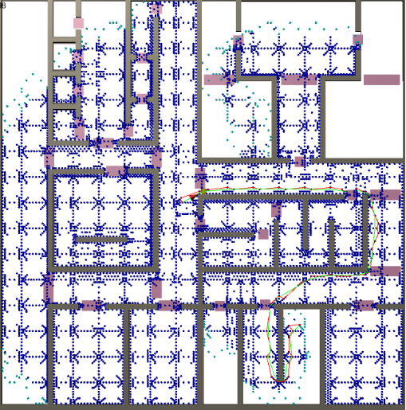NodeArrayAStarPathFinding:

* Using Euclidean Distance

Total Nodes explored: 8228

Max Open Nodes: 256

Total Time: 557.6415

Time per Nodes: 0.0677

NodeArrayAStarPathFinding:

* Using Gateway

Total Nodes explored:

Max Open Nodes:

Total Time:

Time per Nodes:

Level 6 – Optimizations: