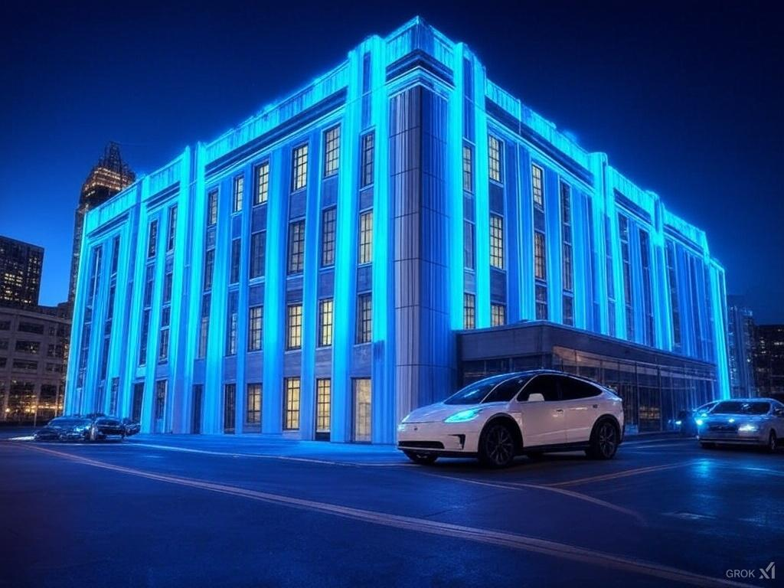

"The Future Begins at T&P"
In the 1930s, the Texas and Pacific Warehouse revolutionized transportation in Fort Worth as part of a $13 million investment in rail infrastructure that helped build the modern DFW metroplex. Today, we stand at the threshold of an even greater transportation revolution - one that will fundamentally reshape how we move, work, and live. The HUB project envisions transforming this historic building into the epicenter of next-generation mobility and technology innovation for the DFW area.
The Vision: By reimagining the T&P Warehouse as a central node in an advanced transportation network, we will create a first-of-its-kind integration of:
- Vertical takeoff and landing (VTOL) aircraft operations
- Autonomous electric vehicle networks
- Advanced robotics and artificial intelligence research facilities
- Technology innovation spaces and public showcases
- High-performance computing infrastructure
Market Opportunity: The DFW metroplex, with its population of 7.4 million and robust economic growth, is ideally positioned to pioneer this transportation revolution. The T&P Warehouse sits at the convergence of over $500 million in planned development, including Texas A&M's new $320 million campus and the $217 million Omni Hotel expansion. This location, combined with existing rail infrastructure and downtown accessibility, creates a unique opportunity to build the future of urban mobility.
Community Impact: The HUB project will:
- Create thousands of high-tech jobs
- Establish DFW as a leader in transportation innovation
- Preserve and revitalize a historic landmark
- Reduce traffic congestion and emissions
- Attract technology companies and investment
- Generate significant economic growth

Historical Context & Future Vision
A Legacy of Transportation Innovation In the 1930s, the Texas and Pacific Railway Company made a bold investment that would shape Fort Worth's future. The T&P Warehouse, part of a visionary three-building complex, represented the pinnacle of transportation technology for its era. As rail gave way to air travel in the 1950s, this architectural landmark entered a period of dormancy - but its potential to revolutionize transportation never diminished.
Today's Technological Convergence We stand at a similar inflection point in transportation history. Multiple transformative technologies are maturing simultaneously:
- Electric vertical takeoff and landing (VTOL) aircraft making urban air mobility possible
- Autonomous vehicles reshaping ground transportation
- Artificial intelligence and robotics transforming logistics
- Virtual and augmented reality changing how we experience travel
- Advanced computing enabling real-time transportation management
The T&P Vision Just as this building once served as a crucial hub for rail freight, connecting Fort Worth to the nation's rail network, we envision it becoming the nexus of future transportation technologies. The building's original design - with its robust structure, strategic location, and expansive spaces - makes it uniquely suited for this transformation.
Key elements of the transformation include:
- Converting the rooftop for VTOL operations
- Utilizing the ground floor for autonomous vehicle operations
- Transforming interior spaces into technology research and development centers
- Creating public spaces that showcase emerging technologies
- Establishing computing infrastructure to manage next-generation transportation networks
Bridging Past and Future This vision honors the building's heritage while propelling it into the future. The same spirit of innovation that drove the original T&P development will guide its transformation into a hub for future mobility. By preserving this historic structure while adapting it for tomorrow's transportation needs, we create a living bridge between Fort Worth's past and its future.

The HUB System
Network Overview The HUB system reimagines urban mobility through a seamlessly integrated network of air and ground transportation. With the T&P Warehouse as its central node, this system will connect the DFW metroplex through:
- A network of VTOL aircraft providing rapid city-to-city transport
- Autonomous electric vehicles offering efficient ground transportation
- Smart traffic management systems optimizing route efficiency
- Integration with existing rail and public transit infrastructure
Central Node: T&P Hub The T&P Warehouse will serve as the flagship hub, showcasing the full potential of integrated transportation:
Ground Level Operations:
- Autonomous vehicle docking and charging stations
- Passenger terminal with seamless modal transfers
- Smart baggage and cargo handling systems
- Direct connection to existing rail infrastructure
Rooftop VTOL Port:
- Multiple VTOL landing pads
- Advanced air traffic management systems
- Weather monitoring and safety systems
- Passenger boarding and waiting areas
Technology Integration The HUB system leverages cutting-edge technologies to ensure safe, efficient operations:
- AI-powered traffic management
- Real-time route optimization
- Predictive maintenance systems
- Integrated passenger booking and tracking
- Advanced security systems
Network Expansion From the central T&P hub, the network will expand through strategic placement of secondary hubs across the DFW metroplex:
- Major business districts
- Residential centers
- Entertainment venues
- Educational institutions
- Healthcare facilities
This hub-and-spoke model allows for scalable growth while maintaining efficient operations and maximizing coverage of the metropolitan area.

Innovation Center Concept
Beyond Transportation: A Technology Ecosystem The T&P Innovation Center will transform this historic warehouse into a living laboratory for future technologies. By combining transportation infrastructure with research and development facilities, we create a unique ecosystem where innovation can thrive.
Facility Layout
Research & Development (Floors 3-5):
- Advanced robotics laboratories
- Artificial intelligence research centers
- Urban mobility testing facilities
- Battery and electric propulsion research spaces
- Technology company offices and collaborative spaces
Light Manufacturing & Testing (Floors 6-7):
- Prototype development facilities
- Small-scale production spaces
- Testing and validation laboratories
- Quality control centers
- Advanced materials research
Technology Showcase (Floor 1-2):
- Interactive technology exhibitions
- Virtual reality experience centers
- Future mobility demonstrations
- Public education spaces
- Technology conference facilities
Infrastructure Hub (Floor 8 & Basement):
- High-performance computing centers
- Data processing facilities
- Network operations center
- Backup power systems
- Advanced telecommunications infrastructure
Public Integration The Innovation Center will engage the public through:
- Educational programs partnering with local schools and universities
- Regular technology demonstrations and exhibitions
- Startup incubator programs
- Public lectures and workshops
- Interactive technology experiences
Economic Impact The Innovation Center will drive economic growth through:
- Creation of high-skilled technology jobs
- Attraction of technology companies to the region
- Development of new intellectual property
- Establishment of DFW as a technology hub
- Support for technology startups and entrepreneurs

Implementation Strategy & Next Steps
Phase 1: Property Acquisition and Initial Development (Months 0-12)
- Secure property through strategic acquisition
- Complete detailed structural assessment
- Begin essential repairs ($2.15M structural rehabilitation)
- Initiate permitting and zoning processes
- Establish key partnerships with technology companies and transportation providers
- Develop detailed architectural and engineering plans
Phase 2: Infrastructure Development (Months 13-24)
- Complete building rehabilitation
- Install VTOL infrastructure on rooftop
- Develop ground transportation facilities
- Establish computing and telecommunications infrastructure
- Begin renovation of research and development spaces
- Install initial charging and support systems
Phase 3: Technology Integration (Months 25-36)
- Launch initial autonomous vehicle operations
- Begin VTOL test flights and certification process
- Open first research and development facilities
- Establish computing centers
- Initialize traffic management systems
- Start public showcase areas
Phase 4: Full System Launch (Months 37-48)
- Begin full VTOL operations
- Launch complete autonomous vehicle network
- Open all research facilities
- Activate public spaces and exhibitions
- Initiate educational programs
- Start incubator programs
Immediate Next Steps
- Form core development team
- Initiate property acquisition negotiations
- Begin regulatory and permitting discussions
- Establish initial public-private partnerships
- Launch community engagement process
Investment Requirements
- Property acquisition: TBD based on negotiations
- Structural repairs: $2.15M (initial estimate)
- Infrastructure development: TBD
- Technology systems: TBD
- Operational costs: TBD
The transformation of the T&P Warehouse into a next-generation transportation and technology hub represents a unique opportunity to position DFW at the forefront of urban mobility and technological innovation. Through strategic planning, strong partnerships, and phased implementation, we can create a model for future urban development that honors our past while building our future.

