Ex-9

import nltk

from sklearn.feature_extraction.text import TfidfVectorizer

from sklearn.metrics.pairwise import cosine_similarity

text1="I am John Wick"

text2="I am from Paris"

tfidf=TfidfVectorizer()

tfidf_matrix=tfidf.fit_transform([text1,text2])

cosine_sim=cosine_similarity(tfidf_matrix[0:1],tfidf_matrix[1:2])

print("Cosine Similarity",cosine_sim[0][0])

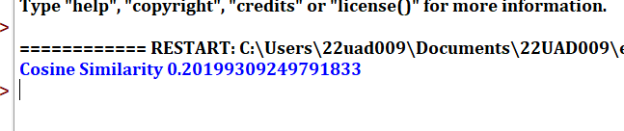

def jaccard_similarity(word1, word2):

set1 = set(word1)

set2 = set(word2)

intersection = set1.intersection(set2)

union = set1.union(set2)

similarity = len(intersection) / len(union)

return similarity

word1 = "king"

word2 = "queen"

similarity_score = jaccard_similarity(word1, word2)

print(f"Jaccard Similarity between '{word1}' and '{word2}': {similarity_score}")

