Preparation of Papers for 'BALTICSTE23'

First A. Author, Second B. Author
Business or Academic Affiliation 1, Country
E-mail: firstauthor@firstauthor.com, secondauthor@secondauthor.com
ORCID:

Third C. Author
Business or Academic Affiliation 2, Country
E-mail: thirdauthor@thirdauthor.com
ORCID:

Fourth D. Author
Business or Academic Affiliation 3, Country
E-mail: fourthauthor@fourthauthor.com
ORCID:

Abstract

Abstract abstract abstract abstract abstract abstract abstract abstract abstract abstract abstract abstract abstract abstract abstract abstract abstract abstract abstract abstract abstract abstract abstract abstract abstract abstract abstract abstract abstract abstract abstract abstract abstract abstract abstract abstract abstract abstract abstract abstract abstract abstract abstract abstract abstract abstract abstract abstract abstract abstract abstract abstract abstract abstract abstract abstract abstract abstract abstract abstract abstract abstract abstract abstract abstract . (100-150 words).
Keywords: keyword, keyword, keyword, keyword, keyword (usually consists from two words, for example, “science education”)

An abstract is a shortened version of the paper and should contain all information necessary for the reader to determine: (1) what the objectives of the research/study were; (2) how the research/study was done; (3) what results were obtained; (4) and the significance of the results. The abstract is important because many journal readers first read the abstract to determine if the entire article is worth reading.

Introduction

Introduction, introduction, introduction, introduction, introduction, introduction, introduction, introduction, introduction, introduction, introduction, introduction, introduction, introduction, introduction, introduction, introduction, introduction, introduction.

Research Problem

Introduction, introduction, introduction, introduction, introduction, introduction, introduction, introduction, introduction, introduction, introduction, introduction, introduction, introduction, introduction, introduction, introduction, introduction, introduction

Research Focus

Introduction, introduction, introduction, introduction, introduction, introduction, introduction, introduction, introduction, introduction, introduction, introduction, introduction, introduction, introduction, introduction, introduction, introduction, introduction.

Research Aim and Research Questions

Etc. …….

The introduction needs to relate to the problems or issues being recognised and eventually leading the research questions. The structuring of the introduction part may vary.
This section discusses the results and conclusions of previously published studies, to help explain why the current study is of scientific interest.

Research Methodology

General Background

General background of research, general background of research, general background of research, general background of research, general background of research, general background of research, general background of research, general background of research, general background of research, general background of research, general background of research.
General description of research is important in order to show the basis of the research. It is like a very brief introduction to the methodology section as a whole.

Sample

Sample of research, sample of research, sample of research, sample of research, sample of research, sample of research, sample of research, sample of research, sample of research, sample of research, sample of research, sample of research, sample of research.

Instrument and Procedures

Instrument and procedures, instrument and procedures, instrument and procedures, instrument and procedures, instrument and procedures, instrument and procedures, instrument and procedures, instrument and procedures.

Data Analysis

Data analysis, data analysis, data analysis, data analysis, data analysis, data analysis, data analysis, data analysis, data analysis, data analysis, data analysis.

Etc.

This section provides all the methodological details necessary for another scientist to duplicate your work.
„Research Methodology“ chapter should convince a reader that this manuscript presents a solid and sound analysis.

Research Results

Results of research, results of research, results of research, results of research, results of research, results of research, results of research.

Table 1
Tables and Figures Should Be Valuable, Relevant, and Visually Attractive

Statements and subscales | Cronbach-α | KMO |  | L | r/itt | Dissemination %
Note: (if needed) (10pt)

Sub-titles (Subchapters) 12-point, Italic, Centered

Figures should be carefully explained in the text and cited in numerical order.

Figure 1
Comparison of Success Rate of Items in the Experimental and Control Class

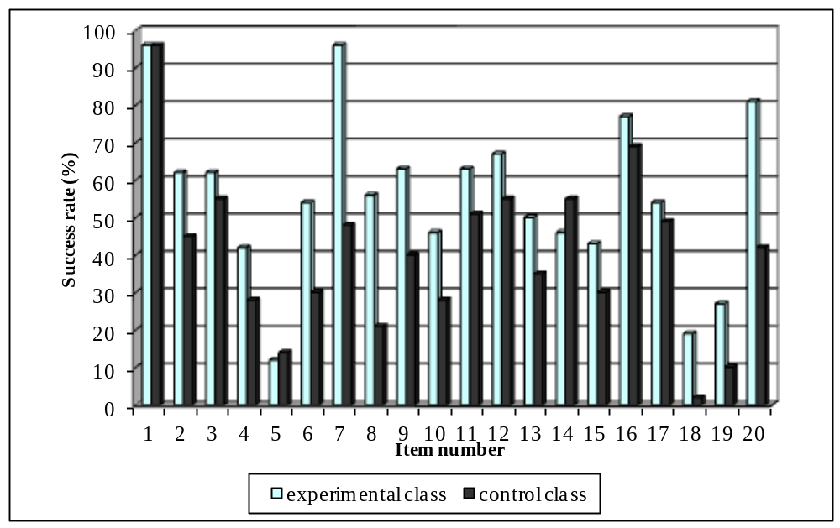
Note: (if needed) (10pt)

Figure 2
Clear Line Drawings Are Essential

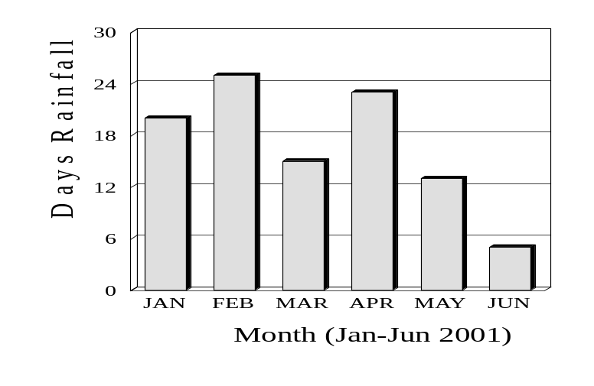
Results should be presented in details and discussed accordingly without any mix with other studies.

Discussion

Discussion, discussion, discussion, discussion, discussion, discussion, discussion, discussion, discussion, discussion, discussion, discussion, discussion, discussion, discussion, discussion, discussion, discussion, discussion.

The objective here is to provide an interpretation of your results and support for all of your conclusions, using evidence from your experiment (research) and generally accepted knowledge, if appropriate. Suggest future directions for research, new methods, explanations for deviations from previously published results, etc.

Conclusions and Implications

Conclusions, conclusions, conclusions, conclusions, conclusions, conclusions, conclusions, conclusions, conclusions, conclusions, conclusions, conclusions, conclusions, conclusions, conclusions, conclusions, conclusions, conclusions, conclusions.

Your conclusion should be the best part of your paper. A conclusion should: (1) stress the importance of the thesis statement, (2) give the essay a sense of completeness, and (3) leave a final impression on the reader.

P.S. Implications and/or recommendations can be as a separate chapter.

Acknowledgements

Acknowledgements of people, grants, funds, etc should be placed in a separate section not numbered at the very end of the paper.

References
Centers for Disease Control and Prevention. (2018, August 22). Preventing HPV-associated cancers. https://www.cdc.gov/features/adultvaccinations/
Cronbach, L. J., & Meehl, P. E. (1955). Construct validity in psychological tests. Psychological Bulletin, 52(4), 281–302. https://doi.org/10.1037/h0040957

Herráez, A. (2006). Biomolecules in the computer: Jmol to the rescue. Biochemistry & Molecular Biology Education, 34(4), 255-261. https://doi.org/10.1002/bmb.2006.494034042644
Jasvin, V. (2000). Psihologija otnoshenija k prirode [Psychology attitudes towards nature]. Smysl.
Johnson, G. M. (2010). Internet use and child development: The techno-microsystem. Australian Journal of Educational and Developmental Psychology, 10, 32-43. https://www.newcastle.edu.au/__data/assets/pdf_file/0014/100292/V10_johnson.pdf
Kennedy, M. (2018, October 15). To prevent wildfires, PG&E pre-emptively cuts power to thousands in California. NPR. https://www.npr.org/2018/10/15/657468903/to-prevent-wildfires-pg-e-preemptively-cuts-power-to-thousands-in-california
Lamanauskas, V., & Augienė, D. (2017). Career education in comprehensive schools of Lithuania: Career professionals` position. In A. Klim-Klimaszewska, M. Podhajecka, A., & Fijalkowska-Mroczek (Eds.), Orientacje i przedsiewziecia w edukacji przedszkolnej i szkolnej /Monografia/ [Orientations and ventures in pre-school and general education] (pp. 216-236). Akka.
Lamanauskas, V., & Makarskaitė-Petkevičienė, R. (2021). Distance lectures in university studies: Advantages, disadvantages, improvement. Contemporary Educational Technology (CEDTECH), 13(3), Article ep309. https://doi.org/10.30935/cedtech/10887
Makamure, C., & Tsakeni, M. (2020). Covid-19 as an agent of change in teaching and learning STEM subjects. Journal of Baltic Science Education, 19(6A), 1078-1091. https://doi.org/10.33225/jbse/20.19.1078
McCormack, B., McCance, T., & Maben, J. (2013). Outcome evaluation in the development of person-centred practice. In B. McCormack, K. Manley, & A. Titchen (Eds.), Practice development in nursing and healthcare (pp. 190-211). John Wiley & Sons.
Novák, M., & Langerová, P. (2006) Raising efficiency in teaching mathematics in non-English speaking countries: An electronic bilingual dictionary of mathematical terminology. In: Proceedings of 3rd International Conference on the Teaching of Mathematics at the Undergraduate Level. TMD (Turkish Mathematical Society), 2006. [CD-ROM].
Posner, M. (2004). Neural systems and individual differences. TC Record. http://www.tcrecord.org/PrintContent.asp?ContentID=11663.
Schmidt, N. A., & Brown, J. M. (2017). Evidence-based practice for nurses: Appraisal and application of research (4th ed.). Jones & Bartlett Learning, LLC.
Thurstone, L. L. (1959). The measurement of attitude: A psycho-social method and some experiments. University of Chicago.
Vaitkevičius, J. (1995). Socialinės pedagogikos pagrindai [Basics of social pedagogy]. Egalda.

Do not use Wikipedia for references. Do not use “et. al.” Provide issue numbers for papers. Reference section should not be used for commentary and notes.

Referencing needs to be brought in line with the APA (7th. Ed.) system

Quick Reference Guide: https://apastyle.apa.org/instructional-aids/reference-guide.pdf

Note: Originality is very important aspect of a research paper. Take great care to avoid plagiarism in your writing and be sure that any text you pull from outside sources is properly quoted and noted in your list of references.

Note: The work should be written in an impersonal style.

Note: A qualitative scientific paper is a description of an event, activity, observation, research or experience. The structure of a qualitative paper includes an abstract, introduction, background to the problem, the researcher's role, theoretical perspective, methodology, ethical considerations, results, data analysis, limitations, discussion, conclusions and implications, references and appendix.

