1.1 Small Group · Group 1 — Homework
Lesson 1-1-group1 • Standard MPP.3
Name: ______________________ Period: ______ Date: ____________

Today's Goals
Content: With my small group, I can describe the ways we are all doers of math, and compare my math story with a classmate's — one step at a time, with support.
Language: I can talk through each step out loud using a sentence frame and the lesson's key words.

Key Words
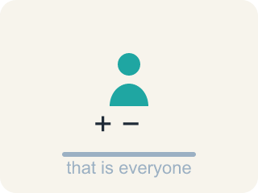
doer of math (persona que hace matemáticas) — Anyone who uses mathematical thinking — which is everyone, every day.

math story (historia matemática) — Your own history with mathematics — what you have done, felt, and learned so far.

strength (fortaleza) — Something you already do well and can share with others.
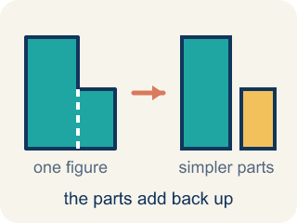
decompose (descomponer) — To break a number into parts that add, subtract, multiply, or divide back to it.
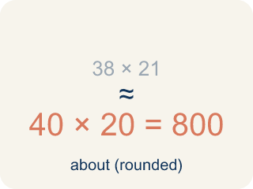
estimate (estimar) — A reasoned answer that is close enough to be useful, without counting every one.

Practice
Show your work. Use the blank space under each problem.
1. About how many people can ride the Ferris wheel at one time if it has 20 cars that each hold about 4 people?
A. About 5
B. About 24
C. About 80
D. About 400
______________________________________________________________________
2. Which of these is a correct way to decompose 78.5?
A. 7 + 8.5
B. 70 + 8.5
C. 70 + 8.05
D. 78 + 5
______________________________________________________________________
3. Tonight the Ferris wheel has 19 cars, and about 4 people fit in each car. Mia rounds 19 up to 20 and says, “About 80 people can ride at one time.” Is Mia's estimate reasonable?
A. No — she has to use 19, so 76 is the only answer allowed
B. No — rounding up always makes an estimate too big to be useful
C. Yes — 20 is close to 19, and 20 × 4 = 80 is close to the exact 76
D. Yes, but only because 80 is a round number
______________________________________________________________________
4. You want to estimate 19 × 4 in your head. Which move makes the numbers friendlier without changing the answer much?
A. Round 4 up to 10, because tens are the easiest to multiply
B. Round 19 to 20 — then 20 × 4 is a double of a double
C. Add 19 + 4 first, then multiply the total by 2
D. Rewrite 19 as 19.0 so it looks like a decimal
______________________________________________________________________
5. Mia rounded 19 cars up to 20 before multiplying. Explain why that made the math easier — and say what she gave up by rounding.
______________________________________________________________________
______________________________________________________________________
______________________________________________________________________
______________________________________________________________________
6. A different wheel has 22 cars holding about 4 people each. Ana rounds 22 down to 20 and says “about 80.” Ben multiplies 22 × 4 and says “exactly 88.” Which statement describes both approaches fairly?
A. Ana is wrong, because she changed a number that was given
B. Ben is wrong, because an estimate has to be a round number
C. Only one of them can be doing real math
D. Ana's is fast for a quick head count; Ben's is what the operator needs to sell tickets
______________________________________________________________________
7. A third student looks at the same 22-car wheel and says, “About 200 people can ride at one time.” Why is that estimate not reasonable?
A. It is wrong only because 200 is not a multiple of 4
B. It would mean about 9 people squeezed into every car, not about 4
C. It is fine — an estimate can be any number you like
D. It is wrong because 200 is too round to be an estimate
______________________________________________________________________
8. The same fair has a carousel with 31 horses. About 1 rider fits on each horse, and it runs 3 times an hour. Estimate about how many people ride the carousel in one hour. Use any strategy you like — then name the strategy you used.
______________________________________________________________________
______________________________________________________________________
______________________________________________________________________
______________________________________________________________________
9. Fix our table's thinking
Step 1 (The problem): You want to estimate 19 × 4 in your head. Which move makes the numbers friendlier without changing the answer much?
Step 2 (A classmate at our table answered): Add 19 + 4 first, then multiply the total by 2
Which step has the mistake? Explain and fix it:
______________________________________________________________________
______________________________________________________________________
______________________________________________________________________

Answer Key (Teacher)
1. C. About 80
20 cars with about 4 riders each is 20 × 4, which is about 80 people.
Watch for: Believing that 'doing math' only counts when it happens on paper in a classroom.
2. B. 70 + 8.5
70 + 8.5 = 78.5. Decomposing means the parts must add back to the original number.
Watch for: Believing that 'doing math' only counts when it happens on paper in a classroom.
3. C. Yes — 20 is close to 19, and 20 × 4 = 80 is close to the exact 76
19 × 4 = 76 and 20 × 4 = 80. Mia's estimate is 4 riders high — close enough to plan with, which is what an estimate is for.
Watch for: Believing that 'doing math' only counts when it happens on paper in a classroom.
4. B. Round 19 to 20 — then 20 × 4 is a double of a double
20 is one step from 19, and 20 × 4 is easy: double 20 to 40, double again to 80. Moving 4 up to 10 would more than double the riders in every car.
Watch for: Believing that 'doing math' only counts when it happens on paper in a classroom.
5. Open response — answers will vary.
6. D. Ana's is fast for a quick head count; Ben's is what the operator needs to sell tickets
22 × 4 = 88, and 20 × 4 = 80. Both are good mathematics doing different jobs: Ana's is quick and close, Ben's is exact. Choosing between them is a decision about what the number is for.
Watch for: Believing that 'doing math' only counts when it happens on paper in a classroom.
7. B. It would mean about 9 people squeezed into every car, not about 4
200 riders shared across 22 cars is about 9 per car (200 ÷ 22 ≈ 9), and the cars hold about 4. Checking an estimate against the quantity it came from is how you catch one that has drifted.
Watch for: Believing that 'doing math' only counts when it happens on paper in a classroom.
8. Open response — answers will vary.
9. Fix our table's thinking
The mistake is in Step 2.
Correct work: The correct answer is Round 19 to 20 — then 20 × 4 is a double of a double. 20 is one step from 19, and 20 × 4 is easy: double 20 to 40, double again to 80. Moving 4 up to 10 would more than double the riders in every car.

