1.1 Small Group · Group 2 — Homework
Lesson 1-1-group2 • Standard MPP.3
Name: ______________________ Period: ______ Date: ____________

Today's Goals
Content: I can describe the ways we are all doers of math, and compare my math story with a classmate's, explain how I can tell, and judge a case I have not seen before.
Language: I can justify my answer to a skeptic and connect it to a second strategy or representation.

Key Words
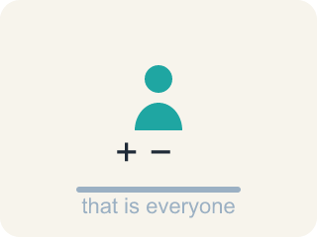
doer of math (persona que hace matemáticas) — Anyone who uses mathematical thinking — which is everyone, every day.

math story (historia matemática) — Your own history with mathematics — what you have done, felt, and learned so far.

strength (fortaleza) — Something you already do well and can share with others.
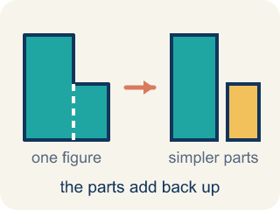
decompose (descomponer) — To break a number into parts that add, subtract, multiply, or divide back to it.
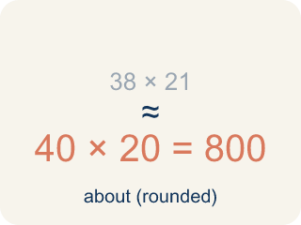
estimate (estimar) — A reasoned answer that is close enough to be useful, without counting every one.

Practice
Show your work. Use the blank space under each problem.
1. A wheel has 23 cars holding about 4 riders each. Dev rounds 23 to 20 and says “about 80.” Priya rounds to 25 and says “about 100.” The operator needs to know whether one full turn can clear a line of 95 people. Whose estimate is more useful here, and why?
A. Priya's — a bigger estimate is always the safer one to plan with
B. Neither — only the exact answer 92 can be used for a decision
C. Dev's — it is below the exact 92, so it will not promise the operator more room than the wheel has
D. Both equally — they are both estimates of the same quantity
______________________________________________________________________
2. Claim: “If you round BOTH numbers up before multiplying, your estimate can never come out below the exact answer.” For counts like cars and riders, is this claim always, sometimes, or never true?
A. Sometimes — it depends which number you round first
B. Sometimes — it fails when the two numbers are close together
C. Never — rounding up changes the answer unpredictably
D. Always — each factor got bigger, so the product cannot get smaller
______________________________________________________________________
3. The wheel has 23 cars holding about 4 riders each. Write an estimate that is deliberately a little LOW, and say how you made it low on purpose. Then say when a low estimate would be the responsible one to give.
______________________________________________________________________
______________________________________________________________________
______________________________________________________________________
______________________________________________________________________
4. Which decomposition of 78.5 uses multiplication correctly?
A. 39 × 2
B. 39.25 × 2
C. 39.25 × 3
D. 78.5 × 2
______________________________________________________________________
5. A Ferris wheel holds about 78 riders per turn and makes 6 turns an hour. About how many riders per hour?
A. About 13
B. About 84
C. About 468
D. About 780
______________________________________________________________________
6. Describe three different situations where you use math in your life. Say how the math is the SAME in each one.
______________________________________________________________________
______________________________________________________________________
______________________________________________________________________
______________________________________________________________________

Answer Key (Teacher)
1. C. Dev's — it is below the exact 92, so it will not promise the operator more room than the wheel has
23 × 4 = 92, so one turn cannot clear 95. Dev's 80 is low and keeps the operator honest; Priya's 100 is high and would suggest the line clears when it does not. Which direction an estimate errs in matters as much as how close it is.
Watch for: Believing that 'doing math' only counts when it happens on paper in a classroom.
2. D. Always — each factor got bigger, so the product cannot get smaller
Try to break it and you cannot: 19 × 4 = 76 goes to 20 × 5 = 100; 23 × 4 = 92 goes to 25 × 4 = 100. Making each factor larger can only make the product larger, so an estimate built this way is always at or above the exact answer — which is why it is the wrong move when you must not overpromise.
Watch for: Believing that 'doing math' only counts when it happens on paper in a classroom.
3. Open response — answers will vary.
4. B. 39.25 × 2
39.25 × 2 = 78.5, so halving and doubling is another way to break the number apart.
Watch for: Believing that 'doing math' only counts when it happens on paper in a classroom.
5. C. About 468
78 riders on each of 6 turns is 78 × 6 = 468 riders in an hour.
Watch for: Believing that 'doing math' only counts when it happens on paper in a classroom.
6. Open response — answers will vary.

