1.2 Small Group · Group 1 — Homework
Lesson 1-2-group1 • Standard 5.NF.B.4
Name: ______________________ Period: ______ Date: ____________

Today's Goals
Content: With my small group, I can make sense of a problem, plan a strategy, and use fractions of a whole number to compare quantities — one step at a time, with support.
Language: I can talk through each step out loud using a sentence frame and the lesson's key words.

Key Words
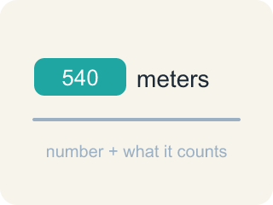
quantity (cantidad) — An amount in a problem — a number with a meaning attached, like 540 meters.
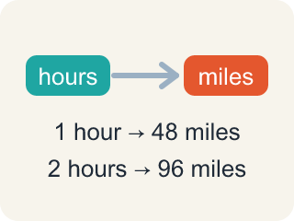
relationship (relación) — How two quantities compare or connect to each other.

strategy (estrategia) — A plan for how to solve a problem before you start computing.
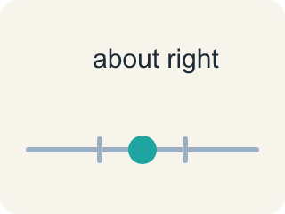
reasonable (razonable) — A solution that makes sense in the context of the problem.
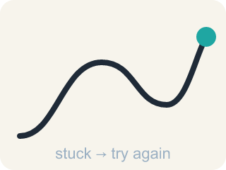
persevere (perseverar) — To keep working on a problem, checking your progress and adjusting your plan when you get stuck.

Practice
Show your work. Use the blank space under each problem.
1. Which of these is a correct way to decompose 105.76?
A. 10 + 5.76
B. 100 + 5.76
C. 100 + 5.076
D. 105 + 7.6
______________________________________________________________________
2. Which is another correct decomposition of 105.76?
A. 106 − 0.34
B. 110 − 4.24
C. 110 − 5.24
D. 110 + 4.24
______________________________________________________________________
3. Ana's route is 24 blocks long and she has walked 1/2 of it. Ben's route is 20 blocks and he has walked 3/4 of it. Before you calculate anything: which question do you have to answer to tell who has walked farther?
A. How many blocks each student has actually walked
B. Whose whole route is longer
C. Which student started walking first
D. How many blocks Ana still has left
______________________________________________________________________
4. Ana has walked 1/2 of her 24-block route. How many blocks has she walked?
A. 2 blocks
B. 12 blocks
C. 24 blocks
D. 48 blocks
______________________________________________________________________
5. Ben has walked 3/4 of his 20-block route. How many blocks is that, and who has walked farther — Ana (12 blocks) or Ben?
A. 5 blocks — Ana has walked farther
B. 15 blocks — Ben has walked farther
C. 15 blocks — Ana has walked farther
D. 16 blocks — Ben has walked farther
______________________________________________________________________
6. Explain your plan for comparing Ana's and Ben's distances. Use the words we know, we don't know, and my strategy is.
______________________________________________________________________
______________________________________________________________________
______________________________________________________________________
______________________________________________________________________
7. Ben walked 3/4 of his route and Ana walked 1/2 of hers, and Ben did walk farther. Does a bigger fraction ALWAYS mean a longer distance?
A. No — each fraction is of a different route, so you have to compare the actual blocks
B. Yes — 3/4 is greater than 1/2, so the person with 3/4 always walked farther
C. No — fractions of different numbers can never be compared at all
D. Yes, but only when both routes are longer than 20 blocks
______________________________________________________________________
8. A third student, Cam, has walked 2/3 of an 18-block route. Work out how far Cam has walked, then place all three students in order. Say what strategy you used.
______________________________________________________________________
______________________________________________________________________
______________________________________________________________________
______________________________________________________________________
9. Fix our table's thinking
Step 1 (The problem): Ana's route is 24 blocks long and she has walked 1/2 of it. Ben's route is 20 blocks and he has walked 3/4 of it. Before you calculate anything: which question do you have to answer to tell who has walked farther?
Step 2 (A classmate at our table answered): Whose whole route is longer
Which step has the mistake? Explain and fix it:
______________________________________________________________________
______________________________________________________________________
______________________________________________________________________

Answer Key (Teacher)
1. B. 100 + 5.76
100 + 5.76 = 105.76. Decomposing means the parts must rebuild the original number exactly.
Watch for: Expecting a fraction of a number to be bigger than the number — 5/6 × 540 must be LESS than 540 because 5/6 is less than 1; only a fraction greater than 1, like 6/5, makes the product bigger.
2. B. 110 − 4.24
110 − 4.24 = 105.76. A decomposition can use subtraction, not only addition.
Watch for: Expecting a fraction of a number to be bigger than the number — 5/6 × 540 must be LESS than 540 because 5/6 is less than 1; only a fraction greater than 1, like 6/5, makes the product bigger.
3. A. How many blocks each student has actually walked
The fractions are of different whole routes, so they cannot be compared directly. Turning each fraction into a number of blocks is the plan.
Watch for: Expecting a fraction of a number to be bigger than the number — 5/6 × 540 must be LESS than 540 because 5/6 is less than 1; only a fraction greater than 1, like 6/5, makes the product bigger.
4. B. 12 blocks
1/2 of 24 means 24 split into 2 equal parts: 24 ÷ 2 = 12 blocks.
Watch for: Expecting a fraction of a number to be bigger than the number — 5/6 × 540 must be LESS than 540 because 5/6 is less than 1; only a fraction greater than 1, like 6/5, makes the product bigger.
5. B. 15 blocks — Ben has walked farther
20 ÷ 4 = 5, and 3 of those parts is 5 × 3 = 15 blocks. 15 is greater than Ana's 12, so Ben has walked farther.
Watch for: Expecting a fraction of a number to be bigger than the number — 5/6 × 540 must be LESS than 540 because 5/6 is less than 1; only a fraction greater than 1, like 6/5, makes the product bigger.
6. Open response — answers will vary.
7. A. No — each fraction is of a different route, so you have to compare the actual blocks
If Ana's route were 40 blocks instead, 1/2 of 40 = 20 blocks, which beats Ben's 15 — same fractions, opposite answer. The size of the whole decides as much as the fraction does.
Watch for: Expecting a fraction of a number to be bigger than the number — 5/6 × 540 must be LESS than 540 because 5/6 is less than 1; only a fraction greater than 1, like 6/5, makes the product bigger.
8. Open response — answers will vary.
9. Fix our table's thinking
The mistake is in Step 2.
Correct work: The correct answer is How many blocks each student has actually walked. The fractions are of different whole routes, so they cannot be compared directly. Turning each fraction into a number of blocks is the plan.

