1.2 Small Group · Group 2 — Homework
Lesson 1-2-group2 • Standard 5.NF.B.4
Name: ______________________ Period: ______ Date: ____________

Today's Goals
Content: I can make sense of a problem, plan a strategy, and use fractions of a whole number to compare quantities, explain how I can tell, and judge a case I have not seen before.
Language: I can justify my answer to a skeptic and connect it to a second strategy or representation.

Key Words
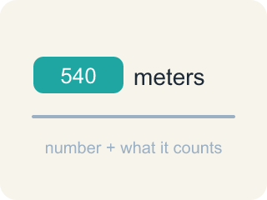
quantity (cantidad) — An amount in a problem — a number with a meaning attached, like 540 meters.
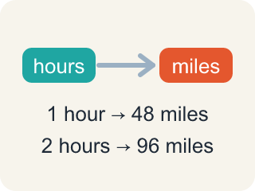
relationship (relación) — How two quantities compare or connect to each other.

strategy (estrategia) — A plan for how to solve a problem before you start computing.
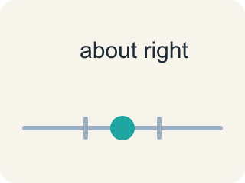
reasonable (razonable) — A solution that makes sense in the context of the problem.
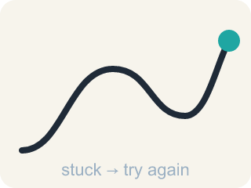
persevere (perseverar) — To keep working on a problem, checking your progress and adjusting your plan when you get stuck.

Practice
Show your work. Use the blank space under each problem.
1. Ana walked 1/2 of 24 blocks; Ben walked 3/4 of 20. Dana says: “3/4 is bigger than 1/2, so Ben walked farther.” Her conclusion is correct — but her reasoning is not. Explain why the reasoning fails, and give a route length for Ana that would make her conclusion wrong.
______________________________________________________________________
______________________________________________________________________
______________________________________________________________________
______________________________________________________________________
2. A student has walked 2/3 of her route and has covered 14 blocks. How long is the whole route?
A. 9 1/3 blocks
B. 21 blocks
C. 28 blocks
D. 42 blocks
______________________________________________________________________
3. Claim: “Taking a fraction of a whole number always gives you a smaller number.” Always, sometimes, or never true?
A. Always — a fraction is a part, and a part is smaller
B. Never — the answer is always larger
C. Sometimes — only when the fraction is less than 1
D. Sometimes — it depends on whether the whole number is even
______________________________________________________________________
4. The Tokyo building will be 6/5 as tall as One World Trade Center (540 meters). How tall will it be?
A. 108 meters
B. 432 meters
C. 450 meters
D. 648 meters
______________________________________________________________________
5. Without calculating, which new building must be TALLER than One World Trade Center, and why?
A. London, because 5/6 has a 6 in it
B. Tokyo, because 6/5 is greater than 1
C. Rio de Janeiro, because 9/10 is close to 1
D. None — a fraction of 540 is always less than 540
______________________________________________________________________
6. Suppose Miguel walked 2 miles. Choose possible distances for Deon and Evelyn that fit the problem, and explain how you checked them.
______________________________________________________________________
______________________________________________________________________
______________________________________________________________________
______________________________________________________________________

Answer Key (Teacher)
1. Open response — answers will vary.
2. B. 21 blocks
If 2 parts are 14 blocks, one part is 7, and the whole is 3 parts: 21 blocks. Check: 2/3 of 21 = 14.
Watch for: Expecting a fraction of a number to be bigger than the number — 5/6 × 540 must be LESS than 540 because 5/6 is less than 1; only a fraction greater than 1, like 6/5, makes the product bigger.
3. C. Sometimes — only when the fraction is less than 1
3/2 of 8 is 12, which is larger than 8, and 4/4 of 8 is exactly 8. The claim holds only while the fraction is below 1.
Watch for: Expecting a fraction of a number to be bigger than the number — 5/6 × 540 must be LESS than 540 because 5/6 is less than 1; only a fraction greater than 1, like 6/5, makes the product bigger.
4. D. 648 meters
You need 6/5 of 540. One fifth of 540 is 108. Six fifths is 6 × 108 = 648 meters. That is taller than 540, because 6/5 is greater than 1.
Watch for: Expecting a fraction of a number to be bigger than the number — 5/6 × 540 must be LESS than 540 because 5/6 is less than 1; only a fraction greater than 1, like 6/5, makes the product bigger.
5. B. Tokyo, because 6/5 is greater than 1
Multiplying 540 by a fraction greater than 1 gives more than 540. Only 6/5 is greater than 1; 5/6 and 9/10 are both less than 1.
Watch for: Expecting a fraction of a number to be bigger than the number — 5/6 × 540 must be LESS than 540 because 5/6 is less than 1; only a fraction greater than 1, like 6/5, makes the product bigger.
6. Open response — answers will vary.

