Math is Exploring and Thinking — Homework
Lesson 1-2 • Standard 5.NF.B.4
Name: ______________________ Period: ______ Date: ____________

Today's Goals
Content: I can make sense of a problem, plan a strategy, and use fractions of a whole number to compare quantities.
Language: I can explain my plan using the words we know, we don't know, and my strategy is ___ .

Key Words
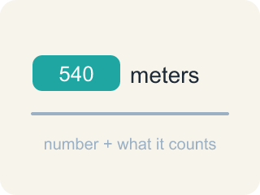
quantity (cantidad) — An amount in a problem — a number with a meaning attached, like 540 meters.
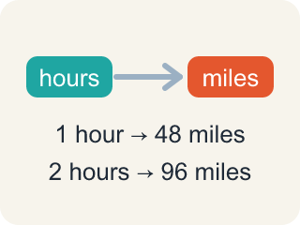
relationship (relación) — How two quantities compare or connect to each other.

strategy (estrategia) — A plan for how to solve a problem before you start computing.
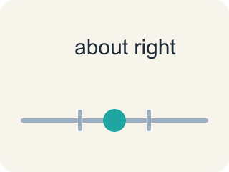
reasonable (razonable) — A solution that makes sense in the context of the problem.
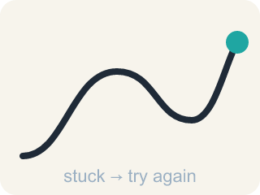
persevere (perseverar) — To keep working on a problem, checking your progress and adjusting your plan when you get stuck.

Practice
Show your work. Use the blank space under each problem.
1. Which of these is a correct way to decompose 105.76?
A. 10 + 5.76
B. 100 + 5.76
C. 100 + 5.076
D. 105 + 7.6
______________________________________________________________________
2. Which is another correct decomposition of 105.76?
A. 106 − 0.34
B. 110 − 4.24
C. 110 − 5.24
D. 110 + 4.24
______________________________________________________________________
3. The Rio de Janeiro building will be 9/10 as tall as One World Trade Center (540 meters). How tall will it be?
A. 54 meters
B. 486 meters
C. 594 meters
D. 4,860 meters
______________________________________________________________________
4. The Tokyo building will be 6/5 as tall as One World Trade Center (540 meters). How tall will it be?
A. 108 meters
B. 432 meters
C. 450 meters
D. 648 meters
______________________________________________________________________
5. Without calculating, which new building must be TALLER than One World Trade Center, and why?
A. London, because 5/6 has a 6 in it
B. Tokyo, because 6/5 is greater than 1
C. Rio de Janeiro, because 9/10 is close to 1
D. None — a fraction of 540 is always less than 540
______________________________________________________________________
6. Miguel walked 2 miles. Deon walked less than Miguel, and Evelyn walked more than Miguel. Choose possible distances for Deon and Evelyn and explain how you checked both relationships.
______________________________________________________________________
______________________________________________________________________
______________________________________________________________________
______________________________________________________________________
7. You calculate 5/6 × 540 and get 650 meters. What does the checking step of your plan tell you?
A. The answer is fine because it is close to 540
B. The answer is fine because 650 is a bigger number than 5/6
C. The answer is unreasonable — 5/6 of 540 must be LESS than 540
D. Checking is only needed when the problem asks for it
______________________________________________________________________
8. The lesson says we check on our progress toward a solution and adjust our plan as needed. Describe one way YOU can check on your progress while solving a problem.
______________________________________________________________________
______________________________________________________________________
______________________________________________________________________
______________________________________________________________________
9. Compute each building's height as a fraction of 540 meters.
Building plan | Fraction of 540 m | Height (m)
Rio de Janeiro | 9/10 of 540
Tokyo | 6/5 of 540
Prototype | 1/2 of 540
______________________________________________________________________

Answer Key (Teacher)
1. B. 100 + 5.76
100 + 5.76 = 105.76. Decomposing means the parts must rebuild the original number exactly.
Watch for: Expecting a fraction of a number to be bigger than the number — 5/6 × 540 must be LESS than 540 because 5/6 is less than 1; only a fraction greater than 1, like 6/5, makes the product bigger.
2. B. 110 − 4.24
110 − 4.24 = 105.76. A decomposition can use subtraction, not only addition.
Watch for: Expecting a fraction of a number to be bigger than the number — 5/6 × 540 must be LESS than 540 because 5/6 is less than 1; only a fraction greater than 1, like 6/5, makes the product bigger.
3. B. 486 meters
9/10 × 540: one tenth of 540 is 54, and 9 tenths is 9 × 54 = 486 meters.
Watch for: Expecting a fraction of a number to be bigger than the number — 5/6 × 540 must be LESS than 540 because 5/6 is less than 1; only a fraction greater than 1, like 6/5, makes the product bigger.
4. D. 648 meters
6/5 × 540: one fifth of 540 is 108, and 6 fifths is 6 × 108 = 648 meters — taller than 540, because 6/5 is greater than 1.
Watch for: Expecting a fraction of a number to be bigger than the number — 5/6 × 540 must be LESS than 540 because 5/6 is less than 1; only a fraction greater than 1, like 6/5, makes the product bigger.
5. B. Tokyo, because 6/5 is greater than 1
Multiplying 540 by a fraction greater than 1 gives more than 540. Only 6/5 is greater than 1; 5/6 and 9/10 are both less than 1.
Watch for: Expecting a fraction of a number to be bigger than the number — 5/6 × 540 must be LESS than 540 because 5/6 is less than 1; only a fraction greater than 1, like 6/5, makes the product bigger.
6. Open response — answers will vary.
7. C. The answer is unreasonable — 5/6 of 540 must be LESS than 540
5/6 is less than 1, so 5/6 of 540 must land below 540. Getting 650 means the plan needs adjusting — which is exactly what checking is for.
Watch for: Expecting a fraction of a number to be bigger than the number — 5/6 × 540 must be LESS than 540 because 5/6 is less than 1; only a fraction greater than 1, like 6/5, makes the product bigger.
8. Open response — answers will vary.
9. Compute each building's height as a fraction of 540 meters.
→ 486
→ 648
→ 270

