Math is In My World — Homework
Lesson 1-3 • Standard 5.NBT.B.7
Name: ______________________ Period: ______ Date: ____________

Today's Goals
Content: I can represent a real-world situation with a tape diagram or table and use decimal operations to solve it.
Language: I can describe my tool using the words tape diagram, table, and this represents ___ .

Key Words
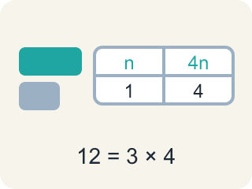
representation (representación) — A picture, diagram, table, or equation that shows the mathematics in a situation.
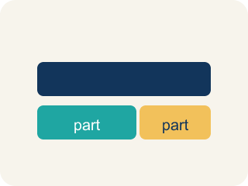
tape diagram (diagrama de cintas) — A rectangle cut into equal parts that helps you visualize how a total breaks apart.
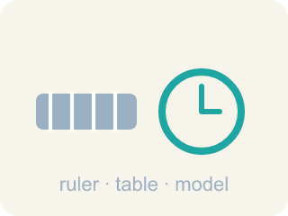
tool (herramienta) — Anything you choose to help you see relationships and solve a problem — a table, a diagram, a graph.
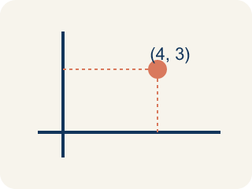
ordered pair (par ordenado) — Two numbers that go together, like a time and a number of trips, that you can plot as a point.
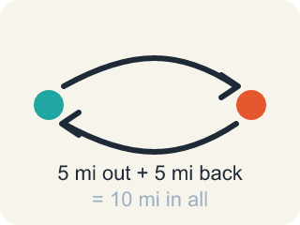
round trip (viaje de ida y vuelta) — A complete journey from the start, to the destination, and back to the start.

Practice
Show your work. Use the blank space under each problem.
1. One tram ride takes 12.5 minutes. How many minutes do 10 rides take?
A. 1.25 minutes
B. 22.5 minutes
C. 125 minutes
D. 1,250 minutes
______________________________________________________________________
2. Five Breaks: which of these is a correct way to decompose 12.5?
A. 1 + 2.5
B. 10 + 2.5
C. 10 + 2.05
D. 12 + 5
______________________________________________________________________
3. The 50 rides take 625 minutes. About how many HOURS is that?
A. About 6.25 hours
B. About 10.42 hours
C. About 12.5 hours
D. About 62.5 hours
______________________________________________________________________
4. How does the answer change for 2,000 passengers? Each ride carries 80 passengers and takes 12.5 minutes. How many MINUTES are needed?
A. 31.25 minutes
B. 300 minutes
C. 312.5 minutes
D. 3,125 minutes
______________________________________________________________________
5. One round trip takes 35 minutes. Using the table (35 → 1, 350 → 10, 525 → 15, 700 → 20), how many round trips does a tram car complete in 10 hours?
A. 15 round trips
B. 17 round trips
C. 18 round trips
D. 20 round trips
______________________________________________________________________
6. Compare these tram problems. A: A tram carries 80 passengers per ride and each ride takes 35 minutes. How long would 4,000 passengers take? B: A different tram completes a round trip in 12.5 minutes. How many round trips fit in 10 hours? How are the problems alike and different?
______________________________________________________________________
______________________________________________________________________
______________________________________________________________________
______________________________________________________________________
7. The round trip is 5 miles. How far does a tram car travel in 5 round trips?
A. 1 mile
B. 10 miles
C. 25 miles
D. 50 miles
______________________________________________________________________
8. How does the answer change if the tram must transport 6,000 passengers? (Each ride carries 80 passengers and takes 12.5 minutes.) Show your steps.
______________________________________________________________________
______________________________________________________________________
______________________________________________________________________
______________________________________________________________________
9. Each tram ride takes 12.5 minutes. Complete the table of total minutes.
Rides | Expression | Total minutes
10 | 10 × 12.5
20 | 20 × 12.5
50 | 50 × 12.5
______________________________________________________________________

Answer Key (Teacher)
1. C. 125 minutes
12.5 × 10 = 125. Multiplying by 10 shifts every digit one place to the left.
Watch for: Converting minutes to hours by moving the decimal point — 625 minutes is NOT 6.25 hours. An hour is 60 minutes, so divide by 60: 625 ÷ 60 ≈ 10.42 hours.
2. B. 10 + 2.5
10 + 2.5 = 12.5. The parts of a decomposition must rebuild the number exactly.
Watch for: Converting minutes to hours by moving the decimal point — 625 minutes is NOT 6.25 hours. An hour is 60 minutes, so divide by 60: 625 ÷ 60 ≈ 10.42 hours.
3. B. About 10.42 hours
625 ÷ 60 ≈ 10.42, so it would take about 10.42 hours to transport 4,000 passengers.
Watch for: Converting minutes to hours by moving the decimal point — 625 minutes is NOT 6.25 hours. An hour is 60 minutes, so divide by 60: 625 ÷ 60 ≈ 10.42 hours.
4. C. 312.5 minutes
2,000 ÷ 80 = 25 rides, and 25 × 12.5 = 312.5 minutes — half the passengers, half the 625 minutes.
Watch for: Converting minutes to hours by moving the decimal point — 625 minutes is NOT 6.25 hours. An hour is 60 minutes, so divide by 60: 625 ÷ 60 ≈ 10.42 hours.
5. B. 17 round trips
10 hours is 600 minutes. 17 trips take 17 × 35 = 595 minutes, and an 18th trip would need 630 — past the 600. So the tram completes 17 round trips.
Watch for: Converting minutes to hours by moving the decimal point — 625 minutes is NOT 6.25 hours. An hour is 60 minutes, so divide by 60: 625 ÷ 60 ≈ 10.42 hours.
6. Open response — answers will vary.
7. C. 25 miles
5 round trips × 5 miles per trip = 25 miles.
Watch for: Converting minutes to hours by moving the decimal point — 625 minutes is NOT 6.25 hours. An hour is 60 minutes, so divide by 60: 625 ÷ 60 ≈ 10.42 hours.
8. Open response — answers will vary.
9. Each tram ride takes 12.5 minutes. Complete the table of total minutes.
→ 125
→ 250
→ 625

