1.4 Small Group · Group 2 — Homework
Lesson 1-4-group2 • Standard 5.MD.C.5
Name: ______________________ Period: ______ Date: ____________

Today's Goals
Content: I can construct an argument using equations, drawings, or words, and use volume to defend a recommendation, explain what each part stands for, and build one for a situation I have not seen before.
Language: I can justify my answer to a skeptic and connect it to a second strategy or representation.

Key Words
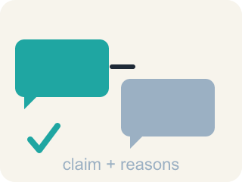
argument (argumento) — A chain of reasons — equations, drawings, or words — used to defend your thinking.
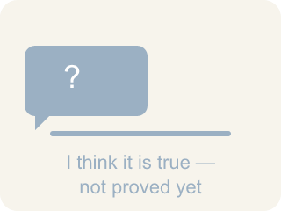
conjecture (conjetura) — A mathematical statement you believe is true but have not yet proven.
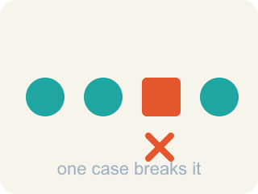
counterexample (contraejemplo) — A single example that shows a statement is not always true.

volume (volumen) — The amount of space a solid figure takes up, measured in cubic units.
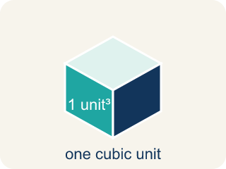
cubic unit (unidad cúbica) — A cube with edges 1 unit long — the unit used to measure volume.

Practice
Show your work. Use the blank space under each problem.
1. Three large boxes hold 240 cubic inches each. Two jumbo boxes hold 400 cubic inches each. Which is the correct volume comparison?
A. 240 cubic inches vs. 400 cubic inches — the jumbo option holds more
B. 480 cubic inches vs. 800 cubic inches — the jumbo option holds more
C. 720 cubic inches vs. 800 cubic inches — the jumbo option holds more
D. 720 cubic inches vs. 800 cubic inches — the large option holds more
______________________________________________________________________
2. One garden bed is 4 ft long, 3 ft wide, and 2 ft deep. A second bed is 6 ft long, 2 ft wide, and 2 ft deep. How much soil fills BOTH beds?
A. 19 cubic feet
B. 24 cubic feet
C. 48 cubic feet
D. 96 cubic feet
______________________________________________________________________
3. The group found the volume by decomposing the garden into prisms and adding. Why would they compute it a SECOND, different way?
A. Because the first way is always wrong
B. To get a bigger number for the soil order
C. If both ways give the same answer, the solution is accurate
D. Because volume changes each time you measure it
______________________________________________________________________
4. A student recommends the three large boxes because the cereal stays fresher — each box is open for less time. Is this argument convincing? Explain.
______________________________________________________________________
______________________________________________________________________
______________________________________________________________________
______________________________________________________________________

Answer Key (Teacher)
1. C. 720 cubic inches vs. 800 cubic inches — the jumbo option holds more
240 × 3 = 720 and 400 × 2 = 800; since 800 > 720, the two jumbo boxes hold more in total.
Watch for: Reporting volume without cubic units — saying the garden needs '48 feet' of soil, which is a length, or '48 square feet', which is an area.
2. C. 48 cubic feet
First bed: 4 × 3 × 2 = 24 cubic feet. Second bed: 6 × 2 × 2 = 24 cubic feet. Together: 24 + 24 = 48 cubic feet.
Watch for: Reporting volume without cubic units — saying the garden needs '48 feet' of soil, which is a length, or '48 square feet', which is an area.
3. C. If both ways give the same answer, the solution is accurate
The book models exactly this: two different decompositions both gave 48 cubic feet, so the solutions match and the answer is accurate.
Watch for: Reporting volume without cubic units — saying the garden needs '48 feet' of soil, which is a length, or '48 square feet', which is an area.
4. Open response — answers will vary.

