1.6 Small Group · Group 1 — Homework
Lesson 1-6-group1 • Standard MPP.3
Name: ______________________ Period: ______ Date: ____________

Today's Goals
Content: With my small group, I can describe my problem-solving process, name strategies for getting unstuck, and identify the behaviors that make our class a community of math thinkers — one step at a time, with support.
Language: I can talk through each step out loud using a sentence frame and the lesson's key words.

Key Words
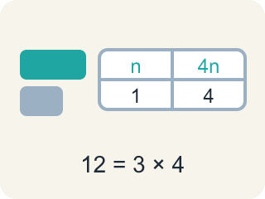
representation (representación) — A way of showing a problem — a drawing, table, equation, or model — that helps you see it.
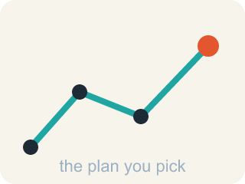
strategy (estrategia) — A plan of attack for a problem — and something you can switch when you get stuck.
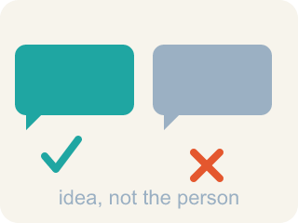
critique (criticar constructivamente) — To examine an idea and say what is convincing or not — about the idea, never about the person.

community agreement (acuerdo comunitario) — A rule the whole class agrees to so that everyone can learn together.

Practice
Show your work. Use the blank space under each problem.
1. A bicycle rack holds 8 bikes, and each bike has 2 wheels. How many wheels are on the rack?
A. 4
B. 10
C. 16
D. 82
______________________________________________________________________
2. Another bicycle rack has 6 times as many wheels as the rack with 16 wheels. About how many wheels does it have?
A. About 22
B. About 66
C. About 96
D. About 616
______________________________________________________________________
3. A rack holds 8 bikes, and each bike has 2 wheels. Another rack has 6 times as many wheels. Before computing anything: what do you need to find FIRST?
A. How many bikes are in the whole school
B. The answer 96, because that is what the book says
C. Nothing — you can multiply 8 × 6 right away and be done
D. How many wheels the first rack has — 6 times as many needs a starting number
______________________________________________________________________
4. You decided to find 16 × 6 for the second rack. Which representation matches the problem?
A. 6 equal groups of 16 wheels
B. 6 wheels shared equally among 16 bikes
C. 16 groups of 6 bikes
D. One group of 16 wheels plus one group of 6 wheels
______________________________________________________________________
5. Carry out the plan: 16 × 6 = ___. Then check your progress — which check actually tests the answer?
A. 22 — because 16 + 6 = 22
B. 48 — because 8 × 6 = 48
C. 96 — and 96 ÷ 6 = 16 brings back the first rack's wheels
D. 96 — and 96 looks like a big number, so it must be right
______________________________________________________________________
6. You read: 'The second rack has 96 wheels. How many BIKES is that?' — and you freeze. Which move is one of this lesson's get-unstuck strategies?
A. Skip it and answer the next one instead
B. Copy what the student next to you wrote
C. Draw the situation — one bike per 2 wheels — or think of a problem like it you already solved
D. Multiply the two numbers you see, because that worked last time
______________________________________________________________________
7. Describe your problem-solving process for the rack problem, in order. Use the phrases make sense of, try a strategy, and check.
______________________________________________________________________
______________________________________________________________________
______________________________________________________________________
______________________________________________________________________
8. A classmate is stuck on the rack problem and says, 'I'm just bad at math.' Write what you would say and do — one sentence that helps them re-enter the problem, and one question you would ask instead of giving the answer.
______________________________________________________________________
______________________________________________________________________
______________________________________________________________________
______________________________________________________________________
9. Fix our table's thinking
Step 1 (The problem): A rack holds 8 bikes, and each bike has 2 wheels. Another rack has 6 times as many wheels. Before computing anything: what do you need to find FIRST?
Step 2 (A classmate at our table answered): Nothing — you can multiply 8 × 6 right away and be done
Which step has the mistake? Explain and fix it:
______________________________________________________________________
______________________________________________________________________
______________________________________________________________________

Answer Key (Teacher)
1. C. 16
8 bikes with 2 wheels each is 8 × 2 = 16 wheels.
Watch for: Treating 'stuck' as a stop sign instead of a signal — waiting silently instead of trying a strategy: asking a question, drawing the problem, or recalling a similar problem.
2. C. About 96
6 times as many as 16 is 16 × 6 = 96 wheels.
Watch for: Treating 'stuck' as a stop sign instead of a signal — waiting silently instead of trying a strategy: asking a question, drawing the problem, or recalling a similar problem.
3. D. How many wheels the first rack has — 6 times as many needs a starting number
Making sense comes before computing. '6 times as many wheels' compares to the FIRST rack's wheels, so that count — 8 × 2 = 16 — has to exist before the 6 can multiply anything.
Watch for: Treating 'stuck' as a stop sign instead of a signal — waiting silently instead of trying a strategy: asking a question, drawing the problem, or recalling a similar problem.
4. A. 6 equal groups of 16 wheels
'6 times as many wheels as 16' means six copies of the 16: 6 groups of 16 = 96. A drawing of six 16s IS the plan — the multiplication just carries it out.
Watch for: Treating 'stuck' as a stop sign instead of a signal — waiting silently instead of trying a strategy: asking a question, drawing the problem, or recalling a similar problem.
5. C. 96 — and 96 ÷ 6 = 16 brings back the first rack's wheels
16 × 6 = 96, and the check runs the plan backward: 96 ÷ 6 = 16 ✓. A check that could FAIL is worth doing; 'it looks big' can never fail, so it checks nothing.
Watch for: Treating 'stuck' as a stop sign instead of a signal — waiting silently instead of trying a strategy: asking a question, drawing the problem, or recalling a similar problem.
6. C. Draw the situation — one bike per 2 wheels — or think of a problem like it you already solved
Visualizing and connecting to a problem you have seen are two of the lesson's strategies. A drawing shows 2 wheels making 1 bike, so 96 wheels make 96 ÷ 2 = 48 bikes.
Watch for: Treating 'stuck' as a stop sign instead of a signal — waiting silently instead of trying a strategy: asking a question, drawing the problem, or recalling a similar problem.
7. Open response — answers will vary.
8. Open response — answers will vary.
9. Fix our table's thinking
The mistake is in Step 2.
Correct work: The correct answer is How many wheels the first rack has — 6 times as many needs a starting number. Making sense comes before computing. '6 times as many wheels' compares to the FIRST rack's wheels, so that count — 8 × 2 = 16 — has to exist before the 6 can multiply anything.

