1.6 Small Group · Group 2 — Homework
Lesson 1-6-group2 • Standard MPP.3
Name: ______________________ Period: ______ Date: ____________

Today's Goals
Content: I can describe my problem-solving process, name strategies for getting unstuck, and identify the behaviors that make our class a community of math thinkers, explain how I can tell, and judge a case I have not seen before.
Language: I can justify my answer to a skeptic and connect it to a second strategy or representation.

Key Words
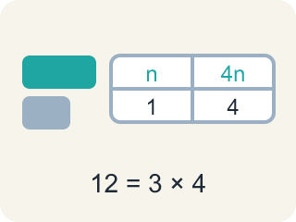
representation (representación) — A way of showing a problem — a drawing, table, equation, or model — that helps you see it.
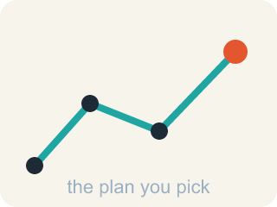
strategy (estrategia) — A plan of attack for a problem — and something you can switch when you get stuck.
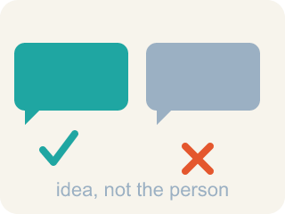
critique (criticar constructivamente) — To examine an idea and say what is convincing or not — about the idea, never about the person.

community agreement (acuerdo comunitario) — A rule the whole class agrees to so that everyone can learn together.

Practice
Show your work. Use the blank space under each problem.
1. For the rack with 6 times as many wheels, Maya computes (8 × 2) × 6 = 96. Jon computes (8 × 6) × 2 = 96. Which statement describes the two strategies fairly?
A. Only Maya's is right, because you must find the wheels before multiplying by 6
B. Only Jon's is right, because bikes come before wheels in the problem
C. Both are valid: Maya scales the wheels, Jon imagines 6 racks of bikes first — the grouping changes, the count does not
D. One of them must have made an error, since they used different orders
______________________________________________________________________
2. A student answers: 'The second rack has 16 + 6 = 22 wheels.' Explain what they misread, why the wrong answer is SO much smaller than 96, and write the question you would ask to help them find it themselves.
______________________________________________________________________
______________________________________________________________________
______________________________________________________________________
______________________________________________________________________
3. A third rack has HALF as many wheels as the 96-wheel rack. How many BIKES does it hold, and which plan gets there?
A. 12 bikes — divide 96 by 6 and then by... something
B. 24 bikes — halve the wheels (96 ÷ 2 = 48), then 2 wheels per bike gives 48 ÷ 2 = 24
C. 48 bikes — half of 96 is 48, and that is the answer
D. 192 bikes — double 96 because each bike has 2 wheels
______________________________________________________________________
4. You are solving a problem and realize your strategy is not making progress. What does the problem-solving process say to do?
A. Keep using the same strategy no matter what
B. Notice your progress has stalled and shift to a different strategy
C. Erase everything and decide the problem is impossible
D. Copy a classmate's paper
______________________________________________________________________
5. The first rack has 16 wheels and the other rack has 6 times as many. How many BIKES does the bigger rack hold, if every bike has 2 wheels?
A. 24
B. 48
C. 96
D. 192
______________________________________________________________________
6. Describe your problem-solving process in order, from reading the problem to checking your answer. Use at least three steps from this lesson.
______________________________________________________________________
______________________________________________________________________
______________________________________________________________________
______________________________________________________________________

Answer Key (Teacher)
1. C. Both are valid: Maya scales the wheels, Jon imagines 6 racks of bikes first — the grouping changes, the count does not
(8 × 2) × 6 and (8 × 6) × 2 both equal 96 — regrouping factors never changes a product. Two students, two mental pictures, one count. Comparing the pictures is the MPP.3 move.
Watch for: Treating 'stuck' as a stop sign instead of a signal — waiting silently instead of trying a strategy: asking a question, drawing the problem, or recalling a similar problem.
2. Open response — answers will vary.
3. B. 24 bikes — halve the wheels (96 ÷ 2 = 48), then 2 wheels per bike gives 48 ÷ 2 = 24
Two steps, each with a reason: 96 ÷ 2 = 48 wheels on the third rack, and 48 wheels ÷ 2 wheels per bike = 24 bikes. Watching your progress means noticing WHICH quantity each number counts.
Watch for: Treating 'stuck' as a stop sign instead of a signal — waiting silently instead of trying a strategy: asking a question, drawing the problem, or recalling a similar problem.
4. B. Notice your progress has stalled and shift to a different strategy
We are aware of our progress in solving the problem and shift strategies when needed.
Watch for: Treating 'stuck' as a stop sign instead of a signal — waiting silently instead of trying a strategy: asking a question, drawing the problem, or recalling a similar problem.
5. B. 48
The bigger rack has 16 × 6 = 96 wheels, and 96 ÷ 2 = 48 bikes.
Watch for: Treating 'stuck' as a stop sign instead of a signal — waiting silently instead of trying a strategy: asking a question, drawing the problem, or recalling a similar problem.
6. Open response — answers will vary.

