Math is Ours — Homework
Lesson 1-6 • Standard MPP.3
Name: ______________________ Period: ______ Date: ____________

Today's Goals
Content: I can describe my problem-solving process, name strategies for getting unstuck, and identify the behaviors that make our class a community of math thinkers.
Language: I can talk about problem solving using the phrases make sense of, get stuck, try a strategy, and work together.

Key Words

make sense of a problem (comprender un problema) — To figure out what a problem is asking — what you know, and what you don't know yet.
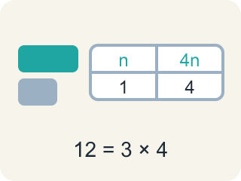
representation (representación) — A way of showing a problem — a drawing, table, equation, or model — that helps you see it.
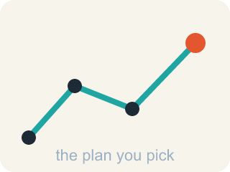
strategy (estrategia) — A plan of attack for a problem — and something you can switch when you get stuck.
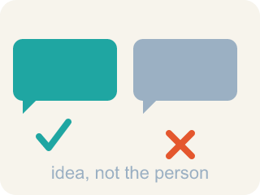
critique (criticar constructivamente) — To examine an idea and say what is convincing or not — about the idea, never about the person.

community agreement (acuerdo comunitario) — A rule the whole class agrees to so that everyone can learn together.

Practice
Show your work. Use the blank space under each problem.
1. A bicycle rack holds 8 bikes, and each bike has 2 wheels. How many wheels are on the rack?
A. 4
B. 10
C. 16
D. 82
______________________________________________________________________
2. Another bicycle rack has 6 times as many wheels as the rack with 16 wheels. About how many wheels does it have?
A. About 22
B. About 66
C. About 96
D. About 616
______________________________________________________________________
3. You are solving a problem and realize your strategy is not making progress. What does the problem-solving process say to do?
A. Keep using the same strategy no matter what
B. Notice your progress has stalled and shift to a different strategy
C. Erase everything and decide the problem is impossible
D. Copy a classmate's paper
______________________________________________________________________
4. The first rack has 16 wheels and the other rack has 6 times as many. How many BIKES does the bigger rack hold, if every bike has 2 wheels?
A. 24
B. 48
C. 96
D. 192
______________________________________________________________________
5. Describe your problem-solving process in order, from reading the problem to checking your answer. Use at least three steps from this lesson.
______________________________________________________________________
______________________________________________________________________
______________________________________________________________________
______________________________________________________________________
6. What part of problem solving is easy for you? What part is challenging?
______________________________________________________________________
______________________________________________________________________
______________________________________________________________________
______________________________________________________________________
7. You are working on your own and get stuck. Which move follows BOTH parts of our working-alone agreements?
A. Immediately call across the room to a friend
B. Sit silently for the rest of class without seeking help
C. Take a classmate's paper to see their work
D. Try a get-unstuck strategy first, then quietly ask for help without interrupting classmates unnecessarily
______________________________________________________________________
8. What skills and knowledge do you bring to a group that help the group be successful?
______________________________________________________________________
______________________________________________________________________
______________________________________________________________________
______________________________________________________________________
9. Use the bicycle rack problem to complete the table.
Question | Thinking | Answer
Wheels on a rack of 8 bikes | 8 bikes × 2 wheels
Wheels on the bigger rack (6 times as many) | 16 × 6
Bikes on the bigger rack | 96 wheels ÷ 2
______________________________________________________________________

Answer Key (Teacher)
1. C. 16
8 bikes with 2 wheels each is 8 × 2 = 16 wheels.
Watch for: Treating 'stuck' as a stop sign instead of a signal — waiting silently instead of trying a strategy: asking a question, drawing the problem, or recalling a similar problem.
2. C. About 96
6 times as many as 16 is 16 × 6 = 96 wheels.
Watch for: Treating 'stuck' as a stop sign instead of a signal — waiting silently instead of trying a strategy: asking a question, drawing the problem, or recalling a similar problem.
3. B. Notice your progress has stalled and shift to a different strategy
We are aware of our progress in solving the problem and shift strategies when needed.
Watch for: Treating 'stuck' as a stop sign instead of a signal — waiting silently instead of trying a strategy: asking a question, drawing the problem, or recalling a similar problem.
4. B. 48
The bigger rack has 16 × 6 = 96 wheels, and 96 ÷ 2 = 48 bikes.
Watch for: Treating 'stuck' as a stop sign instead of a signal — waiting silently instead of trying a strategy: asking a question, drawing the problem, or recalling a similar problem.
5. Open response — answers will vary.
6. Open response — answers will vary.
7. D. Try a get-unstuck strategy first, then quietly ask for help without interrupting classmates unnecessarily
When we work on our own, we seek help when we are stuck AND we avoid interrupting our classmates unnecessarily — the best move honors both.
Watch for: Treating 'stuck' as a stop sign instead of a signal — waiting silently instead of trying a strategy: asking a question, drawing the problem, or recalling a similar problem.
8. Open response — answers will vary.
9. Use the bicycle rack problem to complete the table.
→ 16
→ 96
→ 48

