10.3 Small Group · Group 1 — Homework
Lesson 10-3-group1 • Standard MPP.7
Name: ______________________ Period: ______ Date: ____________

Today's Goals
Content: With my small group, I can use patterns and relationships to make sense of the Tower of Hanoi puzzle and think logically about its solutions — one step at a time, with support.
Language: I can talk through each step out loud using a sentence frame and the lesson's key words.

Key Words

puzzle (rompecabezas) — A problem designed to be played with — it has rules, a goal, and room to imagine solutions.
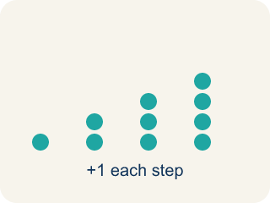
pattern (patrón) — Something that repeats or changes in a predictable way.
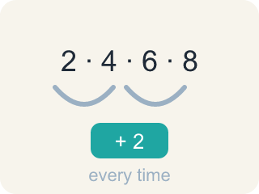
pattern rule (regla del patrón) — A rule that tells you how to get the next value in a pattern from the one before it.
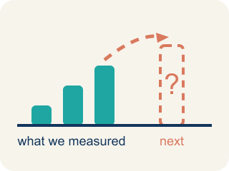
predict (predecir) — To say what will happen before it happens, using a pattern or reasoning.

organize (organizar) — To arrange information — often in a table — so patterns become easier to see.

Practice
Show your work. Use the blank space under each problem.
1. What is the fewest number of moves needed to solve a three-disc Tower of Hanoi puzzle?
A. 3 moves
B. 6 moves
C. 7 moves
D. 9 moves
______________________________________________________________________
2. Which move is against the rules of the Tower of Hanoi?
A. Moving one disc at a time
B. Moving the top disc from a stack
C. Placing a larger disc on top of a smaller disc
D. Placing a smaller disc on top of a larger disc
______________________________________________________________________
3. The number of discs in a Tower of Hanoi puzzle can vary. What NEVER varies?
______________________________________________________________________
______________________________________________________________________
______________________________________________________________________
______________________________________________________________________
4. What does it mean to be playful with math? Use the Tower of Hanoi as your example.
______________________________________________________________________
______________________________________________________________________
______________________________________________________________________
______________________________________________________________________
5. The table shows 1 disc → 1 step, 2 discs → 3 steps, 3 discs → 7 steps. What is the pattern rule for the number of steps when you add one more disc?
A. Add 2 to the number of steps
B. Add the number of discs to the steps
C. Multiply the number of steps by 3
D. Double the number of steps and add 1
______________________________________________________________________
6. Use the pattern rule to complete the table: how many steps for a four-disc tower?
A. 9 steps
B. 14 steps
C. 15 steps
D. 28 steps
______________________________________________________________________
7. What is the minimum number of steps to solve a FIVE-disc Tower of Hanoi puzzle?
A. 15 steps
B. 30 steps
C. 31 steps
D. 35 steps
______________________________________________________________________
8. How can you ORGANIZE the information about discs and moves to help you see patterns?
______________________________________________________________________
______________________________________________________________________
______________________________________________________________________
______________________________________________________________________
9. Fix our table's thinking
Step 1 (The problem): How many moves does a one-disc tower take? A two-disc tower?
Step 2 (A classmate at our table answered): 1 move and 2 moves
Which step has the mistake? Explain and fix it:
______________________________________________________________________
______________________________________________________________________
______________________________________________________________________

Answer Key (Teacher)
1. C. 7 moves
It takes at least 7 moves to solve a three-disc Tower of Hanoi puzzle.
Watch for: Doubling the previous number of steps but forgetting to add 1 — answering 14 instead of 15 for four discs, or 30 instead of 31 for five.
2. C. Placing a larger disc on top of a smaller disc
A larger disc can never be on top of a smaller disc — that is the rule that makes the puzzle a puzzle.
Watch for: Doubling the previous number of steps but forgetting to add 1 — answering 14 instead of 15 for four discs, or 30 instead of 31 for five.
3. Open response — answers will vary.
4. Open response — answers will vary.
5. D. Double the number of steps and add 1
1 × 2 + 1 = 3 and 3 × 2 + 1 = 7, so each new disc doubles the steps and adds 1.
Watch for: Doubling the previous number of steps but forgetting to add 1 — answering 14 instead of 15 for four discs, or 30 instead of 31 for five.
6. C. 15 steps
A three-disc tower takes 7 steps, so a four-disc tower takes 7 × 2 + 1 = 15 steps.
Watch for: Doubling the previous number of steps but forgetting to add 1 — answering 14 instead of 15 for four discs, or 30 instead of 31 for five.
7. C. 31 steps
A four-disc tower takes 15 steps, so a five-disc tower takes 15 × 2 + 1 = 31 steps.
Watch for: Doubling the previous number of steps but forgetting to add 1 — answering 14 instead of 15 for four discs, or 30 instead of 31 for five.
8. Open response — answers will vary.
9. Fix our table's thinking
The mistake is in Step 2.
Correct work: The correct answer is 1 move and 3 moves. You can solve a one-disc tower in 1 step and a two-disc tower in 3 steps.

