10.4 Small Group · Group 1 — Homework
Lesson 10-4-group1 • Standard MPP.4
Name: ______________________ Period: ______ Date: ____________

Today's Goals
Content: With my small group, I can use ratios and models to explain how the Penny Farthing and gear-driven bicycles were ingenious solutions to a real problem — one step at a time, with support.
Language: I can talk through each step out loud using a sentence frame and the lesson's key words.

Key Words

ingenuity (ingenio) — Coming up with different, and sometimes unique, solutions to problems.
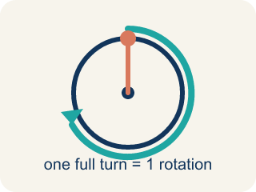
rotation (rotación) — One full turn of a wheel, gear, or pedal all the way around.
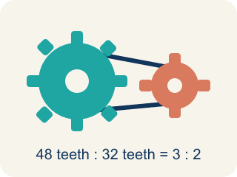
gear (engranaje) — A toothed wheel that passes motion to another toothed wheel through a chain.
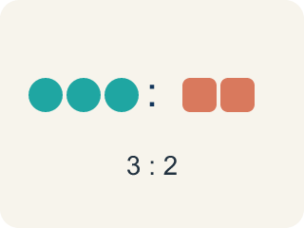
ratio (razón) — A comparison of two quantities, like pedal rotations to wheel rotations.
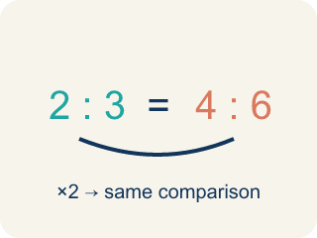
equivalent ratios (razones equivalentes) — Ratios that make the same comparison using different numbers.

Practice
Show your work. Use the blank space under each problem.
1. On the Penny Farthing, what is the ratio of pedal rotations to front-wheel rotations?
A. 1 to 1
B. 1 to 2
C. 1 to 4
D. 2 to 1
______________________________________________________________________
2. How far does the Penny Farthing travel with each pedal rotation?
A. The height of the rider
B. The length of the perimeter of the front wheel
C. The length of the pedal
D. It does not move a fixed distance
______________________________________________________________________
3. For each rotation of the 48-tooth pedal gear, how many teeth does the wheel gear turn?
A. 1 tooth
B. 12 teeth
C. 32 teeth
D. 48 teeth
______________________________________________________________________
4. Name one ingenious solution — from this lesson or from your own life — where math helped solve an everyday problem.
______________________________________________________________________
______________________________________________________________________
______________________________________________________________________
______________________________________________________________________
5. The pedal gear turns 48 teeth per rotation. The largest rear gear needs 32 teeth for one full rotation. How many rotations does the rear wheel make for each pedal rotation?
A. 0.5 rotations
B. 1.5 rotations
C. 2 rotations
D. 16 rotations
______________________________________________________________________
6. The smallest rear gear has 12 teeth. How many rotations will the rear wheel make for each rotation of the 48-tooth pedal gear?
A. 0.25 rotations
B. 3 rotations
C. 4 rotations
D. 36 rotations
______________________________________________________________________
7. You are about to ride up a steep hill. Which rear gear should the chain be on, and why?
A. The 12-tooth gear, because 4 rotations per pedal is always better
B. The 32-tooth gear, because it makes the bike go faster
C. It does not matter which gear you use on a hill
D. The 32-tooth gear, because 1.5 rotations per pedal makes pedaling easier at slow speeds
______________________________________________________________________
8. Why do you think the larger gear makes it easier to pedal at slower speeds?
______________________________________________________________________
______________________________________________________________________
______________________________________________________________________
______________________________________________________________________
9. Fix our table's thinking
Step 1 (The problem): On the Penny Farthing, what is the ratio of pedal rotations to front-wheel rotations?
Step 2 (A classmate at our table answered): 2 to 1
Which step has the mistake? Explain and fix it:
______________________________________________________________________
______________________________________________________________________
______________________________________________________________________

Answer Key (Teacher)
1. A. 1 to 1
The pedals are attached directly to the front wheel, so each pedal rotation rotates the wheel one time — a 1 to 1 ratio.
Watch for: Thinking a rear gear with MORE teeth makes the wheel spin more — it is the opposite: the 32-tooth gear gives only 1.5 rotations per pedal rotation, while the 12-tooth gear gives 4.
2. B. The length of the perimeter of the front wheel
One wheel rotation rolls the bike forward exactly the perimeter of the wheel, and one pedal rotation makes one wheel rotation.
Watch for: Thinking a rear gear with MORE teeth makes the wheel spin more — it is the opposite: the 32-tooth gear gives only 1.5 rotations per pedal rotation, while the 12-tooth gear gives 4.
3. D. 48 teeth
The chain links the gears, so one full rotation of the 48-tooth pedal gear pulls 48 teeth of chain past the wheel gear.
Watch for: Thinking a rear gear with MORE teeth makes the wheel spin more — it is the opposite: the 32-tooth gear gives only 1.5 rotations per pedal rotation, while the 12-tooth gear gives 4.
4. Open response — answers will vary.
5. B. 1.5 rotations
48 ÷ 32 = 1.5, so the rear wheel makes 1.5 rotations for each pedal rotation.
Watch for: Thinking a rear gear with MORE teeth makes the wheel spin more — it is the opposite: the 32-tooth gear gives only 1.5 rotations per pedal rotation, while the 12-tooth gear gives 4.
6. C. 4 rotations
48 ÷ 12 = 4, so the rear wheel makes 4 rotations for each pedal rotation.
Watch for: Thinking a rear gear with MORE teeth makes the wheel spin more — it is the opposite: the 32-tooth gear gives only 1.5 rotations per pedal rotation, while the 12-tooth gear gives 4.
7. D. The 32-tooth gear, because 1.5 rotations per pedal makes pedaling easier at slow speeds
The larger gear turns the wheel fewer times per pedal rotation, which makes it easier to pedal at slower speeds or go uphill.
Watch for: Thinking a rear gear with MORE teeth makes the wheel spin more — it is the opposite: the 32-tooth gear gives only 1.5 rotations per pedal rotation, while the 12-tooth gear gives 4.
8. Open response — answers will vary.
9. Fix our table's thinking
The mistake is in Step 2.
Correct work: The correct answer is 1 to 1. The pedals are attached directly to the front wheel, so each pedal rotation rotates the wheel one time — a 1 to 1 ratio.

