Math is Ingenuity — Homework
Lesson 10-4 • Standard MPP.4
Name: ______________________ Period: ______ Date: ____________

Today's Goals
Content: I can use ratios and models to explain how the Penny Farthing and gear-driven bicycles were ingenious solutions to a real problem.
Language: I can explain a gear ratio using the words rotation, teeth, and 'for each ___, the wheel turns ___.'

Key Words

ingenuity (ingenio) — Coming up with different, and sometimes unique, solutions to problems.
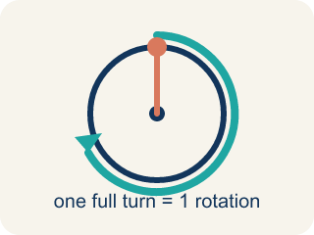
rotation (rotación) — One full turn of a wheel, gear, or pedal all the way around.
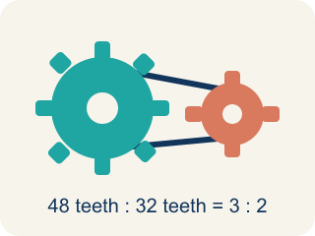
gear (engranaje) — A toothed wheel that passes motion to another toothed wheel through a chain.
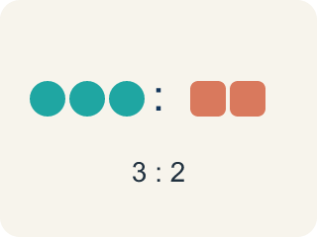
ratio (razón) — A comparison of two quantities, like pedal rotations to wheel rotations.
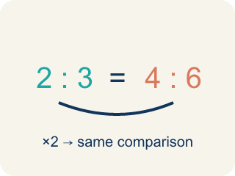
equivalent ratios (razones equivalentes) — Ratios that make the same comparison using different numbers.

Practice
Show your work. Use the blank space under each problem.
1. On the Penny Farthing, what is the ratio of pedal rotations to front-wheel rotations?
A. 1 to 1
B. 1 to 2
C. 1 to 4
D. 2 to 1
______________________________________________________________________
2. How far does the Penny Farthing travel with each pedal rotation?
A. The height of the rider
B. The length of the perimeter of the front wheel
C. The length of the pedal
D. It does not move a fixed distance
______________________________________________________________________
3. The pedal gear turns 48 teeth per rotation. The largest rear gear needs 32 teeth for one full rotation. How many rotations does the rear wheel make for each pedal rotation?
A. 0.5 rotations
B. 1.5 rotations
C. 2 rotations
D. 16 rotations
______________________________________________________________________
4. The smallest rear gear has 12 teeth. How many rotations will the rear wheel make for each rotation of the 48-tooth pedal gear?
A. 0.25 rotations
B. 3 rotations
C. 4 rotations
D. 36 rotations
______________________________________________________________________
5. You are about to ride up a steep hill. Which rear gear should the chain be on, and why?
A. The 12-tooth gear, because 4 rotations per pedal is always better
B. The 32-tooth gear, because it makes the bike go faster
C. It does not matter which gear you use on a hill
D. The 32-tooth gear, because 1.5 rotations per pedal makes pedaling easier at slow speeds
______________________________________________________________________
6. Why do you think the larger gear makes it easier to pedal at slower speeds?
______________________________________________________________________
______________________________________________________________________
______________________________________________________________________
______________________________________________________________________
7. With the chain on the 12-tooth gear, the rider makes 10 pedal rotations. How many rotations does the rear wheel make?
A. 14 rotations
B. 22 rotations
C. 40 rotations
D. 120 rotations
______________________________________________________________________
8. When the chain is on the largest gear the rear wheel makes 1.5 rotations per pedal rotation; on the smallest gear it makes 4. What do you notice about the size of the wheel gears and the distance the bike travels?
______________________________________________________________________
______________________________________________________________________
______________________________________________________________________
______________________________________________________________________
9. The pedal gear has 48 teeth. Complete the table of wheel rotations per pedal turn.
Rear gear (teeth) | Ratio 48 ÷ teeth | Wheel rotations per pedal turn
12 | 48 ÷ 12
16 | 48 ÷ 16
24 | 48 ÷ 24
______________________________________________________________________

Answer Key (Teacher)
1. A. 1 to 1
The pedals are attached directly to the front wheel, so each pedal rotation rotates the wheel one time — a 1 to 1 ratio.
Watch for: Thinking a rear gear with MORE teeth makes the wheel spin more — it is the opposite: the 32-tooth gear gives only 1.5 rotations per pedal rotation, while the 12-tooth gear gives 4.
2. B. The length of the perimeter of the front wheel
One wheel rotation rolls the bike forward exactly the perimeter of the wheel, and one pedal rotation makes one wheel rotation.
Watch for: Thinking a rear gear with MORE teeth makes the wheel spin more — it is the opposite: the 32-tooth gear gives only 1.5 rotations per pedal rotation, while the 12-tooth gear gives 4.
3. B. 1.5 rotations
48 ÷ 32 = 1.5, so the rear wheel makes 1.5 rotations for each pedal rotation.
Watch for: Thinking a rear gear with MORE teeth makes the wheel spin more — it is the opposite: the 32-tooth gear gives only 1.5 rotations per pedal rotation, while the 12-tooth gear gives 4.
4. C. 4 rotations
48 ÷ 12 = 4, so the rear wheel makes 4 rotations for each pedal rotation.
Watch for: Thinking a rear gear with MORE teeth makes the wheel spin more — it is the opposite: the 32-tooth gear gives only 1.5 rotations per pedal rotation, while the 12-tooth gear gives 4.
5. D. The 32-tooth gear, because 1.5 rotations per pedal makes pedaling easier at slow speeds
The larger gear turns the wheel fewer times per pedal rotation, which makes it easier to pedal at slower speeds or go uphill.
Watch for: Thinking a rear gear with MORE teeth makes the wheel spin more — it is the opposite: the 32-tooth gear gives only 1.5 rotations per pedal rotation, while the 12-tooth gear gives 4.
6. Open response — answers will vary.
7. C. 40 rotations
The rear wheel makes 4 rotations per pedal rotation, so 10 pedal rotations give 10 × 4 = 40 wheel rotations.
Watch for: Thinking a rear gear with MORE teeth makes the wheel spin more — it is the opposite: the 32-tooth gear gives only 1.5 rotations per pedal rotation, while the 12-tooth gear gives 4.
8. Open response — answers will vary.
9. The pedal gear has 48 teeth. Complete the table of wheel rotations per pedal turn.
→ 4
→ 3
→ 2

