10.6 Small Group · Group 2 — Homework
Lesson 10-6-group2 • Standard MPP.3
Name: ______________________ Period: ______ Date: ____________

Today's Goals
Content: I can look back at my answers from Lesson 1-1, describe how my math biography has changed this year, and recognize ways we are all doers of math, explain how I can tell, and judge a case I have not seen before.
Language: I can justify my answer to a skeptic and connect it to a second strategy or representation.

Key Words

math biography (biografía matemática) — The story of your relationship with math — and how it has changed over time.
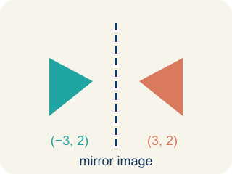
reflect (reflexionar) — To look back at what you did, felt, and learned, and think about what it means.
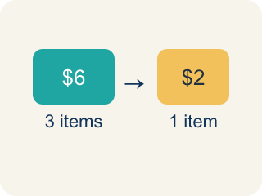
growth (crecimiento) — The change between what you could do before and what you can do now.

confidence (confianza) — Trusting yourself to try a problem, even when the first attempt might fail.

community (comunidad) — The people and places around you — where math shows up outside the classroom.

Practice
Show your work. Use the blank space under each problem.
1. Percents were new this year. What is 50% of 157?
A. 31.4
B. 77.5
C. 78.5
D. 107
______________________________________________________________________
2. What challenges did you face in math this year, and how did you respond to these challenges?
______________________________________________________________________
______________________________________________________________________
______________________________________________________________________
______________________________________________________________________
3. Which of these is the strongest evidence that YOUR math reasoning grew this year?
A. You finish worksheets faster than in September
B. You memorized more answers than before
C. You can explain why a method works, not just follow its steps
D. You stopped making any mistakes
______________________________________________________________________

Answer Key (Teacher)
1. C. 78.5
50% means half, and 157 ÷ 2 = 78.5 — the very number you decomposed back in Lesson 1-1.
Watch for: Treating your math story as finished — writing the same answers you wrote in Lesson 1-1 instead of looking for what actually changed. The story grows and evolves; a retrospective that copies September has missed the point.
2. Open response — answers will vary.
3. C. You can explain why a method works, not just follow its steps
Constructing and explaining reasoning is the growth this lesson asks you to look for — it is what makes the math yours.
Watch for: Treating your math story as finished — writing the same answers you wrote in Lesson 1-1 instead of looking for what actually changed. The story grows and evolves; a retrospective that copies September has missed the point.

