Math is Mine — Homework
Lesson 10-6 • Standard MPP.3
Name: ______________________ Period: ______ Date: ____________

Today's Goals
Content: I can look back at my answers from Lesson 1-1, describe how my math biography has changed this year, and recognize ways we are all doers of math.
Language: I can compare my beginning-of-year and end-of-year math stories using the words then, now, changed, and grown.

Key Words

math biography (biografía matemática) — The story of your relationship with math — and how it has changed over time.
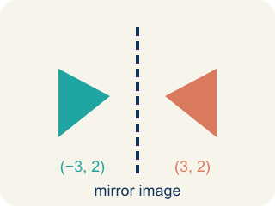
reflect (reflexionar) — To look back at what you did, felt, and learned, and think about what it means.
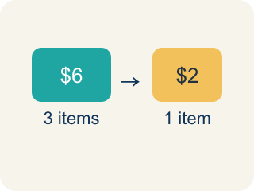
growth (crecimiento) — The change between what you could do before and what you can do now.

confidence (confianza) — Trusting yourself to try a problem, even when the first attempt might fail.

community (comunidad) — The people and places around you — where math shows up outside the classroom.

Practice
Show your work. Use the blank space under each problem.
1. In Lesson 1-1 you estimated the Ferris wheel: 20 cars each holding about 4 people. About how many riders was that?
A. About 5
B. About 24
C. About 80
D. About 400
______________________________________________________________________
2. How has your attitude about math changed over the year?
______________________________________________________________________
______________________________________________________________________
______________________________________________________________________
______________________________________________________________________
3. Now stretch the September estimate with this year's math: about 80 riders per turn, 6 turns each hour. About how many riders per hour?
A. About 13
B. About 86
C. About 480
D. About 800
______________________________________________________________________
4. Percents were new this year. What is 50% of 157?
A. 31.4
B. 77.5
C. 78.5
D. 107
______________________________________________________________________
5. What challenges did you face in math this year, and how did you respond to these challenges?
______________________________________________________________________
______________________________________________________________________
______________________________________________________________________
______________________________________________________________________
6. Which of these is the strongest evidence that YOUR math reasoning grew this year?
A. You finish worksheets faster than in September
B. You memorized more answers than before
C. You can explain why a method works, not just follow its steps
D. You stopped making any mistakes
______________________________________________________________________
7. Ask a classmate, family member, or trusted adult how their math story has changed. You may also reflect on your own story. Describe one change since the beginning of the year and give an example.
______________________________________________________________________
______________________________________________________________________
______________________________________________________________________
______________________________________________________________________
8. In what areas are you more confident about math now? What are your strengths in math?
______________________________________________________________________
______________________________________________________________________
______________________________________________________________________
______________________________________________________________________
9. Answer each quick problem with this year's skills — the same numbers you met in Lesson 1-1.
Problem from this year | Thinking | Answer
50% of 157 | half of 157
10% of 480 | move the decimal
Riders per hour: 80 per turn × 6 turns | 80 × 6
______________________________________________________________________

Answer Key (Teacher)
1. C. About 80
20 × 4 = 80 — the same estimate you made in September, and it still holds up.
Watch for: Treating your math story as finished — writing the same answers you wrote in Lesson 1-1 instead of looking for what actually changed. The story grows and evolves; a retrospective that copies September has missed the point.
2. Open response — answers will vary.
3. C. About 480
80 riders on each of 6 turns is 80 × 6 = 480 riders per hour — a rate, one of this year's tools.
Watch for: Treating your math story as finished — writing the same answers you wrote in Lesson 1-1 instead of looking for what actually changed. The story grows and evolves; a retrospective that copies September has missed the point.
4. C. 78.5
50% means half, and 157 ÷ 2 = 78.5 — the very number you decomposed back in Lesson 1-1.
Watch for: Treating your math story as finished — writing the same answers you wrote in Lesson 1-1 instead of looking for what actually changed. The story grows and evolves; a retrospective that copies September has missed the point.
5. Open response — answers will vary.
6. C. You can explain why a method works, not just follow its steps
Constructing and explaining reasoning is the growth this lesson asks you to look for — it is what makes the math yours.
Watch for: Treating your math story as finished — writing the same answers you wrote in Lesson 1-1 instead of looking for what actually changed. The story grows and evolves; a retrospective that copies September has missed the point.
7. Open response — answers will vary.
8. Open response — answers will vary.
9. Answer each quick problem with this year's skills — the same numbers you met in Lesson 1-1.
→ 78.5
→ 48
→ 480

