2.12 Small Group · Group 1 — Homework
Lesson 2-12-group1 • Standard 6.NOS.3
Name: ______________________ Period: ______ Date: ____________

Today's Goals
Content: With my small group, I can multiply decimals and place the decimal point correctly in the product — one step at a time, with support.
Language: I can talk through each step out loud using a sentence frame and the lesson's key words.

Key Words
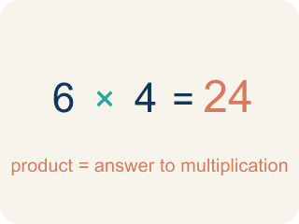
Product (Producto) — The answer when you multiply.
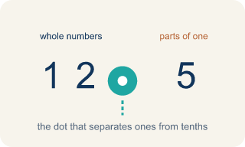
Decimal point (Punto decimal) — The dot that splits the whole number from the part after it.
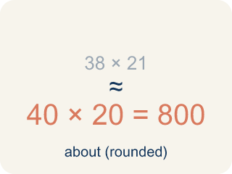
Estimate (Estimar) — A close answer you get by rounding first.
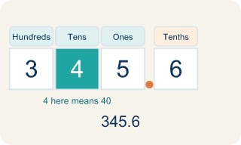
Place value (Valor posicional) — What a digit is worth based on where it sits in a number.
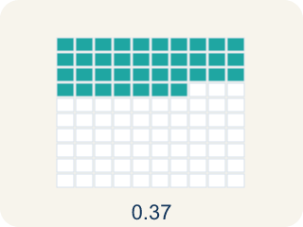
Decimal places (Cifras decimales) — How many digits come after the decimal point.

Practice
Show your work. Use the blank space under each problem.
1. What is 3.4 × 2.6?
A. 0.884
B. 8.48
C. 8.84
D. 88.4
______________________________________________________________________
2. What is 0.7 × 1.5?
A. 0.105
B. 1.05
C. 1.50
D. 10.5
______________________________________________________________________
3. Spot the Common Mistake — Counting Decimal Places
Step 1 (Problem): 0.3 × 0.6
Step 2 (Multiply as whole numbers): 3 × 6 = 18
Step 3 (Count decimal places): 0.3 has 1 decimal place and 0.6 has 1 decimal place → 1 total
Step 4 (Place the decimal point): Move the point 1 place in 18 to get 1.8
Which step has the mistake? Explain and fix it:
______________________________________________________________________
______________________________________________________________________
______________________________________________________________________
4. A car travels 55.5 miles per hour for 2.4 hours. How far does it go?
A. 13.32 miles
B. 57.9 miles
C. 133.2 miles
D. 1,332 miles
______________________________________________________________________
5. Spot the Common Mistake — Placing the Decimal Point
Step 1 (Problem): 1.5 × 2.4
Step 2 (Multiply as whole numbers): 15 × 24 = 360
Step 3 (Count decimal places): 1.5 has 1 decimal place and 2.4 has 1 decimal place → 2 total
Step 4 (Place the decimal point): Move the point 2 places in 360 to get 0.36
Which step has the mistake? Explain and fix it:
______________________________________________________________________
______________________________________________________________________
______________________________________________________________________
6. A customer orders 3 taco baskets at $4.25 each. What is the total before tax?
A. $1.275
B. $12.15
C. $12.75
D. $127.50
______________________________________________________________________
7. Each lemonade uses 0.6 of a cup of sugar, and sugar costs $0.40 per cup. How much sugar cost is in one lemonade? (0.6 × 0.4)
A. $0.024
B. $0.24
C. $2.40
D. $24.00
______________________________________________________________________
8. The truck sells 2.5 pounds of fries, and each pound earns $1.20 in profit. What is the total profit? (2.5 × 1.2)
A. $0.30
B. $3.00
C. $3.70
D. $30.00
______________________________________________________________________
9. Fix our table's thinking
Step 1 (The problem): Which estimate is closest to 4.8 × 3.2?
Step 2 (A classmate at our table answered): 48 × 32 = 1,536
Which step has the mistake? Explain and fix it:
______________________________________________________________________
______________________________________________________________________
______________________________________________________________________

Answer Key (Teacher)
1. C. 8.84
34 × 26 = 884. There are 2 total decimal places (1 + 1), so place the decimal to get 8.84.
Watch for: A common mistake in Multiply Decimals is counting decimal places from only one factor instead of adding the decimal places from BOTH factors. For example, in 0.4 × 0.06, a student multiplies 4 × 6 = 24, then places the decimal point using just one factor's place count (1 place), writing 0.24 instead of the correct answer: 0.4 has 1 decimal place and 0.06 has 2 decimal places, for a total of 3, so 24 becomes 0.024. Before you submit, count the decimal places in EACH factor separately and add them together — that total is how many decimal places belong in your final answer.
2. B. 1.05
7 × 15 = 105. There are 2 total decimal places (1 + 1), so place the decimal to get 1.05.
Watch for: A common mistake in Multiply Decimals is counting decimal places from only one factor instead of adding the decimal places from BOTH factors. For example, in 0.4 × 0.06, a student multiplies 4 × 6 = 24, then places the decimal point using just one factor's place count (1 place), writing 0.24 instead of the correct answer: 0.4 has 1 decimal place and 0.06 has 2 decimal places, for a total of 3, so 24 becomes 0.024. Before you submit, count the decimal places in EACH factor separately and add them together — that total is how many decimal places belong in your final answer.
3. Spot the Common Mistake — Counting Decimal Places
The mistake is in Step 3.
Correct work: The whole-number product 3 × 6 = 18 is correct, but the decimal-place count is wrong. 0.3 has 1 place and 0.6 has 1 place, so 1 + 1 = 2 total places — not 1. Move the point 2 places from the right in 18 to get 0.18. So 0.3 × 0.6 = 0.18.
Watch for: The count of decimal places is wrong. 0.3 has 1 decimal place and 0.6 has 1, so the product needs 1 + 1 = 2 places, not 1. The digits 3 × 6 = 18 are correct, and moving the point 2 places from the right gives 0.18. That size also makes sense: taking 0.3 of 0.6 must land below both factors, so 1.8 is far too large.
4. C. 133.2 miles
555 × 24 = 13,320. Total decimal places: 1 + 1 = 2. Answer: 133.20 = 133.2 miles.
Watch for: A common mistake in Multiply Decimals is counting decimal places from only one factor instead of adding the decimal places from BOTH factors. For example, in 0.4 × 0.06, a student multiplies 4 × 6 = 24, then places the decimal point using just one factor's place count (1 place), writing 0.24 instead of the correct answer: 0.4 has 1 decimal place and 0.06 has 2 decimal places, for a total of 3, so 24 becomes 0.024. Before you submit, count the decimal places in EACH factor separately and add them together — that total is how many decimal places belong in your final answer.
5. Spot the Common Mistake — Placing the Decimal Point
The mistake is in Step 4.
Correct work: The whole-number product 15 × 24 = 360 and the count of 2 decimal places are both correct. The mistake is in placing the point: moving it 2 places from the right in 360 gives 3.60, not 0.36. So 1.5 × 2.4 = 3.6. An estimate of 2 × 2 = 4 confirms 3.6 is reasonable, while 0.36 is far too small.
Watch for: The digits 15 × 24 = 360 and the count of 2 decimal places are both correct; only the placement is off. Counting 2 places from the right end of 360 lands the point between the 3 and the 6, giving 3.60 = 3.6. An estimate of 2 × 2 = 4 confirms that 3.6 is the reasonable size and 0.36 is about ten times too small.
6. C. $12.75
3 × 425 = 1,275. The factor $4.25 has 2 decimal places, so 3 × $4.25 = $12.75.
Watch for: A common mistake in Multiply Decimals is counting decimal places from only one factor instead of adding the decimal places from BOTH factors. For example, in 0.4 × 0.06, a student multiplies 4 × 6 = 24, then places the decimal point using just one factor's place count (1 place), writing 0.24 instead of the correct answer: 0.4 has 1 decimal place and 0.06 has 2 decimal places, for a total of 3, so 24 becomes 0.024. Before you submit, count the decimal places in EACH factor separately and add them together — that total is how many decimal places belong in your final answer.
7. B. $0.24
6 × 4 = 24. There are 2 total decimal places (1 + 1), so 0.6 × 0.4 = 0.24, which is $0.24.
Watch for: A common mistake in Multiply Decimals is counting decimal places from only one factor instead of adding the decimal places from BOTH factors. For example, in 0.4 × 0.06, a student multiplies 4 × 6 = 24, then places the decimal point using just one factor's place count (1 place), writing 0.24 instead of the correct answer: 0.4 has 1 decimal place and 0.06 has 2 decimal places, for a total of 3, so 24 becomes 0.024. Before you submit, count the decimal places in EACH factor separately and add them together — that total is how many decimal places belong in your final answer.
8. B. $3.00
25 × 12 = 300. There are 2 total decimal places (1 + 1), so 2.5 × 1.2 = 3.00 = $3.00.
Watch for: A common mistake in Multiply Decimals is counting decimal places from only one factor instead of adding the decimal places from BOTH factors. For example, in 0.4 × 0.06, a student multiplies 4 × 6 = 24, then places the decimal point using just one factor's place count (1 place), writing 0.24 instead of the correct answer: 0.4 has 1 decimal place and 0.06 has 2 decimal places, for a total of 3, so 24 becomes 0.024. Before you submit, count the decimal places in EACH factor separately and add them together — that total is how many decimal places belong in your final answer.
9. Fix our table's thinking
The mistake is in Step 2.
Correct work: The correct answer is 5 × 3 = 15. Round 4.8 to 5 and 3.2 to 3. The estimate 5 × 3 = 15 is closest to the exact answer 15.36.

