3.8 · 3.10 · 4.4 · 4.5 Catch-Up — Homework
Lesson 3-8-catchup • Standard 6.AT.2
Name: ______________________ Period: ______ Date: ____________

Today's Goals
Content: I can show I am caught up on Lessons 3.8 · 3.10 · 4.4 · 4.5 by using each lesson's big idea in mixed practice.
Language: I can explain which lesson's big idea I used and how, using key vocabulary from Lessons 3.8 · 3.10 · 4.4 · 4.5.

Key Words
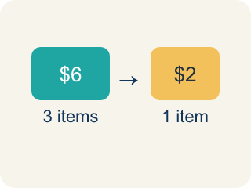
Unit Rate (Tasa unitaria) — A rate for just 1 of something, like cost for 1 item.
Better Buy (Mejor compra) — The choice that costs less for each item.
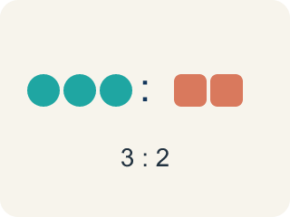
Comparison (Comparación) — Looking at two or more amounts to see how they are related.
Per Unit (Por unidad) — For each single item.
Rate (Tasa) — A ratio comparing two amounts with different units, like miles per hour.
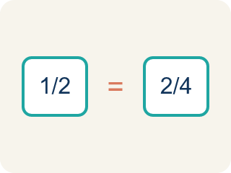
Proportion (Proporción) — A math sentence saying two ratios are equal. It helps find a missing number.
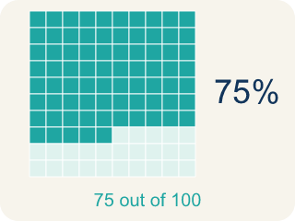
Percent (Porcentaje) — A way to compare a number to 100, shown with the % sign.
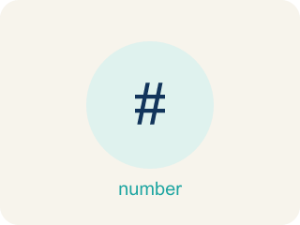
Percent Problem Solving (Resolución de problemas con porcentajes) — Use a percent to find a part, a whole, or a percent change in a real situation.
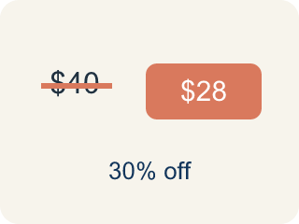
Discount (Descuento) — Money taken off the first price to make it cheaper.
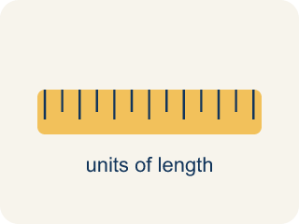
Conversion Factor (Factor de conversión) — A ratio that helps you change one unit into another.
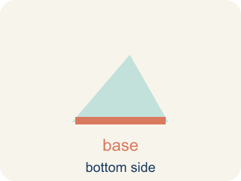
Base (Base) — The number you take the percent OF — it is the number right after the word 'of'.
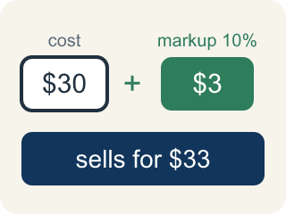
Markup (Recargo (margen)) — Money added to the cost to set the selling price.
Unit (Unidad) — A standard amount used to measure, like an inch or a liter.

Practice
Show your work. Use the blank space under each problem.
1. (Lesson 3.8) Which is the better buy: 6 bouncy balls for $4.50 or 10 bouncy balls for $8.00?
A. 10 for $8.00 — $0.80 each
B. They cost the same per ball
C. Not enough information
D. 6 for $4.50 — $0.75 each
______________________________________________________________________
2. (Lesson 3.8) A faucet drips 15 ounces of water in 5 minutes. What is the unit rate?
A. 0.33 ounces per minute
B. 3 ounces per minute
C. 5 ounces per minute
D. 15 ounces per minute
______________________________________________________________________
3. (Lesson 3.8) A machine dispenses 24 tokens in 3 minutes. At this rate, how many tokens does it dispense in 10 minutes?
A. 60 tokens
B. 72 tokens
C. 80 tokens
D. 240 tokens
______________________________________________________________________
4. (Lesson 3.8) A factory produces 360 widgets in 8 hours. At the same rate, how many widgets are produced in a 12-hour shift?
A. 360 widgets
B. 480 widgets
C. 540 widgets
D. 720 widgets
______________________________________________________________________
5. (Lesson 3.10) A shelf is 30 inches long. How many feet and inches is that?
A. 1 foot 18 inches
B. 2 feet 6 inches
C. 2 feet 8 inches
D. 3 feet 0 inches
______________________________________________________________________
6. (Lesson 3.10) Spot the Common Mistake
Step 1 (Convert 80 ounces of bolts to pounds): 80 ounces → pounds
Step 2 (Use the conversion factor): 1 pound = 16 ounces
Step 3 (Operate): 80 × 16 = 1,280 pounds
Step 4 (Final answer): 80 ounces = 1,280 pounds
Which step has the mistake? Explain and fix it:
______________________________________________________________________
______________________________________________________________________
______________________________________________________________________
7. (Lesson 4.4) An arcade prize costs 240 tickets. If you have a coupon for 15% off, how many tickets do you save?
A. 15 tickets
B. 24 tickets
C. 36 tickets
D. 204 tickets
______________________________________________________________________
8. (Lesson 4.4) A student scored 72 out of 90 on a test. What percent did they score?
A. 72%
B. 75%
C. 80%
D. 90%
______________________________________________________________________
9. (Lesson 4.5) A car is now worth $26,600, which is 70% of its purchase price. What was the purchase price?
A. $18,620
B. $26,670
C. $38,000
D. $45,200
______________________________________________________________________
10. (Lesson 4.5) Which statement correctly names the pieces of "18 students is 30% of the class"?
A. 18 is the whole, 30% is the part
B. 30 is the part, 18 is the percent
C. The class size is the part
D. 18 is the part, 30% is the percent, the class size is the whole
______________________________________________________________________

Answer Key (Teacher)
1. D. 6 for $4.50 — $0.75 each
$4.50 ÷ 6 = $0.75 each. $8.00 ÷ 10 = $0.80 each. $0.75 < $0.80, so 6 for $4.50 is the better buy.
Watch for: A common mistake when finding the whole is multiplying by the percent instead of dividing. For "$42 is 60% of the original price," computing 0.6 × 42 = $25.20 makes the original price SMALLER than the sale price — impossible for a discount. Since percent × whole = part, the whole is found by dividing: 42 ÷ 0.6 = $70. Whenever the percent is less than 100%, the whole must come out larger than the part, so a smaller answer is the tell.
2. B. 3 ounces per minute
15 ÷ 5 = 3 ounces per minute.
Watch for: A common mistake when finding the whole is multiplying by the percent instead of dividing. For "$42 is 60% of the original price," computing 0.6 × 42 = $25.20 makes the original price SMALLER than the sale price — impossible for a discount. Since percent × whole = part, the whole is found by dividing: 42 ÷ 0.6 = $70. Whenever the percent is less than 100%, the whole must come out larger than the part, so a smaller answer is the tell.
3. C. 80 tokens
Unit rate: 24 ÷ 3 = 8 tokens per minute. In 10 minutes: 8 × 10 = 80 tokens.
Watch for: A common mistake when finding the whole is multiplying by the percent instead of dividing. For "$42 is 60% of the original price," computing 0.6 × 42 = $25.20 makes the original price SMALLER than the sale price — impossible for a discount. Since percent × whole = part, the whole is found by dividing: 42 ÷ 0.6 = $70. Whenever the percent is less than 100%, the whole must come out larger than the part, so a smaller answer is the tell.
4. C. 540 widgets
Unit rate: 360 ÷ 8 = 45 widgets per hour. In 12 hours: 45 × 12 = 540 widgets.
Watch for: A common mistake when finding the whole is multiplying by the percent instead of dividing. For "$42 is 60% of the original price," computing 0.6 × 42 = $25.20 makes the original price SMALLER than the sale price — impossible for a discount. Since percent × whole = part, the whole is found by dividing: 42 ÷ 0.6 = $70. Whenever the percent is less than 100%, the whole must come out larger than the part, so a smaller answer is the tell.
5. B. 2 feet 6 inches
30 ÷ 12 = 2 remainder 6. So 30 inches = 2 feet 6 inches.
Watch for: A common mistake when finding the whole is multiplying by the percent instead of dividing. For "$42 is 60% of the original price," computing 0.6 × 42 = $25.20 makes the original price SMALLER than the sale price — impossible for a discount. Since percent × whole = part, the whole is found by dividing: 42 ÷ 0.6 = $70. Whenever the percent is less than 100%, the whole must come out larger than the part, so a smaller answer is the tell.
6. (Lesson 3.10) Spot the Common Mistake
The mistake is in Step 3.
Correct work: Ounces are smaller than pounds, so you divide (not multiply): 80 ÷ 16 = 5 pounds. Changing to a bigger unit gives a smaller number.
Watch for: The Operate step multiplied when it should have divided. Pounds are bigger than ounces, so the 80 ounces bundle into 80 ÷ 16 = 5 pounds. An answer of 1,280 pounds should stand out immediately — a container of bolts that weighs 80 ounces is only about 5 pounds.
7. C. 36 tickets
15% of 240 = 0.15 × 240 = 36 tickets saved.
Watch for: A common mistake when finding the whole is multiplying by the percent instead of dividing. For "$42 is 60% of the original price," computing 0.6 × 42 = $25.20 makes the original price SMALLER than the sale price — impossible for a discount. Since percent × whole = part, the whole is found by dividing: 42 ÷ 0.6 = $70. Whenever the percent is less than 100%, the whole must come out larger than the part, so a smaller answer is the tell.
8. C. 80%
72/90 simplifies to 8/10, and 10 × 10 = 100, so 8 × 10 = 80. That makes 72/90 = 80/100 = 80%.
Watch for: A common mistake when finding the whole is multiplying by the percent instead of dividing. For "$42 is 60% of the original price," computing 0.6 × 42 = $25.20 makes the original price SMALLER than the sale price — impossible for a discount. Since percent × whole = part, the whole is found by dividing: 42 ÷ 0.6 = $70. Whenever the percent is less than 100%, the whole must come out larger than the part, so a smaller answer is the tell.
9. C. $38,000
Write 0.7v = 26,600 and divide: v = 26,600 ÷ 0.7 = $38,000.
Watch for: A common mistake when finding the whole is multiplying by the percent instead of dividing. For "$42 is 60% of the original price," computing 0.6 × 42 = $25.20 makes the original price SMALLER than the sale price — impossible for a discount. Since percent × whole = part, the whole is found by dividing: 42 ÷ 0.6 = $70. Whenever the percent is less than 100%, the whole must come out larger than the part, so a smaller answer is the tell.
10. D. 18 is the part, 30% is the percent, the class size is the whole
The known count is the part, the percent describes it, and the missing class size is the whole (100%).
Watch for: A common mistake when finding the whole is multiplying by the percent instead of dividing. For "$42 is 60% of the original price," computing 0.6 × 42 = $25.20 makes the original price SMALLER than the sale price — impossible for a discount. Since percent × whole = part, the whole is found by dividing: 42 ÷ 0.6 = $70. Whenever the percent is less than 100%, the whole must come out larger than the part, so a smaller answer is the tell.

