3.9 Small Group · Group 1 — Homework
Lesson 3-9-group1 • Standard 6.AT.3
Name: ______________________ Period: ______ Date: ____________

Today's Goals
Content: With my small group, I can find and check equivalent ratios using multiplication and division — one step at a time, with support.
Language: I can talk through each step out loud using a sentence frame and the lesson's key words.

Key Words
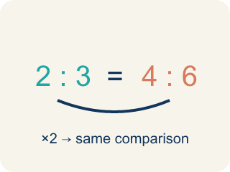
Equivalent Ratios (Razones equivalentes) — Ratios that compare quantities in the same relationship.
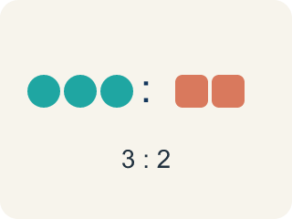
Ratio (Razón) — A way to compare two amounts, like 3 to 2.
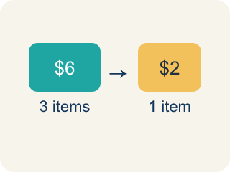
Rate (Tasa) — A ratio comparing two amounts with different units, like miles per hour.
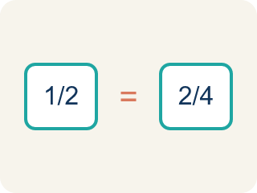
Proportion (Proporción) — A math sentence saying two ratios are equal.

Simplify (Simplificar) — To write a ratio with smaller numbers that still compares the same way. 6:8 and 3:4 are the same ratio.
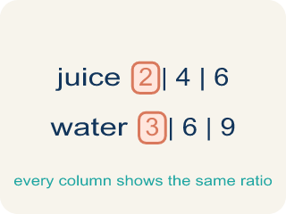
Ratio table (Tabla de razones) — A table of equal ratios that shows a pattern.

Practice
Show your work. Use the blank space under each problem.
1. Which ratio is equivalent to 2:5?
A. 2:10
B. 3:6
C. 4:10
D. 5:2
______________________________________________________________________
2. A recipe uses 4 eggs for every 6 cups of flour. Which ratio is equivalent?
A. 2:3
B. 4:3
C. 6:4
D. 8:10
______________________________________________________________________
3. Spot the Common Mistake — Lemonade Ratio
Step 1 (Set up the ratio): 2 cups lemon : 5 cups water = 6 cups lemon : ? cups water
Step 2 (Find the multiplier): 6 ÷ 2 = 3
Step 3 (Apply to the water): 5 + 3 = 8
Step 4 (Answer): 6 cups lemon : 8 cups water
Which step has the mistake? Explain and fix it:
______________________________________________________________________
______________________________________________________________________
______________________________________________________________________
4. Marcus earns $45 for every 3 hours of work. How much does he earn in 8 hours?
A. $90
B. $105
C. $120
D. $135
______________________________________________________________________
5. Spot the Common Mistake — Simplifying a Ratio
Step 1 (Set up the ratio): A student wants to write 12:18 in simplest form.
Step 2 (Find the common factor): Both 12 and 18 can be divided by 6.
Step 3 (Divide each part): 12 ÷ 6 = 2 and 18 ÷ 3 = 6, so they wrote 2:6.
Step 4 (Answer): 12:18 simplifies to 2:6
Which step has the mistake? Explain and fix it:
______________________________________________________________________
______________________________________________________________________
______________________________________________________________________
6. Chef Montoya's dressing uses 3 spoons of oil to 4 spoons of vinegar (3:4). Which recipe card shows an EQUIVALENT ratio?
A. 3:8
B. 4:3
C. 6:7
D. 9:12
______________________________________________________________________
7. The lemonade station mixes 5 cups of lemon juice to 2 cups of sugar (5:2). Which batch keeps the SAME taste?
A. 5:4
B. 7:4
C. 10:6
D. 15:6
______________________________________________________________________
8. Level 2 Extension — The Scaled-Up Pancake Batter
Step 1 (Set up the ratio): 3 cups flour : 8 cups water = ? : 24 cups water
Step 2 (Find the multiplier): 24 ÷ 8 = 3
Step 3 (Apply to the flour): 3 + 3 = 6
Step 4 (Answer): 6 cups flour : 24 cups water
Which step has the mistake? Explain and fix it:
______________________________________________________________________
______________________________________________________________________
______________________________________________________________________
9. Fix our table's thinking
Step 1 (The problem): The lemonade station mixes 5 cups of lemon juice to 2 cups of sugar (5:2). Which batch keeps the SAME taste?
Step 2 (A classmate at our table answered): 7:4
Which step has the mistake? Explain and fix it:
______________________________________________________________________
______________________________________________________________________
______________________________________________________________________

Answer Key (Teacher)
1. C. 4:10
Multiply both parts by 2: 2×2 = 4 and 5×2 = 10, so 4:10 is equivalent to 2:5.
Watch for: A common mistake in Equivalent Ratios is ADDING the scale factor to one part instead of MULTIPLYING both parts by it. For example, scaling 2:5 by a factor of 4 should give 8:20 (2×4 and 5×4) — not 6:9 (2+4 and 5+4). Adding changes the taste of the recipe (and the value of the ratio); only multiplying or dividing both numbers by the same amount keeps it equivalent.
2. A. 2:3
Divide both by 2: 4÷2 = 2 and 6÷2 = 3. The ratio 2:3 is equivalent to 4:6.
Watch for: A common mistake in Equivalent Ratios is ADDING the scale factor to one part instead of MULTIPLYING both parts by it. For example, scaling 2:5 by a factor of 4 should give 8:20 (2×4 and 5×4) — not 6:9 (2+4 and 5+4). Adding changes the taste of the recipe (and the value of the ratio); only multiplying or dividing both numbers by the same amount keeps it equivalent.
3. Spot the Common Mistake — Lemonade Ratio
The mistake is in Step 3.
Correct work: 5 × 3 = 15 (multiply both parts by the scale factor, do not add it), so the answer is 6 cups lemon : 15 cups water.
Watch for: The "Apply to the water" step adds the scale factor instead of multiplying by it. The lemon went from 2 to 6, which is × 3, so the water must also be × 3: 5 × 3 = 15. The equivalent ratio is 6 cups lemon : 15 cups water, and you can check it because 6:15 and 2:5 both simplify to 2:5.
4. C. $120
Unit rate: $45 ÷ 3 = $15/hour. In 8 hours: $15 × 8 = $120.
Watch for: A common mistake in Equivalent Ratios is ADDING the scale factor to one part instead of MULTIPLYING both parts by it. For example, scaling 2:5 by a factor of 4 should give 8:20 (2×4 and 5×4) — not 6:9 (2+4 and 5+4). Adding changes the taste of the recipe (and the value of the ratio); only multiplying or dividing both numbers by the same amount keeps it equivalent.
5. Spot the Common Mistake — Simplifying a Ratio
The mistake is in Step 3.
Correct work: Divide BOTH parts by the same number: 12 ÷ 6 = 2 and 18 ÷ 6 = 3, so 12:18 simplifies to 2:3.
Watch for: The "Divide each part" step uses two different divisors: 12 ÷ 6 but 18 ÷ 3. Simplifying only keeps a ratio equivalent when both parts are divided by the same number, so 12 ÷ 6 = 2 and 18 ÷ 6 = 3 give 2:3. The student's 2:6 simplifies to 1:3, which is not the same comparison as 12:18.
6. D. 9:12
Multiply both parts of 3:4 by 3: 3 x 3 = 9 and 4 x 3 = 12, so 9:12 is equivalent to 3:4.
Watch for: A common mistake in Equivalent Ratios is ADDING the scale factor to one part instead of MULTIPLYING both parts by it. For example, scaling 2:5 by a factor of 4 should give 8:20 (2×4 and 5×4) — not 6:9 (2+4 and 5+4). Adding changes the taste of the recipe (and the value of the ratio); only multiplying or dividing both numbers by the same amount keeps it equivalent.
7. D. 15:6
Multiply both parts of 5:2 by 3: 5 x 3 = 15 and 2 x 3 = 6, so 15:6 is equivalent to 5:2.
Watch for: A common mistake in Equivalent Ratios is ADDING the scale factor to one part instead of MULTIPLYING both parts by it. For example, scaling 2:5 by a factor of 4 should give 8:20 (2×4 and 5×4) — not 6:9 (2+4 and 5+4). Adding changes the taste of the recipe (and the value of the ratio); only multiplying or dividing both numbers by the same amount keeps it equivalent.
8. Level 2 Extension — The Scaled-Up Pancake Batter
The mistake is in Step 3.
Correct work: 3 x 3 = 9 (multiply by the scale factor, do not add it)
Watch for: The "Apply to the flour" step adds 3 instead of multiplying by 3. The water went from 8 to 24, which is a scale factor of 3, so the flour must be 3 × 3 = 9 cups, giving 9 cups flour : 24 cups water. Checking, 9:24 both divide by 3 to return to 3:8, while the answer 6:24 would simplify to 1:4.
9. Fix our table's thinking
The mistake is in Step 2.
Correct work: The correct answer is 15:6. Multiply both parts of 5:2 by 3: 5 x 3 = 15 and 2 x 3 = 6, so 15:6 is equivalent to 5:2.

