5.10 Small Group · Group 1 — Homework
Lesson 5-10-group1 • Standard 6.GR.2
Name: ______________________ Period: ______ Date: ____________

Today's Goals
Content: With my small group, I can find the volume of a rectangular prism, including ones with fractional edge lengths, using base area × height — one step at a time, with support.
Language: I can talk through each step out loud using a sentence frame and the lesson's key words.

Key Words

Volume (Volumen) — How much space is inside a solid shape.
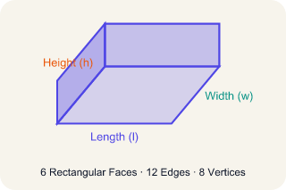
Rectangular prism (Prisma rectangular) — A solid box shape with six flat rectangle sides.
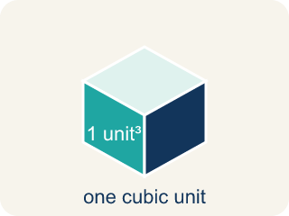
Cubic units (Unidades cúbicas) — The units used to measure space inside, like cubic inches.
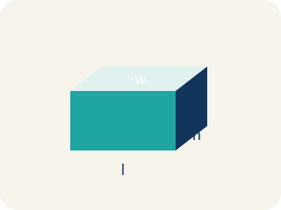
Dimensions (Dimensiones) — How long, how wide, and how tall a shape is.
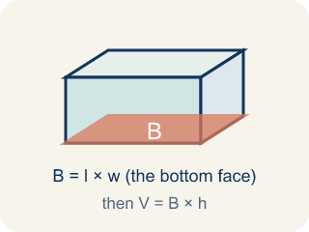
Base area (Área de la base) — The area of the bottom of a solid. Volume = base area × height.

Practice
Show your work. Use the blank space under each problem.
1. What is the volume of a rectangular prism with l = 4 in, w = 3 in, h = 5 in?
A. 12 in³
B. 24 in³
C. 60 in³
D. 60 in²
______________________________________________________________________
2. A box has a volume of 36 cm³. Its length is 6 cm and width is 3 cm. What is the height?
A. 2 cm
B. 3 cm
C. 6 cm
D. 12 cm
______________________________________________________________________
3. Two boxes: Box A is 10 × 5 × 4 inches. Box B is 8 × 6 × 5 inches. Which has more volume and by how much?
A. Box B by 40 in³
B. Box A by 40 in³
C. Box B by 60 in³
D. They're equal
______________________________________________________________________
4. What is the volume of a prism with edge lengths 1/2 m, 3 m, and 4 m?
A. 3 m³
B. 6 m³
C. 7.5 m³
D. 12 m³
______________________________________________________________________
5. A cube has an edge length of 5 cm. What is its volume?
A. 15 cm³
B. 25 cm³
C. 75 cm³
D. 125 cm³
______________________________________________________________________
6. A time-capsule box measures 6 in long, 4 in wide, and 3 in tall. What is its volume?
A. 13 cubic in
B. 24 cubic in
C. 72 cubic in
D. 72 square in
______________________________________________________________________
7. Two storage boxes are ready to pack. Box A is 5 × 5 × 2 inches and Box B is 4 × 4 × 3 inches. Which box holds more?
A. Box B, because 48 cubic in is more than 50 cubic in
B. Box A, because 50 cubic in is more than 48 cubic in
C. They hold the same amount
D. Box B, because it is taller
______________________________________________________________________
8. A keepsake box is 4 in long, 3 in wide, and 1½ in tall. What is its volume?
A. 8.5 cubic in
B. 12 cubic in
C. 18 cubic in
D. 36 cubic in
______________________________________________________________________
9. Fix our table's thinking
Step 1 (The problem): How is volume different from area?
Step 2 (A classmate at our table answered): Volume uses square units; area uses cubic units
Which step has the mistake? Explain and fix it:
______________________________________________________________________
______________________________________________________________________
______________________________________________________________________

Answer Key (Teacher)
1. C. 60 in³
V = l × w × h = 4 × 3 × 5 = 60 cubic inches.
Watch for: A common mistake in Volume of Rectangular Prisms is rounding a fractional edge length to the nearest whole number before multiplying, instead of using the exact fraction or decimal. For a box that is 2 ft × 1.5 ft × 1 ft, a student might round 1.5 down to 1 and compute 2 × 1 × 1 = 2 ft³, but the correct volume uses the exact edge length: 2 × 1.5 × 1 = 3 ft³ — a full cubic foot larger. Before you submit, ask: 'Did I multiply using the exact fractional or decimal edge length, or did I round it off first?'
2. A. 2 cm
V = l × w × h → 36 = 6 × 3 × h → 36 = 18h → h = 2 cm.
Watch for: A common mistake in Volume of Rectangular Prisms is rounding a fractional edge length to the nearest whole number before multiplying, instead of using the exact fraction or decimal. For a box that is 2 ft × 1.5 ft × 1 ft, a student might round 1.5 down to 1 and compute 2 × 1 × 1 = 2 ft³, but the correct volume uses the exact edge length: 2 × 1.5 × 1 = 3 ft³ — a full cubic foot larger. Before you submit, ask: 'Did I multiply using the exact fractional or decimal edge length, or did I round it off first?'
3. A. Box B by 40 in³
Box A: 10 × 5 × 4 = 200 in³. Box B: 8 × 6 × 5 = 240 in³. Box B is bigger by 40 in³.
Watch for: A common mistake in Volume of Rectangular Prisms is rounding a fractional edge length to the nearest whole number before multiplying, instead of using the exact fraction or decimal. For a box that is 2 ft × 1.5 ft × 1 ft, a student might round 1.5 down to 1 and compute 2 × 1 × 1 = 2 ft³, but the correct volume uses the exact edge length: 2 × 1.5 × 1 = 3 ft³ — a full cubic foot larger. Before you submit, ask: 'Did I multiply using the exact fractional or decimal edge length, or did I round it off first?'
4. B. 6 m³
V = 1/2 × 3 × 4 = 6 m³.
Watch for: A common mistake in Volume of Rectangular Prisms is rounding a fractional edge length to the nearest whole number before multiplying, instead of using the exact fraction or decimal. For a box that is 2 ft × 1.5 ft × 1 ft, a student might round 1.5 down to 1 and compute 2 × 1 × 1 = 2 ft³, but the correct volume uses the exact edge length: 2 × 1.5 × 1 = 3 ft³ — a full cubic foot larger. Before you submit, ask: 'Did I multiply using the exact fractional or decimal edge length, or did I round it off first?'
5. D. 125 cm³
A cube's volume is edge³ = 5 × 5 × 5 = 125 cm³.
Watch for: A common mistake in Volume of Rectangular Prisms is rounding a fractional edge length to the nearest whole number before multiplying, instead of using the exact fraction or decimal. For a box that is 2 ft × 1.5 ft × 1 ft, a student might round 1.5 down to 1 and compute 2 × 1 × 1 = 2 ft³, but the correct volume uses the exact edge length: 2 × 1.5 × 1 = 3 ft³ — a full cubic foot larger. Before you submit, ask: 'Did I multiply using the exact fractional or decimal edge length, or did I round it off first?'
6. C. 72 cubic in
V = length × width × height = 6 × 4 × 3 = 72 cubic in. Volume uses cubic units.
Watch for: A common mistake in Volume of Rectangular Prisms is rounding a fractional edge length to the nearest whole number before multiplying, instead of using the exact fraction or decimal. For a box that is 2 ft × 1.5 ft × 1 ft, a student might round 1.5 down to 1 and compute 2 × 1 × 1 = 2 ft³, but the correct volume uses the exact edge length: 2 × 1.5 × 1 = 3 ft³ — a full cubic foot larger. Before you submit, ask: 'Did I multiply using the exact fractional or decimal edge length, or did I round it off first?'
7. B. Box A, because 50 cubic in is more than 48 cubic in
Box A: 5 × 5 × 2 = 50 cubic in. Box B: 4 × 4 × 3 = 48 cubic in. 50 > 48, so Box A holds more.
Watch for: A common mistake in Volume of Rectangular Prisms is rounding a fractional edge length to the nearest whole number before multiplying, instead of using the exact fraction or decimal. For a box that is 2 ft × 1.5 ft × 1 ft, a student might round 1.5 down to 1 and compute 2 × 1 × 1 = 2 ft³, but the correct volume uses the exact edge length: 2 × 1.5 × 1 = 3 ft³ — a full cubic foot larger. Before you submit, ask: 'Did I multiply using the exact fractional or decimal edge length, or did I round it off first?'
8. C. 18 cubic in
V = 4 × 3 × 1.5 = 12 × 1.5 = 18 cubic in. A fractional edge does not change the steps.
Watch for: A common mistake in Volume of Rectangular Prisms is rounding a fractional edge length to the nearest whole number before multiplying, instead of using the exact fraction or decimal. For a box that is 2 ft × 1.5 ft × 1 ft, a student might round 1.5 down to 1 and compute 2 × 1 × 1 = 2 ft³, but the correct volume uses the exact edge length: 2 × 1.5 × 1 = 3 ft³ — a full cubic foot larger. Before you submit, ask: 'Did I multiply using the exact fractional or decimal edge length, or did I round it off first?'
9. Fix our table's thinking
The mistake is in Step 2.
Correct work: The correct answer is Volume uses cubic units; area uses square units. Volume measures the space inside a 3D shape (cubic units like in³). Area measures a flat 2D surface (square units like in²).

