Area of Regular Polygons — Homework
Lesson 5-9 • Standard 6.GR.1
Name: ______________________ Period: ______ Date: ____________

Today's Goals
Content: I can find the area of a regular polygon by decomposing it into triangles.
Language: I can explain my steps using the words regular polygon, decompose, triangle, and composite.

Key Words
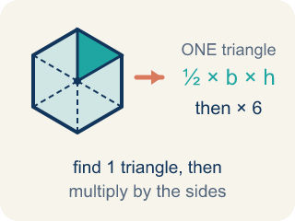
Area of Regular Polygons (Área de polígonos regulares) — The space a regular polygon covers. Split it from the center into identical triangles, find one triangle's area, then multiply by how many there are.
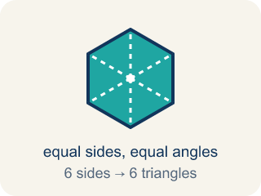
Regular Polygon (Polígono regular) — A closed flat shape made of straight sides, where every side is the same length and every angle is the same size.
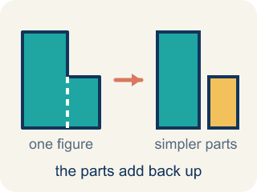
Decompose (Descomponer) — To break a shape into smaller, simpler shapes.
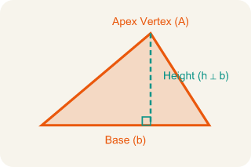
Triangle (Triángulo) — A shape with three sides.
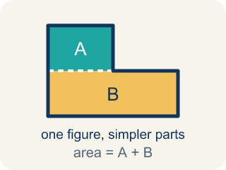
Composite (Compuesto) — Made by putting two or more simple shapes together.
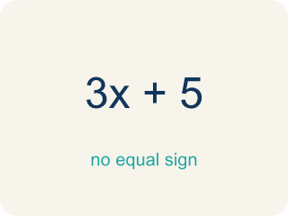
Formula (Fórmula) — A math rule written with symbols.

Practice
Show your work. Use the blank space under each problem.
1. A regular hexagon is divided into 6 equal triangles from the center. Each triangle has a base of 6 ft and a height of 5.2 ft. What is the area of one triangle? Use the given heights; nonsquare heights are rounded, so their areas are estimates.
A. 11.2 sq ft
B. 15.6 sq ft
C. 15.6 ft
D. 31.2 sq ft
______________________________________________________________________
2. A regular hexagonal skylight has 6 central triangles, each with base 6 ft and rounded height 5.2 ft. Using those measurements, what is the approximate total area?
A. 15.6 sq ft
B. 62.4 sq ft
C. 93.6 sq ft
D. 187.2 sq ft
______________________________________________________________________
3. Complete the table.
Polygon | Number of Triangles | Triangle Base | Triangle Height | Area of One Triangle | Total Area
Hexagon | 6 | 6 ft | 5.2 ft
Pentagon | 5 | 8 ft | 5.5 ft
Square | 4 | 5 ft | 2.5 ft
Octagon | 8 | 4 ft | 4.8 ft
______________________________________________________________________
4. Match each polygon to its total area. Use the given heights; nonsquare heights are rounded, so their areas are estimates.
Item | Answer choices
____ Hexagon: 6 triangles, each ½×6×5.2 | F. 7.2 sq ft
____ Pentagon: 5 triangles, each ½×8×5.5 | E. 69 sq ft
____ Octagon: 8 triangles, each ½×4×4.8 | D. 25 sq ft
____ Square: 4 triangles, each ½×5×2.5 | C. 76.8 sq ft
____ Decagon: 10 triangles, each about ½×3×4.6 | B. 110 sq ft
____ Equilateral triangle: 3 central triangles, each about ½×4×1.2 | A. 93.6 sq ft
______________________________________________________________________
5. Find the TOTAL area of each regular polygon, then sort it against the 90 sq ft cutoff. Use the given heights; nonsquare heights are rounded, so their areas are estimates.
Groups: Total area ≥ 90 sq ft | Total area < 90 sq ft
• Pentagon: 5 triangles, base 8 ft, height 5.5 ft → __________________
• Hexagon: 6 triangles, base 6 ft, height 5.2 ft → __________________
• Octagon: 8 triangles, base 4 ft, height 4.8 ft → __________________
• Square: 4 triangles, base 5 ft, height 2.5 ft → __________________
______________________________________________________________________
6. Spot the Common Mistake (use rounded heights)
Step 1 (Decompose the pentagon): A regular pentagon = 5 congruent triangles
Step 2 (Identify one triangle): base = 6 ft, height = 4 ft
Step 3 (Find the area of one triangle): A = 6 × 4 = 24 sq ft
Step 4 (Find total area): Total area = 5 × 24 = 120 sq ft
Which step has the mistake? Explain and fix it:
______________________________________________________________________
______________________________________________________________________
______________________________________________________________________
7. A regular hexagonal floor tile splits from its center into 6 congruent triangles, each with an area of 12 cm². What is the total area of the tile?
A. 12 cm²
B. 18 cm²
C. 36 cm²
D. 72 cm²
______________________________________________________________________
8. A regular pentagonal tile splits into 5 congruent triangles. Each triangle has a base of 4 in and a height of about 2.8 in. What is the total area of the tile? Use the given heights; nonsquare heights are rounded, so their areas are estimates.
A. 5.6 in²
B. 11.2 in²
C. 28 in²
D. 56 in²
______________________________________________________________________
9. Each tile decomposes into congruent triangles from its center. Work out the area of ONE triangle, then sort the tile. Use the given heights; nonsquare heights are rounded, so their areas are estimates.
Groups: One triangle ≤ 12 sq ft | One triangle > 12 sq ft
• Square tile: base 4 ft, height 2 ft → __________________
• Hexagon tile: base 4 ft, height ≈ 3.5 ft → __________________
• Octagon tile: base 6 ft, height ≈ 7.2 ft → __________________
• Pentagon tile: base 8 ft, height ≈ 5.5 ft → __________________
______________________________________________________________________
10. Match each polygon tile to its total area. Use the given heights; nonsquare heights are rounded, so their areas are estimates.
Item | Answer choices
____ Square tile: 4 triangles, each ½×9×4.5 | D. About 15.6 sq ft
____ Octagon tile: 8 triangles, each about ½×3×3.6 | C. About 64.5 sq ft
____ Hexagon tile: 6 triangles, each about ½×5×4.3 | B. About 43.2 sq ft
____ Equilateral triangle tile: 1 whole triangle, about ½×6×5.2 | A. 81 sq ft
______________________________________________________________________

Answer Key (Teacher)
1. B. 15.6 sq ft
A = ½ × b × h = ½ × 6 × 5.2 = 15.6 square feet.
Watch for: A common mistake in Area of Regular Polygons is stopping after finding the area of ONE triangle and reporting that as the total area — or adding the number of triangles instead of multiplying. Remember: total area = (one triangle's area) × (number of sides), not (one triangle's area) + (number of sides).
2. C. 93.6 sq ft
Total area = 6 triangles × 15.6 sq ft = 93.6 square feet.
Watch for: A common mistake in Area of Regular Polygons is stopping after finding the area of ONE triangle and reporting that as the total area — or adding the number of triangles instead of multiplying. Remember: total area = (one triangle's area) × (number of sides), not (one triangle's area) + (number of sides).
3. Table
Hexagon — Area of One Triangle: 15.6 sq ft
Hexagon — Total Area: 93.6 sq ft
Pentagon — Area of One Triangle: 22 sq ft
Pentagon — Total Area: 110 sq ft
Square — Area of One Triangle: 6.25 sq ft
Square — Total Area: 25 sq ft
Octagon — Area of One Triangle: 9.6 sq ft
Octagon — Total Area: 76.8 sq ft

4. Matches:
Hexagon: 6 triangles, each ½×6×5.2 → 93.6 sq ft
Pentagon: 5 triangles, each ½×8×5.5 → 110 sq ft
Octagon: 8 triangles, each ½×4×4.8 → 76.8 sq ft
Square: 4 triangles, each ½×5×2.5 → 25 sq ft
Decagon: 10 triangles, each about ½×3×4.6 → 69 sq ft
Equilateral triangle: 3 central triangles, each about ½×4×1.2 → 7.2 sq ft

5. Correct groups:
Pentagon: 5 triangles, base 8 ft, height 5.5 ft → Total area ≥ 90 sq ft
Hexagon: 6 triangles, base 6 ft, height 5.2 ft → Total area ≥ 90 sq ft
Octagon: 8 triangles, base 4 ft, height 4.8 ft → Total area < 90 sq ft
Square: 4 triangles, base 5 ft, height 2.5 ft → Total area < 90 sq ft

6. Spot the Common Mistake (use rounded heights)
The mistake is in Step 3.
Correct work: The student forgot to multiply by ½ when finding the triangle's area. A = ½ × 6 × 4 = 12 sq ft, so Total = 5 × 12 = 60 sq ft.
Watch for: In the step that finds one triangle's area, the student used 6 × 4 = 24 and left out the ½. A triangle is half of the rectangle with the same base and height, so A = ½ × 6 × 4 = 12 sq ft and the pentagon's total is 5 × 12 = 60 sq ft.
7. D. 72 cm²
A hexagon has 6 sides, so it splits into 6 equal triangles. Total = 6 × 12 = 72 cm².
Watch for: A common mistake in Area of Regular Polygons is stopping after finding the area of ONE triangle and reporting that as the total area — or adding the number of triangles instead of multiplying. Remember: total area = (one triangle's area) × (number of sides), not (one triangle's area) + (number of sides).
8. C. 28 in²
One triangle = ½ × 4 × 2.8 = 5.6 in². A pentagon has 5 triangles, so total = 5 × 5.6 = 28 in².
Watch for: A common mistake in Area of Regular Polygons is stopping after finding the area of ONE triangle and reporting that as the total area — or adding the number of triangles instead of multiplying. Remember: total area = (one triangle's area) × (number of sides), not (one triangle's area) + (number of sides).
9. Correct groups:
Square tile: base 4 ft, height 2 ft → One triangle ≤ 12 sq ft
Hexagon tile: base 4 ft, height ≈ 3.5 ft → One triangle ≤ 12 sq ft
Octagon tile: base 6 ft, height ≈ 7.2 ft → One triangle > 12 sq ft
Pentagon tile: base 8 ft, height ≈ 5.5 ft → One triangle > 12 sq ft

10. Matches:
Square tile: 4 triangles, each ½×9×4.5 → 81 sq ft
Octagon tile: 8 triangles, each about ½×3×3.6 → About 43.2 sq ft
Hexagon tile: 6 triangles, each about ½×5×4.3 → About 64.5 sq ft
Equilateral triangle tile: 1 whole triangle, about ½×6×5.2 → About 15.6 sq ft

