Divide Mixed Numbers — Homework
Lesson 6-10 • Standard 6.NOS.1
Name: ______________________ Period: ______ Date: ____________

Today's Goals
Content: I can explain what dividing with mixed numbers means, rewrite them as improper fractions, find the quotient with common denominators or by multiplying by the reciprocal, and check it by multiplying.
Language: I can explain my steps and why they work, using the words mixed number, improper fraction, convert, reciprocal, and simplify.

Key Words
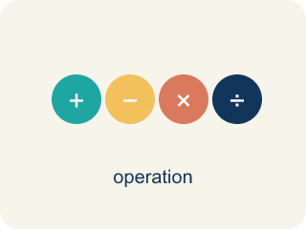
Divide Mixed Numbers (Dividir números mixtos) — Change mixed numbers to improper fractions, then multiply by the reciprocal.
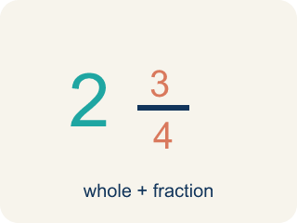
Mixed Number (Número mixto) — A whole number plus a fraction, like 2 1/3.
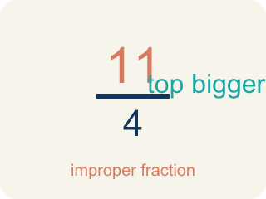
Improper Fraction (Fracción impropia) — A fraction where the top is bigger than or equal to the bottom, like 7/4.
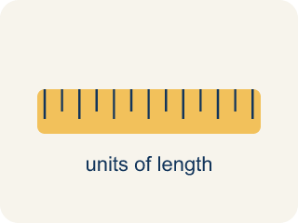
Convert (Convertir) — To change a number to a new form but keep the same value.

Simplify (Simplificar) — To write a fraction with smaller numbers that names the same amount, like 2/4 = 1/2.
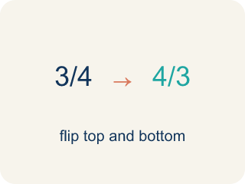
Reciprocal (Recíproco) — A fraction turned upside down. Dividing by a fraction gives the same answer as multiplying by its reciprocal.

Practice
Show your work. Use the blank space under each problem.
1. What is 1 1/2 ÷ 3/4?
A. 1 1/8
B. 2
C. 3/4
D. 9/8
______________________________________________________________________
2. Convert 3 2/5 to an improper fraction.
A. 6/5
B. 15/5
C. 17/5
D. 32/5
______________________________________________________________________
3. Convert each mixed number to an improper fraction, then divide.
Problem | Convert to Improper | The reciprocal shortcut | Quotient
3 1/2 ÷ 1/4 | 7/2 ÷ 1/4 | 7/2 × 4/1 = 28/2
1 3/4 ÷ 1/2 | 7/4 ÷ 1/2 | 7/4 × 2/1 = 14/4
2 1/3 ÷ 7/6 | 7/3 ÷ 7/6 | 7/3 × 6/7 = 42/21
4 1/5 ÷ 3/5 | 21/5 ÷ 3/5 | 21/5 × 5/3 = 105/15
______________________________________________________________________
4. Match each mixed number division to its quotient.
Item | Answer choices
____ 2 1/4 ÷ 3/4 | F. 6
____ 4 1/2 ÷ 9/8 | E. 7
____ 1 2/3 ÷ 5/6 | D. 5
____ 3 1/3 ÷ 2/3 | C. 2
____ 5 1/4 ÷ 3/4 | B. 4
____ 1 1/2 ÷ 1/4 | A. 3
______________________________________________________________________
5. A baker has 2 1/4 cups of butter. Each batch of cookies needs 3/4 cup of butter. How many batches can the baker make?
A. 1 1/2 batches
B. 2 batches
C. 3 batches
D. 6 batches
______________________________________________________________________
6. Spot the Common Mistake
Step 1 (Problem): 3 1/3 ÷ 2/3
Step 2 (Multiply by the reciprocal (skipped converting)): 3 1/3 × 3/2
Step 3 (Multiply the fraction part only): 1/3 × 3/2 = 3/6 = 1/2
Step 4 (Combine with the whole): 3 + 1/2 = 3 1/2
Which step has the mistake? Explain and fix it:
______________________________________________________________________
______________________________________________________________________
______________________________________________________________________
7. Agent Chen has walked 2 1/4 miles, which is 3/4 of her whole route. How long is the whole route? (2 1/4 ÷ 3/4 asks how much is in one whole route.)
A. 1 11/16 miles
B. 3 miles
C. 1/3 mile
D. 2 1/3 miles
______________________________________________________________________
8. A 4 1/2-cup jar of fingerprint gel fills exactly 1 1/2 test kits. How much gel is in ONE kit? (4 1/2 ÷ 1 1/2 asks how much is in one whole kit.)
A. 6 3/4 cups
B. 1/3 cup
C. 3 cups
D. 4 1/3 cups
______________________________________________________________________
9. Mission 1: The stakeout shift is 4 1/2 hours long. Each agent covers a 1 1/2-hour watch. How many agent watches fill one shift?
A. 2 1/2
B. 3
C. 4 1/2
D. 6
______________________________________________________________________
10. Mission 2: A surveillance route is 3 miles long, split into 1 1/2-mile patrol sections. How many sections are on the route?
A. 1 1/2
B. 2
C. 3
D. 4 1/2
______________________________________________________________________

Answer Key (Teacher)
1. B. 2
1 1/2 = 3/2. Then 3/2 ÷ 3/4 = 3/2 × 4/3 = 12/6 = 2.
Watch for: A common mistake in Divide Mixed Numbers is dividing the whole-number parts and fraction parts separately instead of converting first — for example, treating 4 1/2 ÷ 1 1/2 as (4 ÷ 1) + (1/2 ÷ 1/2) = 5. Always convert each mixed number to one improper fraction first, then divide using the reciprocal shortcut: 4 1/2 ÷ 1 1/2 = 9/2 ÷ 3/2 = 9/2 × 2/3 = 3.
2. C. 17/5
3 × 5 = 15, then 15 + 2 = 17. So 3 2/5 = 17/5.
Watch for: A common mistake in Divide Mixed Numbers is dividing the whole-number parts and fraction parts separately instead of converting first — for example, treating 4 1/2 ÷ 1 1/2 as (4 ÷ 1) + (1/2 ÷ 1/2) = 5. Always convert each mixed number to one improper fraction first, then divide using the reciprocal shortcut: 4 1/2 ÷ 1 1/2 = 9/2 ÷ 3/2 = 9/2 × 2/3 = 3.
3. Convert each mixed number to an improper fraction, then divide.
→ 14
→ 3 1/2
→ 2
→ 7

4. Matches:
2 1/4 ÷ 3/4 → 3
4 1/2 ÷ 9/8 → 4
1 2/3 ÷ 5/6 → 2
3 1/3 ÷ 2/3 → 5
5 1/4 ÷ 3/4 → 7
1 1/2 ÷ 1/4 → 6

5. C. 3 batches
Convert 2 1/4 = 9/4. Then 2 1/4 ÷ 3/4 = 9/4 × 4/3 = 36/12 = 3 batches.
Watch for: A common mistake in Divide Mixed Numbers is dividing the whole-number parts and fraction parts separately instead of converting first — for example, treating 4 1/2 ÷ 1 1/2 as (4 ÷ 1) + (1/2 ÷ 1/2) = 5. Always convert each mixed number to one improper fraction first, then divide using the reciprocal shortcut: 4 1/2 ÷ 1 1/2 = 9/2 ÷ 3/2 = 9/2 × 2/3 = 3.
6. Spot the Common Mistake
The mistake is in Step 2.
Correct work: The student divided before converting the mixed number. First convert: 3 1/3 = 10/3. Then 10/3 ÷ 2/3 = 10/3 × 3/2 = 30/6 = 5, not 3 1/2.
Watch for: The break happens at the second step: the student jumped straight to multiplying by the reciprocal while 3 1/3 was still a mixed number, then multiplied only the fraction part. Convert first — 3 1/3 = 10/3 — then 10/3 × 3/2 = 30/6 = 5, not 3 1/2.
7. B. 3 miles
2 1/4 = 9/4. Three fourths of the route is 9/4 miles, so one fourth is 9/4 ÷ 3 = 3/4 mile and the whole route (4 fourths) is 4 × 3/4 = 3 miles. Shortcut: 9/4 × 4/3 = 36/12 = 3. Check: 3/4 × 3 = 9/4 = 2 1/4.
Watch for: A common mistake in Divide Mixed Numbers is dividing the whole-number parts and fraction parts separately instead of converting first — for example, treating 4 1/2 ÷ 1 1/2 as (4 ÷ 1) + (1/2 ÷ 1/2) = 5. Always convert each mixed number to one improper fraction first, then divide using the reciprocal shortcut: 4 1/2 ÷ 1 1/2 = 9/2 ÷ 3/2 = 9/2 × 2/3 = 3.
8. C. 3 cups
4 1/2 = 9/2 and 1 1/2 = 3/2. One and a half kits hold 9/2 cups, so half a kit holds 9/2 ÷ 3 = 3/2 cups and a whole kit holds 2 × 3/2 = 3 cups. Shortcut: 9/2 × 2/3 = 18/6 = 3. Check: 1 1/2 × 3 = 4 1/2.
Watch for: A common mistake in Divide Mixed Numbers is dividing the whole-number parts and fraction parts separately instead of converting first — for example, treating 4 1/2 ÷ 1 1/2 as (4 ÷ 1) + (1/2 ÷ 1/2) = 5. Always convert each mixed number to one improper fraction first, then divide using the reciprocal shortcut: 4 1/2 ÷ 1 1/2 = 9/2 ÷ 3/2 = 9/2 × 2/3 = 3.
9. B. 3
4 1/2 = 9/2 and 1 1/2 = 3/2. So 9/2 ÷ 3/2 = 9/2 × 2/3 = 18/6 = 3 watches.
Watch for: A common mistake in Divide Mixed Numbers is dividing the whole-number parts and fraction parts separately instead of converting first — for example, treating 4 1/2 ÷ 1 1/2 as (4 ÷ 1) + (1/2 ÷ 1/2) = 5. Always convert each mixed number to one improper fraction first, then divide using the reciprocal shortcut: 4 1/2 ÷ 1 1/2 = 9/2 ÷ 3/2 = 9/2 × 2/3 = 3.
10. B. 2
3 ÷ 1 1/2 = 3 ÷ 3/2 = 3 × 2/3 = 6/3 = 2 sections.
Watch for: A common mistake in Divide Mixed Numbers is dividing the whole-number parts and fraction parts separately instead of converting first — for example, treating 4 1/2 ÷ 1 1/2 as (4 ÷ 1) + (1/2 ÷ 1/2) = 5. Always convert each mixed number to one improper fraction first, then divide using the reciprocal shortcut: 4 1/2 ÷ 1 1/2 = 9/2 ÷ 3/2 = 9/2 × 2/3 = 3.

