6.7 · 6.12 · 6.13 Catch-Up — Homework
Lesson 6-12-catchup • Standard 6.NOS.4
Name: ______________________ Period: ______ Date: ____________

Today's Goals
Content: I can show I am caught up on Lessons 6.7 · 6.12 · 6.13 by using each lesson's big idea in mixed practice.
Language: I can explain which lesson's big idea I used and how, using key vocabulary from Lessons 6.7 · 6.12 · 6.13.

Key Words
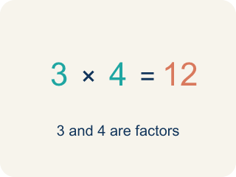
Factor (Factor) — A whole number that divides another number evenly, with no remainder.
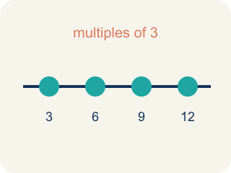
Multiple (Múltiplo) — The result of multiplying a number by 1, 2, 3, and so on — where you land when you skip-count by it.
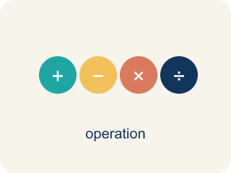
Greatest common factor (GCF) (Máximo común divisor (MCD)) — The largest number that is a factor of two or more numbers. It answers “how many equal groups can I make?”
Least common multiple (LCM) (Mínimo común múltiplo (mcm)) — The smallest number that is a multiple of two or more numbers. It answers “when will these line up again?”
Factor pair (Par de factores) — Two factors that multiply to make a number. In a word problem, one is the number of groups and the other is the size of each group.
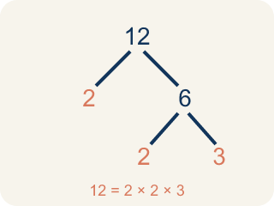
Prime factorization (Descomposición en factores primos) — Writing a number as a product of prime numbers, usually with a factor tree. Multiplying the primes two numbers share also gives the GCF.
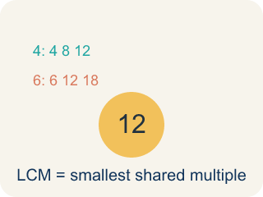
Least Common Multiple (Mínimo común múltiplo) — The least positive number that is a multiple of two or more numbers.
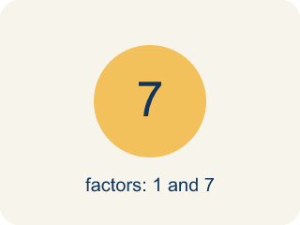
Prime number (Número primo) — A number bigger than 1 that you can only divide by 1 and itself.
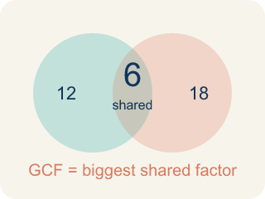
Greatest Common Factor (Máximo común divisor) — The greatest whole number that divides two or more numbers with no remainder.
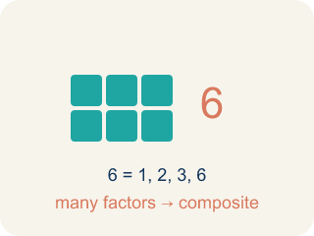
Composite number (Número compuesto) — A number bigger than 1 that you can divide by more than just 1 and itself.

Practice
Show your work. Use the blank space under each problem.
1. (Lesson 6.7) Which list shows all the factors of 12?
A. 1, 2, 3, 4, 6, 12
B. 1, 12
C. 2, 3, 4, 6
D. 12, 24, 36, 48
______________________________________________________________________
2. (Lesson 6.7) Which list shows the first four multiples of 8?
A. 1, 2, 4, 8
B. 2, 4, 6, 8
C. 8, 16, 24, 32
D. 8, 9, 10, 11
______________________________________________________________________
3. (Lesson 6.7) Using prime factors, 48 = 2 × 2 × 2 × 2 × 3 and 36 = 2 × 2 × 3 × 3. What is their GCF?
A. 2, the only prime they share
B. 6, from one 2 and one 3
C. 12, from the shared 2 × 2 × 3
D. 144, from multiplying all the primes
______________________________________________________________________
4. (Lesson 6.7) Ayasha has painting every 8 weeks and pottery every 6 weeks, both this week. When do they next fall in the same week?
A. In 2 weeks
B. In 14 weeks
C. In 24 weeks
D. In 48 weeks
______________________________________________________________________
5. (Lesson 6.12) Two buses leave the station at 8:00 AM. Bus A returns every 15 minutes and Bus B returns every 20 minutes. When is the next time both buses are at the station together?
A. 8:30 AM (30 minutes later)
B. 8:40 AM (40 minutes later)
C. 9:00 AM (60 minutes later)
D. 9:20 AM (80 minutes later)
______________________________________________________________________
6. (Lesson 6.12) Spot Maya's Mistake — LCM of 6 and 9
Step 1 (Problem): Find the LCM of 6 and 9.
Step 2 (Multiples of 6): 6, 12, 18, 24
Step 3 (Multiples of 9): 9, 18, 27
Step 4 (Choose the answer): Maya saw that 9 is bigger than 6, so she wrote LCM = 9.
Which step has the mistake? Explain and fix it:
______________________________________________________________________
______________________________________________________________________
______________________________________________________________________
7. (Lesson 6.13) Two students found different factor trees for 60. Student A started with 2 × 30. Student B started with 6 × 10. Which statement is true?
A. Both get the same prime factorization: 2 × 2 × 3 × 5
B. Only Student A gets the correct prime factorization
C. Only Student B gets the correct prime factorization
D. They will get different prime factorizations
______________________________________________________________________
8. (Lesson 6.13) Spot the Common Mistake
Step 1 (Find the prime factorization of 45, using exponents): Start: 45
Step 2 (First split): 45 = 5 × 9
Step 3 (Break down 9): 9 = 3 × 3, so 45 = 5 × 3 × 3
Step 4 (Write with exponents): 45 = 3² × 5²
Which step has the mistake? Explain and fix it:
______________________________________________________________________
______________________________________________________________________
______________________________________________________________________
9. Fix our table's thinking
Step 1 (The problem): (Lesson 6.12) What is the LCM of 6 and 8?
Step 2 (A classmate at our table answered): 48
Which step has the mistake? Explain and fix it:
______________________________________________________________________
______________________________________________________________________
______________________________________________________________________
10. (Lesson 6.7) Is 4 a factor or a multiple of 12?
A. A multiple
B. Both
C. A factor
D. Neither
______________________________________________________________________

Answer Key (Teacher)
1. A. 1, 2, 3, 4, 6, 12
A factor divides 12 evenly. Every one of 1, 2, 3, 4, 6, and 12 does, and nothing else does.
Watch for: A common mistake in Prime Factorization is stopping the factor tree too soon — leaving a composite number like 4, 6, 8, or 9 in the final answer instead of continuing to split it. For example, writing 20 = 4 × 5 as the prime factorization (4 is composite) instead of finishing with 20 = 2 × 2 × 5. Before you submit, check every number in your final answer: if any factor can still be broken into smaller factors, the tree isn't finished yet.
2. C. 8, 16, 24, 32
Multiples come from multiplying by 1, 2, 3, 4: 8, 16, 24, and 32 — the numbers you say skip-counting by 8.
Watch for: A common mistake in Prime Factorization is stopping the factor tree too soon — leaving a composite number like 4, 6, 8, or 9 in the final answer instead of continuing to split it. For example, writing 20 = 4 × 5 as the prime factorization (4 is composite) instead of finishing with 20 = 2 × 2 × 5. Before you submit, check every number in your final answer: if any factor can still be broken into smaller factors, the tree isn't finished yet.
3. C. 12, from the shared 2 × 2 × 3
Take only the primes both numbers have: two 2s and one 3. Multiplying them gives 2 × 2 × 3 = 12, matching the answer from the factor lists.
Watch for: A common mistake in Prime Factorization is stopping the factor tree too soon — leaving a composite number like 4, 6, 8, or 9 in the final answer instead of continuing to split it. For example, writing 20 = 4 × 5 as the prime factorization (4 is composite) instead of finishing with 20 = 2 × 2 × 5. Before you submit, check every number in your final answer: if any factor can still be broken into smaller factors, the tree isn't finished yet.
4. C. In 24 weeks
Multiples of 8: 8, 16, 24 …; multiples of 6: 6, 12, 18, 24 …. The first week they share is week 24.
Watch for: A common mistake in Prime Factorization is stopping the factor tree too soon — leaving a composite number like 4, 6, 8, or 9 in the final answer instead of continuing to split it. For example, writing 20 = 4 × 5 as the prime factorization (4 is composite) instead of finishing with 20 = 2 × 2 × 5. Before you submit, check every number in your final answer: if any factor can still be broken into smaller factors, the tree isn't finished yet.
5. C. 9:00 AM (60 minutes later)
LCM(15, 20) = 60 minutes. Both buses return together 60 minutes after 8:00 AM, at 9:00 AM.
Watch for: A common mistake in Prime Factorization is stopping the factor tree too soon — leaving a composite number like 4, 6, 8, or 9 in the final answer instead of continuing to split it. For example, writing 20 = 4 × 5 as the prime factorization (4 is composite) instead of finishing with 20 = 2 × 2 × 5. Before you submit, check every number in your final answer: if any factor can still be broken into smaller factors, the tree isn't finished yet.
6. (Lesson 6.12) Spot Maya's Mistake — LCM of 6 and 9
The mistake is in Step 4.
Correct work: The LCM is not just the larger number. Check: 9 is in the multiples of 9, but it is NOT in the multiples of 6 (6, 12, 18...). The first number in BOTH lists is 18, so the LCM of 6 and 9 is 18.
Watch for: In the last step Maya chose 9 just because it is the larger number, but 9 never appears in the multiples of 6 (6, 12, 18, 24). The LCM has to be in both lists, and the first number in both is 18, so the LCM of 6 and 9 is 18.
7. A. Both get the same prime factorization: 2 × 2 × 3 × 5
The Fundamental Theorem of Arithmetic says every composite number has exactly one prime factorization. No matter how you start the factor tree, you always end with 2 × 2 × 3 × 5.
Watch for: A common mistake in Prime Factorization is stopping the factor tree too soon — leaving a composite number like 4, 6, 8, or 9 in the final answer instead of continuing to split it. For example, writing 20 = 4 × 5 as the prime factorization (4 is composite) instead of finishing with 20 = 2 × 2 × 5. Before you submit, check every number in your final answer: if any factor can still be broken into smaller factors, the tree isn't finished yet.
8. (Lesson 6.13) Spot the Common Mistake
The mistake is in Step 4.
Correct work: 45 = 5 × 3 × 3 has one 5 and two 3's — not two 5's. The exponent on a prime factor shows how many times that factor appears, so the correct form is 45 = 3² × 5 (the 5 has no exponent shown because it appears only once).
Watch for: An exponent records how many times a prime appears, and the last step gave the 5 an exponent of 2 even though 45 = 3 × 3 × 5 contains only one 5. Two 3s and one 5 means the correct form is 45 = 3² × 5.
9. Fix our table's thinking
The mistake is in Step 2.
Correct work: The correct answer is 24. Multiples of 6: 6, 12, 18, 24, ... Multiples of 8: 8, 16, 24, ... The smallest common multiple is 24.
10. C. A factor
4 divides 12 evenly (12 ÷ 4 = 3), so 4 is a factor of 12. Multiples of 12 start at 12 and grow.
Watch for: A common mistake in Prime Factorization is stopping the factor tree too soon — leaving a composite number like 4, 6, 8, or 9 in the final answer instead of continuing to split it. For example, writing 20 = 4 × 5 as the prime factorization (4 is composite) instead of finishing with 20 = 2 × 2 × 5. Before you submit, check every number in your final answer: if any factor can still be broken into smaller factors, the tree isn't finished yet.

