6.4–6.15 Catch-Up — Homework
Lesson 6-15-catchup • Standard 6.AT.7
Name: ______________________ Period: ______ Date: ____________

Today's Goals
Content: I can show I am caught up on Lessons 6.4–6.15 by using each lesson's big idea in mixed practice.
Language: I can explain which lesson's big idea I used and how, using key vocabulary from Lessons 6.4–6.15.

Key Words
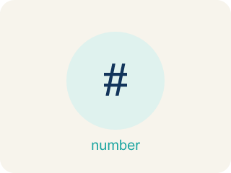
Numerical expression (Expresión numérica) — A math phrase built from numbers and operations, with no equal sign and no variable.
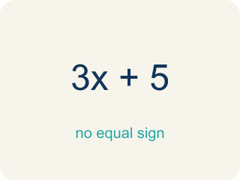
Evaluate (Evaluar) — To find the single value an expression is worth by carrying out its operations in order.
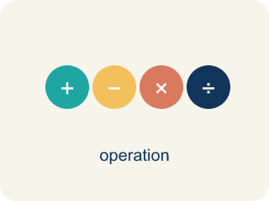
Order of operations (Orden de las operaciones) — The agreed order for evaluating: grouping symbols, then exponents, then multiply and divide left to right, then add and subtract left to right.
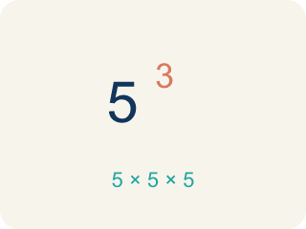
Power (Potencia) — A short way to write repeated multiplication of the same factor, such as 2³ for 2 × 2 × 2.
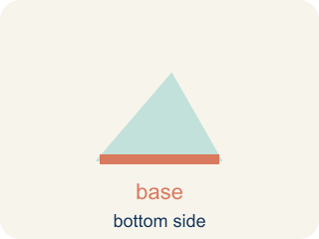
Base (Base) — In a power, the number being multiplied by itself. In 2³ the base is 2.
Exponent (Exponente) — In a power, the small raised number that says how many times the base is used as a factor.
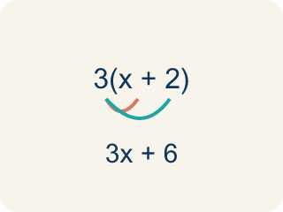
Equivalent Expressions (Expresiones equivalentes) — Expressions that look different but have the same value for every allowed variable value.
Properties of Operations (Propiedades de las operaciones) — Rules that let you reorder or regroup numbers without changing an expression's value.
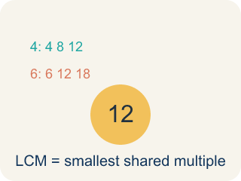
Least Common Multiple (Mínimo común múltiplo) — The least positive number that is a multiple of two or more numbers.
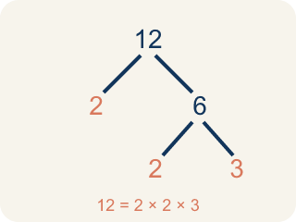
Prime Factorization (Factorización prima) — Writing a whole number as a product of only prime numbers.
The Distributive Property (La propiedad distributiva) — Multiply a factor by every term inside parentheses.
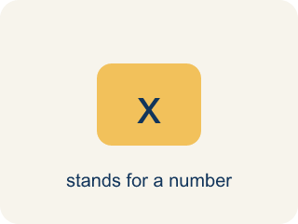
Variable (Variable) — A letter that stands for a number that is unknown or can change.

Equivalent (Equivalente) — Expressions that always have the same value.
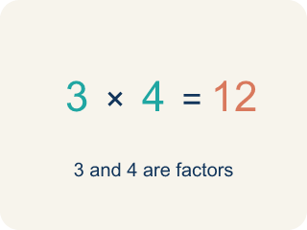
Factor (Factor) — A whole number that divides another number evenly, with no remainder.
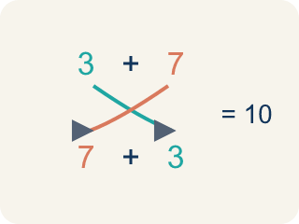
Commutative Property (Propiedad conmutativa) — You can change the order and get the same answer.
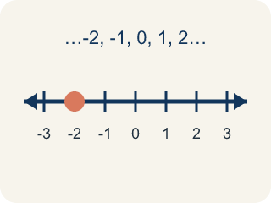
Whole Number (Número entero) — A counting number with no fraction or decimal, like 0, 1, 2, 3.
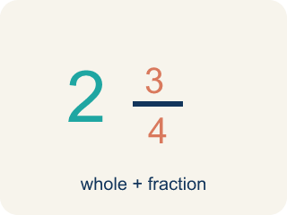
Mixed Number (Número mixto) — A whole number plus a fraction, like 2 1/3.
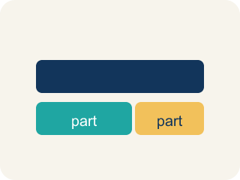
Model (Modelo) — A picture or math way to show a problem so you can solve it.
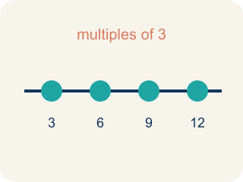
Multiple (Múltiplo) — What you get when you multiply a number by 1, 2, 3, and so on.
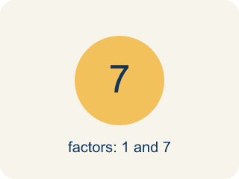
Prime number (Número primo) — A number bigger than 1 that you can only divide by 1 and itself.
Distributive Property (Propiedad distributiva) — Multiplying a number by everything inside the parentheses: a(b + c) = ab + ac.
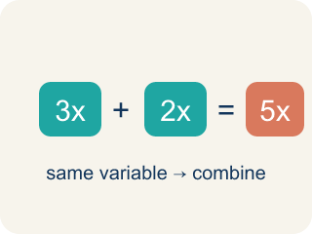
Like Terms (Términos semejantes) — Terms with the same letter raised to the same power, like 2x and 5x.
Evaluate Expressions (Evaluar expresiones) — Find the value of an expression by substituting numbers and following the order of operations.
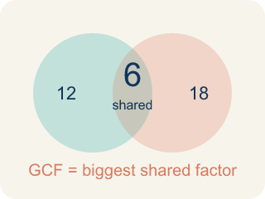
Greatest Common Factor (Máximo común divisor) — The greatest whole number that divides two or more numbers with no remainder.
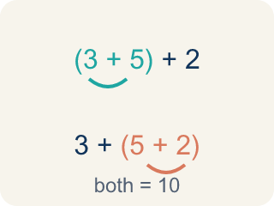
Associative Property (Propiedad asociativa) — You can change the grouping and get the same answer.
Simplify (Simplificar) — To rewrite an expression in a shorter form that is still equal to the original.
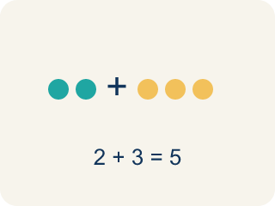
Combine (Combinar) — To add or subtract terms with the same letter into one.

Practice
Show your work. Use the blank space under each problem.
1. (Lesson 6.4) Evaluate 3 + 4 × 2.
A. 9
B. 11
C. 14
D. 24
______________________________________________________________________
2. (Lesson 6.4) What does 2³ mean?
A. 2 × 2 × 2
B. 2 × 3
C. 2 + 2 + 2
D. 3 × 3
______________________________________________________________________
3. (Lesson 6.4) What is the total of 2 × 15 + 4 × 20 + 8 × 2³?
A. 126
B. 174
C. 210
D. 1,392
______________________________________________________________________
4. (Lesson 6.4) Miguel evaluates 12 − 2 × 3 and gets 30. Margaret gets 6. Who is right?
A. Margaret, because multiplication comes before subtraction
B. Miguel, because he worked left to right
C. Both are right
D. Neither is right
______________________________________________________________________
5. (Lesson 6.5) The expression 8n + 15 gives the cost of n tickets plus a fee. What is the cost for 6 tickets?
A. $29
B. $48
C. $63
D. $138
______________________________________________________________________
6. (Lesson 6.5) Spot the Common Mistake
Step 1 (Phrase): 8 divided by a number m
Step 2 (Student's expression): m ÷ 8
Step 3 (Reasoning): I saw 'divided by' so I wrote the variable first and then 8.
Which step has the mistake? Explain and fix it:
______________________________________________________________________
______________________________________________________________________
______________________________________________________________________
7. (Lesson 6.6) Spot the Combining Mistake
Step 1 (Expression): 7x + 3 + 2x
Step 2 (Combine): Combine every number you see: 7x + 2x + 3 = 9x + 3, then add the 9 and 3 too
Step 3 (Result): 7x + 3 + 2x = 12x
Which step has the mistake? Explain and fix it:
______________________________________________________________________
______________________________________________________________________
______________________________________________________________________
8. (Lesson 6.6) Match each expression with its simplified form.
Groups: Correctly Matched
• 8y + 2y → 10y → __________________
• 3(a + 6) → 3a + 18 → __________________
• 5n + 4 + 2n → 7n + 4 → __________________
• 9p − 3p → 6p → __________________
• 4(2x − 1) → 8x − 4 → __________________
• 6t + t → 7t → __________________
______________________________________________________________________
9. (Lesson 6.7) Using prime factors, 48 = 2 × 2 × 2 × 2 × 3 and 36 = 2 × 2 × 3 × 3. What is their GCF?
A. 2, the only prime they share
B. 6, from one 2 and one 3
C. 12, from the shared 2 × 2 × 3
D. 144, from multiplying all the primes
______________________________________________________________________
10. (Lesson 6.7) Ayasha has painting every 8 weeks and pottery every 6 weeks, both this week. When do they next fall in the same week?
A. In 2 weeks
B. In 14 weeks
C. In 24 weeks
D. In 48 weeks
______________________________________________________________________

Answer Key (Teacher)
1. B. 11
Multiplication comes before addition: 4 × 2 = 8, then 3 + 8 = 11.
Watch for: A common mistake in Simplify Algebraic Expressions is sweeping a constant into the variable terms — for example, simplifying 6x + 4 + 2x as 12x by adding all three numbers (6 + 4 + 2 = 12) instead of recognizing that 4 has no variable and cannot combine with 6x and 2x. The correct simplified expression is 8x + 4 (combine 6x + 2x = 8x, and let the 4 stay on its own). Before you submit, check that every term you combined has the exact same variable part.
2. A. 2 × 2 × 2
The exponent says how many times the base is used as a factor, so 2³ = 2 × 2 × 2 = 8.
Watch for: A common mistake in Simplify Algebraic Expressions is sweeping a constant into the variable terms — for example, simplifying 6x + 4 + 2x as 12x by adding all three numbers (6 + 4 + 2 = 12) instead of recognizing that 4 has no variable and cannot combine with 6x and 2x. The correct simplified expression is 8x + 4 (combine 6x + 2x = 8x, and let the 4 stay on its own). Before you submit, check that every term you combined has the exact same variable part.
3. B. 174
Power first: 2³ = 8. Multiply: 30, 80, 64. Add: 30 + 80 + 64 = 174.
Watch for: A common mistake in Simplify Algebraic Expressions is sweeping a constant into the variable terms — for example, simplifying 6x + 4 + 2x as 12x by adding all three numbers (6 + 4 + 2 = 12) instead of recognizing that 4 has no variable and cannot combine with 6x and 2x. The correct simplified expression is 8x + 4 (combine 6x + 2x = 8x, and let the 4 stay on its own). Before you submit, check that every term you combined has the exact same variable part.
4. A. Margaret, because multiplication comes before subtraction
Multiplying first gives 2 × 3 = 6, then 12 − 6 = 6. Miguel subtracted first, getting 10 × 3 = 30.
Watch for: A common mistake in Simplify Algebraic Expressions is sweeping a constant into the variable terms — for example, simplifying 6x + 4 + 2x as 12x by adding all three numbers (6 + 4 + 2 = 12) instead of recognizing that 4 has no variable and cannot combine with 6x and 2x. The correct simplified expression is 8x + 4 (combine 6x + 2x = 8x, and let the 4 stay on its own). Before you submit, check that every term you combined has the exact same variable part.
5. C. $63
Substitute n = 6: 8 × 6 + 15 = 48 + 15 = $63.
Watch for: A common mistake in Simplify Algebraic Expressions is sweeping a constant into the variable terms — for example, simplifying 6x + 4 + 2x as 12x by adding all three numbers (6 + 4 + 2 = 12) instead of recognizing that 4 has no variable and cannot combine with 6x and 2x. The correct simplified expression is 8x + 4 (combine 6x + 2x = 8x, and let the 4 stay on its own). Before you submit, check that every term you combined has the exact same variable part.
6. (Lesson 6.5) Spot the Common Mistake
The mistake is in Step 2.
Correct work: '8 divided by a number m' means start with 8 and divide it by m: 8 ÷ m. Division is not commutative, so order matters — m ÷ 8 means something different (a number m divided by 8).
Watch for: The expression step wrote the variable first, but "8 divided by a number m" starts with the 8 and splits it. Division is not commutative, so the correct translation is 8 ÷ m — with m = 2, 8 ÷ 2 = 4 while 2 ÷ 8 = 0.25.
7. (Lesson 6.6) Spot the Combining Mistake
The mistake is in Step 2.
Correct work: Only LIKE terms combine. 7x and 2x are like terms (7x + 2x = 9x), but the 3 is a constant and cannot be added to the 9x. The simplified form is 9x + 3. Check x = 2: 7(2) + 3 + 2(2) = 21 and 9(2) + 3 = 21, but 12(2) = 24 — so 12x is wrong.
Watch for: 7x and 2x are like terms, so 7x + 2x = 9x is fine — but the step keeps going and adds the 9 to the 3. A constant like 3 has no variable, so it cannot join 9x in one term. The simplified form is 9x + 3. Check with x = 2: 7(2) + 3 + 2(2) = 21 and 9(2) + 3 = 21, but 12(2) = 24.
8. Correct groups:
8y + 2y → 10y → Correctly Matched
3(a + 6) → 3a + 18 → Correctly Matched
5n + 4 + 2n → 7n + 4 → Correctly Matched
9p − 3p → 6p → Correctly Matched
4(2x − 1) → 8x − 4 → Correctly Matched
6t + t → 7t → Correctly Matched

9. C. 12, from the shared 2 × 2 × 3
Take only the primes both numbers have: two 2s and one 3. Multiplying them gives 2 × 2 × 3 = 12, matching the answer from the factor lists.
Watch for: A common mistake in Simplify Algebraic Expressions is sweeping a constant into the variable terms — for example, simplifying 6x + 4 + 2x as 12x by adding all three numbers (6 + 4 + 2 = 12) instead of recognizing that 4 has no variable and cannot combine with 6x and 2x. The correct simplified expression is 8x + 4 (combine 6x + 2x = 8x, and let the 4 stay on its own). Before you submit, check that every term you combined has the exact same variable part.
10. C. In 24 weeks
Multiples of 8: 8, 16, 24 …; multiples of 6: 6, 12, 18, 24 …. The first week they share is week 24.
Watch for: A common mistake in Simplify Algebraic Expressions is sweeping a constant into the variable terms — for example, simplifying 6x + 4 + 2x as 12x by adding all three numbers (6 + 4 + 2 = 12) instead of recognizing that 4 has no variable and cannot combine with 6x and 2x. The correct simplified expression is 8x + 4 (combine 6x + 2x = 8x, and let the 4 stay on its own). Before you submit, check that every term you combined has the exact same variable part.

