6.15 Small Group · Group 1 — Homework
Lesson 6-15-group1 • Standard 6.AT.7
Name: ______________________ Period: ______ Date: ____________

Today's Goals
Content: With my small group, I can simplify algebraic expressions by combining like terms — one step at a time, with support.
Language: I can talk through each step out loud using a sentence frame and the lesson's key words.

Key Words
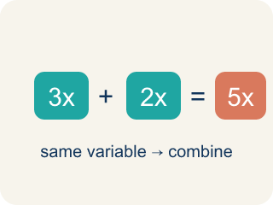
Like Terms (Términos semejantes) — Terms with the same letter raised to the same power, like 2x and 5x.
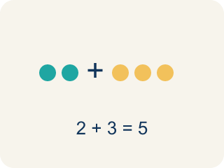
Combine (Combinar) — To add or subtract terms with the same letter into one.

Simplify (Simplificar) — To rewrite an expression in a shorter form that is still equal to the original.
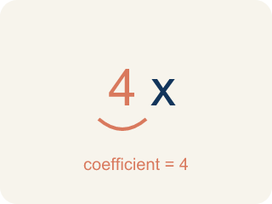
Coefficient (Coeficiente) — The number in front of a letter, like the 3 in 3x.
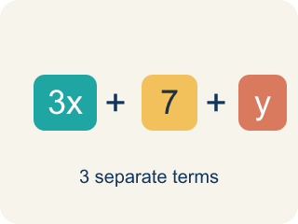
Term (Término) — A single number, variable, or product of them, separated by + or − signs.
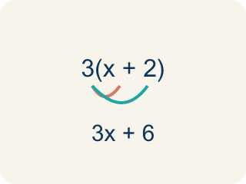
Distributive property (Propiedad distributiva) — Multiplying a number by everything inside the parentheses: a(b + c) = ab + ac.

Practice
Show your work. Use the blank space under each problem.
1. Simplify 7x + 3x.
A. 10x
B. 10x²
C. 21x
D. 73x
______________________________________________________________________
2. Simplify 9n + 4 + 2n.
A. 11n + 4
B. 11n² + 4
C. 15n
D. 92n + 4
______________________________________________________________________
3. Spot the Mistake — Exponent Slip
Step 1 (Expression): 4x + 3x
Step 2 (Combine): Add the coefficients: 4 + 3 = 7
Step 3 (Simplify): 7x²
Which step has the mistake? Explain and fix it:
______________________________________________________________________
______________________________________________________________________
______________________________________________________________________
4. Spot the Mistake — Swept-Up Constant
Step 1 (Expression): 6x + 4 + 2x
Step 2 (Combine): Add everything: 6 + 4 + 2 = 12
Step 3 (Simplify): 12x
Which step has the mistake? Explain and fix it:
______________________________________________________________________
______________________________________________________________________
______________________________________________________________________
5. The board shows 3x + 5x on one channel. Simplify it.
A. 8x
B. 8x²
C. 15x
D. 35x
______________________________________________________________________
6. Simplify the track: 4a + 2 + a.
A. 5a + 2
B. 5a²+ 2
C. 6a
D. 7a
______________________________________________________________________
7. Clean up this channel: 7y − 3y.
A. 4y
B. 4
C. 10y
D. 21y
______________________________________________________________________
8. Simplify the mix: 6m + 4 + 3m.
A. 9m + 4
B. 9m + 4m
C. 10m
D. 13m
______________________________________________________________________
9. Fix our table's thinking
Step 1 (The problem): Simplify the mix: 6m + 4 + 3m.
Step 2 (A classmate at our table answered): 10m
Which step has the mistake? Explain and fix it:
______________________________________________________________________
______________________________________________________________________
______________________________________________________________________

Answer Key (Teacher)
1. A. 10x
7x + 3x = 10x. Add the coefficients: 7 + 3 = 10.
Watch for: A common mistake in Simplify Algebraic Expressions is sweeping a constant into the variable terms — for example, simplifying 6x + 4 + 2x as 12x by adding all three numbers (6 + 4 + 2 = 12) instead of recognizing that 4 has no variable and cannot combine with 6x and 2x. The correct simplified expression is 8x + 4 (combine 6x + 2x = 8x, and let the 4 stay on its own). Before you submit, check that every term you combined has the exact same variable part.
2. A. 11n + 4
9n + 2n = 11n. The constant 4 has no like term, so it stays. Result: 11n + 4.
Watch for: A common mistake in Simplify Algebraic Expressions is sweeping a constant into the variable terms — for example, simplifying 6x + 4 + 2x as 12x by adding all three numbers (6 + 4 + 2 = 12) instead of recognizing that 4 has no variable and cannot combine with 6x and 2x. The correct simplified expression is 8x + 4 (combine 6x + 2x = 8x, and let the 4 stay on its own). Before you submit, check that every term you combined has the exact same variable part.
3. Spot the Mistake — Exponent Slip
The mistake is in Step 3.
Correct work: 4x and 3x are like terms, so add the coefficients 4 + 3 = 7 and KEEP the variable exactly as it is: the answer is 7x, not 7x². Adding like terms never changes the exponent on the variable. (Check: at x = 2, 4x + 3x = 8 + 6 = 14, and 7x = 14, but 7x² = 28.)
Watch for: Adding the coefficients 4 + 3 = 7 was right, but the Simplify step also changed x into x². Combining like terms only counts how many x's you have, so 4x + 3x = 7x — check it at x = 2, where 8 + 6 = 14 matches 7x but not 7x² = 28.
4. Spot the Mistake — Swept-Up Constant
The mistake is in Step 2.
Correct work: The 4 is a constant with no variable, so it cannot be combined with the x-terms. Combine only the like terms: 6x + 2x = 8x, and the 4 stays on its own. The correct simplified expression is 8x + 4. (Check: at x = 1, 6x + 4 + 2x = 6 + 4 + 2 = 12, and 8x + 4 = 12, but 12x = 12 only by accident — at x = 2 it gives 24 instead of the true 20.)
Watch for: The Combine step swept the constant 4 in with the coefficients 6 and 2, but 4 has no variable, so it is not a like term. Only 6x + 2x = 8x combine, and the 4 stays on its own, giving 8x + 4 — at x = 2 that is 20, while 12x would give 24.
5. A. 8x
3x and 5x are like terms, so add the coefficients: 3 + 5 = 8. The variable x stays, giving 8x.
Watch for: A common mistake in Simplify Algebraic Expressions is sweeping a constant into the variable terms — for example, simplifying 6x + 4 + 2x as 12x by adding all three numbers (6 + 4 + 2 = 12) instead of recognizing that 4 has no variable and cannot combine with 6x and 2x. The correct simplified expression is 8x + 4 (combine 6x + 2x = 8x, and let the 4 stay on its own). Before you submit, check that every term you combined has the exact same variable part.
6. A. 5a + 2
4a + a = 5a (remember a means 1a). The 2 has no like term, so it stays. Result: 5a + 2.
Watch for: A common mistake in Simplify Algebraic Expressions is sweeping a constant into the variable terms — for example, simplifying 6x + 4 + 2x as 12x by adding all three numbers (6 + 4 + 2 = 12) instead of recognizing that 4 has no variable and cannot combine with 6x and 2x. The correct simplified expression is 8x + 4 (combine 6x + 2x = 8x, and let the 4 stay on its own). Before you submit, check that every term you combined has the exact same variable part.
7. A. 4y
Subtract the coefficients of the like terms: 7 − 3 = 4. Keep the variable y, giving 4y.
Watch for: A common mistake in Simplify Algebraic Expressions is sweeping a constant into the variable terms — for example, simplifying 6x + 4 + 2x as 12x by adding all three numbers (6 + 4 + 2 = 12) instead of recognizing that 4 has no variable and cannot combine with 6x and 2x. The correct simplified expression is 8x + 4 (combine 6x + 2x = 8x, and let the 4 stay on its own). Before you submit, check that every term you combined has the exact same variable part.
8. A. 9m + 4
6m + 3m = 9m. The constant 4 has no like term, so it stays. Result: 9m + 4.
Watch for: A common mistake in Simplify Algebraic Expressions is sweeping a constant into the variable terms — for example, simplifying 6x + 4 + 2x as 12x by adding all three numbers (6 + 4 + 2 = 12) instead of recognizing that 4 has no variable and cannot combine with 6x and 2x. The correct simplified expression is 8x + 4 (combine 6x + 2x = 8x, and let the 4 stay on its own). Before you submit, check that every term you combined has the exact same variable part.
9. Fix our table's thinking
The mistake is in Step 2.
Correct work: The correct answer is 9m + 4. 6m + 3m = 9m. The constant 4 has no like term, so it stays. Result: 9m + 4.

