Divide Whole Numbers by Fractions — Homework
Lesson 6-9 • Standard 6.NOS.1
Name: ______________________ Period: ______ Date: ____________

Today's Goals
Content: I can explain what dividing a whole number by a fraction means — how many pieces fit, or how much is in one whole — find the quotient with a model or by multiplying by the reciprocal, and check it by multiplying.
Language: I can explain why multiplying by the reciprocal works, using the words fraction, reciprocal, quotient, and Keep, Change, Flip.

Key Words
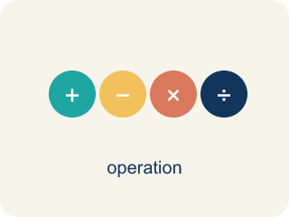
Divide Whole Numbers by Fractions (Dividir números enteros entre fracciones) — Find how many fractional groups fit in a whole number by multiplying by the reciprocal.
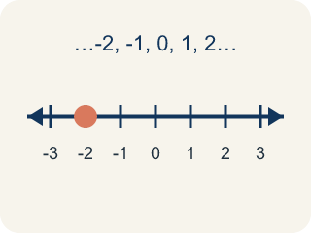
Whole Number (Número entero) — A counting number with no fraction or decimal, like 0, 1, 2, 3.

Fraction (Fracción) — A number that shows part of a whole, like 3/4.
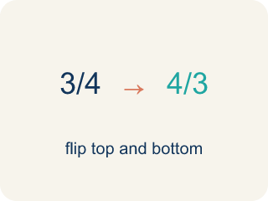
Reciprocal (Recíproco) — A fraction turned upside down.
Keep, Change, Flip (Mantener, cambiar, invertir) — A shortcut for dividing fractions: keep the first number, change ÷ to ×, flip the second. It works because dividing by a fraction gives the same answer as multiplying by its reciprocal.
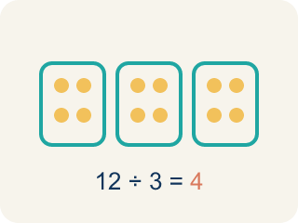
Quotient (Cociente) — The answer when you divide.

Practice
Show your work. Use the blank space under each problem.
1. What is 6 ÷ 1/3?
A. 2
B. 3
C. 6/3
D. 18
______________________________________________________________________
2. What is 3 ÷ 1/5?
A. 3/5
B. 5/3
C. 8
D. 15
______________________________________________________________________
3. Complete the table: Whole Number ÷ Fraction. Use the reciprocal shortcut.
Expression | Rewrite as Multiplication | Quotient
5 ÷ 1/4 | 5 × 4/1 | 20
8 ÷ 1/2 | 8 × 2/1 | 16
3 ÷ 1/6 | 3 × 6/1 | 18
7 ÷ 1/3 | 7 × 3/1 | 21
______________________________________________________________________
4. Match each division expression to its quotient.
Item | Answer choices
____ 4 ÷ 1/3 | F. 30
____ 7 ÷ 1/2 | E. 36
____ 5 ÷ 1/6 | D. 16
____ 2 ÷ 1/8 | C. 30
____ 9 ÷ 1/4 | B. 14
____ 6 ÷ 1/5 | A. 12
______________________________________________________________________
5. What is 6 ÷ 2/3?
A. 2/18
B. 4
C. 9
D. 12
______________________________________________________________________
6. Spot the Common Mistake
Step 1 (Problem): 8 ÷ 3/4
Step 2 (Multiply by the reciprocal): Flipped the wrong number — wrote 1/8 × 3/4 instead of 8 × 4/3
Step 3 (Multiply): 1/8 × 3/4 = 3/32
Which step has the mistake? Explain and fix it:
______________________________________________________________________
______________________________________________________________________
______________________________________________________________________
7. Agent Park's 6 pounds of evidence powder fill 3/4 of a storage tub. How many pounds fill a WHOLE tub? (6 ÷ 3/4 asks how much is in one whole tub.)
A. 4 1/2 pounds
B. 8 pounds
C. 2 pounds
D. 6 3/4 pounds
______________________________________________________________________
8. A 5-foot strip of evidence tape is 1/3 of a full roll. How long is the full roll? (5 ÷ 1/3 asks how much is in one whole roll.)
A. 5/3 feet
B. 8 feet
C. 1/15 foot
D. 15 feet
______________________________________________________________________
9. Detective Park has 4 cups of flour. Each batch of evidence-cookies needs 1/2 cup. How many batches can he make?
A. 2
B. 4
C. 6
D. 8
______________________________________________________________________
10. The crew has 8 quarts of sports drink. Each detective's water bottle holds 4/5 of a quart. How many bottles can be filled?
A. 5
B. 10
C. 12
D. 32/5
______________________________________________________________________

Answer Key (Teacher)
1. D. 18
6 ÷ 1/3 = 6 × 3/1 = 18. There are 18 thirds in 6 wholes.
Watch for: A common mistake in Divide Whole Numbers by Fractions is doing 'Keep, Change' but skipping the 'Flip' — students multiply by the divisor as it is instead of by its reciprocal. For example, for 6 ÷ 3/4, a student might write 6 × 3/4 = 4 1/2 and stop there, but the divisor 3/4 must be flipped to 4/3 first: 6 × 4/3 = 24/3 = 8. Before you submit, check: did I flip the second fraction (the divisor) upside down before multiplying?
2. D. 15
3 ÷ 1/5 = 3 × 5/1 = 15. There are 15 fifths in 3 wholes.
Watch for: A common mistake in Divide Whole Numbers by Fractions is doing 'Keep, Change' but skipping the 'Flip' — students multiply by the divisor as it is instead of by its reciprocal. For example, for 6 ÷ 3/4, a student might write 6 × 3/4 = 4 1/2 and stop there, but the divisor 3/4 must be flipped to 4/3 first: 6 × 4/3 = 24/3 = 8. Before you submit, check: did I flip the second fraction (the divisor) upside down before multiplying?
3. Complete the table: Whole Number ÷ Fraction. Use the reciprocal shortcut.
(See completed table.)

4. Matches:
4 ÷ 1/3 → 12
7 ÷ 1/2 → 14
5 ÷ 1/6 → 30
2 ÷ 1/8 → 16
9 ÷ 1/4 → 36
6 ÷ 1/5 → 30

5. C. 9
6 ÷ 2/3 = 6 × 3/2 = 18/2 = 9. Keep 6, change ÷ to ×, flip 2/3 to 3/2.
Watch for: A common mistake in Divide Whole Numbers by Fractions is doing 'Keep, Change' but skipping the 'Flip' — students multiply by the divisor as it is instead of by its reciprocal. For example, for 6 ÷ 3/4, a student might write 6 × 3/4 = 4 1/2 and stop there, but the divisor 3/4 must be flipped to 4/3 first: 6 × 4/3 = 24/3 = 8. Before you submit, check: did I flip the second fraction (the divisor) upside down before multiplying?
6. Spot the Common Mistake
The mistake is in Step 2.
Correct work: Keep the dividend 8 the same and flip only the divisor: 8 × 4/3 = 32/3 = 10 2/3. The mistake was flipping the whole number 8 into 1/8 instead of flipping the divisor 3/4 into 4/3.
Watch for: Only the divisor gets flipped. The reciprocal step turned the dividend 8 into 1/8 and left 3/4 alone, which is backwards; the correct rewrite is 8 × 4/3 = 32/3 = 10 2/3. Since 3/4 is less than 1, more than 8 of those pieces fit into 8 wholes, so a tiny answer like 3/32 cannot be right.
7. B. 8 pounds
3 fourths of the tub hold 6 pounds, so 1 fourth holds 6 ÷ 3 = 2 pounds and the whole tub (4 fourths) holds 4 × 2 = 8 pounds. The shortcut agrees: 6 × 4/3 = 24/3 = 8. Check: 3/4 × 8 = 6.
Watch for: A common mistake in Divide Whole Numbers by Fractions is doing 'Keep, Change' but skipping the 'Flip' — students multiply by the divisor as it is instead of by its reciprocal. For example, for 6 ÷ 3/4, a student might write 6 × 3/4 = 4 1/2 and stop there, but the divisor 3/4 must be flipped to 4/3 first: 6 × 4/3 = 24/3 = 8. Before you submit, check: did I flip the second fraction (the divisor) upside down before multiplying?
8. D. 15 feet
5 feet is one third of the roll, and a whole roll is 3 thirds: 5 ÷ 1/3 = 5 × 3 = 15 feet. Check by multiplying: 1/3 × 15 = 5.
Watch for: A common mistake in Divide Whole Numbers by Fractions is doing 'Keep, Change' but skipping the 'Flip' — students multiply by the divisor as it is instead of by its reciprocal. For example, for 6 ÷ 3/4, a student might write 6 × 3/4 = 4 1/2 and stop there, but the divisor 3/4 must be flipped to 4/3 first: 6 × 4/3 = 24/3 = 8. Before you submit, check: did I flip the second fraction (the divisor) upside down before multiplying?
9. D. 8
4 ÷ 1/2 = 4 × 2/1 = 8 batches. Each cup makes 2 half-cup batches.
Watch for: A common mistake in Divide Whole Numbers by Fractions is doing 'Keep, Change' but skipping the 'Flip' — students multiply by the divisor as it is instead of by its reciprocal. For example, for 6 ÷ 3/4, a student might write 6 × 3/4 = 4 1/2 and stop there, but the divisor 3/4 must be flipped to 4/3 first: 6 × 4/3 = 24/3 = 8. Before you submit, check: did I flip the second fraction (the divisor) upside down before multiplying?
10. B. 10
8 ÷ 4/5 = 8 × 5/4 = 40/4 = 10 bottles.
Watch for: A common mistake in Divide Whole Numbers by Fractions is doing 'Keep, Change' but skipping the 'Flip' — students multiply by the divisor as it is instead of by its reciprocal. For example, for 6 ÷ 3/4, a student might write 6 × 3/4 = 4 1/2 and stop there, but the divisor 3/4 must be flipped to 4/3 first: 6 × 4/3 = 24/3 = 8. Before you submit, check: did I flip the second fraction (the divisor) upside down before multiplying?

