Solve and Graph Inequalities — Homework
Lesson 8-6 • Standard 6.AT.8
Name: ______________________ Period: ______ Date: ____________

Today's Goals
Content: I can solve an inequality and graph its solution set on a number line.
Language: I can explain my work using the words solve, graph, solution, and substitute.

Key Words
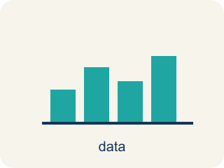
Solve and Graph Inequalities (Resolver y representar desigualdades) — Isolate the variable, then show the complete solution set on a number line.
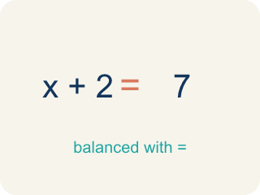
Solve (Resolver) — To find the number that makes it true.
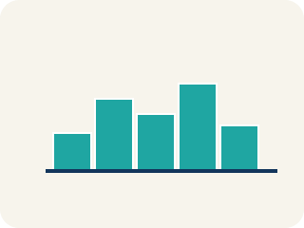
Graph (Graficar) — To show answers on a number line with circles and shading.
Solution (Solución) — A number that makes the equation or inequality true.
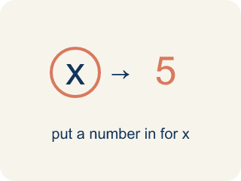
Substitute (Sustituir) — To put a number in place of a letter.
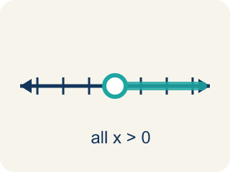
Solution set (Conjunto solución) — All the numbers that make the inequality true.
Inverse operation (Operación inversa) — Two math actions that undo each other, like × and ÷.

Practice
Show your work. Use the blank space under each problem.
1. Solve: x + 6 > 14
A. x > 8
B. x < 8
C. x = 8
D. x > 20
______________________________________________________________________
2. Solve: x − 9 ≤ 3
A. x ≤ 6
B. x ≤ 12
C. x ≥ 12
D. x = 12
______________________________________________________________________
3. Solve each inequality, describe the inverse operation, and describe the graph.
Inequality | Inverse Operation | Solution | Graph Description
x + 11 ≥ 20 | Subtract 11 | x ≥ 9 | Closed circle at 9, shade right
x − 3 < 7 | Add 3 | x < 10 | Open circle at 10, shade left
x + 8 ≤ 20 | Subtract 8 | x ≤ 12 | Closed circle at 12, shade left
______________________________________________________________________
4. Is x = 5 a solution to x + 4 > 12?
A. No, because 5 + 4 = 9, and 9 is not greater than 12
B. Yes, because 5 + 4 = 9
C. Yes, because 5 > 4
D. No, because 5 < 12
______________________________________________________________________
5. Solve each inequality first, then sort by whether x = 10 is a solution.
Groups: x = 10 IS a solution | x = 10 is NOT a solution
• x + 2 > 8 → __________________
• x − 5 ≥ 3 → __________________
• x + 1 ≤ 15 → __________________
• x + 3 > 15 → __________________
• x − 2 ≥ 9 → __________________
• x + 6 < 10 → __________________
______________________________________________________________________
6. Catch the Open vs. Closed Circle Mistake
Step 1 (Inequality): x − 4 ≥ 9
Step 2 (Inverse operation): Add 4 to both sides
Step 3 (Simplify): x ≥ 13
Step 4 (Graph): Open circle at 13, shade right
Which step has the mistake? Explain and fix it:
______________________________________________________________________
______________________________________________________________________
______________________________________________________________________
7. Clue 1: Which value is a solution of x > 7?
A. 3
B. 5
C. 7
D. 9
______________________________________________________________________
8. Clue 2: Is 5 a solution of x ≤ 5?
A. Yes, because 5 ≤ 5 is true
B. No, because 5 is not less than 5
C. No, because ≤ means only smaller numbers
D. Yes, but only because 5 is odd
______________________________________________________________________
9. Detective, sort each suspect's badge number into the right vault door for the rule x ≥ 4. A value is a solution if it makes x ≥ 4 true.
Groups: Solution of x ≥ 4 | NOT a solution of x ≥ 4
• 9 → __________________
• 5 → __________________
• 4 → __________________
• 3 → __________________
• 2 → __________________
• 0 → __________________
______________________________________________________________________
10. Match each inequality to the equivalent inequality written with the number first. Both inequalities in a pair must have the same solutions.
Item | Answer choices
____ x > 10 | D. 5 > x
____ x ≤ 6 | C. 8 ≤ x
____ x ≥ 8 | B. 6 ≥ x
____ x < 5 | A. 10 < x
______________________________________________________________________

Answer Key (Teacher)
1. A. x > 8
Subtract 6 from both sides: x > 14 − 6 = 8. Graph: open circle at 8, shade right.
Watch for: A common mistake in Solve and Graph Inequalities is shading the number line in the wrong direction after solving. For example, a student solves x + 4 > 10 correctly to get x > 6, but then shades LEFT toward smaller numbers instead of RIGHT toward greater numbers. The shading direction always matches the solved symbol, not the original problem: '>' and '≥' shade right (greater numbers), '<' and '≤' shade left (smaller numbers) — check this AFTER you solve, not before. To catch this mistake, substitute one shaded value and one unshaded value back into the original inequality: the shaded value should make it true, and the unshaded value should make it false.
2. B. x ≤ 12
Add 9 to both sides: x ≤ 3 + 9 = 12. Graph: closed circle at 12, shade left.
Watch for: A common mistake in Solve and Graph Inequalities is shading the number line in the wrong direction after solving. For example, a student solves x + 4 > 10 correctly to get x > 6, but then shades LEFT toward smaller numbers instead of RIGHT toward greater numbers. The shading direction always matches the solved symbol, not the original problem: '>' and '≥' shade right (greater numbers), '<' and '≤' shade left (smaller numbers) — check this AFTER you solve, not before. To catch this mistake, substitute one shaded value and one unshaded value back into the original inequality: the shaded value should make it true, and the unshaded value should make it false.
3. Solve each inequality, describe the inverse operation, and describe the graph.
(See completed table.)

4. A. No, because 5 + 4 = 9, and 9 is not greater than 12
Substitute: 5 + 4 = 9. Since 9 > 12 is false, x = 5 is NOT a solution.
Watch for: A common mistake in Solve and Graph Inequalities is shading the number line in the wrong direction after solving. For example, a student solves x + 4 > 10 correctly to get x > 6, but then shades LEFT toward smaller numbers instead of RIGHT toward greater numbers. The shading direction always matches the solved symbol, not the original problem: '>' and '≥' shade right (greater numbers), '<' and '≤' shade left (smaller numbers) — check this AFTER you solve, not before. To catch this mistake, substitute one shaded value and one unshaded value back into the original inequality: the shaded value should make it true, and the unshaded value should make it false.
5. Correct groups:
x + 2 > 8 → x = 10 IS a solution
x − 5 ≥ 3 → x = 10 IS a solution
x + 1 ≤ 15 → x = 10 IS a solution
x + 3 > 15 → x = 10 is NOT a solution
x − 2 ≥ 9 → x = 10 is NOT a solution
x + 6 < 10 → x = 10 is NOT a solution

6. Catch the Open vs. Closed Circle Mistake
The mistake is in Step 4.
Correct work: The solving is correct: x ≥ 13. But the symbol ≥ means 'greater than OR equal to,' so 13 IS a solution and must be included. Use a CLOSED circle at 13 (not open), then shade right.
Watch for: The solving is correct — adding 4 to both sides gives x ≥ 13 — but the graph left the boundary out. The symbol ≥ means "greater than or equal to," so 13 is itself a solution and must be filled in: a closed circle at 13, shaded to the right.
7. D. 9
A solution makes x > 7 true. Substitute each: 9 > 7 is true, but 7 > 7, 5 > 7, and 3 > 7 are all false. So 9 is the solution that opens the gate.
Watch for: A common mistake in Solve and Graph Inequalities is shading the number line in the wrong direction after solving. For example, a student solves x + 4 > 10 correctly to get x > 6, but then shades LEFT toward smaller numbers instead of RIGHT toward greater numbers. The shading direction always matches the solved symbol, not the original problem: '>' and '≥' shade right (greater numbers), '<' and '≤' shade left (smaller numbers) — check this AFTER you solve, not before. To catch this mistake, substitute one shaded value and one unshaded value back into the original inequality: the shaded value should make it true, and the unshaded value should make it false.
8. A. Yes, because 5 ≤ 5 is true
Substitute x = 5 into x ≤ 5: 5 ≤ 5 is true because ≤ means 'less than OR equal to.' The boundary value 5 IS a solution, so the gate opens.
Watch for: A common mistake in Solve and Graph Inequalities is shading the number line in the wrong direction after solving. For example, a student solves x + 4 > 10 correctly to get x > 6, but then shades LEFT toward smaller numbers instead of RIGHT toward greater numbers. The shading direction always matches the solved symbol, not the original problem: '>' and '≥' shade right (greater numbers), '<' and '≤' shade left (smaller numbers) — check this AFTER you solve, not before. To catch this mistake, substitute one shaded value and one unshaded value back into the original inequality: the shaded value should make it true, and the unshaded value should make it false.
9. Correct groups:
9 → Solution of x ≥ 4
5 → Solution of x ≥ 4
4 → Solution of x ≥ 4
3 → NOT a solution of x ≥ 4
2 → NOT a solution of x ≥ 4
0 → NOT a solution of x ≥ 4

10. Matches:
x > 10 → 10 < x
x ≤ 6 → 6 ≥ x
x ≥ 8 → 8 ≤ x
x < 5 → 5 > x

