8.7 Small Group · Group 1 — Homework
Lesson 8-7-group1 • Standard 6.AT.8
Name: ______________________ Period: ______ Date: ____________

Today's Goals
Content: With my small group, I can model and solve real-world problems using equations and inequalities — one step at a time, with support.
Language: I can talk through each step out loud using a sentence frame and the lesson's key words.

Key Words
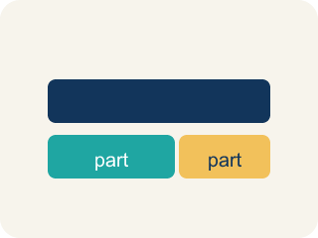
Model (Modelar) — To show a real-life situation with an equation or inequality.
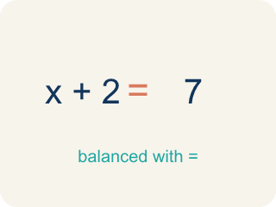
Equation (Ecuación) — A math sentence with an equal sign showing both sides are the same.
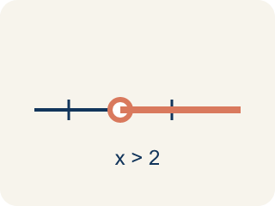
Inequality (Desigualdad) — A math sentence that compares two sides with <, >, ≤, or ≥.
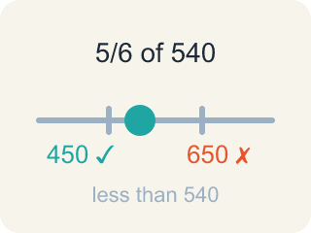
Reasonableness (Razonabilidad) — Checking if your answer makes sense.
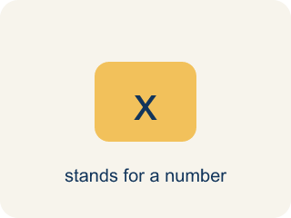
Variable (Variable) — A letter that stands for a number that is unknown or can change.
Constraint (Restricción) — A limit in a problem that tells what values are allowed.

Practice
Show your work. Use the blank space under each problem.
1. A museum has some paintings. After adding 12, they have 45. Which equation models this?
A. p + 12 = 45
B. p − 12 = 45
C. 12p = 45
D. p / 12 = 45
______________________________________________________________________
2. A detective needs more than 8 hours to finish the investigation. She has already worked 3 hours. Which inequality represents the additional hours h she needs?
A. 3 + h > 8
B. 3 + h = 8
C. h > 3
D. 8 + h > 3
______________________________________________________________________
3. Spot the Common Mistake
Step 1 (Problem): A detective already found 8 fingerprints at the scene. After dusting more surfaces, she has 15 fingerprints in all. How many new fingerprints did she find?
Step 2 (Model): x + 8 = 15
Step 3 (Solve): x = 15 + 8 = 23
Step 4 (Answer): 23 new fingerprints.
Which step has the mistake? Explain and fix it:
______________________________________________________________________
______________________________________________________________________
______________________________________________________________________
4. A student solved 4n = 52 and got n = 13. Is the answer reasonable if n represents the number of notebooks in a box?
A. No — 13 is too many notebooks
B. No — the answer should be 48
C. Yes — 13 notebooks per box is reasonable
D. Yes — but only if n is a fraction
______________________________________________________________________
5. Room 2: The vault keypad clue reads, 'A number of stolen coins plus 6 equals 14.' Solve x + 6 = 14 to find the code x.
A. x = 2
B. x = 6
C. x = 8
D. x = 20
______________________________________________________________________
6. Room 3: A sign warns, 'The safe holds at most 20 gold bars.' Which inequality models the number of bars x?
A. x ≤ 20
B. x ≥ 20
C. x > 20
D. x = 20
______________________________________________________________________
7. Room 4: A locked drawer clue reads, 'Five identical evidence boxes weigh 60 pounds in all.' Solve 5w = 60 for each box's weight w.
A. w = 12
B. w = 55
C. w = 65
D. w = 300
______________________________________________________________________
8. Level 2 Extension — The Final Door: Catch the Detective's Mistake
Step 1 (Clue): Solve the keypad inequality 3x ≤ 18 to find how many bars x fit.
Step 2 (Step 1): 3x ≤ 18
Step 3 (Step 2): Divide only the left side by 3: 3x ÷ 3 ≤ 18
Step 4 (Step 3): x ≤ 18
Step 5 (Answer): At most 18 bars fit.
Which step has the mistake? Explain and fix it:
______________________________________________________________________
______________________________________________________________________
______________________________________________________________________
9. Fix our table's thinking
Step 1 (The problem): A bus can carry at most 48 passengers. There are already 31 on board. Which inequality shows how many more can board?
Step 2 (A classmate at our table answered): 31 + p > 48
Which step has the mistake? Explain and fix it:
______________________________________________________________________
______________________________________________________________________
______________________________________________________________________

Answer Key (Teacher)
1. A. p + 12 = 45
'Adding 12' to the original number gives 45: p + 12 = 45. Solve: p = 33.
Watch for: A common mistake in Equations and Inequalities Problem Solving is matching the wrong model to a key phrase. For 'the getaway car held no more than 6 bags,' students often write the equation b = 6 instead of the inequality b ≤ 6, because they see one number and assume it must be exact. The same mistake happens in reverse: for 'the reward split equally among 5 people gave each $40,' students sometimes write the inequality 5p ≥ 40 instead of the equation 5p = 40, because 'split equally' sounds like it could mean a range. Before you submit, ask: does this phrase give one exact value (equation, =) or a limit/range (inequality, <, >, ≤, ≥)?
2. A. 3 + h > 8
3 hours plus additional hours h must be more than 8: 3 + h > 8. Solve: h > 5.
Watch for: A common mistake in Equations and Inequalities Problem Solving is matching the wrong model to a key phrase. For 'the getaway car held no more than 6 bags,' students often write the equation b = 6 instead of the inequality b ≤ 6, because they see one number and assume it must be exact. The same mistake happens in reverse: for 'the reward split equally among 5 people gave each $40,' students sometimes write the inequality 5p ≥ 40 instead of the equation 5p = 40, because 'split equally' sounds like it could mean a range. Before you submit, ask: does this phrase give one exact value (equation, =) or a limit/range (inequality, <, >, ≤, ≥)?
3. Spot the Common Mistake
The mistake is in Step 3.
Correct work: The variable x is increased by 8, so you undo addition by subtracting 8 from both sides (the inverse operation), not by adding 8 again. x + 8 = 15 becomes x = 15 − 8 = 7. So she found 7 new fingerprints. Check: 7 + 8 = 15 ✓
Watch for: The model x + 8 = 15 is set up correctly, but the solving step adds 8 again instead of undoing it. Since 8 was added to x, you subtract 8 from both sides: x = 15 − 8 = 7 new fingerprints. Check it in the story: 7 + 8 = 15 ✓
4. C. Yes — 13 notebooks per box is reasonable
4 × 13 = 52 ✓. 13 notebooks per box is a reasonable whole number answer.
Watch for: A common mistake in Equations and Inequalities Problem Solving is matching the wrong model to a key phrase. For 'the getaway car held no more than 6 bags,' students often write the equation b = 6 instead of the inequality b ≤ 6, because they see one number and assume it must be exact. The same mistake happens in reverse: for 'the reward split equally among 5 people gave each $40,' students sometimes write the inequality 5p ≥ 40 instead of the equation 5p = 40, because 'split equally' sounds like it could mean a range. Before you submit, ask: does this phrase give one exact value (equation, =) or a limit/range (inequality, <, >, ≤, ≥)?
5. C. x = 8
Subtract 6 from both sides: x = 14 − 6 = 8. Check: 8 + 6 = 14 ✓
Watch for: A common mistake in Equations and Inequalities Problem Solving is matching the wrong model to a key phrase. For 'the getaway car held no more than 6 bags,' students often write the equation b = 6 instead of the inequality b ≤ 6, because they see one number and assume it must be exact. The same mistake happens in reverse: for 'the reward split equally among 5 people gave each $40,' students sometimes write the inequality 5p ≥ 40 instead of the equation 5p = 40, because 'split equally' sounds like it could mean a range. Before you submit, ask: does this phrase give one exact value (equation, =) or a limit/range (inequality, <, >, ≤, ≥)?
6. A. x ≤ 20
'At most 20' means 20 or fewer, so x ≤ 20.
Watch for: A common mistake in Equations and Inequalities Problem Solving is matching the wrong model to a key phrase. For 'the getaway car held no more than 6 bags,' students often write the equation b = 6 instead of the inequality b ≤ 6, because they see one number and assume it must be exact. The same mistake happens in reverse: for 'the reward split equally among 5 people gave each $40,' students sometimes write the inequality 5p ≥ 40 instead of the equation 5p = 40, because 'split equally' sounds like it could mean a range. Before you submit, ask: does this phrase give one exact value (equation, =) or a limit/range (inequality, <, >, ≤, ≥)?
7. A. w = 12
Divide both sides by 5: w = 60 ÷ 5 = 12 pounds. Check: 5 × 12 = 60 ✓
Watch for: A common mistake in Equations and Inequalities Problem Solving is matching the wrong model to a key phrase. For 'the getaway car held no more than 6 bags,' students often write the equation b = 6 instead of the inequality b ≤ 6, because they see one number and assume it must be exact. The same mistake happens in reverse: for 'the reward split equally among 5 people gave each $40,' students sometimes write the inequality 5p ≥ 40 instead of the equation 5p = 40, because 'split equally' sounds like it could mean a range. Before you submit, ask: does this phrase give one exact value (equation, =) or a limit/range (inequality, <, >, ≤, ≥)?
8. Level 2 Extension — The Final Door: Catch the Detective's Mistake
The mistake is in Step 3.
Correct work: Whatever you do to one side of an inequality, you must do to the OTHER side too. Dividing only the left side by 3 breaks the balance. 3x ≤ 18 becomes 3x ÷ 3 ≤ 18 ÷ 3, which gives x ≤ 6. So at most 6 bars fit, not 18.
Watch for: An inequality stays true only if both sides get exactly the same treatment. Dividing just the left side by 3 breaks that balance, which is how the impossible x ≤ 18 appeared. Dividing both sides gives 3x ÷ 3 ≤ 18 ÷ 3, so x ≤ 6 — at most 6 bars fit.
9. Fix our table's thinking
The mistake is in Step 2.
Correct work: The correct answer is 31 + p ≤ 48. 'At most 48' means the total must be ≤ 48. So 31 + p ≤ 48. Solve: p ≤ 17.

