UNIT 1 · LESSON 1 STANDARD MPP.3

Math is Mine
Student Notes Packet
Name: ______________________ Date: ____________ Period: ________
Level 3 · Enrichment

Today's Goals
Content: I can describe the ways we are all doers of math, and compare my math story with a classmate's.
Language: I can tell my math story using the words strength, challenge, and I use math when ___ .

Key Vocabulary
Look at the picture, read the word, then read what it means.
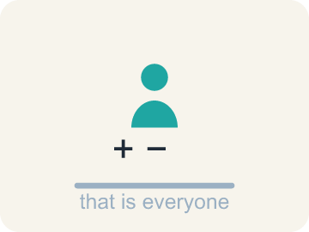 | doer of math persona que hace matemáticas  Anyone who uses mathematical thinking — which is everyone, every day.  Example: Splitting a bill 4 ways at dinner — that is a doer of math.
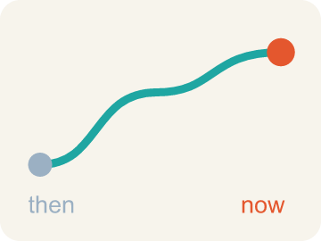 | math story historia matemática  Your own history with mathematics — what you have done, felt, and learned so far.  Example: “In 3rd grade I hated fractions; this year I can explain them.”
 | strength fortaleza  Something you already do well and can share with others.  Example: “I am good at mental math with money” — a strength you can teach.
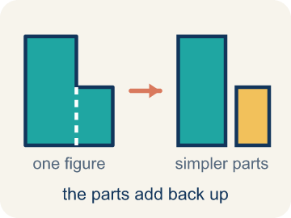 | decompose descomponer  To break a number into parts that add, subtract, multiply, or divide back to it.  Example: 78.5 = 70 + 8.5, and also 157 ÷ 2 — both rebuild the same number.
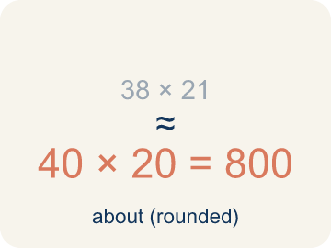 | estimate estimar  A reasoned answer that is close enough to be useful, without counting every one.  Example: 20 cars × about 4 riders ≈ 80 people on the Ferris wheel.

Guided Notes
Fill in each blank as we go. Use the Word Bank to help you.
WORD BANK
doer of math • math story • strength • decompose • estimate

1. Anyone who uses mathematical thinking is a ________________ ________________ ________________.
2. Your history with mathematics — what you have done and felt — is your ________________ ________________.
3. Something you already do well and can share with others is a ________________.
4. To break a number into parts that rebuild it exactly is to ________________ it.
5. A reasoned answer that is close enough to be useful is an ________________.

Write About the Math
Use the support level you need. Every level answers the same math question.

1. Understand the Question explain
What do you believe are your math strengths, and which area do you most want to grow this year?
Your job: Answer the question. Use math evidence. Explain how the evidence proves your answer.
Responde la pregunta. Usa evidencia matemática. Explica cómo la evidencia demuestra tu respuesta.

2. Plan Your Math Words check at least two
☐ doer of math — Anyone who uses mathematical thinking — which is everyone, every day.
persona que hace matemáticas — Cualquiera que use el pensamiento matemático, es decir, todos, todos los días.
☐ math story — Your own history with mathematics — what you have done, felt, and learned so far.
historia matemática — Tu propia historia con las matemáticas: lo que has hecho, sentido y aprendido.
☐ strength — Something you already do well and can share with others.
fortaleza — Algo que ya haces bien y puedes compartir con otros.
☐ decompose — To break a number into parts that add, subtract, multiply, or divide back to it.
descomponer — Separar un número en partes que se combinan para volver a formarlo.
☐ estimate — A reasoned answer that is close enough to be useful, without counting every one.
estimar — Una respuesta razonada, lo bastante cercana para ser útil, sin contar todo.
Say it first: Say your idea to a partner or quietly to yourself before you write.
Name one math ___ you already have and one area you want to ___ . Then name one thing you learned from a ___ 's math story.
Di tu respuesta primero: Mi respuesta es ___ porque ___.

3. Build Your Explanation choose your support
This model shows the parts of an explanation. It does not answer your writing question.
Claim: The book estimates about 80 riders by multiplying 20 cars by about 4 riders per car, without counting every person.
Evidence: A strong answer says the 4-riders-per-car is a reasoned guess, not a real count, so the total (about 80) is close enough to be useful. A weak answer just restates '80' with no reasoning about why it's an estimate.
Reasoning: This evidence connects the definition of doer of math to the mathematical claim.

Start Most language support
Complete the frames. Use the word bank.
Completa las oraciones. Usa el banco de palabras.
Name one math ___ you already have and one area you want to ___ . Then name one thing you learned from a ___ 's math story.
My answer is ___.
Mi respuesta es ___.

Build Some language support
Write two connected sentences. Use because, so, or but.
Escribe dos oraciones conectadas. Usa porque, entonces o pero.
My claim is ___.
Mi afirmación es ___.
I know because ___.
Lo sé porque ___.
So ___.
Entonces ___.

Explain Light language support
Write a claim, give math evidence, and explain your reasoning.
Escribe una afirmación, da evidencia matemática y explica tu razonamiento.
My claim is ___.
Mi afirmación es ___.
My math evidence is ___.
Mi evidencia matemática es ___.
This proves ___ because ___.
Esto demuestra ___ porque ___.

4. Check Your Explanation five quick checks
☐ I answered the question.
Respondí la pregunta.
☐ I used math evidence: numbers, an equation, a model, or a comparison.
Usé evidencia matemática: números, una ecuación, un modelo o una comparación.
☐ I explained how the evidence proves my answer.
Expliqué cómo la evidencia demuestra mi respuesta.
☐ I used at least two math words.
Usé por lo menos dos palabras matemáticas.
☐ I reread complete sentences and punctuation.
Volví a leer mis oraciones completas y la puntuación.

Worked Example

Watch & Read I Do — follow along with your teacher
Unit 1 · Lesson 1
You have been doing math your whole life — at home, in school, and in your neighborhood — often without calling it math. This year starts by naming what you already do. Today you will take a Strengths Inventory — naming one thing you can already do well and one area you want to grow — and you will write your own math story. Then you will read a classmate’s story and find one thing that is the same as yours and one thing that is different. Estimating the riders on that Ferris wheel is math. So is deciding whether an answer is reasonable.

Solved Example I Do — watch each step
Problem: About how many people can ride the Ferris wheel at one time if it has 20 cars that each hold about 4 people?
A) About 80
B) About 24
C) About 5
D) About 400
Step 1: 20 cars with about 4 riders each is 20 × 4, which is about 80 people.
Answer: A. About 80

Independent Practice

On Your Own You Do — show your work
Solve each problem. Show your thinking in the work box.

Level 2 Enrichment stretch your thinking
1. Which set shows FIVE different correct decompositions of 78.5?
A) 70 + 8.5, 78 + 0.5, 80 − 1.5, 39.25 × 2, 157 ÷ 2
B) 70 + 8.5, 78 + 5, 80 − 1.5, 39.25 × 2, 157 ÷ 2
C) 70 + 8.5, 78 + 0.5, 80 + 1.5, 39.25 × 2, 157 ÷ 2
D) 70 + 8.5, 78 + 0.5, 80 − 1.5, 39.25 × 3, 157 ÷ 2

2. Someone says “I'm just not a math person.” Using this lesson, write what you would say back.
3. Sharing math strengths helps everyone grow. Name a strength you have that you could TEACH someone, and how you would teach it.
4. Why does the book start the year with this lesson instead of with computation?
A) Because what you believe about yourself shapes how you learn all year
B) Because there is no mathematics in Unit 1
C) Because sixth graders have forgotten all their math
D) Because estimating is the hardest skill in the book

Exit Ticket
Answer on your own. This shows what you learned today.
★ Which statement best shows what this lesson means by “we are all doers of math”?
A) Everyone uses mathematical thinking daily, in different ways, and sharing those ways helps us grow
B) Everyone gets the same score if they try hard enough
C) Everyone must solve problems the same way to be correct
D) Only the fastest students are really doing math

