UNIT 1 · LESSON 2 STANDARD 5.NF.B.4

Math is Exploring and Thinking
Student Notes Packet
Name: ______________________ Date: ____________ Period: ________
Level 1 · Support

Today's Goals
Content: I can make sense of a problem, plan a strategy, and use fractions of a whole number to compare quantities.
Language: I can explain my plan using the words we know, we don't know, and my strategy is ___ .

Key Vocabulary
Look at the picture, read the word, then read what it means.
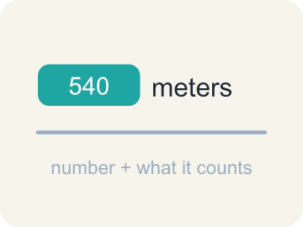 | quantity cantidad  An amount in a problem — a number with a meaning attached, like 540 meters.  Example: 540 meters — the number 540 AND what it measures.
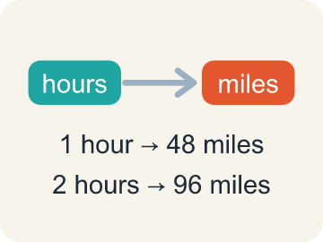 | relationship relación  How two quantities compare or connect to each other.  Example: 1 hour → 48 km, 2 hours → 96 km: as one grows, so does the other.
 | strategy estrategia  A plan for how to solve a problem before you start computing.  Example: “I will draw a tape diagram first, then divide” — chosen before computing.
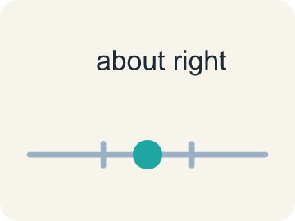 | reasonable razonable  A solution that makes sense in the context of the problem.  Example: 5/6 of 540 must be under 540, so 450 is reasonable and 650 is not.
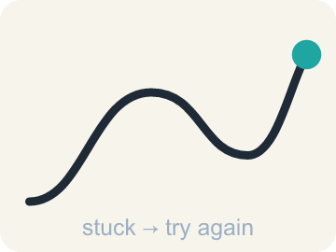 | persevere perseverar  To keep working on a problem, checking your progress and adjusting your plan when you get stuck.  Example: Stuck on the tram problem → try a tape diagram instead → keep going.

Guided Notes
Fill in each blank as we go. Use the Word Bank to help you.
WORD BANK
quantity • relationship • strategy • reasonable • persevere

1. A number with a meaning attached, like 540 meters, is a ________________.
2. How two quantities connect or change together is a ________________.
3. The plan you choose before you start computing is your ________________.
4. An answer that makes sense in the story of the problem is ________________.
5. To keep working and change your plan when you get stuck is to ________________.

Write About the Math
Use the support level you need. Every level answers the same math question.

1. Understand the Question explain
How can you use the relationships among the distances to choose possible values for how far Deon, Miguel, and Evelyn walked?
Your job: Answer the question. Use math evidence. Explain how the evidence proves your answer.
Responde la pregunta. Usa evidencia matemática. Explica cómo la evidencia demuestra tu respuesta.

2. Plan Your Math Words check at least two
☐ quantity — An amount in a problem — a number with a meaning attached, like 540 meters.
cantidad — Una cantidad en un problema: un número con un significado, como 540 metros.
☐ relationship — How two quantities compare or connect to each other.
relación — Cómo se comparan o se conectan dos cantidades entre sí.
☐ strategy — A plan for how to solve a problem before you start computing.
estrategia — Un plan para resolver un problema antes de empezar a calcular.
☐ reasonable — A solution that makes sense in the context of the problem.
razonable — Una solución que tiene sentido en el contexto del problema.
☐ persevere — To keep working on a problem, checking your progress and adjusting your plan when you get stuck.
perseverar — Seguir trabajando en un problema, revisando tu progreso y ajustando tu plan cuando te atascas.
Say it first: Say your idea to a partner or quietly to yourself before you write.
Pick a distance for Miguel. Then choose a distance for Deon that is ___ than Miguel's and a distance for Evelyn that is ___ than Miguel's, and explain how you ___ that your three values work.
Di tu respuesta primero: Mi respuesta es ___ porque ___.

3. Build Your Explanation choose your support
This model shows the parts of an explanation. It does not answer your writing question.
Claim: The lesson's warm-up decomposes 105.76 several different ways, and each decomposition must sum back to 105.76.
Evidence: A strong answer explains that each digit must land in its correct place value so the parts add back to exactly 105.76. A weak answer just says '100 and 5.76 are parts' without checking they sum correctly.
Reasoning: This evidence connects the definition of quantity to the mathematical claim.

Start Most language support
Complete the frames. Use the word bank.
Completa las oraciones. Usa el banco de palabras.
Pick a distance for Miguel. Then choose a distance for Deon that is ___ than Miguel's and a distance for Evelyn that is ___ than Miguel's, and explain how you ___ that your three values work.
My answer is ___.
Mi respuesta es ___.

Build Some language support
Write two connected sentences. Use because, so, or but.
Escribe dos oraciones conectadas. Usa porque, entonces o pero.
My claim is ___.
Mi afirmación es ___.
I know because ___.
Lo sé porque ___.
So ___.
Entonces ___.

Explain Light language support
Write a claim, give math evidence, and explain your reasoning.
Escribe una afirmación, da evidencia matemática y explica tu razonamiento.
My claim is ___.
Mi afirmación es ___.
My math evidence is ___.
Mi evidencia matemática es ___.
This proves ___ because ___.
Esto demuestra ___ porque ___.

4. Check Your Explanation five quick checks
☐ I answered the question.
Respondí la pregunta.
☐ I used math evidence: numbers, an equation, a model, or a comparison.
Usé evidencia matemática: números, una ecuación, un modelo o una comparación.
☐ I explained how the evidence proves my answer.
Expliqué cómo la evidencia demuestra mi respuesta.
☐ I used at least two math words.
Usé por lo menos dos palabras matemáticas.
☐ I reread complete sentences and punctuation.
Volví a leer mis oraciones completas y la puntuación.

Worked Example

Watch & Read I Do — follow along with your teacher
Unit 1 · Lesson 2
Doing math is exploring: you make sense of a problem, plan a strategy, check your progress, and try new paths when you hit a dead end. Today's problems — walking distances and skyscraper heights — reward thinkers, not just calculators.

Solved Example I Do — watch each step
Problem: Which of these is a correct way to decompose 105.76?
A) 100 + 5.76
B) 100 + 5.076
C) 105 + 7.6
D) 10 + 5.76
Step 1: 100 + 5.76 = 105.76.
Step 2: Decomposing means the parts must rebuild the original number exactly.
Answer: A. 100 + 5.76

Guided Practice

Solve Together We Do — work with your class
Problem: Which is another correct decomposition of 105.76?
A) 110 − 4.24
B) 110 − 5.24
C) 106 − 0.34
D) 110 + 4.24
Step 1:

Step 2:

Answer:

Deon walked a shorter distance than Miguel, and Evelyn walked a longer distance than Miguel. You never learn the exact distances — but the relationships still tell you a lot.
How can you use the relationships among the distances to choose possible values for how far Deon, Miguel, and Evelyn walked?

Sentence frame: Pick a distance for Miguel. Then choose a distance for Deon that is ___ than Miguel's and a distance for Evelyn that is ___ than Miguel's, and explain how you ___ that your three values work.

Turn & Talk discuss with a partner
1. [Launch] The book decomposes 105.76 as one example: 100 + 5.76. Why must the parts of a decomposition always rebuild the original number exactly?
Start with: 100 + 5.76 works because ___.
100 + 5.76 funciona porque ___.
Word bank: Decompose, Place value, Sum
2. [Explore] You sorted 'Deon walked a shorter distance than Miguel' as something we KNOW, even without exact numbers. How can a relationship like 'shorter than' be knowledge, if we don't know the actual distance?
Start with: We know this because the problem states a ___, not an exact number.
Sabemos esto porque el problema da una ___, no un número exacto.
Word bank: Relationship, Compare, Exact value
3. [Connect] If you pick a distance for Miguel, how do you choose distances for Deon and Evelyn that stay true to the relationships in the problem?
Start with: I picked ___ miles for Miguel, so Deon must be ___ and Evelyn must be ___.
Elegí ___ millas para Miguel, así que Deon debe ser ___ y Evelyn debe ser ___.
Word bank: Shorter, Longer, Relationship
4. [Practice] During practice on decomposing numbers, what strategy did you use when a decomposition felt tricky?
Start with: I checked my decomposition by ___.
Comprobé mi descomposición al ___.
Word bank: Decompose, Place value, Check

Independent Practice

On Your Own You Do — show your work
Solve each problem. Show your thinking in the work box.

Level 1 Support extra scaffolding
1. Deon walked a shorter distance than Miguel, and Evelyn walked a longer distance than Miguel. Who walked the shortest distance?
A) Deon
B) Miguel
C) Evelyn
D) It cannot be determined

2. In the Comparing Walks problem, name one thing you KNOW and one thing you DON'T know.
3. The London building will be 5/6 as tall as One World Trade Center, which is 540 meters. How tall will the London building be?
A) 450 meters
B) 90 meters
C) 648 meters
D) 534 meters

4. What can you do if you're stuck on a problem?

Exit Ticket
Answer on your own. This shows what you learned today.
★ Which statement best shows what this lesson means by "math is exploring and thinking"?
A) We make sense of problems, plan a strategy, check our progress, and try other strategies at dead ends
B) We compute as fast as possible and move on to the next problem
C) We wait for someone to show us the one correct method
D) We only check our work when the answer looks wrong

