1.1–1.3 Catch-Up — Homework
Lesson 1-3-catchup • Standard 5.NBT.B.7
Name: ______________________ Period: ______ Date: ____________

Today's Goals
Content: I can show I am caught up on Lessons 1.1–1.3 by using each lesson's big idea in mixed practice.
Language: I can explain which lesson's big idea I used and how, using key vocabulary from Lessons 1.1–1.3.

Key Words
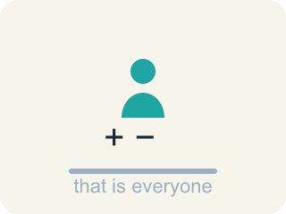
doer of math (persona que hace matemáticas) — Anyone who uses mathematical thinking — which is everyone, every day.
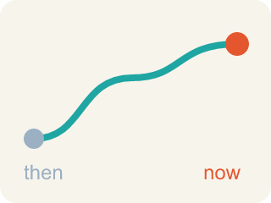
math story (historia matemática) — Your own history with mathematics — what you have done, felt, and learned so far.

strength (fortaleza) — Something you already do well and can share with others.
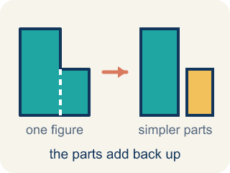
decompose (descomponer) — To break a number into parts that add, subtract, multiply, or divide back to it.
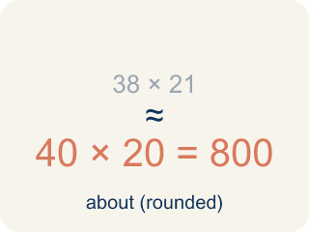
estimate (estimar) — A reasoned answer that is close enough to be useful, without counting every one.
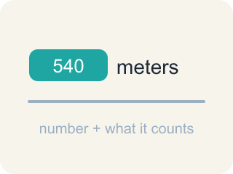
quantity (cantidad) — An amount in a problem — a number with a meaning attached, like 540 meters.
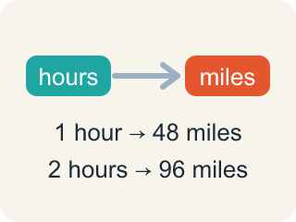
relationship (relación) — How two quantities compare or connect to each other.

strategy (estrategia) — A plan for how to solve a problem before you start computing.
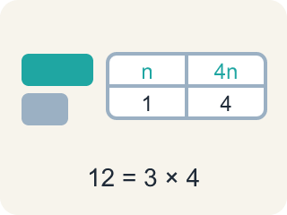
representation (representación) — A picture, diagram, table, or equation that shows the mathematics in a situation.
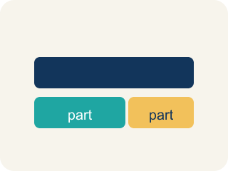
tape diagram (diagrama de cintas) — A rectangle cut into equal parts that helps you visualize how a total breaks apart.

Practice
Show your work. Use the blank space under each problem.
1. (Lesson 1.1) About how many people can ride the Ferris wheel at one time if it has 20 cars that each hold about 4 people?
A. About 80
B. About 24
C. About 5
D. About 400
______________________________________________________________________
2. (Lesson 1.1) Which of these is a correct way to decompose 78.5?
A. 70 + 8.5
B. 70 + 8.05
C. 78 + 5
D. 7 + 8.5
______________________________________________________________________
3. (Lesson 1.1) Which decomposition of 78.5 uses multiplication correctly?
A. 39.25 × 2
B. 39.25 × 3
C. 78.5 × 2
D. 39 × 2
______________________________________________________________________
4. (Lesson 1.1) A Ferris wheel holds about 78 riders per turn and makes 6 turns an hour. About how many riders per hour?
A. About 468
B. About 84
C. About 13
D. About 780
______________________________________________________________________
5. (Lesson 1.2) The Rio de Janeiro building will be 9/10 as tall as One World Trade Center (540 meters). How tall will it be?
A. 486 meters
B. 54 meters
C. 4,860 meters
D. 594 meters
______________________________________________________________________
6. (Lesson 1.2) The Tokyo building will be 6/5 as tall as One World Trade Center (540 meters). How tall will it be?
A. 648 meters
B. 450 meters
C. 108 meters
D. 432 meters
______________________________________________________________________
7. (Lesson 1.3) The 50 rides take 625 minutes. About how many HOURS is that?
A. About 10.42 hours
B. About 6.25 hours
C. About 62.5 hours
D. About 12.5 hours
______________________________________________________________________
8. (Lesson 1.3) How does the answer change for 2,000 passengers? Each ride carries 80 passengers and takes 12.5 minutes. How many MINUTES are needed?
A. 312.5 minutes
B. 31.25 minutes
C. 3,125 minutes
D. 300 minutes
______________________________________________________________________

Answer Key (Teacher)
1. A. About 80
20 cars with about 4 riders each is 20 × 4, which is about 80 people.
Watch for: Converting minutes to hours by moving the decimal point — 625 minutes is NOT 6.25 hours. An hour is 60 minutes, so divide by 60: 625 ÷ 60 ≈ 10.42 hours.
2. A. 70 + 8.5
70 + 8.5 = 78.5. Decomposing means the parts must add back to the original number.
Watch for: Converting minutes to hours by moving the decimal point — 625 minutes is NOT 6.25 hours. An hour is 60 minutes, so divide by 60: 625 ÷ 60 ≈ 10.42 hours.
3. A. 39.25 × 2
39.25 × 2 = 78.5, so halving and doubling is another way to break the number apart.
Watch for: Converting minutes to hours by moving the decimal point — 625 minutes is NOT 6.25 hours. An hour is 60 minutes, so divide by 60: 625 ÷ 60 ≈ 10.42 hours.
4. A. About 468
78 riders on each of 6 turns is 78 × 6 = 468 riders in an hour.
Watch for: Converting minutes to hours by moving the decimal point — 625 minutes is NOT 6.25 hours. An hour is 60 minutes, so divide by 60: 625 ÷ 60 ≈ 10.42 hours.
5. A. 486 meters
9/10 × 540: one tenth of 540 is 54, and 9 tenths is 9 × 54 = 486 meters.
Watch for: Converting minutes to hours by moving the decimal point — 625 minutes is NOT 6.25 hours. An hour is 60 minutes, so divide by 60: 625 ÷ 60 ≈ 10.42 hours.
6. A. 648 meters
6/5 × 540: one fifth of 540 is 108, and 6 fifths is 6 × 108 = 648 meters — taller than 540, because 6/5 is greater than 1.
Watch for: Converting minutes to hours by moving the decimal point — 625 minutes is NOT 6.25 hours. An hour is 60 minutes, so divide by 60: 625 ÷ 60 ≈ 10.42 hours.
7. A. About 10.42 hours
625 ÷ 60 ≈ 10.42, so it would take about 10.42 hours to transport 4,000 passengers.
Watch for: Converting minutes to hours by moving the decimal point — 625 minutes is NOT 6.25 hours. An hour is 60 minutes, so divide by 60: 625 ÷ 60 ≈ 10.42 hours.
8. A. 312.5 minutes
2,000 ÷ 80 = 25 rides, and 25 × 12.5 = 312.5 minutes — half the passengers, half the 625 minutes.
Watch for: Converting minutes to hours by moving the decimal point — 625 minutes is NOT 6.25 hours. An hour is 60 minutes, so divide by 60: 625 ÷ 60 ≈ 10.42 hours.

