UNIT 1 · LESSON 3 STANDARD 5.NBT.B.7

Math is In My World
Student Notes Packet
Name: ______________________ Date: ____________ Period: ________
Level 1 · Support

Today's Goals
Content: I can represent a real-world situation with a tape diagram or table and use decimal operations to solve it.
Language: I can describe my tool using the words tape diagram, table, and this represents ___ .

Key Vocabulary
Look at the picture, read the word, then read what it means.
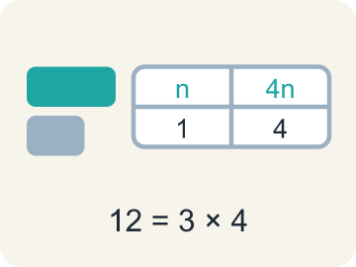 | representation representación  A picture, diagram, table, or equation that shows the mathematics in a situation.  Example: The same 12 shown three ways: a tape diagram, a table, and 3 × 4.
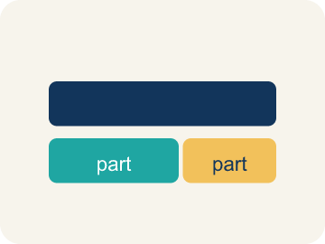 | tape diagram diagrama de cintas  A rectangle cut into equal parts that helps you visualize how a total breaks apart.  Example: One bar of 4,000 passengers cut into equal groups of 80.
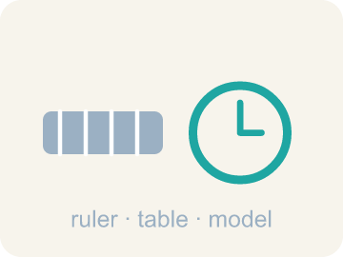 | tool herramienta  Anything you choose to help you see relationships and solve a problem — a table, a diagram, a graph.  Example: A table, a number line, or a tape diagram — whichever shows the relationship.
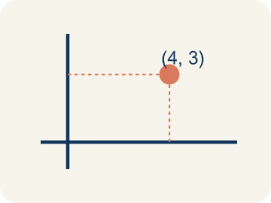 | ordered pair par ordenado  Two numbers that go together, like a time and a number of trips, that you can plot as a point.  Example: (4, 60): 4 hours costs $60 — the hours always come first.
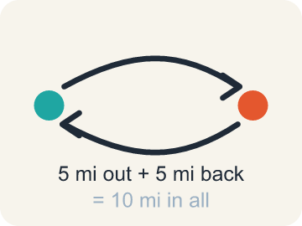 | round trip viaje de ida y vuelta  A complete journey from the start, to the destination, and back to the start.  Example: 5 miles out plus 5 miles back = 10 miles in all.

Guided Notes
Fill in each blank as we go. Use the Word Bank to help you.
WORD BANK
representation • tape diagram • tool • ordered pair • round trip

1. A drawing, table, or equation that shows the math in a situation is a ________________.
2. A rectangle cut into equal parts that shows how a total breaks apart is a ________________ ________________.
3. Anything you choose to help you see relationships and solve is a ________________.
4. Two numbers that go together and can be plotted as a point are an ________________ ________________.
5. A journey out to a place and all the way back is a ________________ ________________.

Write About the Math
Use the support level you need. Every level answers the same math question.

1. Understand the Question explain
What tool can you use to represent the relationship between time and round trips, and how does it answer the question?
Your job: Answer the question. Use math evidence. Explain how the evidence proves your answer.
Responde la pregunta. Usa evidencia matemática. Explica cómo la evidencia demuestra tu respuesta.

2. Plan Your Math Words check at least two
☐ representation — A picture, diagram, table, or equation that shows the mathematics in a situation.
representación — Un dibujo, diagrama, tabla o ecuación que muestra las matemáticas de una situación.
☐ tape diagram — A rectangle cut into equal parts that helps you visualize how a total breaks apart.
diagrama de cintas — Un rectángulo dividido en partes iguales que te ayuda a visualizar cómo se separa un total.
☐ tool — Anything you choose to help you see relationships and solve a problem — a table, a diagram, a graph.
herramienta — Cualquier cosa que eliges para ver relaciones y resolver un problema: una tabla, un diagrama, una gráfica.
☐ ordered pair — Two numbers that go together, like a time and a number of trips, that you can plot as a point.
par ordenado — Dos números que van juntos, como un tiempo y un número de viajes, que puedes graficar como un punto.
☐ round trip — A complete journey from the start, to the destination, and back to the start.
viaje de ida y vuelta — Un recorrido completo desde el inicio hasta el destino y de regreso al inicio.
Say it first: Say your idea to a partner or quietly to yourself before you write.
Name the tool you would use to show the relationship — a ___ of values — then name the two quantities in the problem: ___ and ___ .
Di tu respuesta primero: Mi respuesta es ___ porque ___.

3. Build Your Explanation choose your support
This model shows the parts of an explanation. It does not answer your writing question.
Claim: Moving 4,000 passengers in rides of 80 each requires dividing 4,000 by 80.
Evidence: A strong answer identifies division because you're splitting a total into equal-sized groups (rides of 80). A weak answer just says 'divide' without connecting it to splitting the total passengers into groups.
Reasoning: This evidence connects the definition of representation to the mathematical claim.

Start Most language support
Complete the frames. Use the word bank.
Completa las oraciones. Usa el banco de palabras.
Name the tool you would use to show the relationship — a ___ of values — then name the two quantities in the problem: ___ and ___ .
My answer is ___.
Mi respuesta es ___.

Build Some language support
Write two connected sentences. Use because, so, or but.
Escribe dos oraciones conectadas. Usa porque, entonces o pero.
My claim is ___.
Mi afirmación es ___.
I know because ___.
Lo sé porque ___.
So ___.
Entonces ___.

Explain Light language support
Write a claim, give math evidence, and explain your reasoning.
Escribe una afirmación, da evidencia matemática y explica tu razonamiento.
My claim is ___.
Mi afirmación es ___.
My math evidence is ___.
Mi evidencia matemática es ___.
This proves ___ because ___.
Esto demuestra ___ porque ___.

4. Check Your Explanation five quick checks
☐ I answered the question.
Respondí la pregunta.
☐ I used math evidence: numbers, an equation, a model, or a comparison.
Usé evidencia matemática: números, una ecuación, un modelo o una comparación.
☐ I explained how the evidence proves my answer.
Expliqué cómo la evidencia demuestra mi respuesta.
☐ I used at least two math words.
Usé por lo menos dos palabras matemáticas.
☐ I reread complete sentences and punctuation.
Volví a leer mis oraciones completas y la puntuación.

Worked Example

Watch & Read I Do — follow along with your teacher
Unit 1 · Lesson 3
Math lives in your world — in coins on a table and tram cars over a valley. Today you visualize real situations, pick tools like tape diagrams and tables, and let decimal arithmetic do the heavy lifting.

Solved Example I Do — watch each step
Problem: One tram ride takes 12.5 minutes. How many minutes do 10 rides take?
A) 125 minutes
B) 22.5 minutes
C) 1.25 minutes
D) 1,250 minutes
Step 1: 12.5 × 10 = 125.
Step 2: Multiplying by 10 shifts every digit one place to the left.
Answer: A. 125 minutes

Guided Practice

Solve Together We Do — work with your class
Problem: Five Breaks: which of these is a correct way to decompose 12.5?
A) 10 + 2.5
B) 10 + 2.05
C) 12 + 5
D) 1 + 2.5
Step 1:

Step 2:

Answer:

It takes 35 minutes for one tram car to make the 5-mile round trip, from valley to mountain top and back down — including time for passengers to disembark and embark at each station. You want to know how many round trips a single tram car completes in 10 hours.
What tool can you use to represent the relationship between time and round trips, and how does it answer the question?

Sentence frame: Name the tool you would use to show the relationship — a ___ of values — then name the two quantities in the problem: ___ and ___ .

Turn & Talk discuss with a partner
1. [Launch] The aerial tram must move 4,000 passengers, and each ride carries 80 passengers. What operation tells you how many rides are needed, and why?
Start with: I would ___ 4,000 by 80 to find the number of rides.
Yo ___ 4,000 entre 80 para hallar el número de viajes.
Word bank: Divide, Equal groups, Rides
2. [Explore] You sorted 'find how many rides are needed for 4,000 passengers' under division and 'find the total minutes for 50 rides at 12.5 minutes each' under multiplication. What tells you which operation a tram task needs?
Start with: This task needs ___ because we are ___.
Esta tarea necesita ___ porque estamos ___.
Word bank: Division, Multiplication, Equal groups
3. [Connect] One tram round trip takes 35 minutes. Before you can find how many round trips fit in 10 hours, what units problem do you have to solve first?
Start with: I need to convert ___ hours into ___ so the units match.
Necesito convertir ___ horas en ___ para que las unidades coincidan.
Word bank: Convert, Minutes, Table
4. [Practice] During practice, one problem asked how many minutes 10 rides of 12.5 minutes each take. What strategy did you use?
Start with: I multiplied ___ by ___ to get 125 minutes.
Multipliqué ___ por ___ para obtener 125 minutos.
Word bank: Multiply, Decimal, Place value

Independent Practice

On Your Own You Do — show your work
Solve each problem. Show your thinking in the work box.

Level 1 Support extra scaffolding
1. About how many coins are in the picture in your book? Explain how you estimated WITHOUT counting every coin.
2. How many minutes do 50 tram rides take, at 12.5 minutes per ride?
A) 625 minutes
B) 62.5 minutes
C) 600 minutes
D) 6,250 minutes

3. Each tram ride carries 80 passengers. How many rides are needed to transport 4,000 passengers?
A) 50 rides
B) 500 rides
C) 320,000 rides
D) 3,920 rides

4. How can a tape diagram help you visualize the tram problem of moving 4,000 passengers?

Exit Ticket
Answer on your own. This shows what you learned today.
★ Which statement best shows what this lesson means by "math is in my world"?
A) We visualize real problems, use tools to show relationships among quantities, and choose our tools strategically
B) Real-world problems can only be solved with a calculator
C) Tables and diagrams are decorations we add after solving
D) Every problem must be solved with the same one tool

