UNIT 1 · LESSON 4 STANDARD 5.MD.C.5

Math is Explaining and Sharing
Student Notes Packet
Name: ______________________ Date: ____________ Period: ________
Level 3 · Enrichment

Today's Goals
Content: I can construct an argument using equations, drawings, or words, and use volume to defend a recommendation.
Language: I can explain my thinking with clear math vocabulary using the words argument, conjecture, and cubic units.

Key Vocabulary
Look at the picture, read the word, then read what it means.
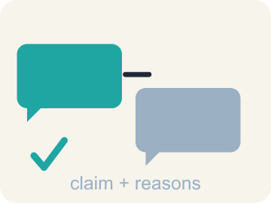 | argument argumento  A chain of reasons — equations, drawings, or words — used to defend your thinking.  Example: “Two jumbo boxes hold more, because 400 × 2 = 800 > 720.”
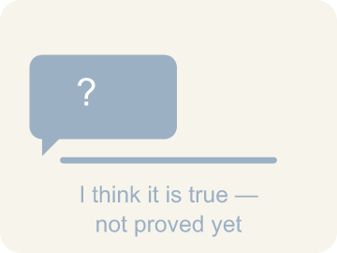 | conjecture conjetura  A mathematical statement you believe is true but have not yet proven.  Example: “A bigger box ALWAYS holds more cereal” — believed, not yet proven.
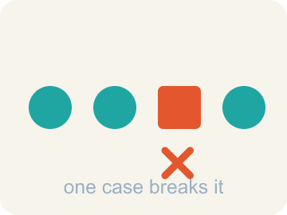 | counterexample contraejemplo  A single example that shows a statement is not always true.  Example: One jumbo box sold half full of air breaks “bigger always holds more”.
 | volume volumen  The amount of space a solid figure takes up, measured in cubic units.  Example: 8 in × 3 in × 10 in = 240 cubic inches of cereal space.
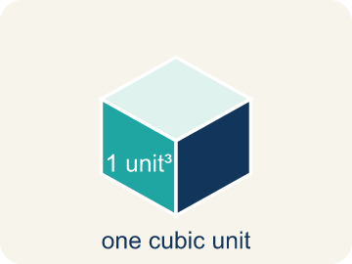 | cubic unit unidad cúbica  A cube with edges 1 unit long — the unit used to measure volume.  Example: One cube, 1 unit on every edge — the block volume is counted in.

Guided Notes
Fill in each blank as we go. Use the Word Bank to help you.
WORD BANK
argument • conjecture • counterexample • volume • cubic unit

1. A chain of reasons used to defend your thinking is an ________________.
2. A statement you believe is true but have not yet proven is a ________________.
3. A single case that shows a statement is not always true is a ________________.
4. The amount of space a solid figure takes up, in cubic units, is its ________________.
5. A cube with edges 1 unit long, used to measure volume, is a ________________ ________________.

Write About the Math
Use the support level you need. Every level answers the same math question.

1. Understand the Question explain
How can the group determine the amount of soil needed, and how can they check that their answer is accurate?
Your job: Answer the question. Use math evidence. Explain how the evidence proves your answer.
Responde la pregunta. Usa evidencia matemática. Explica cómo la evidencia demuestra tu respuesta.

2. Plan Your Math Words check at least two
☐ argument — A chain of reasons — equations, drawings, or words — used to defend your thinking.
argumento — Una cadena de razones — ecuaciones, dibujos o palabras — que usas para defender tu pensamiento.
☐ conjecture — A mathematical statement you believe is true but have not yet proven.
conjetura — Una afirmación matemática que crees verdadera pero que aún no has probado.
☐ counterexample — A single example that shows a statement is not always true.
contraejemplo — Un solo ejemplo que muestra que una afirmación no siempre es verdadera.
☐ volume — The amount of space a solid figure takes up, measured in cubic units.
volumen — La cantidad de espacio que ocupa una figura sólida, medida en unidades cúbicas.
☐ cubic unit — A cube with edges 1 unit long — the unit used to measure volume.
unidad cúbica — Un cubo cuyas aristas miden 1 unidad — la unidad que se usa para medir el volumen.
Say it first: Say your idea to a partner or quietly to yourself before you write.
To find how much soil is needed, find the ___ of the garden beds. Because volume covers three dimensions, label the answer in ___ feet. Finding the volume two different ways and getting matching totals shows the solution is ___.
Di tu respuesta primero: Mi respuesta es ___ porque ___.

3. Build Your Explanation choose your support
This model shows the parts of an explanation. It does not answer your writing question.
Claim: Three large boxes hold 240 × 3 = 720 cubic inches, and two jumbo boxes hold 400 × 2 = 800 cubic inches, so 800 > 720.
Evidence: A strong answer calculates both totals (720 and 800) and compares them to recommend the jumbo boxes. A weak answer picks an option without computing and comparing both volumes.
Reasoning: This evidence connects the definition of argument to the mathematical claim.

Start Most language support
Complete the frames. Use the word bank.
Completa las oraciones. Usa el banco de palabras.
To find how much soil is needed, find the ___ of the garden beds. Because volume covers three dimensions, label the answer in ___ feet. Finding the volume two different ways and getting matching totals shows the solution is ___.
My answer is ___.
Mi respuesta es ___.

Build Some language support
Write two connected sentences. Use because, so, or but.
Escribe dos oraciones conectadas. Usa porque, entonces o pero.
My claim is ___.
Mi afirmación es ___.
I know because ___.
Lo sé porque ___.
So ___.
Entonces ___.

Explain Light language support
Write a claim, give math evidence, and explain your reasoning.
Escribe una afirmación, da evidencia matemática y explica tu razonamiento.
My claim is ___.
Mi afirmación es ___.
My math evidence is ___.
Mi evidencia matemática es ___.
This proves ___ because ___.
Esto demuestra ___ porque ___.

4. Check Your Explanation five quick checks
☐ I answered the question.
Respondí la pregunta.
☐ I used math evidence: numbers, an equation, a model, or a comparison.
Usé evidencia matemática: números, una ecuación, un modelo o una comparación.
☐ I explained how the evidence proves my answer.
Expliqué cómo la evidencia demuestra mi respuesta.
☐ I used at least two math words.
Usé por lo menos dos palabras matemáticas.
☐ I reread complete sentences and punctuation.
Volví a leer mis oraciones completas y la puntuación.

Worked Example

Watch & Read I Do — follow along with your teacher
Unit 1 · Lesson 4
Yuzuki is buying her favorite breakfast cereal. She can buy three large-sized boxes or two jumbo-sized boxes for the same price. Which option should she pick — and can you convince a classmate you are right?

Solved Example I Do — watch each step
Problem: An egg muffin is about 60 calories. A plate holds 4 egg muffins. About how many calories are on the plate?
A) About 240
B) About 64
C) About 15
D) About 600
Step 1: 4 muffins at about 60 calories each is 60 × 4 = 240 calories.
Answer: A. About 240

Independent Practice

On Your Own You Do — show your work
Solve each problem. Show your thinking in the work box.

Level 2 Enrichment stretch your thinking
1. A student claims: “Greater box volume ALWAYS means more cereal inside.” Which is the best counterexample?
A) A jumbo box with more volume that is sold half-filled with air
B) A large box that costs more than a jumbo box
C) Two jumbo boxes that are easier to store than three large boxes
D) A box of a different cereal brand

2. The garden needs 48 cubic feet of soil. One decomposition used two prisms of 24 cubic feet each. Which of these is ANOTHER decomposition of the same garden volume?
A) A 4 × 4 × 2 prism and a 4 × 2 × 2 prism
B) A 4 × 4 × 2 prism and a 4 × 4 × 2 prism
C) A 3 × 3 × 3 prism and a 3 × 3 × 2 prism
D) A 6 × 4 × 2 prism and a 2 × 2 × 2 prism

3. Another garden bed design is also being considered. What information would you need to compare the two designs, and how would you argue for the one you recommend?
4. Write TWO arguments for the same recommendation about Yuzuki's cereal — one using equations, one using only words. Then say which you think would convince a classmate more, and why.

Exit Ticket
Answer on your own. This shows what you learned today.
★ Which statement best captures what this lesson means by 'Math is Explaining and Sharing'?
A) We communicate our reasoning, listen to classmates' arguments, decide whether they are convincing, and check our calculations for accuracy
B) We keep our methods private so nobody can copy our answers
C) An argument only counts in math if it uses equations
D) Once you have an answer, checking it a second way is a waste of time

Answer Key & Teacher Guide
Teacher reference — remove or fold back before distributing to students.

Guided Notes (Fill-in)
Notes 1: argument
Notes 2: conjecture
Notes 3: counterexample
Notes 4: volume
Notes 5: cubic unit

Worked Notes (I Do / We Do)
I Do: A. About 240
We Do: A. 240 cubic inches

Independent Practice
Watch for this mistake: Reporting volume without cubic units — saying the garden needs '48 feet' of soil, which is a length, or '48 square feet', which is an area.

Level 1 Support
1. A) 800 cubic inches — Two boxes of 400 cubic inches each is 400 × 2 = 800 cubic inches.
2. Answers vary.
3. A) Cubic feet — Volume is measured in cubic units, so soil that fills a space is measured in cubic feet.
4. Answers vary.

On Level
5. A) 720 cubic inches vs. 800 cubic inches — the jumbo option holds more — 240 × 3 = 720 and 400 × 2 = 800; since 800 > 720, the two jumbo boxes hold more in total.
6. A) 48 cubic feet — First bed: 4 × 3 × 2 = 24 cubic feet. Second bed: 6 × 2 × 2 = 24 cubic feet. Together: 24 + 24 = 48 cubic feet.

Exit Ticket
A) We communicate our reasoning, listen to classmates' arguments, decide whether they are convincing, and check our calculations for accuracy — The summary says it directly: we communicate our reasoning, make conjectures, listen and probe classmates' arguments, communicate precisely, label units accurately, and check that our calculations are accurate.

Math Writing Criteria
The support level changes the amount of language scaffolding, not the mathematical expectation.
☐ I answered the question.
☐ I used math evidence: numbers, an equation, a model, or a comparison.
☐ I explained how the evidence proves my answer.
☐ I used at least two math words.
☐ I reread complete sentences and punctuation.

